Name – Nabaskar Brahma
2023IMG-035
WCT LAB 3

- A hospital tests medical sensors by generating Gaussian noise and plotting its PDF.
Modify the given program so that the mean of the Gaussian distribution becomes 1 instead of 0. Plot the new PDF and observe how the histogram shifts compared to the original output.

clc;
clear;

N = 10000;

% Gaussian noise with mean = 0
noise0 = randn(N,1);

% Gaussian noise with mean = 1
noise1 = 1 + randn(N,1);

figure;

% Histogram for mean = 0
histogram(noise0,40,'Normalization','pdf','FaceColor','b')
hold on

% Histogram for mean = 1
histogram(noise1,40,'Normalization','pdf','FaceColor','r')

% Theoretical PDFs
x = linspace(-5,6,1000);
pdf0 = (1/sqrt(2*pi)) * exp(-(x).^2/2);
pdf1 = (1/sqrt(2*pi)) * exp(-(x-1).^2/2);

plot(x, pdf0, 'k', 'LineWidth', 2)
plot(x, pdf1, 'g', 'LineWidth', 2)

xlabel('Noise Value')
ylabel('Probability Density')
title('Comparison of Gaussian PDFs (Mean = 0 and Mean = 1)')
legend('Histogram μ=0','Histogram μ=1','PDF μ=0','PDF μ=1')
grid on
hold off

Output:

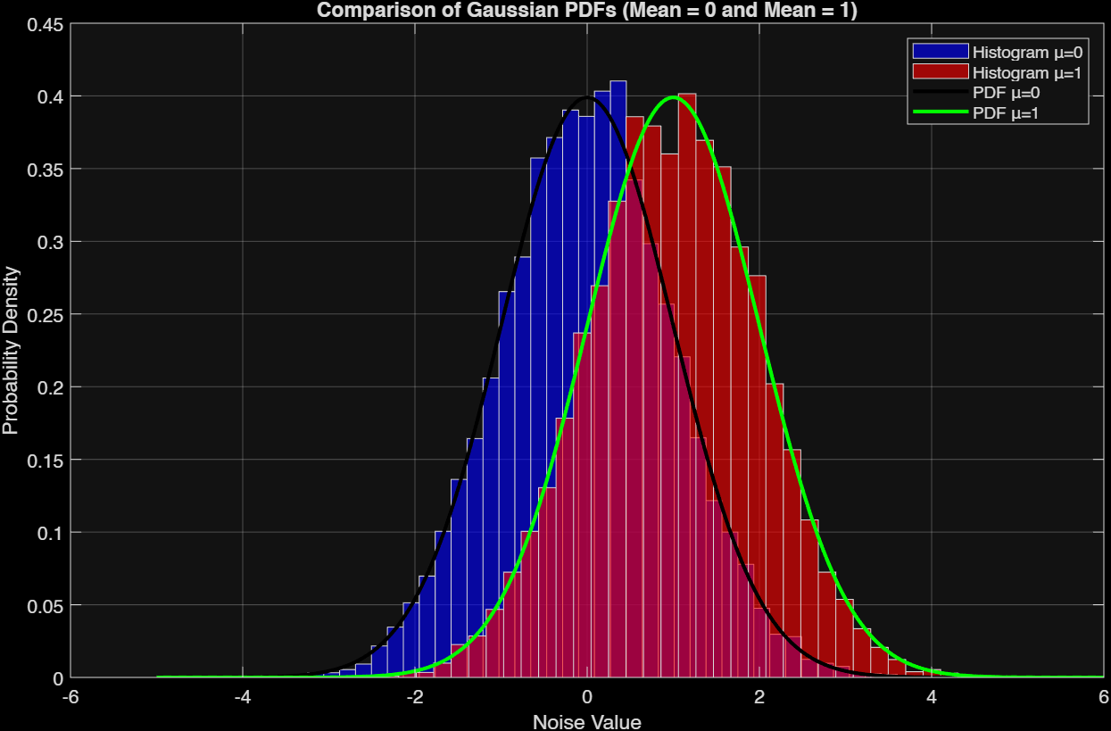

- A medical instrumentation company evaluates two sensors that are affected by random measurement errors. To compare their performance, the same Gaussian noise generation code is used twice with identical mean but different standard deviations. Modify the program so that one sensor has a standard deviation of 1 and the other has a standard deviation of 2. Plot the probability density functions for both cases in separate subplots and observe how the spread of noise differs between the two sensors.

Code:
clc;
clear;

N = 10000;
mu = 0; % Same mean for both sensors

% Sensor 1: standard deviation = 1
sigma1 = 1;
noise1 = mu + sigma1*randn(N,1);

% Sensor 2: standard deviation = 2
sigma2 = 2;
noise2 = mu + sigma2*randn(N,1);

figure;

% Subplot for Sensor 1
subplot(1,2,1)
histogram(noise1,40,'Normalization','pdf')
hold on
x = linspace(-8,8,1000);
pdf1 = (1/(sigma1*sqrt(2*pi))) * exp(-(x-mu).^2/(2*sigma1^2));
plot(x,pdf1,'r','LineWidth',2)
title('Sensor 1 (\sigma = 1)')
xlabel('Noise Value')
ylabel('PDF')
grid on

% Subplot for Sensor 2
subplot(1,2,2)
histogram(noise2,40,'Normalization','pdf')
hold on
pdf2 = (1/(sigma2*sqrt(2*pi))) * exp(-(x-mu).^2/(2*sigma2^2));
plot(x,pdf2,'r','LineWidth',2)
title('Sensor 2 (\sigma = 2)')
xlabel('Noise Value')
ylabel('PDF')
grid on

Output:
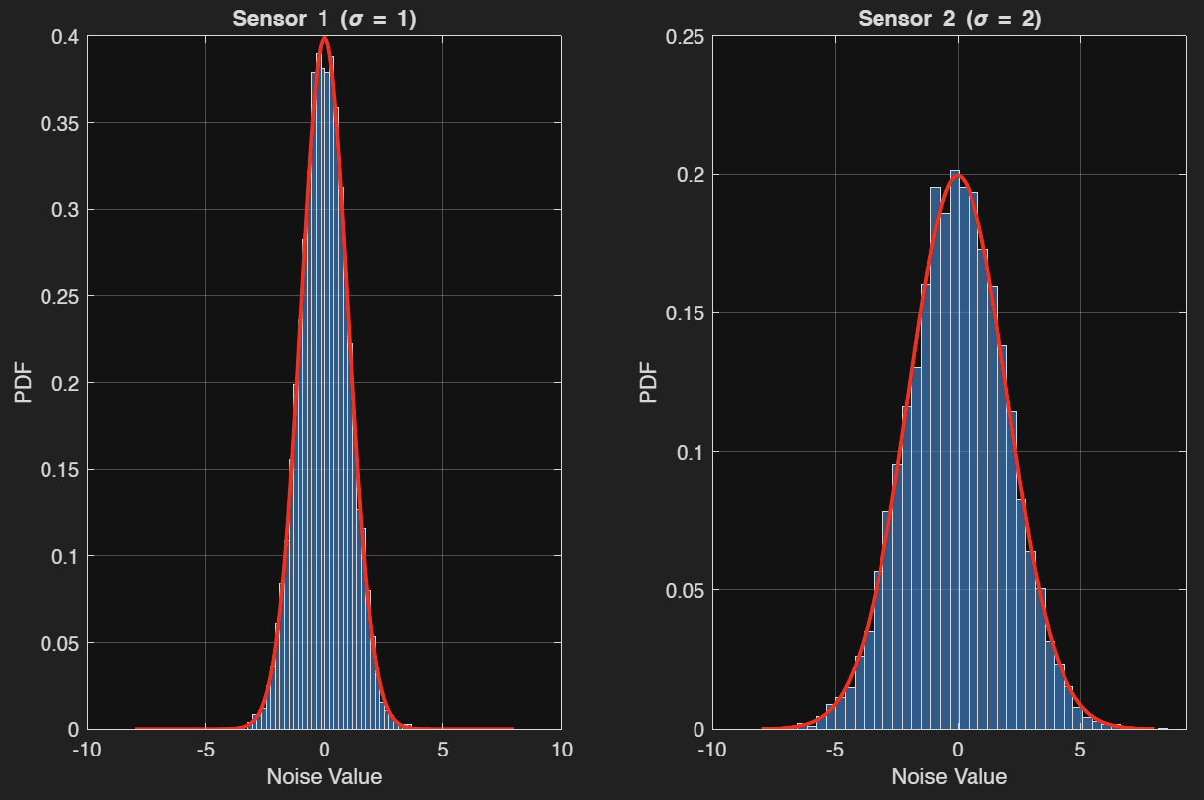
3) A smart traffic system records both continuous signal noise and discrete vehicle counts. Modify the program so that the Gaussian distribution is displayed using a histogram, while the Poisson distribution is displayed using a bar plot. Place both plots in different subplots and compare how continuous and discrete data are represented visually.

Code:
clc;
clear;

N = 10000;

% Gaussian noise (continuous)
mu = 0;
sigma = 1;
gauss = mu + sigma*randn(N,1);

% Poisson counts (discrete)
lambda = 5;
pois = poissrnd(lambda,N,1);

figure;

% Subplot 1: Gaussian Histogram
subplot(1,2,1)
histogram(gauss,40,'Normalization','pdf')
title('Gaussian Distribution (Continuous)')
xlabel('Value')
ylabel('PDF')
grid on

% Subplot 2: Poisson Bar Plot
subplot(1,2,2)
values = unique(pois);
counts = histcounts(pois, ...
[values; max(values)+1]');
bar(values, counts/sum(counts))
title('Poisson Distribution (Discrete)')
xlabel('k')
ylabel('Probability')
grid on

Output:
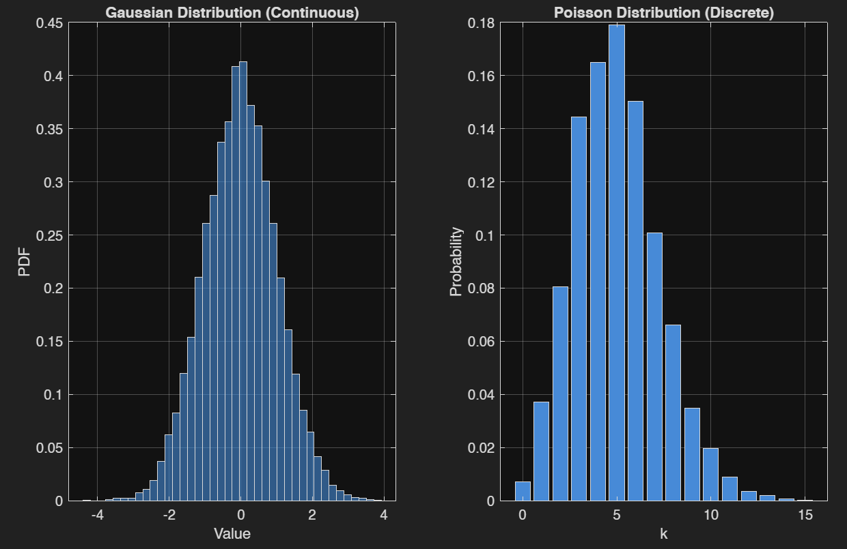

4) A reliability engineer evaluates whether increasing the number of collected samples improves confidence in statistical modeling. Modify the program so that two different sample sizes are used for all continuous distributions (Gaussian, Exponential, Rayleigh, and Uniform). Plot the PDFs for both cases and analyze which distributions show the most noticeable improvement in smoothness.

Code:
clc;
clear;

% Two different sample sizes
N1 = 1000; % small sample size
N2 = 100000; % large sample size

% Parameters
mu = 0; sigma = 1;
s = 2;
a = 0; b = 1;

%% Generate samples (small)
g1 = mu + sigma*randn(N1,1);
e1 = exprnd(1,N1,1);
r1 = raylrnd(s,N1,1);
u1 = a + (b-a)*rand(N1,1);

%% Generate samples (large)
g2 = mu + sigma*randn(N2,1);
e2 = exprnd(1,N2,1);
r2 = raylrnd(s,N2,1);
u2 = a + (b-a)*rand(N2,1);

%% Plot PDFs
figure;

subplot(4,2,1)
histogram(g1,40,'Normalization','pdf')
title('Gaussian (N = 1000)'); grid on

subplot(4,2,2)
histogram(g2,40,'Normalization','pdf')
title('Gaussian (N = 100000)'); grid on

subplot(4,2,3)
histogram(e1,40,'Normalization','pdf')
title('Exponential (N = 1000)'); grid on

subplot(4,2,4)
histogram(e2,40,'Normalization','pdf')
title('Exponential (N = 100000)'); grid on

subplot(4,2,5)
histogram(r1,40,'Normalization','pdf')
title('Rayleigh (N = 1000)'); grid on

subplot(4,2,6)
histogram(r2,40,'Normalization','pdf')
title('Rayleigh (N = 100000)'); grid on

subplot(4,2,7)
histogram(u1,40,'Normalization','pdf')
title('Uniform (N = 1000)'); grid on

subplot(4,2,8)
histogram(u2,40,'Normalization','pdf')
title('Uniform (N = 100000)'); grid on

Output:

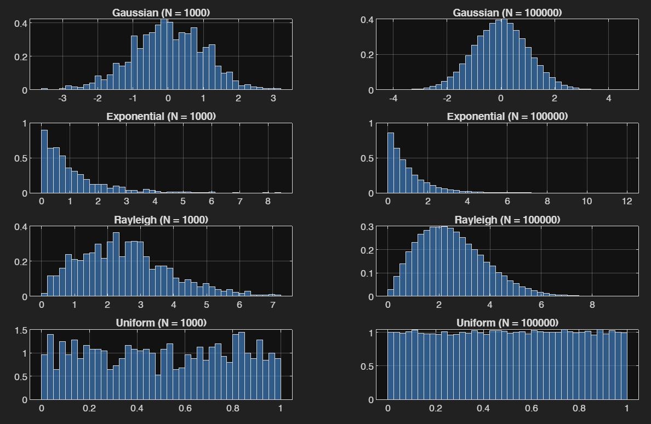

- A wireless testing laboratory studies how different noise environments affect received signals. Using the same program structure, modify the code so that Gaussian and Rayleigh random variables are generated using the same variance value, and plot their PDFs in separate subplots. Analyze how the shape differences arise even when the variance is kept identical, based on the output plots.

Code:
clc;
clear;

N = 100000;

% Desired common variance
var_common = 1;

% Gaussian parameters
mu = 0;
sigma_g = sqrt(var_common);

% Rayleigh parameter
% Variance of Rayleigh = (4 - pi)/2 * s^2
s = sqrt((2*var_common)/(4-pi));

% Generate data
gauss = mu + sigma_g*randn(N,1);
ray = raylrnd(s,N,1);

figure;

% Gaussian PDF
subplot(1,2,1)
histogram(gauss,50,'Normalization','pdf')
title('Gaussian PDF (Variance = 1)')
xlabel('Value'); ylabel('PDF')
grid on

% Rayleigh PDF
subplot(1,2,2)
histogram(ray,50,'Normalization','pdf')
title('Rayleigh PDF (Variance = 1)')
xlabel('Value'); ylabel('PDF')
grid on

Output:
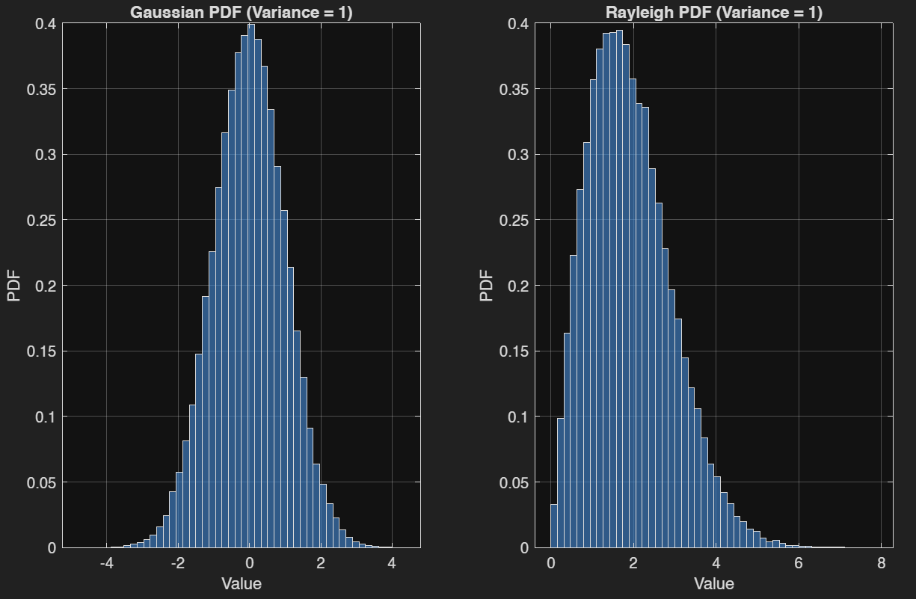

- A statistical verification system tests whether sample size alone explains PDF smoothness. Modify the program so that each distribution uses a different number of samples, but the total number of generated samples across the entire program remains constant. Replot all PDFs and analyze which distributions are most sensitive to reduced sample size.

Code:
clc;
clear;

% Total samples fixed
N_total = 200000;

% Different sample sizes for each distribution
N_gauss = 80000;
N_exp = 40000;
N_ray = 30000;
N_uni = 30000;
N_pois = 20000;

% Parameters
mu = 0; sigma = 1;
lambda = 1;
s = 2;
lambda_p = 5;
a = 0; b = 1;

%% Generate random variables
gauss = mu + sigma*randn(N_gauss,1);
expo = exprnd(1/lambda,N_exp,1);
ray = raylrnd(s,N_ray,1);
uni = a + (b-a)*rand(N_uni,1);
pois = poissrnd(lambda_p,N_pois,1);

%% Plot PDFs
figure;

subplot(2,3,1)
histogram(gauss,40,'Normalization','pdf')
title(['Gaussian (N=',num2str(N_gauss),')'])
grid on

subplot(2,3,2)
histogram(expo,40,'Normalization','pdf')
title(['Exponential (N=',num2str(N_exp),')'])
grid on

subplot(2,3,3)
histogram(ray,40,'Normalization','pdf')
title(['Rayleigh (N=',num2str(N_ray),')'])
grid on

subplot(2,3,4)
histogram(uni,40,'Normalization','pdf')
title(['Uniform (N=',num2str(N_uni),')'])
grid on

subplot(2,3,5)
histogram(pois,'Normalization','pdf')
title(['Poisson (N=',num2str(N_pois),')'])
grid on

Output:

