1. Xml schema.org has created… correct issues in this process…

* Api has created parts and plane with some modification

doing changes from frontend as well

* Handle & analysis of the “Title” is not coming up properly in Google

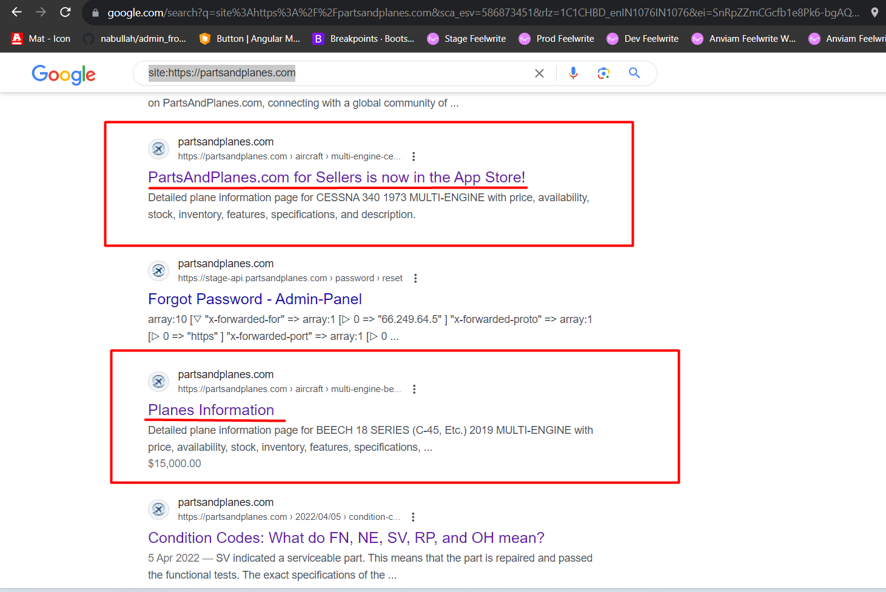

* Add heading in Detail page for Parts and Planes (SEO Purpose)
* Add title in Detail Page (SEO Purpose for Browser Tab)
* Change the Icon in the Plane Detail Page (UI Issue)
* Improve the HTML Tag in Pages (SEO Purposes)

1. Deployed changes in Production
2. Minor changes of PSIEC and Deployed changes in PSIEC

* Wallet Changes
* Show Coal and Steel Pdf
* Analysis of tally prime integration with laravel

1. Stripe Api :-

Frontend view for customer multiple card holding change – Completed ( local )

Update Stripe Api for making compatible with hold credit card where one user has multiple credit card – In Progress – Currently working on this