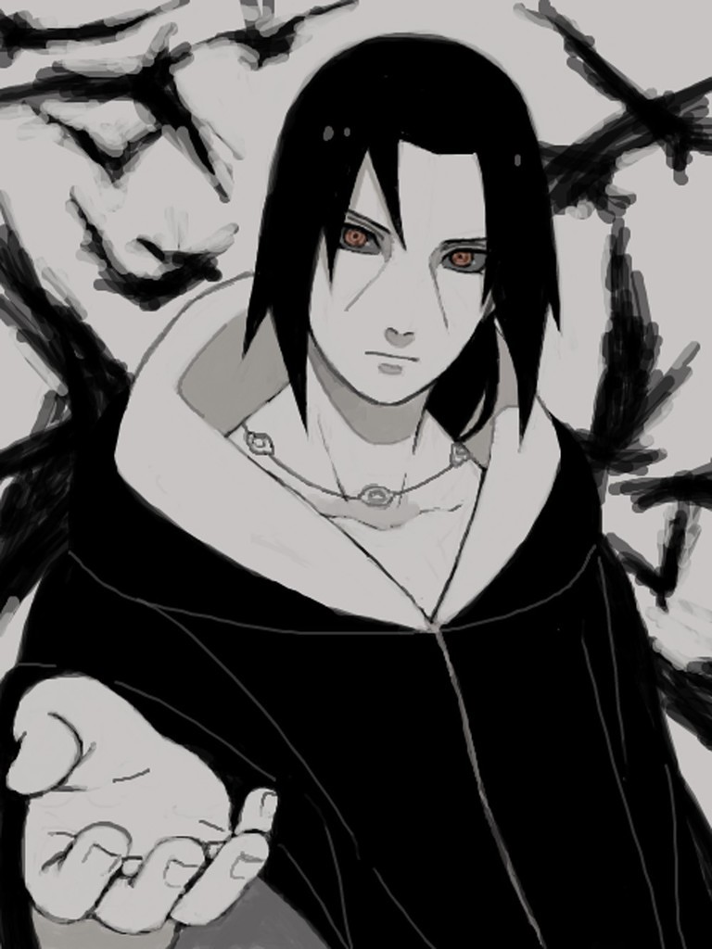

& C:/Users/nhamm/AppData/Local/Programs/Python/Python39/python.exe c:/CV_builder_project/documents.py | Itachi | & C:/Users/nhamm/AppData/Local/Programs/Python/Python39/python.exe c:/CV_builder_project/documents.py

# About me

& C:/Users/nhamm/AppData/Local/Programs/Python/Python39/python.exe c:/CV_builder_project/documents.py

# Work Experience

**& C:/Users/nhamm/AppData/Local/Programs/Python/Python39/python.exe c:/CV_builder_project/documents.py** *& C:/Users/nhamm/AppData/Local/Programs/Python/Python39/python.exe c:/CV_builder_project/documents.py-& C:/Users/nhamm/AppData/Local/Programs/Python/Python39/python.exe c:/CV_builder_project/documents.py*& C:/Users/nhamm/AppData/Local/Programs/Python/Python39/python.exe c:/CV_builder_project/documents.py

# Skills

* & C:/Users/nhamm/AppData/Local/Programs/Python/Python39/python.exe c:/CV_builder_project/documents.py