MAPS Assignment 1: OpenMP Programming – Designs

Goldberg, Peter | Hornung, Nico | Worszeck, Sascha | SHU 2012

sortRows – sort each row of data

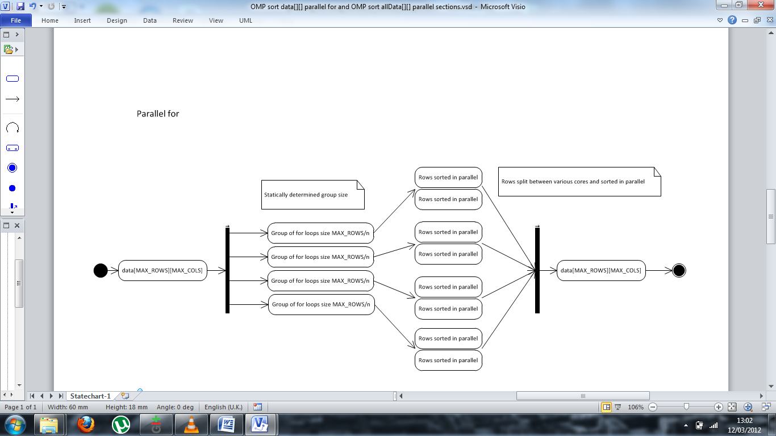***Parallel For***

***Parallel Sections***

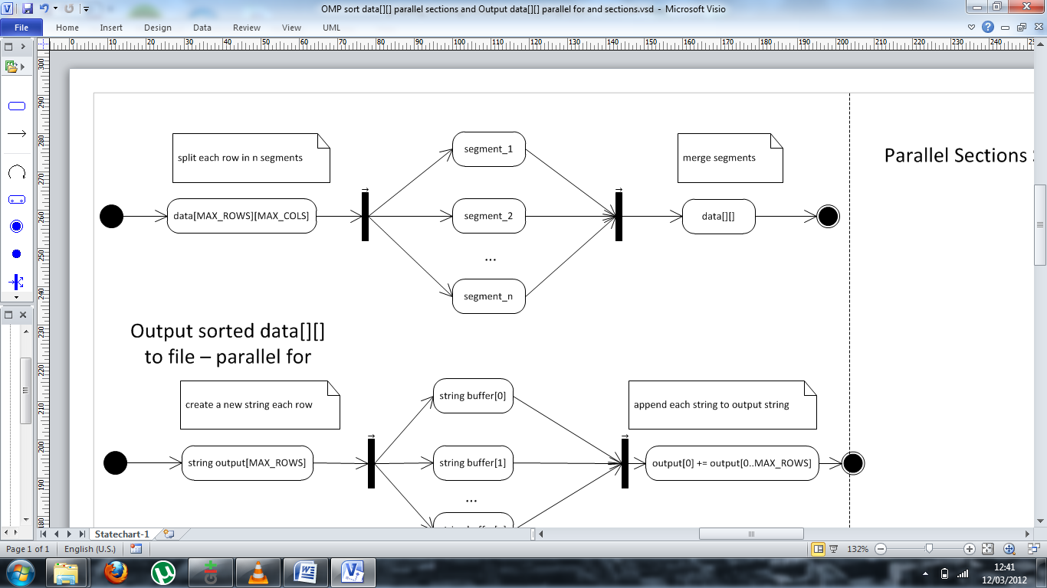

outputSortedRows() – prints the sorted rows to a file

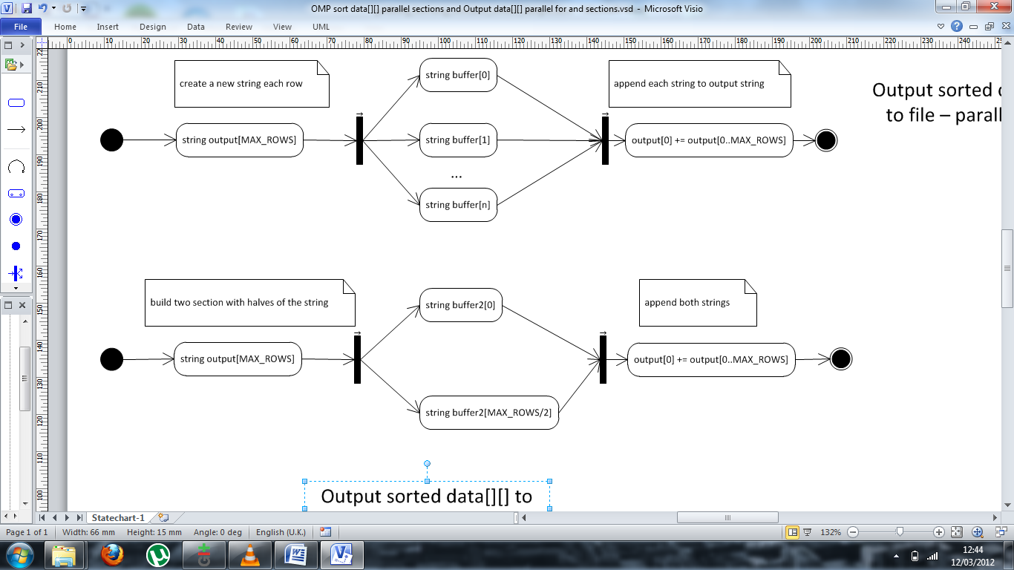***Parallel For***

***Parallel Section***

sortAll – sort all data (2,000,000 numbers) – For both .exe files

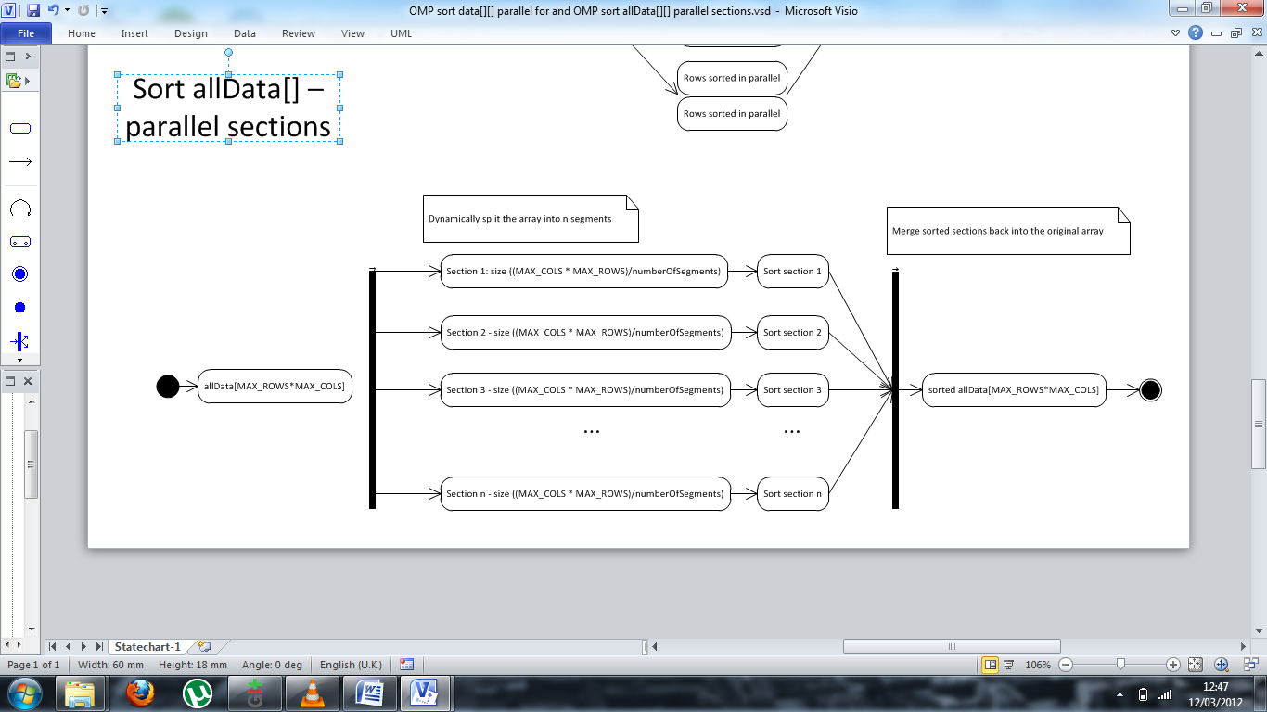

outputSortedAll – output the 2,000,000 sorted numbers

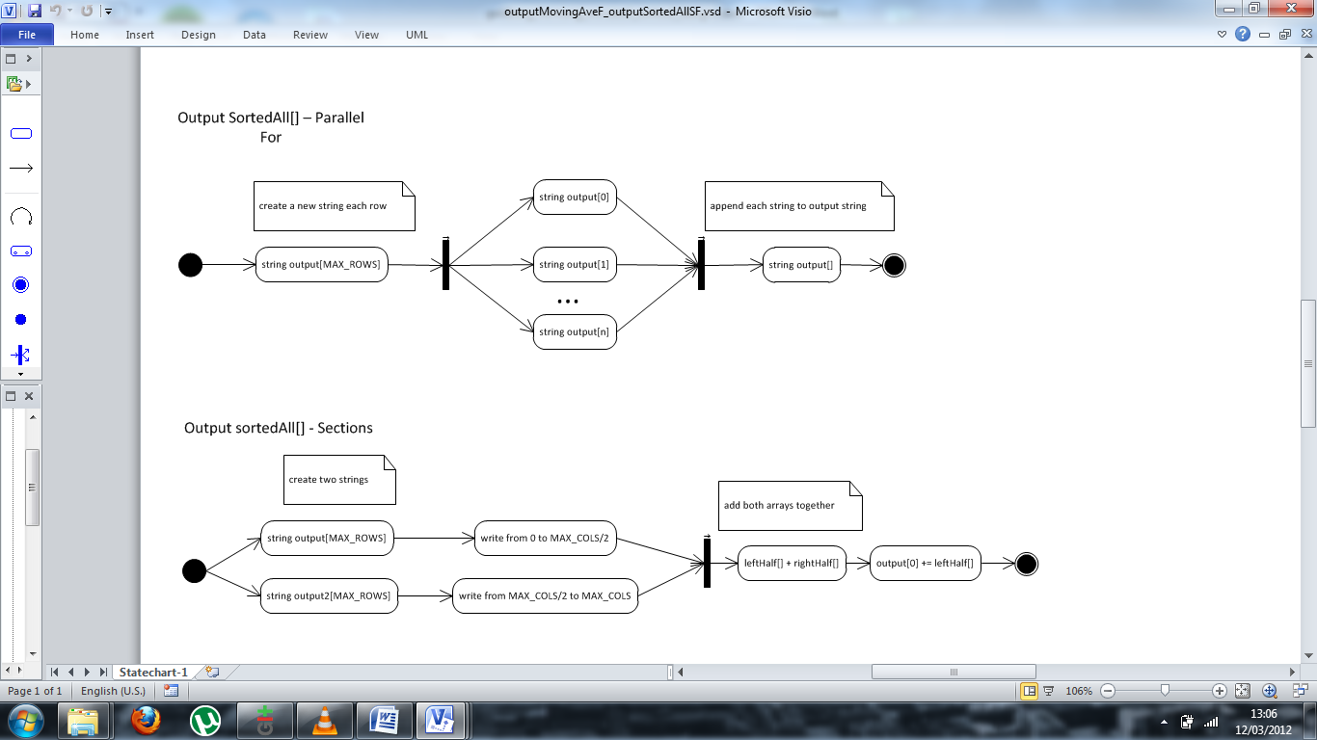***Parallel For***

***Parallel Section***



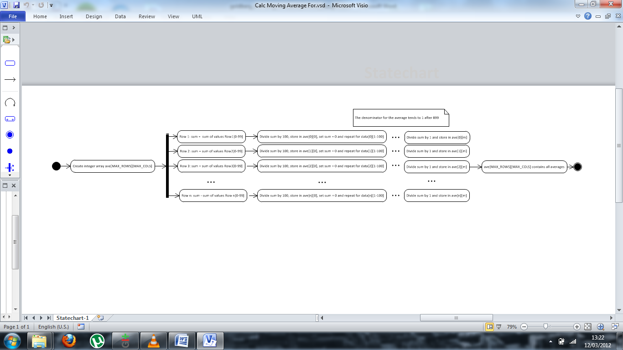calcMovingAve – calculate a 100 number moving int average

***Parallel For***

***Parallel Sections***

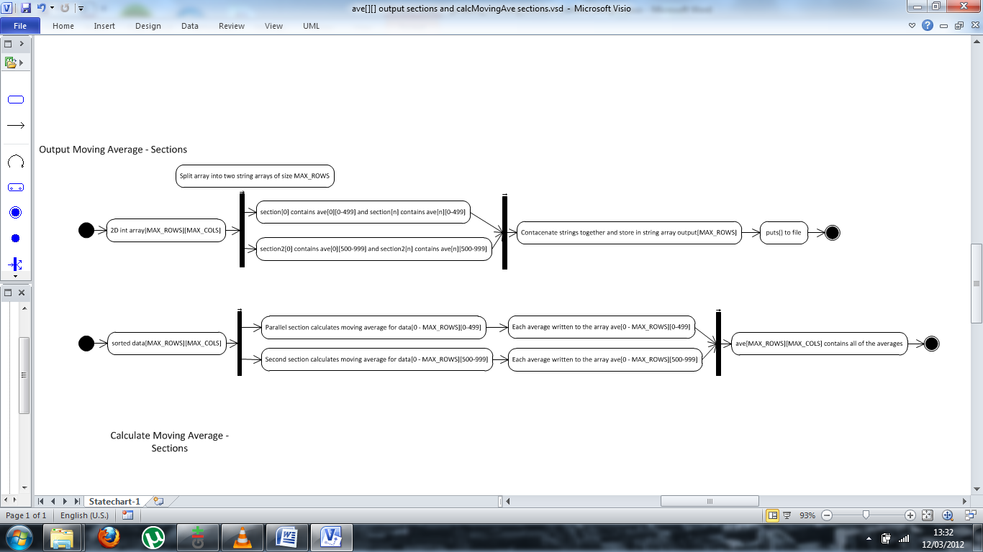

outputAveRows – output the rows of moving averages

***Parallel For***

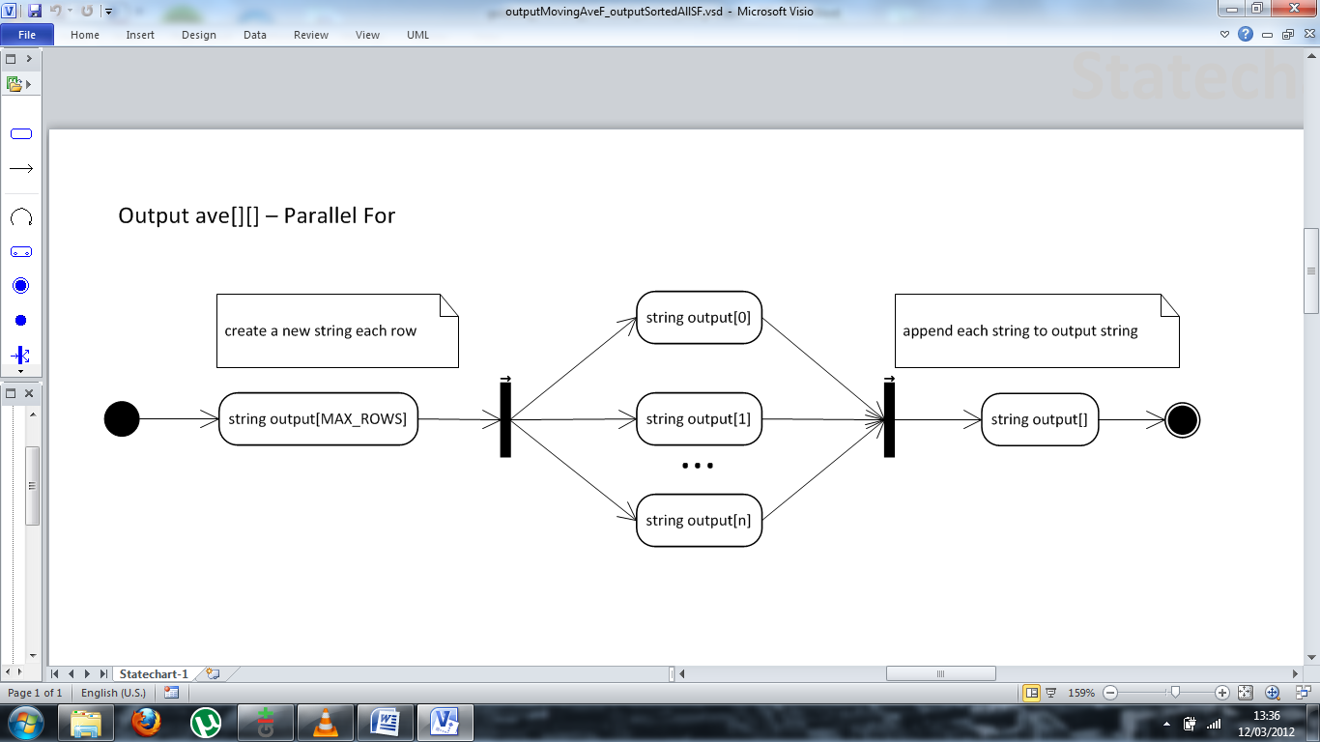

***Parallel Sections***

