

**Warehouse Output Manager**

**Software Requirement Specification**

**Team 4**

|  |  |  |
| --- | --- | --- |
| **MSSV** | **Name** | **Account** |
| QE170139 | Dinh Quoc Tien | TienDQ |
| QE170030 | Tran Minh Tuan | TuanTM |
| QE170154 | Nguyen Minh Tuan | TuanNM |
| QE170233 | Nguyen Thanh Hau | HauNT |
| QE170162 | Diep Minh Hung | HungDM |
| QE170073 | Nguyen Tuan Hao | HaoNT |
| QE170103 | Le Dong Tam | TamLD |

– Quy Nhon, Jan 2024 –

Record of change

|  |  |  |  |
| --- | --- | --- | --- |
| Date | A*  M, D | In charge | Change Description |
| 10/02/2024 | A | TienDQ | In the Create View of Note, when selecting the dropdown of |
| 01/03/2024 | M | TienDQ | Get the customer list directly in the database |
| 03/03/2024 | M | TienDQ | Get created name by database |
| 03/03/2024 | M | TienDQ | Change add phone by dropdown search |
| 04/03/2024 | M | TienDQ | Change not edit phone number |
| 05/03/2024 | A | TienDQ | Add Customer Rank |
| 13/03/2024 | A | TienDQ | Add download excel file |

*A - Added M - Modified D - Deleted

**Table of Contents**

**I. Overview. 5**

**1. Introduction. 5**

**2. System Functions. 5**

**3. Entity Relationship Diagram. 9**

**II. Functional Requirements. 11**

**1 .Common Feature. 11**

* 1. Home page 11
  2. Login. 12
  3. Create new account. 12

**2. Warehouse Feature. 13**

1. Index page of feature. 13
2. Create new Warehouse. 14
3. Edit Warehouse. 15
4. Details of warehouse. 16

**3. Manage Products. 17**

1. Index page of feature. 17
2. Create new Products. 19
3. Edit Products. 20
4. Details of Products. 21
5. search by name product. 23
6. show product with low quantity. 24
7. set product not available. 24
8. show out of stock products. 25
9. set products available. 26
10. download product. 27

**4. Manage Customer. 28**

1. Index page of feature. 28
2. Create new Customer. 29
3. Edit Customer. 30
4. Details of Customer. 31

**5. Manage Category. 33**

1. Index page of feature. 33
2. Create new Category. 33
3. Edit Category. 34
4. Details of Category. 36

**6. Manage note. 37**

1. Index page of feature. 37
2. Search note. 38

* Search by pattern. 38
* search by number. 38
* Search by day create. 39

1. download note. 40
2. print note. 40
3. create note. 41
4. role. 43

* Keeper note. 43
* Accountant note. 43
* Chief Financial Officer note. 43

1. details of note. 44

# **I. Overview**

## **1. Introduction**

- One of the pivotal features of the Warehouse Output is its ability to manage the export of products from the inventory. This functionality is crucial for maintaining accurate records, ensuring proper documentation, and facilitating a smooth flow of goods out of the system..

- Export Request Form: Users can initiate product export by filling out an export request form. This form captures essential details such as product identification, quantity, destination, and any special handling instructions.

- Documentation Generation: Upon approval, the system automatically generates necessary export documentation, such as shipping labels, packing lists, and invoices. This reduces manual efforts and minimizes the risk of errors.

## **2. System Functions**

#### **a. Screen Flow**

#### **b. Screen Details**

|  |  |  |  |
| --- | --- | --- | --- |
| **#** | **Feature** | **Screen** | **Description** |
| 1 | Public | Login | Login as user to manage system |
| 2 | Keeper, CFO, Accountant | Dashboard | After the Admin logs in, the Admin Home page will display, containing a dashboard and a button to export goods from the warehouse |
| 3 | Manage Customer | Keeper, Accountant | Manage Customer of system |
| 4 | Manage Products | Keeper | List of all products compiled from warehouses |
| 5 | Manage Category | Keeper | Manage category of product |
| 6 | Manage Warehouse | Keeper | The warehouse list includes a list of warehouses |
| 7 | Create new Account | Accountant | Create new account for staff |
| 9 | Manage Supplier | Admin | Manage Supplier connect with system |
| 10 | Manage Note Delivery Goods | Keeper | Manage note delivery goods |
| 11 | Approved note phase 1 | Accountant | Approved note delivery goods by Accountant  .  ​ |
| 12 | Approved note phase 2 | CFO | Approved or disapproved note delivery goods by CFO |

#### **c. User Authorization**

#### 

| **#** | **Screen function** | **Keeper** | **Accountant** | **CFO** |
| --- | --- | --- | --- | --- |
|  | **Login** | **x** | **x** | **x** |
|  | **Create new account** |  | **x** |  |
|  | **Dashboard** | **x** | **x** | **x** |
|  | **Manage Category** | **x** |  |  |
|  | **Manage Warehouse** | **x** |  |  |
|  | **Manage Product** | **x** |  |  |
|  | **Manage Customer** | **x** | **x** |  |
|  | **Manage role** |  |  | **x** |
|  | **Create new note delivery goods** | **x** |  |  |
|  | **Approved note phase 1** |  | **x** |  |
|  | **Approved note phase 2** |  |  | **x** |

#### In which:

- Keeper: is a user who plays the keeper role in the system. Keeper's actions with the system are to manage inventory, manage products, create delivery notes and send them to Accounting and CFO for approval.

- Accountant: is a user who plays an accounting role in the system. The accountant's action in the system is to accept Keeper's first warehouse delivery order, then transfer the application to the CFO for approval to release warehouse.

- CFO (Chief Officer): is a user who plays the role of CFO in the system. The CFO's action is to agree or reject the warehouse release order after being approved by the accountant

#### **d. Non-Screen Functions**

|  |  |  |  |
| --- | --- | --- | --- |
| **#** | **Feature** | **System Function** | **Description** |
| 1 | Common | Usability | This Web easy to use for User, because all object’s name same with the function this object do |
| 2 | Common | User Authentication | Implementation of authorization mechanism in the system, including the specify the role of logged-in user, his/her authorized page links (building the displayed menu items (in the front end) and preventing unauthorized access via enter the links directly). |

## **3. Entity Relationship Diagram**

**Entities Description**

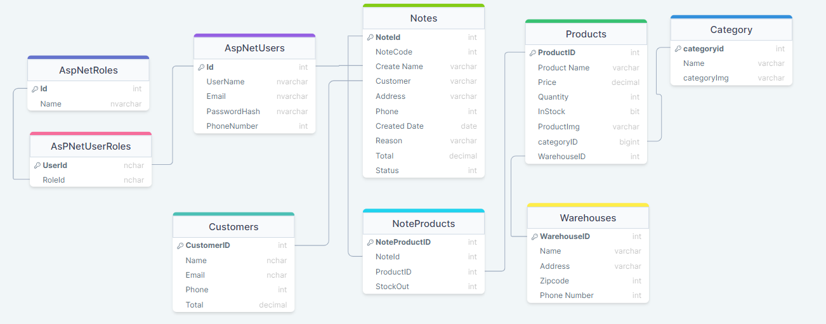

|  |  |  |
| --- | --- | --- |
| **#** | **Entity** | **Description** |
| 1 | AspNetUsers | User management through the support of Asp Net MVC |
| 2 | AspNetRole | Role management through the support of Asp Net MVC |
| 3 | AspNetUserRole | Role User management through the support of Asp Net MVC |
| 4 | Category | The table includes the ingredients of a product |
| 5 | Warehouse | The table includes the ingredients of a warehouse |
| 6 | Product | Manage product in warehouse |
| 7 | Customer | Manage customer in customer |
| 8 | Notes | Manage note delivery goods in system |
| 9 | NoteProduct | Manage product in each note |

# **II. Functional Requirements**

## **1. Common** **feature**

### **a. Home Page:**

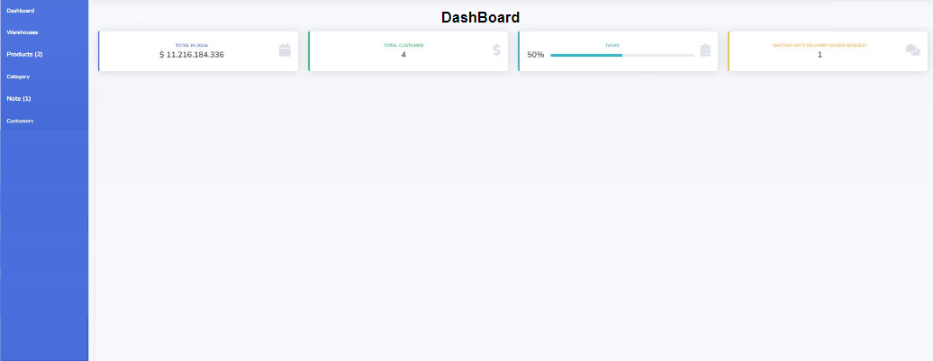

* **Function Trigger**: When the user accesses the homepage of the web application.
* **Function Description**:
* The homepage presents a navigation bar on the left side with options such as “Dashboard,” “Warehouse,” “Products,” “Category,” “Media,” and “Customers,” each with corresponding icons.
* The main content area of the homepage displays various informational widgets that provide quick insights or status updates, such as IP address monitoring, sales figures, progress tracking, and notifications.
* The top center of the page is labeled “DashBoard,” indicating that the user is on the main dashboard view where they can oversee all the key metrics at a glance.

### **b. Login**

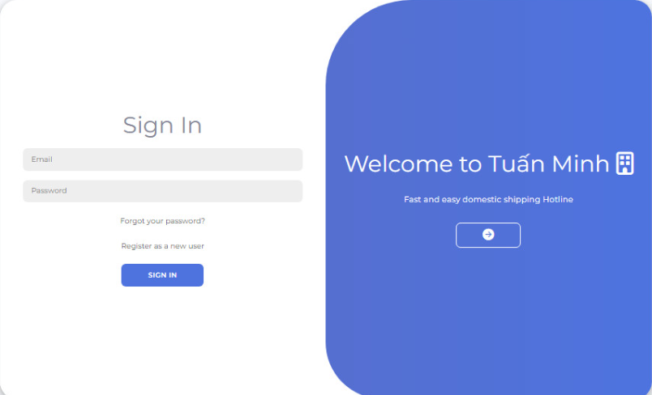

* **Function Trigger**: When the user navigates to the “Sign In” page.
* **Function Description**:
* The page presents fields for the user to enter their email and password.
* A “SIGN IN” button is provided for the user to submit their credentials and access their account.
* The right side of the page welcomes users with a message and provides information about the service, including a hotline for assistance.

**c.**  **Create new account.**

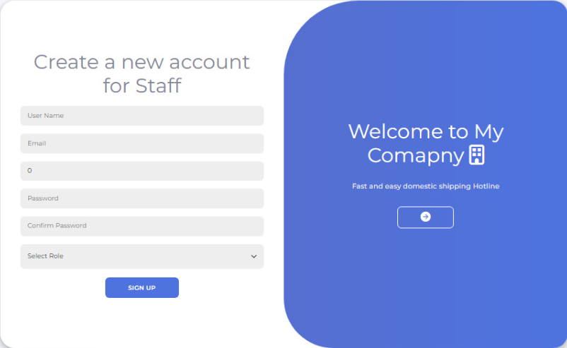

* **Function Trigger**: When a staff member navigates to the “Create a New Account for Staff” page.
* **Function Description**:
* The page presents a form titled “Create a New Account for Staff” with fields for “User Name”, “Email”, “Password”, and “Confirm Password”.
* There is a dropdown menu labeled “Select Role” to assign a specific role to the new account.
* A “SIGN UP” button is provided for the staff member to submit the form and create the new account.

## **2. Warehouse features**

**a. Index page of feature**

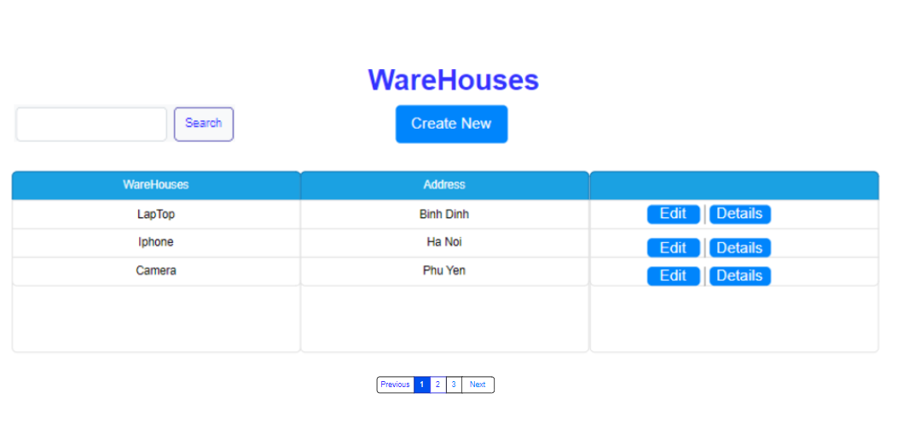

* **Function Trigger:** After clicking on the "WareHouses" tab at the top of the interface, users will be redirected to a page containing a list of warehouses.
* **Function Description:**
* The list displays warehouse information including Warehouse names and Addresses.
* Each warehouse entry has an "Edit" and "Details" option for modifying warehouse information or viewing more details, respectively.
* Above the list, there is a “Create New” button that users can click to add a new warehouse to the list.
* There is also a search bar for filtering through the listed warehouses based on user input.

**b. Create new Warehouse:**

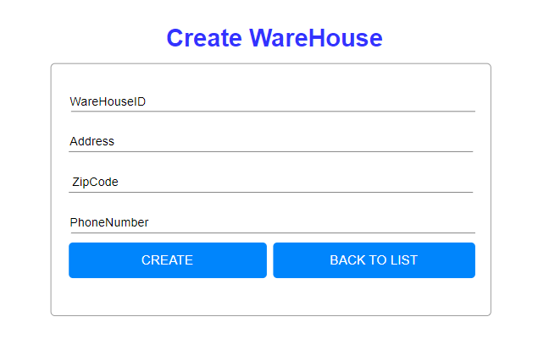

* **Function Trigger:** After clicking on the "Create WareHouse" button, users will be directed to the Warehouse creation page.
* **Function Description:**
* Users can enter details such as WareHouseID, Address, ZipCode, and PhoneNumber.
* After filling in the details, click “CREATE” to add the new warehouse.
* Click “BACK TO LIST” to return to the warehouse list.

**c. Edit Warehouse**

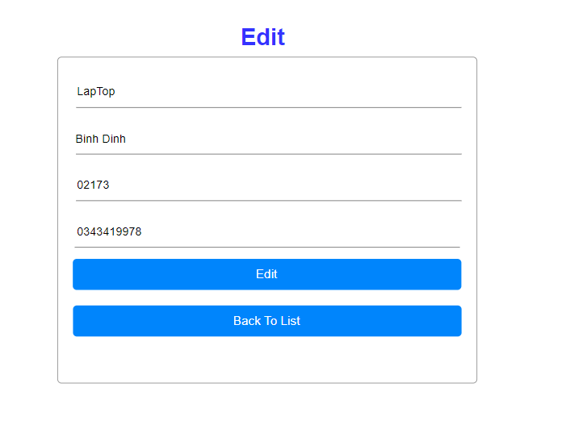

* **Function Trigger:** After clicking on the "Edit" button corresponding to a warehouse, users will be directed to the Warehouse editing page.
* **Function Description:**
* Users can modify details such as Warehouse Name, Address, ZipCode, and Phone Number.
* After making changes, click “EDIT” to update the warehouse information.
* Click “BACK TO LIST” to return to the warehouse list.

**d. Details of Warehouse**

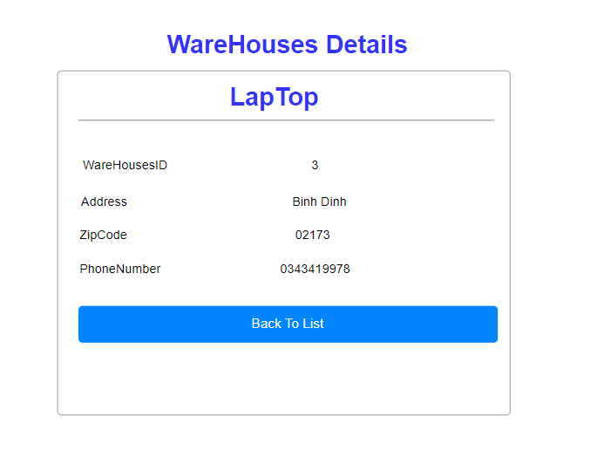

* **Function Trigger:** After the user clicks "Details" on the Warehouse they wish to view, they will be redirected to the Warehouse Details page.
* **Function Description:**
* Can view Warehouse ID, Address, ZipCode, and Phone Number.
* Displays details of a specific warehouse named "Laptop".
* Click “Back to List” to return to the warehouse list.

**3. Manage Products**

**a. Index page of feature**

* **Function Trigger:** After clicking on the "Product List" tab, users will be directed to the page containing a list of products.
* **Function Description:**
* The list displays product information including Product Name, Price, Quantity, Product Code, Warehouse, Category ID, and Product Image.
* The "Actions" section contains options to Edit or View Details for each product.
* Users can filter the list using the search bar, download the product list, or create a new product entry.
* The "Set Product not available" button allows users to mark selected products as unavailable.
* The "Show out of stock products" button filters the list to display only those products that are currently out of stock.
* The "Show product with low quantity" button highlights products that are low in stock and may need replenishment.

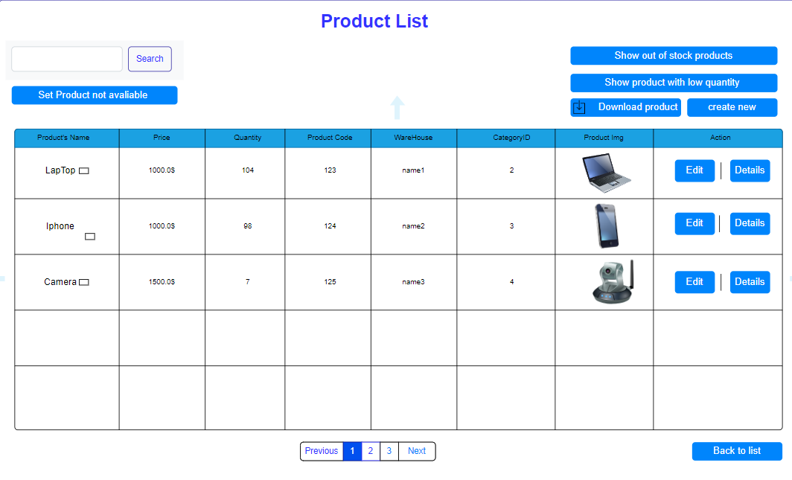

**b. Create New Product**

* **Function Trigger:** After clicking on the "Create Product" button, users will be directed to the product creation page.
* **Function Description:**
* Users can enter details such as ProductName, Price, Quantity, and ProductCode.
* Dropdown menus are available to select a Warehouse and Category.
* A "Choose File" button allows for uploading product images.
* After entering all details, click “CREATE” to add the product to the list.
* Click “BACK TO LIST” to return to the product list.

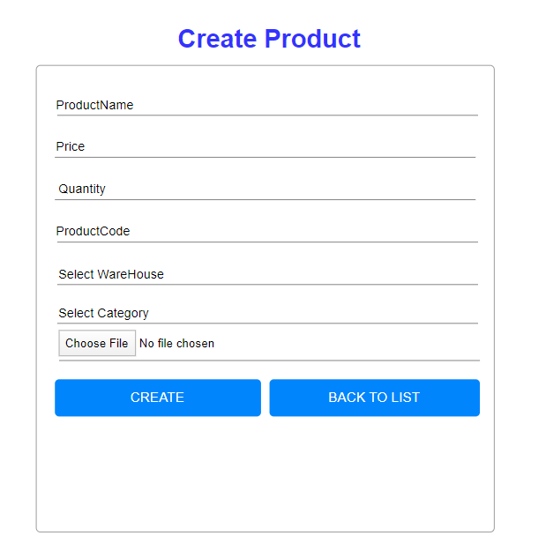

**c. Edit Products**

* **Function Trigger:** After clicking on the "Edit" button corresponding to a product, users will be directed to the product editing page.
* **Function Description:**
* Users can modify details such as Product Name, Price, Quantity, Product Code, Warehouse, and Category ID.
* A "Choose File" button allows for uploading a product image.
* After making changes, click “EDIT” to update the product information.
* Click “BACK TO LIST” to return to the product list.

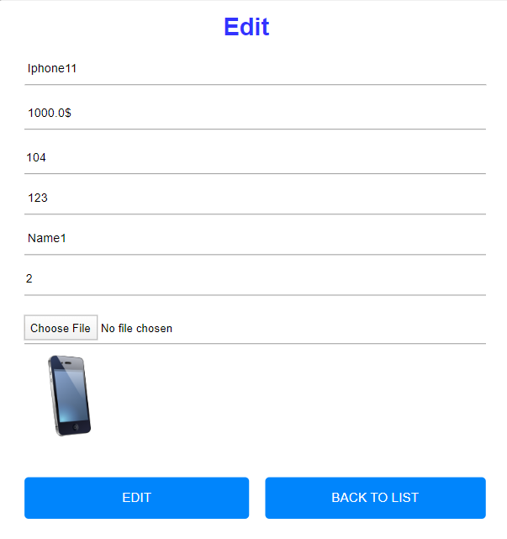

·

**d. Details of Products**

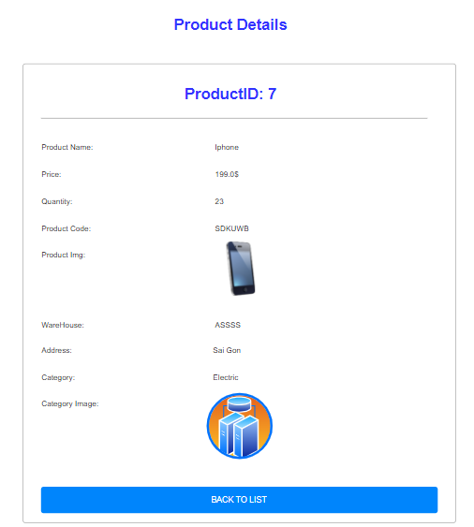

* **Function Trigger:** After selecting a product to view its details, users will be directed to the Product Details page.
* **Function Description:**
* Displays detailed information including ProductID, Product Name, Price, Quantity, Product Code, Warehouse, Address, and Category.
* The product details for "Iphone" with ProductID: 7 are shown, priced at 199.05, available quantity of 23, and Product Code: 5DKUWJB.
* Warehouse details are listed as "ASSSS" with the address "Sai Gon" under the “Electric” category.
* Users can return to the product list by clicking “BACK TO LIST”.

**e. Search by name products**

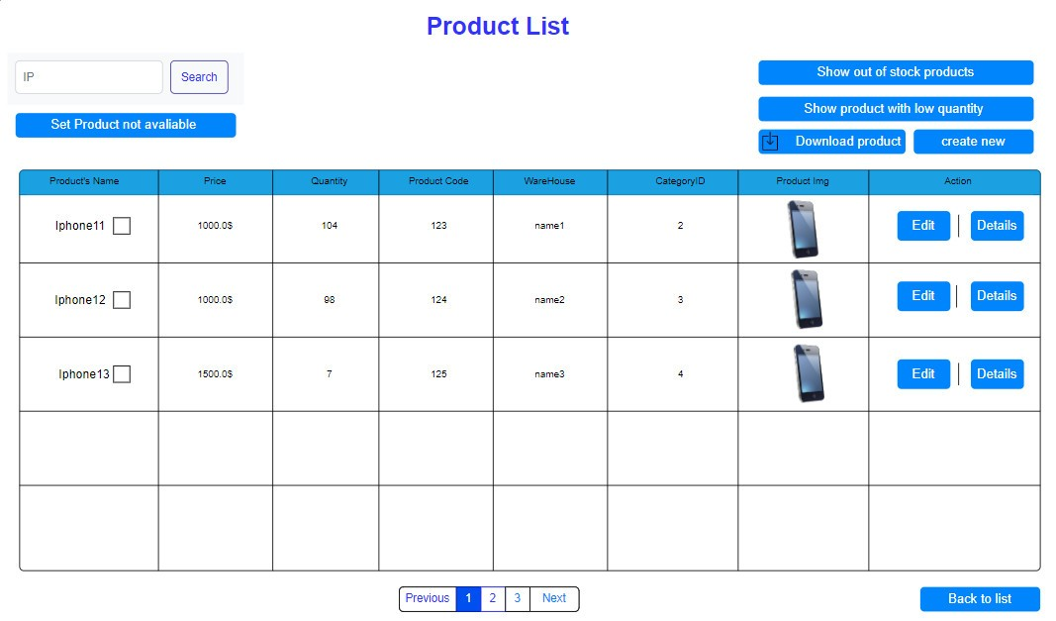

* **Function Trigger:** When the user enters a product name into the search field and clicks the “search” button, the system will execute a function to retrieve and display a list of products matching the entered name.
* **Function Description:**
* The function is activated upon the “search” button click event after a product name is entered into the search input field.
* It queries the database or data source for products with names that match or contain the entered search term.
* A list of matching products is then presented to the user, typically including details like product name, price, and availability.
* This function enhances the user experience by enabling quick and easy access to specific product information within a large inventory.

**f. Show products with low quantity**

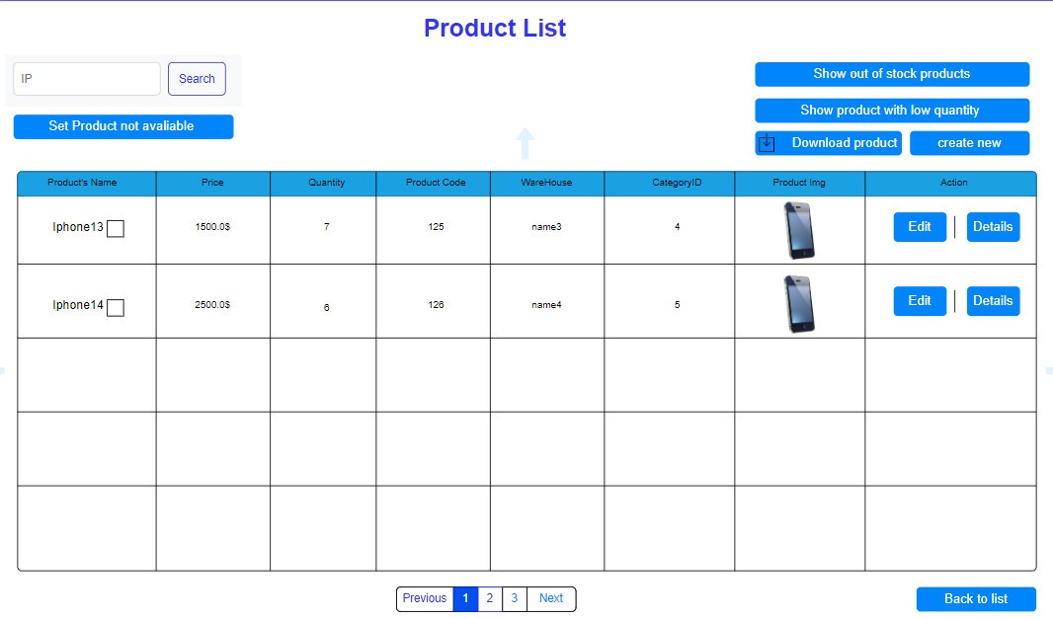

* **Function Trigger:**When the user clicks the "Show products with low quantity" button, the system will execute a function to search for and display all products with a quantity below 10.
* **Function Description:**
* The function is activated upon the click event of the "Show products with low quantity" button.
* It performs a search query within the product database or inventory list to find products where the quantity is less than 10.
* A list of these low-quantity products is then generated, typically including details such as Product Name, Price, Quantity, and other relevant information.
* This list is displayed to the user, allowing them to identify and potentially restock items that are low in supply.
* This functionality is crucial for inventory management, enabling users to maintain adequate stock levels and prevent shortages.

**g. set product not available**

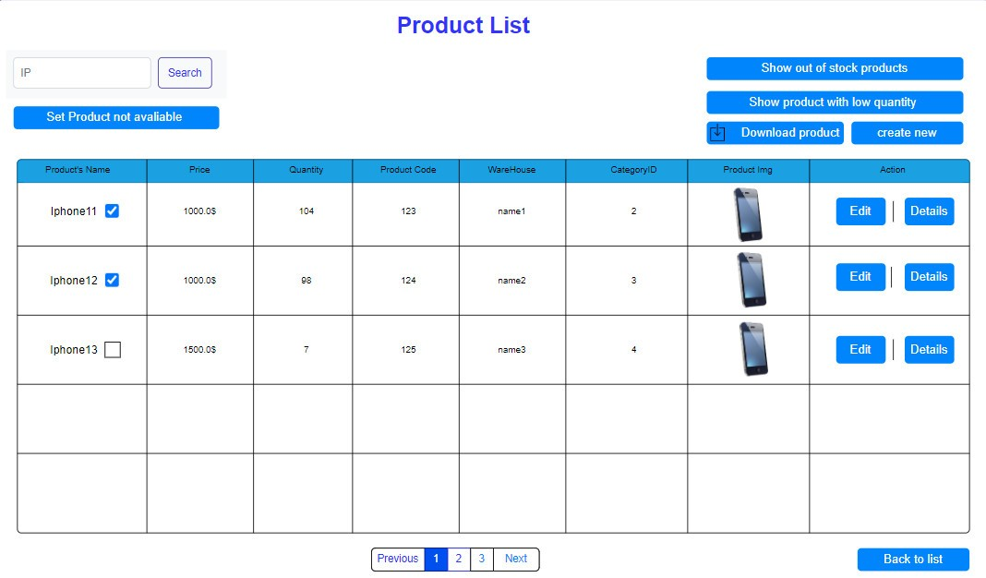

* **Function Trigger:** When the user clicks the “Set Product not available” button, the system will trigger a function to move the selected products to a list of unavailable items.
* **Function Description:**
* Users can select one or multiple products from the product list by ticking the checkbox next to the product name.
* After selection, clicking the “Set Product not available” button will transfer the selected products to a list of unavailable products.
* This unavailable products list will display products that are out of stock or not entered into inventory.
* Users can view this list to manage inventory and place orders for restocking if necessary.

**h. show out of stock products**

* **Function Trigger:**When the user clicks the "Show out of stock products" button, the system will trigger a function to display all products that have been previously marked as not available.
* **Function Description:**
* The function is activated upon the click event of the "Show out of stock products" button.
* It retrieves a list of all products that have been set to the status of 'not available' by the "Set Product not available" function.
* The retrieved list is then displayed to the user, showing products that are currently out of stock.
* This function allows users to manage inventory by identifying products that need to be restocked.

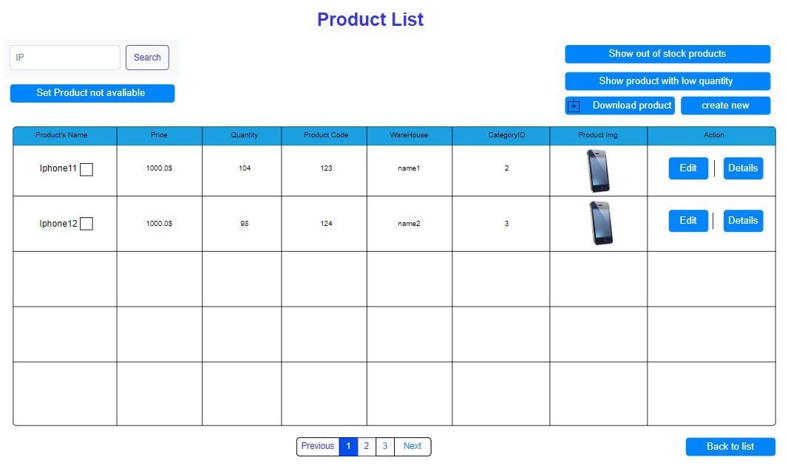

**i. set product available**

* **Function Trigger:** When the user clicks the “Set Product Available” button, the system will trigger a function to move the selected products from the unavailable list back to the available inventory.
* **Function Description:**
* Users can select one or multiple products from the unavailable product list by ticking the checkbox next to each product name.
* After selection, clicking the “Set Product Available” button will transfer those selected products out of the unavailable products list and mark them as available again.
* This action updates the inventory status, making these items visible and available
* Users can utilize this feature to manage inventory effectively, especially after restocking or verifying product availability.

**j. download product**

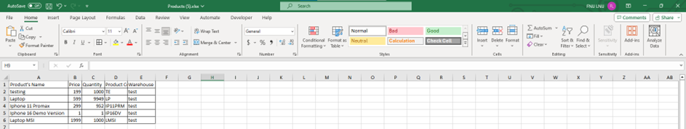

* **Function Trigger:**When the user clicks the "Download Product" button, the system will execute a function to download the detailed information of all products as an Excel file.
* **Function Description:**
* The function is activated upon the click event of the "Download Product" button.
* It compiles all the product information currently available in the system, including details such as product names, prices, quantities, and other relevant data.
* The compiled data is then converted into an Excel file format, which is a common requirement for such functionality. This conversion can be done using a server-side script or a client-side library that supports Excel file creation.
* Once the Excel file is ready, the function triggers a download prompt in the user's browser, allowing them to save the file to their local machine.
* This feature is particularly useful for users who need to analyze product data offline or use it for reporting and inventory management purposes.

**4. Customer Manage**

**a. Index page of feature**

* **Function Trigger:** After clicking on the "Customers" icon on the toolbar, users will be redirected to the page containing the Customers list.
* **Function Description:**
* The Customers list page displays a table with columns for Customer's Name, Phone Number, Actions, and Rank.
* Each row in the table represents an individual customer with their respective information displayed.
* The Actions column contains "Edit" and "Details" buttons for each customer. Users can click "Edit" to modify customer information or "Details" to view more about the customer.
* Above the table, there are options to “Download Customer” data or “Create New” customer entries.
* A search bar is available for users to quickly find specific customers by entering keywords.
* Pagination options ("Previous", numbered pages, and "Next") are provided below the table for easy navigation through multiple pages of customer data.

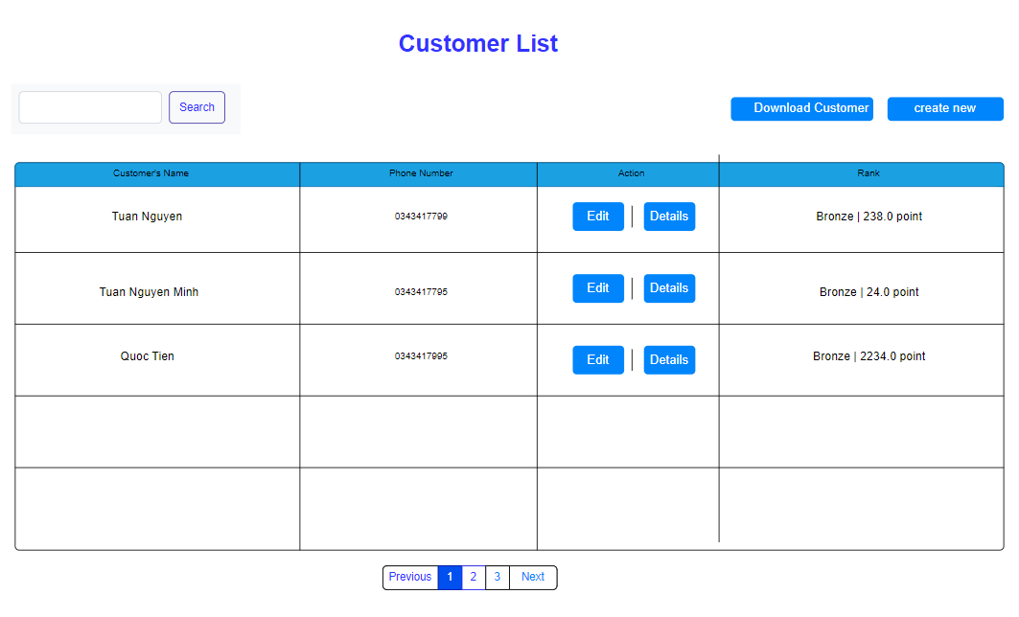

**b. Create New Customer:**

* **Function Trigger:** After clicking the "Create New Customer" button, the user will be directed to the new Customer creation page.
* **Function Description:**
* The new Customer creation page presents a form with fields to input the customer's information, including Name, Address, Email, and Phone.
* Each field is labeled for clarity, ensuring the user knows what information to enter in each box.
* Once the information is filled in, the user can click the “Create” button to add the new customer to the system.
* If the user needs to return to the Customer list without creating a new entry, they can click the “Back to List” button.

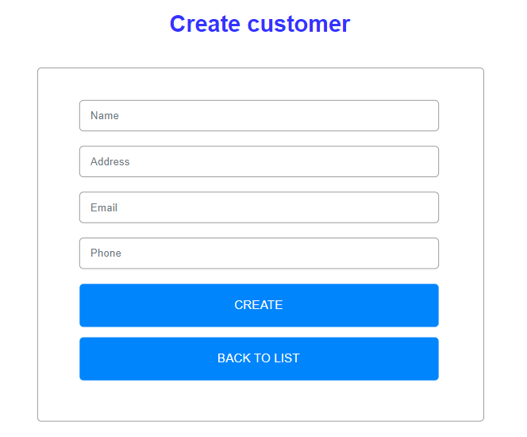

**c. Edit Customer:**

* **Function Trigger:** After clicking the "Edit" button for a selected customer, the admin will be redirected to the Edit Customer page.
* **Function Description:**
* The Edit Customer page allows the admin to modify customer information, including Name, Address, Email, and Phone.
* Each field is pre-filled with the customer's current information, which can be updated as needed.
* To save the changes, the admin clicks the "Save" button, which updates the customer's details in the system.
* The admin can return to the Customer list by clicking the “Back to List” button.
* This process ensures that customer information can be kept up-to-date easily and efficiently.

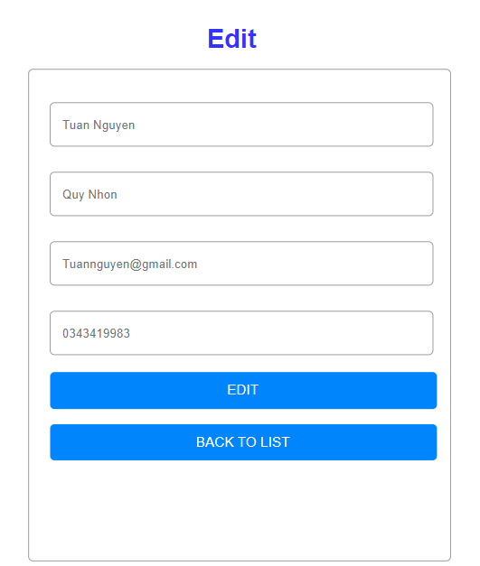

**d. Details Customer:**

* **Function Trigger:** After clicking the “Details” button for a selected customer, the user will be presented with a detailed view of the customer’s information.
* **Function Description:**
* The Details page displays comprehensive information about the customer, including Name, Address, Email, Phone, and Total Points.
* This information is presented in a read-only format, meaning it cannot be edited from this page.
* The user can return to the Customer list by clicking the “Back to List” button.

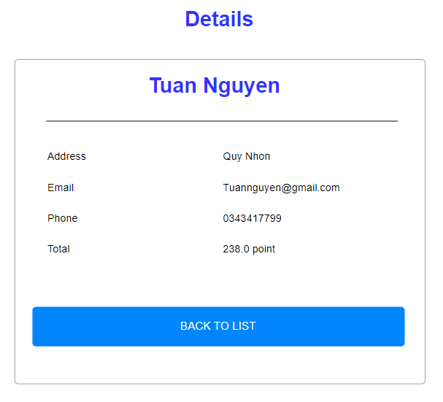

**5. Manage Category**

**a. Index page of feature**

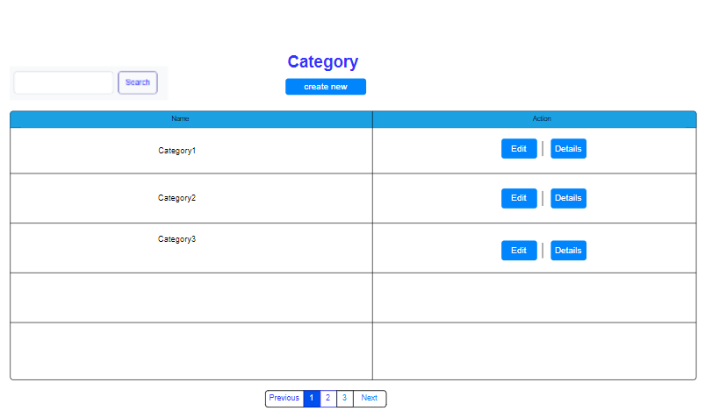

* **Function Trigger:** Clicking on the "Category" option will navigate the user to the page that lists all the categories.
* **Function Description:**
* The Category List page displays a table with the names of the categories and corresponding actions.
* Users can perform actions such as "Edit" to modify a category or "Details" to view more information about it.
* The "Create New" button at the top allows users to add new categories to the system.
* A search bar is provided to filter the categories displayed in the list.
* Pagination options are available to browse through the list if there are multiple pages of categories.

**b. Create new Category:**

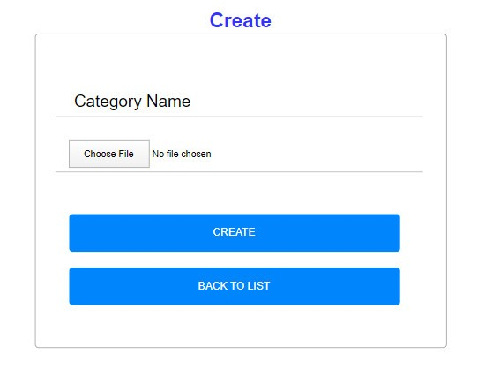

* **Function Trigger:** When the user selects the "Create New Category" option, they will be directed to a page to input details for the new category.
* **Function Description:**
* The page presents a form where the user can enter the new category's name in the "Category Name" field.
* If applicable, the user can also upload an associated image or file by clicking the "Choose File" button.
* To finalize the creation of the new category, the user clicks the "CREATE" button.
* Should the user decide to return to the previous page without creating a new category, they can click the "BACK TO LIST" button.

**c. Edit Category:**

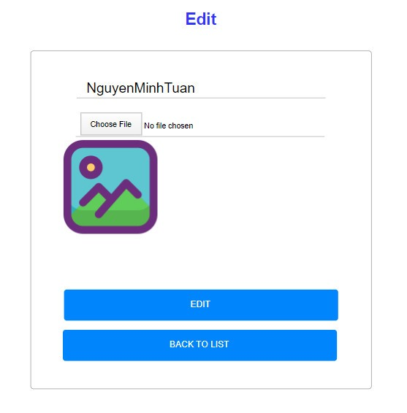

* **Function Trigger**: When the user clicks on the “EDIT” button, they are directed to a page where they can modify the details of an entry.
* **Function Description**:
* The user is presented with a form containing an editable field for the entry’s name.
* Below the name field, there is a “Choose File” option allowing users to upload or change an associated image.
* An icon representing the current image is displayed next to the “Choose File” option.
* Users can confirm and save changes by clicking on the blue “EDIT” button at the bottom of the form.
* If users wish to cancel editing and return to the previous list, they can click on the “BACK TO LIST” button.

**d.Details of Category:**

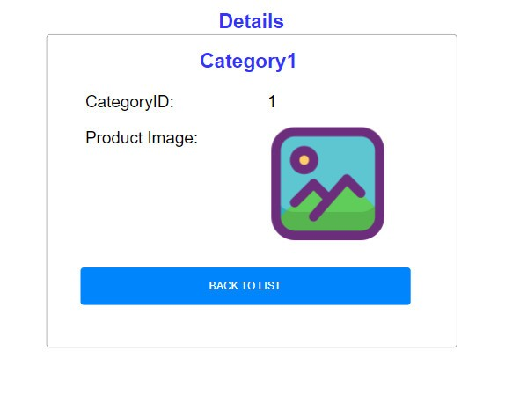

* **Function Trigger:** When the user views the “Details” of a product, they are presented with the product’s specific information.
* **Function Description:**
* The page displays the title “Details” at the top, followed by the category name “Category1”.
* The “CategoryID” is listed as “1”, indicating the unique identifier for the category.
* A section labeled “Product Image” shows an icon representing the product’s image, which appears to be a placeholder for an actual image.
* To navigate back to the previous list without making changes, the user can click the “BACK TO LIST” button at the bottom of the page.

## **6. Manager note**

1. **Index page of feature**

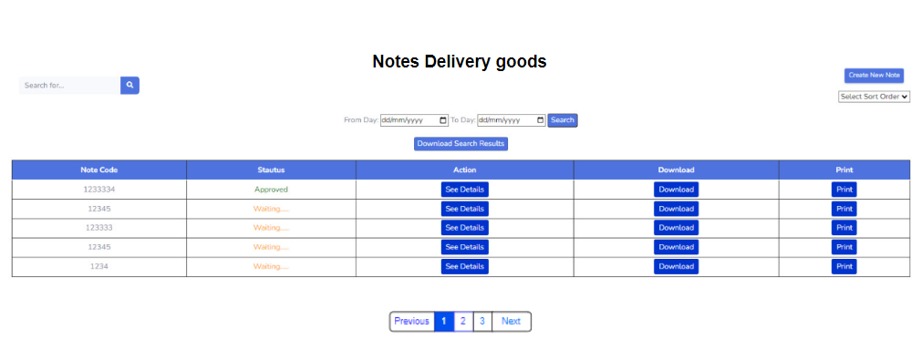

* **Function Trigger:** When the user accesses the “Notes Delivery goods” section.
* **Function Description:**
* The page displays the title “Notes Delivery goods” at the top.
* There is a search bar that allows users to enter keywords to filter and find specific delivery notes.
* “From Day” and “To Day” filter options enable users to select a date range to filter notes based on creation or delivery dates.
* The “Search” button, when clicked, performs the search based on the entered keyword or selected date range.
* The “Create New Note” button allows users to create a new delivery note entry.
* The “Select Sort Order” dropdown menu lets users sort the list of notes by various criteria such as date, status, etc.
* Links for “See Details”, “Download”, and “Print” provide functionalities to view details, download, and print specific notes, respectively.

1. **Search note**

**#Search by pattern**

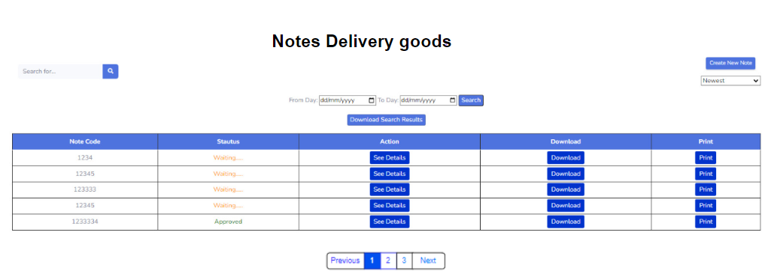

* **Function Trigger:** When the user interacts with the “Select Sort Order” dropdown.
* **Function Description:**
* The dropdown menu provides different sorting options for the user.
* Selecting “Newest” will sort the notes to display the most recent ones at the top of the list.
* Selecting “Oldest” will sort the notes to display the earliest ones at the top of the list.
* The list will refresh to reflect the notes’ statuses according to the chosen sort order.

**#search by number**

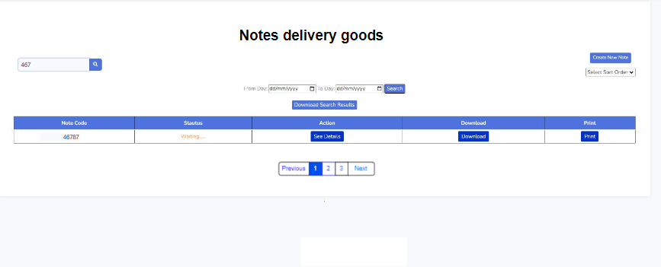

* **Function Trigger**: When the user enters a number into the search bar and clicks the “Search” button.
* **Function Description**:
* The system will perform a search for delivery notes corresponding to the entered number.
* If the number matches a Note Code, the relevant note’s details will be displayed.
* The user can then view, download, or print the delivery note as needed.

**#Search by day create**

* **Function Trigger**: When the user uses the “Search by Create Day” feature.
* **Function Description**:
* The interface provides a date range selection with “From Day” and “To Day” fields.
* Users can select a start date in the “From Day” field and an end date in the “To Day” field to define the search range.
* After selecting the date range, clicking the “Search” button will filter and display notes created within the specified period.

1. **Download note**

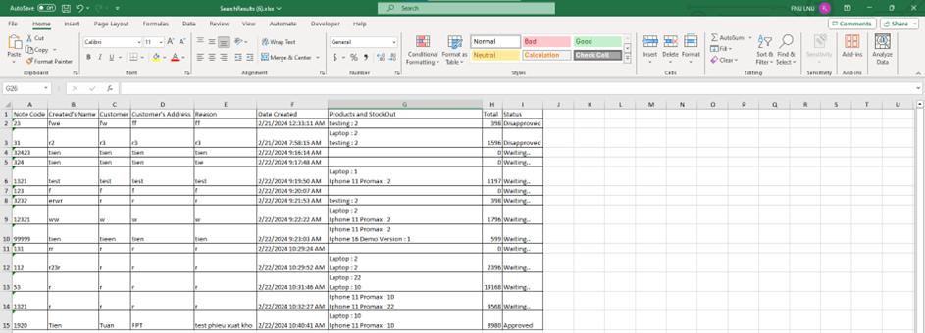

* **Function Trigger:** When the user clicks on the “Download” link for a note.
* **Function Description:**
* The system will prompt the download of the selected note’s details.
* The note will be downloaded as an Excel file, allowing users to view and manage the data in a spreadsheet format.

1. **print note**

* **Function Trigger:** When the user selects the “Print” option for a delivery note.
* **Function Description:**
* The system prepares the note for printing, organizing the content to fit a standard page layout.
* The printed note includes details such as the note code, creator’s name, customer information, and a list of products with their quantities and prices.
* It also provides spaces for signatures from the CFO, Accountant, Keeper, and Customer, ensuring proper authorization and confirmation of the delivery.

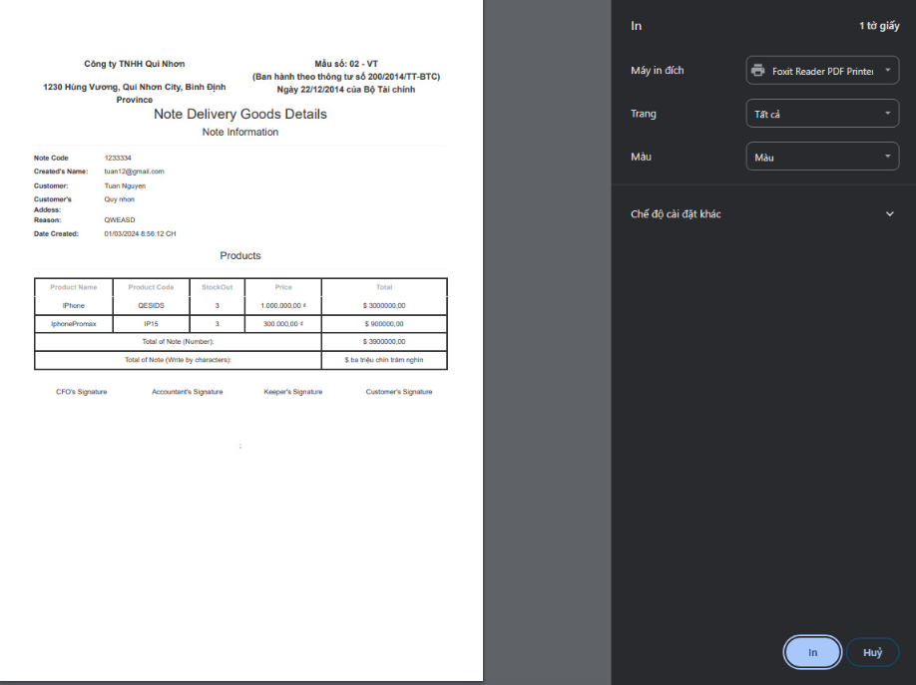

1. **Create note**

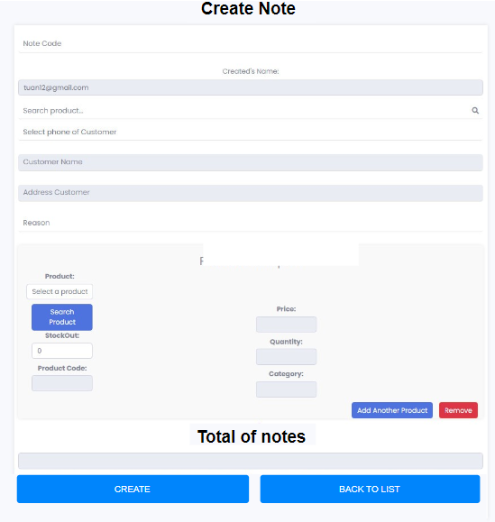

* **Function trigger:** Once the user clicks "create note", the Keeper will be redirected to the note creation page
* **Function description:**
* Keepers can enter note information such as: NoteCode, CreateName, Customer, AddressCustomer, reason
* then the keeper selects the product.
* When entering the product name, the product information (Product code, price, quantity) will be automatically entered
* The keeper will put the quantity in the "StockOut" box and the product price to be paid will be automatically calculated and displayed in the "total" box.
* Click "Remove" to delete the newly created product
* Press "Add Another Product". to add a product to the note
* Click "create" to create Note

1. **Role**

**# Keeper note**

* **Function trigger:** when logging into Keeper's account
* **Function description:**
* Show information columns: NoteCode, Status
* The status column contains the numbers 1,2,3,4. Number 1 is the default number when keepers create notes.

**# Accountant note**

* **Function trigger:** when logging into your Accountant account
* **Function description:**
* Show information columns: NoteCode, Status
* The status column contains the numbers 1,2,3,4.
* When there is a note from the keepers, the Accountant will update the status of the note for approval.
* When clicking "approved" Accountant will accept the note. and the status note changes from 1 to 2

**# Chief Financial Officer note**

* **Function trigger:** when logged into the CFO account
* **Function description:**
* Show information columns: NoteCode, Status
* The status column contains the numbers 1,2,3,4.
* When there is a note from the Accountant, the CFO will update the status of the note for approval.
* When clicking "approve" CFO will accept the note. and the status note changes from 2 to 3.
* When clicking "Disapprove" CFO will not accept the note. and the status note changes from 2 to 4.

1. **details of note**

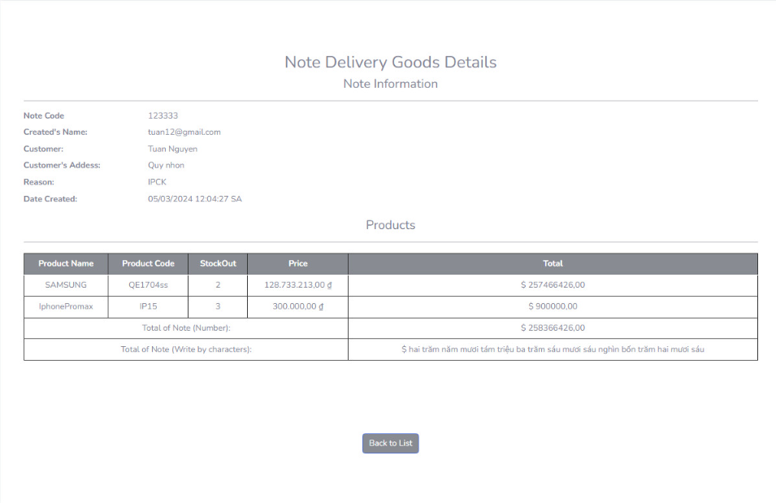

* **Function Trigger**: When the user selects a note to view its details.
* **Function Description**:
* The system displays a detailed form titled “Note Delivery Goods Details”.
* The “Note Information” section includes the note code, creator’s email, customer’s name, address, reason for delivery, and the date created.
* The “Products” section lists items such as SAMSUNG and iPhonePromix, with details like product code, quantity (StockOut), and price, along with the total price for each.
* At the bottom, the form shows the total amount of the note both numerically and written out in words.