Forecast aggregation in HFC RCT-A
Giving newer forecasts more weight improved accuracy on this dataset. For the geometric mean of odds (GMO), halving a forecast's weight for each day of age reduced error by 14.2%, compared with giving all forecasts equal weight. Both versions used only forecasts available by the previous day. The geometric mean (GM) also improved with daily halving and performed similarly to GMO, but its result depended on whether I calculated Yes or No first. I recommend testing both methods on new questions, alongside the arithmetic mean with aging weights.

Comparing the five methods
The arithmetic (usual) mean averages the probabilities. The median uses the middle value, while the trimmed mean removes the highest and lowest 10% before averaging. GM combines probabilities by multiplication: for two forecasts, it takes the square root of their product. For Yes/No questions, GMO does this with odds, which compare the probability of one answer with the probability of the other. A probability of 80% is equivalent to odds of 4 to 1. I then convert the resulting odds back to a probability.
HFC's Brier score measures forecast error: lower is better, and zero is perfect. I first averaged the daily scores for each question, then averaged across questions, so longer-running questions don't dominate the result.
Table 1. Average HFC Brier score for each method.
Method | Score
Arithmetic mean | 0.2897
Median | 0.2828
Geometric mean (GM) | 0.2661
Trimmed mean | 0.2803
Geometric mean of odds (GMO) | 0.2716

GM had the lowest error. Both geometric methods beat the arithmetic mean on Yes/No and ordered questions but were slightly worse on the 13 unordered questions. Very low probabilities can pull a geometric average down strongly, even when other forecasts are much higher. This may have helped the geometric methods when the low estimates carried useful information, but I did not test that explanation separately.
The median and trimmed mean also beat the arithmetic mean, perhaps because they are less sensitive to extreme forecasts.
For the 101 questions with more than two answers, both geometric methods calculate the same geometric averages of answer probabilities, then rescale them to 100%. For Yes/No questions, I calculated GM from the Yes probabilities and assigned the remaining probability to No. For example, with Yes forecasts of 10% and 90%, GM gives 30% to Yes and 70% to No. GMO and the arithmetic mean give 50% to each answer.
Where GM and GMO differed, GM assigned a higher probability to No, so GM was more accurate on the 66 questions resolved No and less accurate on the 20 resolved Yes. Its gains on the No questions exceeded its losses on the Yes questions. Calculating GM directly from No probabilities instead raised its overall error to 0.3299. GMO is consistent and gives the same result whichever answer I calculate first, like the usual mean.

Weighting newer forecasts more
Suppose a participant forecasts on Monday and does not return. I still use that estimate on Wednesday, even if relevant news appeared on Tuesday. Giving newer forecasts more influence may help the aggregate reflect that news.
I reduced each forecast's weight as it aged. A half-life is the time needed for its weight to halve. With daily halving, a forecast one day older receives half the weight; one two days older receives a quarter. I tested 12 half-lives from 0.01 to 60 days. I applied the same aging weights to GM, GMO and the arithmetic mean.
These predictions use only information available by the previous day's cutoff. I recalculated all five original methods using the same information for a fair comparison. Their scores in Table 2 differ slightly from Table 1, which includes the current day's updates.
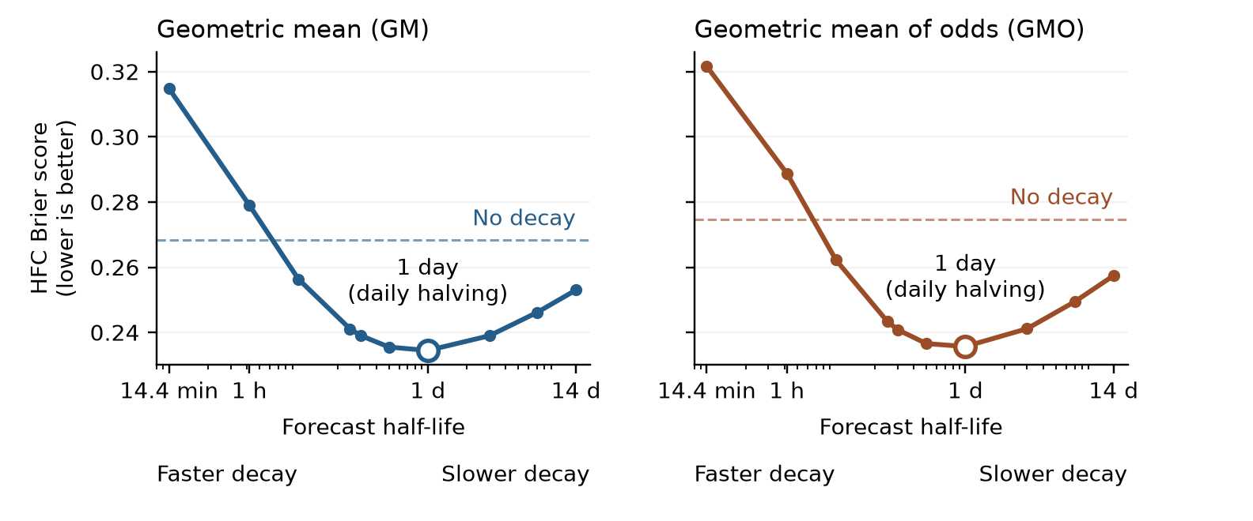
Figure 1. Tested half-lives. Dashed lines show the score of each method without decay.
Daily halving was best among the 12 tested rates for both geometric methods, with half a day close. At very short half-lives, older forecasts get almost no weight, so we lose most of their information. Daily halving keeps older forecasts involved.
Table 2. Average HFC Brier score using the previous day's information cutoff.
Method | Score
Arithmetic mean | 0.2917
Median | 0.2853
Geometric mean | 0.2683
Trimmed mean | 0.2825
Geometric mean of odds | 0.2747
GM with daily halving | 0.2345
GMO with daily halving | 0.2357
Arithmetic mean with daily halving | 0.2485

Daily halving reduced error by 12.6% for GM, 14.2% for GMO and 14.8% for the arithmetic mean.

Data, cleaning and scoring
rct-a-prediction-sets.csv contains individual submissions: one row per answer probability, with account, question and submission identifiers and submission times. rct-a-questions-answers.csv has one row per answer option, with status, outcomes, opening and closing times, and when outcomes became known. Question identifiers and answer order connect these files. rct-a-daily-forecasts.csv contains combined answer probabilities by question, method and day. I rebuilt the five methods from submissions across all six platforms; the provided aggregates use their own methods and populations.
The individual file contains 750,181 probability rows in 279,289 submissions. After eligibility checks and keeping the latest daily update per account and question, I retained 254,405 updates from 4,938 accounts. The study includes 187 resolved questions: 86 Yes/No, 88 with ordered answers, and 13 with unordered answers. Account identifiers distinguish accounts, not necessarily different people.
I checked that submissions were complete, their answer options matched the question, and their probabilities were valid. Where only Yes was stored, I derived No as the remainder to 100%. I corrected small discrepancies in probability totals that were consistent with rounding. For GM and GMO, I raised probabilities below 0.1% to 0.1%, then rescaled each forecast to total 100%, so a reported zero could not rule out an answer for everyone. I retained forecasts submitted while questions were open and before their answers became available. Within each account, question and reporting day, I kept the latest submission.
I evaluated each question on days with new eligible submissions, using HFC's daily cutoff. Each cutoff had to fall while the question was open and before its answer was known. Accounts that had not updated kept their latest earlier forecast. This produced 12,831 question-days for Table 1: one question-day means one question evaluated on one day.
For Table 2, I excluded 176 question-days because the previous day's cutoff came before the question opened, leaving 12,655. On 11 of the remaining question-days, no forecast was available yet at the previous day's cutoff, so every method assigned equal probabilities to the possible answers.
For questions with ordered answers, I used HFC's cumulative version of the Brier score, which gives a smaller penalty when the forecast misses by one category than when it misses by several. I kept HFC's common scoring scale and gave every question equal weight.

Choosing the rate and testing it next
I also tested choosing the decay rate from past results. The rule could choose no decay or a half-life of 1, 3, 7, 14, 30 or 60 days. Each day, it compared these options on questions whose answers were already known by the previous day's cutoff. It used the one with the lowest average error. Until the first answer became known, it used no decay. After that, it always chose daily halving for both GM and GMO. Under this rule, GM scored 0.2351 and GMO scored 0.2364. I chose which rates to test after exploring the data, so we still want to test on new questions.
These comparisons do not establish why recency helped. Newer forecasts may reflect new information or come from more accurate forecasters. I would compare the full range of rates and no decay on new questions, using GMO, GM and the age-weighted arithmetic mean. The technical supplement gives uncertainty estimates and the proposed further checks.

