**UDS 4.0 REDCap Style Guide – DRAFT**

8/23/2022

Below are naming conventions for some common types of fields in UDS 4.0 REDCap forms.

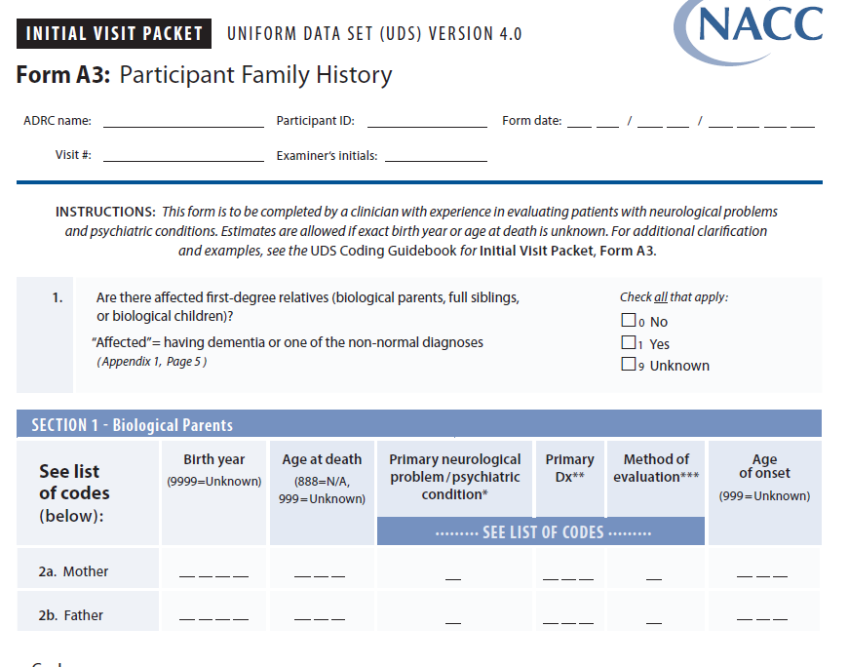

Use descriptive fields with embedding.

Fieldname: a3_instructions

Field type: descriptive

Use a constant header form, and do not add a header to each form in REDCap data dict.

Fieldname: a3_section1,

Field type: descriptive

I find it tricky to get branching logic correct so that section headers (column C in data dict.) are hidden when I really want them hidden. I prefer to use descriptive text boxes instead. What do other centers think??

There isn’t a need to show this type of info on the form in a separate descriptive field. The choices will be obvious in the dropdown menu or radio buttons.

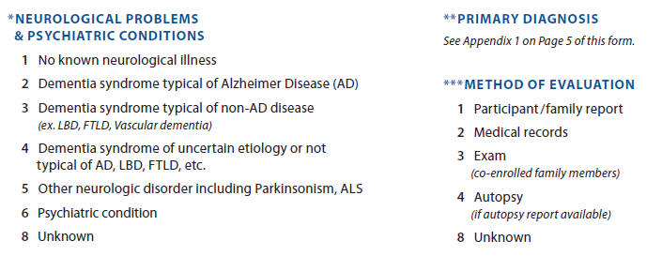

Fieldname: a3_instructions2

Should I have added a 1 to fieldname for the first occurrence?

Field type: descriptive

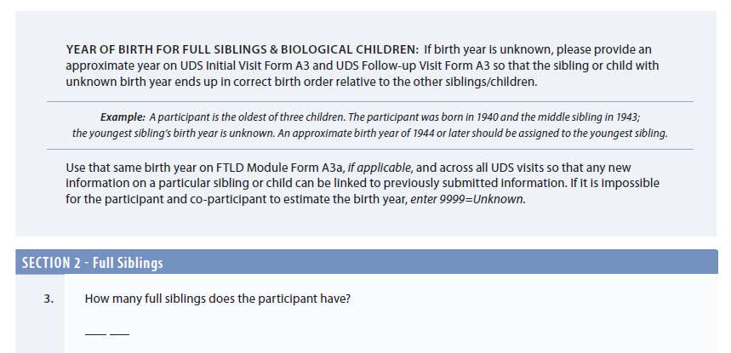

Fieldname: a3_section2,

Field type: descriptive

Keep the text field about YEAR OF BIRTH separate from the section field since these instructions apply to siblings **and** children

Fieldname: a3_abbreviations,

Field type: descriptive

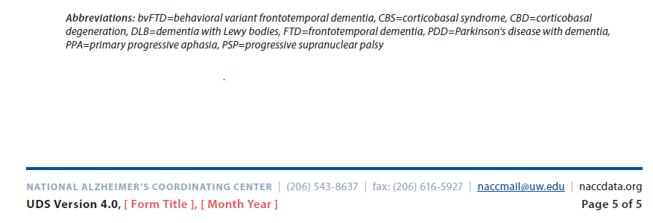

Fieldname: a3_footer,

Field type: descriptive

Footer fields should show up only once - at the end of a form.

It may be helpful to add abbreviation legends to section fields as opposed to the end of the form?? That would save some scrolling if you need to reference them. -and would reduce the # of fields needed. What does the group think?

Is seems that NACC is not expecting the copyright to be shown on every form. However, when needed here is the suggestion:

Fieldname: a3_copyright,

Field type: descriptive

Some forms have a reference instead of a copyright. The suggested language is:

Fieldname: a3_reference,

Field type: descriptive

Sometimes there is a need for a note. I can’t find any examples in the 2 pdf drafts available.

Fieldname: a3_note1, a3_note2 etc

Field type: descriptive

When creating a descriptive field to display data, we use a suffix of _display on field name.

For example, on follow-up forms, Kansas displays the answer to amylpet from prior visits. That descriptive field is called amylpet_display. I am ok with shortening this to _dsply for those worried about the length of field names. What does the group think?

U Kansas uses descriptive fields to provide some real time data quality checks. For example, if sex at a follow-up is different than initial visit, a descriptive field shows up alerting staff to the difference. The field is called sex_alert. I am suggesting a suffix of _alert.

Link – links such as those to NACC’s drug lookup should be set to open in a new window.

**Feedback on next page**

**From:** Steven Brown <notifications@github.com>   
**Sent:** Tuesday, May 3, 2022 3:46 PM  
**To:** naccdata/uniform-data-set <uniform-data-set@noreply.github.com>  
**Cc:** Suzanne Hunt <shunt@kumc.edu>; Comment <comment@noreply.github.com>  
**Subject:** Re: [naccdata/uniform-data-set] Style Guide (Issue #2)

This looks great! No concerns with anything proposed in the draft, but a few comments to consider:

1. For the header information, agree to not have header fields in each form. But, potentially would be helpful to pipe these into a descriptive field to make the header info super visible? It has helped us in stopping erroneous data entry in the wrong form/participant, especially for clinicians not very comfortable in REDCap.
2. For implementation of real-time data quality checks, IU uses some descriptive fields similarly to the way Suzanne describes at KU. One of the differences between using descriptive fields versus the Data Quality Rules is that the alert happens immediately as the entry in questions happens, instead of at the time of form saving. We’ve received feedback that this is preferable as it works better with the flow of the forms/visit rather than having to go back after finishing a form to several previous items. Some of our users also find the data quality alert can be cumbersome in real time. For example, if more than 1 alert is found, and the user clicks on one, the dialog box disappears and you would need to save the form again to retrieve the data quality violation list. In general our coordinators want less pop-up boxes as they conduct the visit. I don't have strong feelings on this and definitely think having all of the QC checks in the Data Quality rules makes sense, since Centers could use them at their discretion even if they did not want to execute in real time.

**Steve Brown IU**

Forgot to mention that IU uses REDCap as an EDC, so some of these nuances are more important in that context, as opposed to collecting data on paper first then entering into REDcap.

**From:** haseenaR <notifications@github.com>   
**Sent:** Monday, May 9, 2022 5:59 PM

Style Guide looks great. Thanks!  
Would like to bring up a point regarding Header Fields.  
We are using OnCore at Yale and now migrating to REDCap for UDS4. In OnCore we pipe the header fields into all the forms. This has helped us in catching erroneous data entry.

Dan Hoang, UC Irvine commented. Can’t find the details. I’ll look in GitHub

**From:** gauravvedvyas <notifications@github.com>   
**Sent:** Tuesday, May 10, 2022 12:32 PM

The Style Guide looks good to me as well.  
I would prefer the shortened field names where ever they are possible.

Steve Brown IU

Small item to perhaps add to the style guide - all external links should be set to open in a new window?