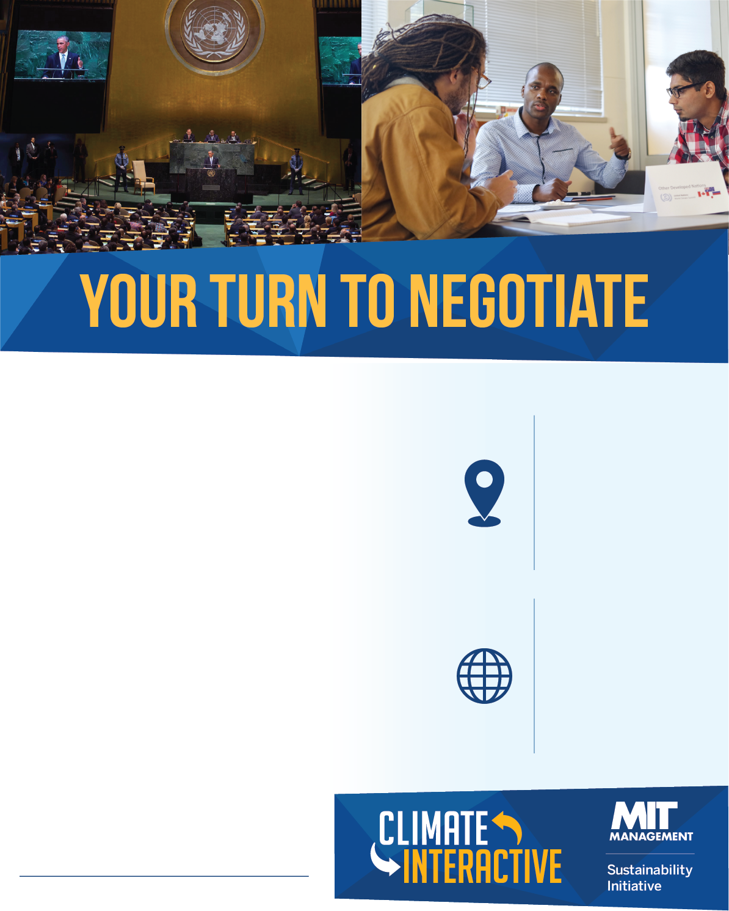

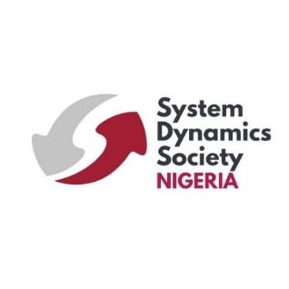
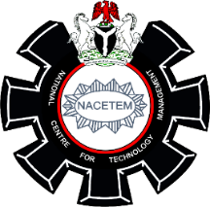
Host:
Dr. Olushola Odusanya (NACETEM DG/CEO)

Facilitator:
Prof. Stefano Armenia
Connect:
@ClimateInteract
climateinteractive.org
nacetem.gov.ng
National Centre for Technology Management (NACETEM) Headquarters
Obafemi Awolowo University, Ile-Ife, Nigeria
Date: September 2/3, 2026
Time: 10am
Join us @ NACETEM to experience what it’s like to negotiate a climate deal and address one of the greatest human and environmental challenges of this century.

The World Climate Simulation is an interactive roleplaying exercise developed by Climate Interactive and MIT Sloan. This model-based game parallels the UN climate change negotiation process.

Participants will take on the roles of world leaders, government officials, industry leaders, and advocates, working together to craft a strategy to limit global warming and mitigate climate impacts with the help of the En‑ROADS Simulator.

