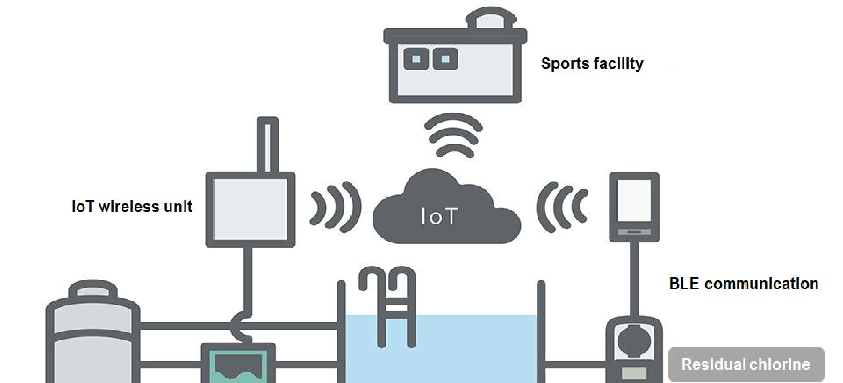
Project Title: Water Quality Monitoring in Public Pools
Block Diagram:

