NIP Project — Movie Ticket Booking Submission
Pega Platform project · This document is your complete submission
Read this before you start:
1. Fill in Section 1 completely. The Pega application name must follow the format NIP-[Project]-[YourName].
2. Create a new Operator in Pega with your full name and log in as that operator before taking any screenshot.
3. When you create your test case, enter YOUR FULL NAME in the Issue Description (Vehicle) or Movie Name (Movie) field.
4. Complete only the section for your chosen project. Delete the other project section.
5. Paste one screenshot per user story (10 total). Follow the screenshot rules in your selected project section.
6. Answer every question in Sections 3 and 4 in your own words.
7. Save the file using this format: ProjectName_FirstName_LastName.docx. Use VehicleService or MovieTicket as the ProjectName. Examples: VehicleService_Ravi_Kumar.docx or MovieTicket_Ravi_Kumar.docx.

Section 1 — Your Details
Full Name | PARUVATHANACHIAR P
Email ID (registered on NIP) | ppnachiar@gmail.com
Phone Number | 9344772396
College Name | V. S. B. Engineering College, Karur
Course (e.g. IT, CS) | B.E. Computer Science and Engineering
State | Tamil Nadu
Project Chosen (Vehicle Service OR Movie Ticket Booking) | Movie Ticket Booking
Pega Application Name (e.g. NIP-VehicleService-YourName) | Movie Ticket Booking Management
Case Type Name (exact) | Ticket Request
Pega Instance URL | https://008jyy0e.pegaacademy.net/prweb/app/movie-ticket-booking-management-1/
Operator Name (created in Pega with your full name) | PARUVATHANACHIAR P (Operator ID: PARUVATHANACHIAR P)

Section 2B — Movie Ticket Booking Management Application
Complete this section only if you selected this project. Delete the other project section before submitting.

Screenshot rules — IMPORTANT before you start:
1. Name your Pega application as: NIP-VehicleService-YourName OR NIP-MovieTicket-YourName
2. Create a new Operator in Pega with your full name (Security → Operators) and log in as that operator.
3. When you create your test case, enter YOUR FULL NAME in the Issue Description (Vehicle) or Movie Name (Movie) field.
4. The logged-in operator name must be visible in every screenshot wherever the Pega interface displays it.
5. The student's full name must be visible in all running-case screenshots.
6. Configuration screenshots must clearly show the relevant application or rule name.
Screenshots that do not show these will not be accepted.

US-001 — Submit Movie Ticket Request
What is expected:
Case created, customer submits Movie Name, Show Date, Show Time, Number of Tickets. Validation applied.
Screenshot — paste your screenshot below this line:
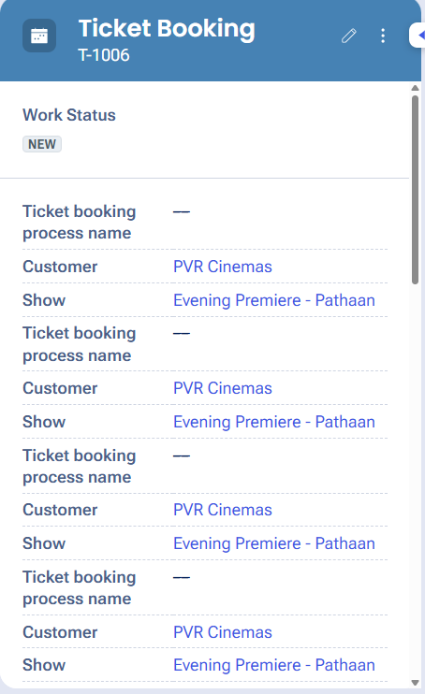
What I built for this (1–2 lines in your own words):
Configured the Booking Intake stage to capture Movie Name, Show Date, Show Time and Number of Tickets with required-field validation.

US-002 — Check Show Availability
What is expected:
Availability stage. Seat Availability Status and Available Seats Count captured. Booking proceeds only if available.
Screenshot — paste your screenshot below this line:
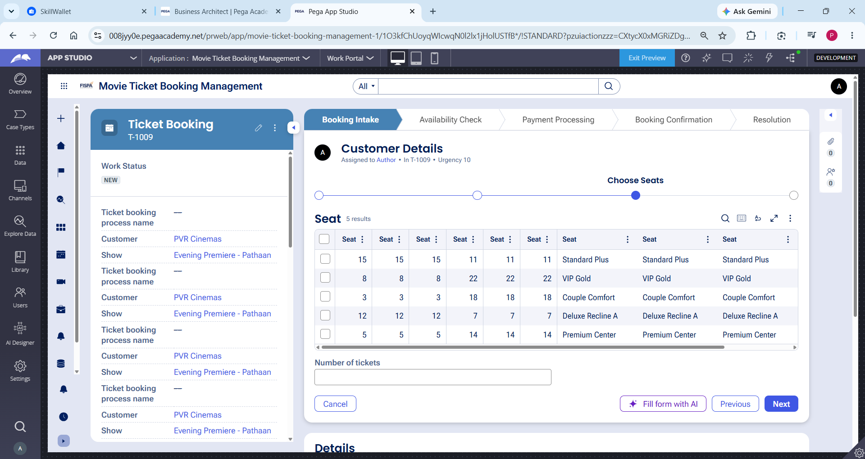
What I built for this (1–2 lines in your own words):
Configured the Availability Check stage to capture seat availability information and allow the booking to proceed only when seats are available.
US-003 — Calculate Booking Cost
What is expected:
Total Cost calculated automatically from Ticket Price and Number of Tickets using a business rule.
Screenshot — paste your screenshot below this line:
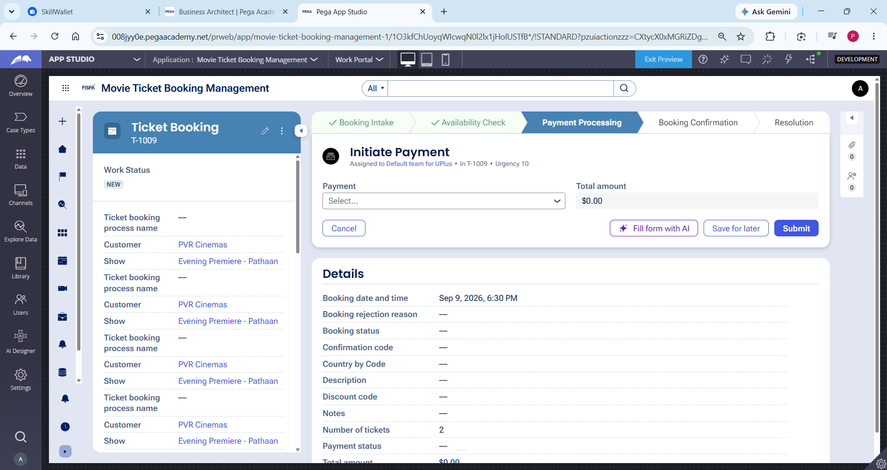
What I built for this (1–2 lines in your own words):
Configured the Total Cost calculation using Ticket Price and Number of Tickets so that the booking cost is calculated automatically.
US-004 — Confirm Booking Request
What is expected:
Approval stage assigned to Customer. Booking Status captured. Flow branches on confirm/cancel.
Screenshot — paste your screenshot below this line:
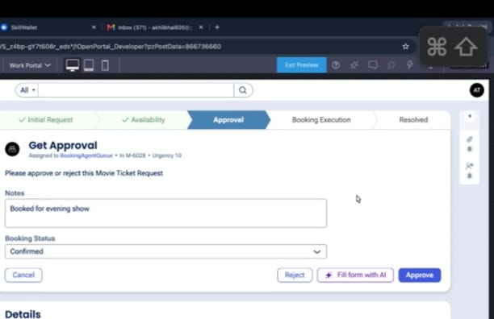
What I built for this (1–2 lines in your own words):
Configured the Booking Confirmation stage to capture booking status and continue the case based on the customer's confirmation decision.

US-005 — Maintain Movie and Show Data
What is expected:
Reusable Movie and Show data objects created with Movie Name, Genre, Show Date, Show Time, Seat Capacity — linked to case.
Screenshot — paste your screenshot below this line:
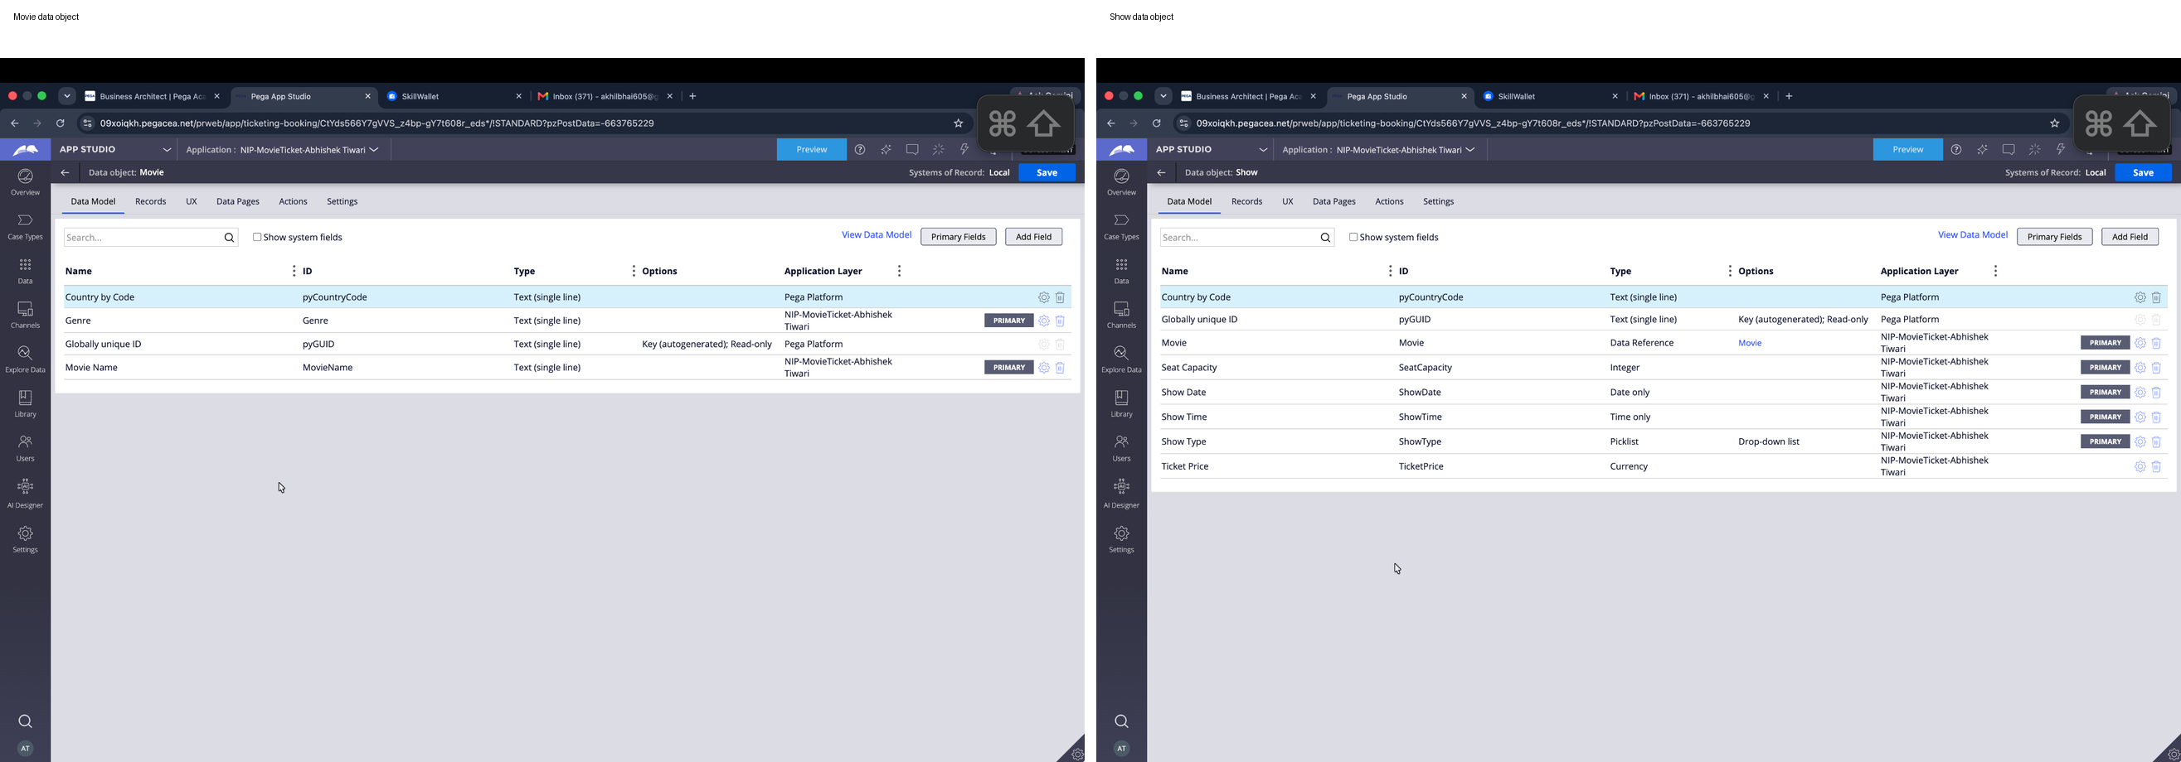

What I built for this (1–2 lines in your own words):
Created reusable Movie and Show data structures and associated the movie and show information with the Ticket Booking case.
US-006 — Review Booking Details
What is expected:
Confirmation screen shows Movie Name, Show Timing, Number of Tickets and Total Cost clearly.
Screenshot — paste your screenshot below this line:
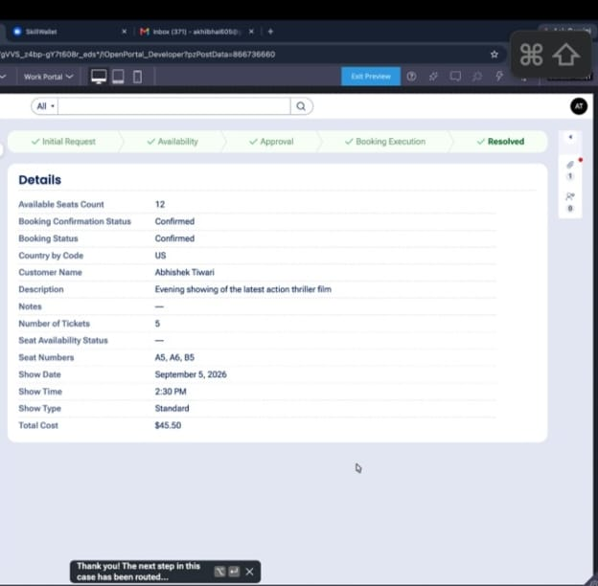
What I built for this (1–2 lines in your own words):
Configured the booking review screen to display the movie, show timing, ticket quantity and total booking cost clearly.
US-007 — Process Ticket Booking
What is expected:
Booking Execution stage. Seat Numbers, Ticket ID and Booking Confirmation Status maintained.
Screenshot — paste your screenshot below this line:
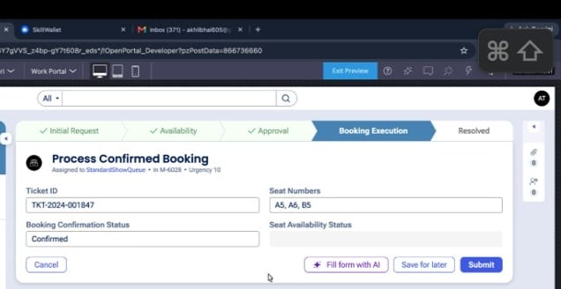
What I built for this (1–2 lines in your own words):
Configured the booking processing flow to maintain Ticket ID, Seat Numbers and Booking Confirmation Status.
US-008 — Notify Booking Confirmation
What is expected:
Correspondence rule triggered on case resolution. Email includes movie, show, seat and cost details.
Screenshot — paste your screenshot below this line:
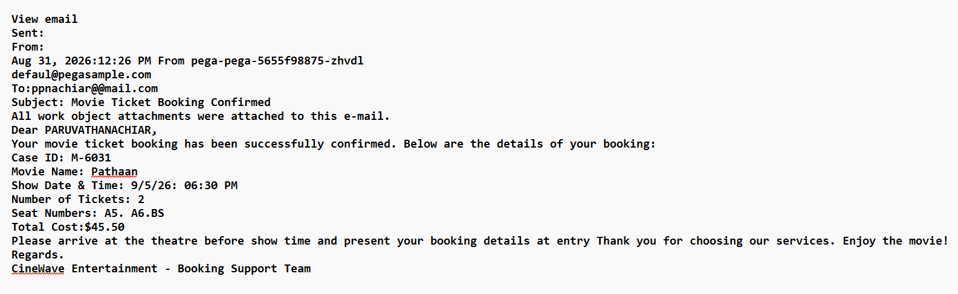
What I built for this (1–2 lines in your own words):
Configured a confirmation correspondence step to notify the customer with the booking details when the case is resolved.
US-009 — Define Booking SLA
What is expected:
SLA configured on the case type. Goal: 1 day. Deadline: 2 days. Priority increases on breach.
Screenshot — paste your screenshot below this line:
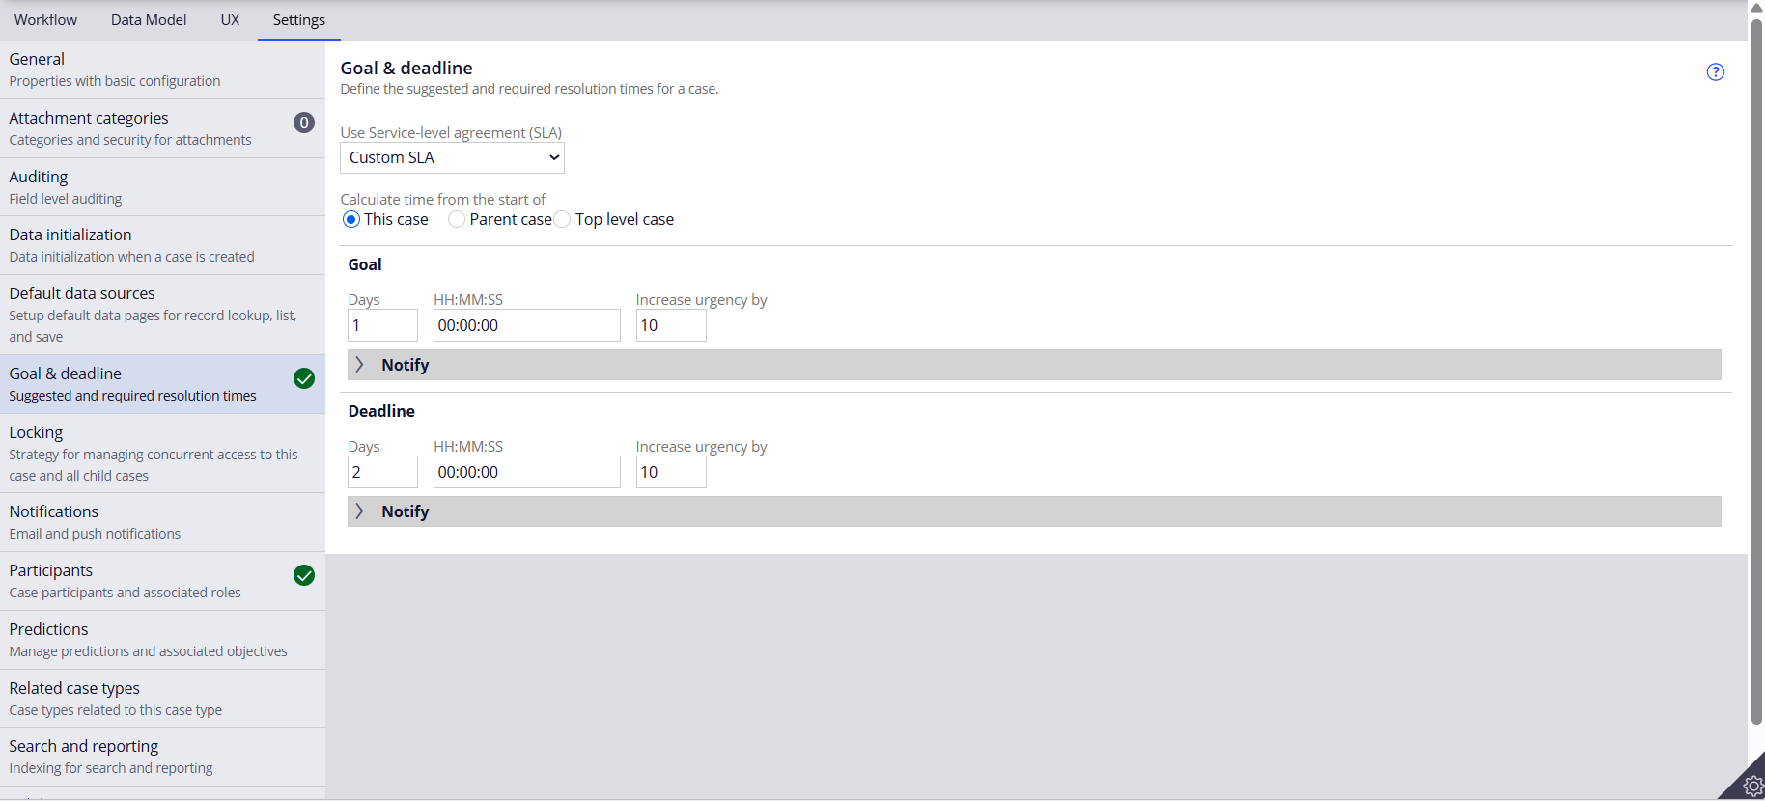
What I built for this (1–2 lines in your own words):
Configured a booking SLA with a 1-day goal and 2-day deadline, with priority increasing when the deadline is breached.
US-010 — Route by Show Type
What is expected:
Routing rule or Decision Table routes to PremiumShowQueue or StandardShowQueue based on Show Type property.
Screenshot — paste your screenshot below this line:
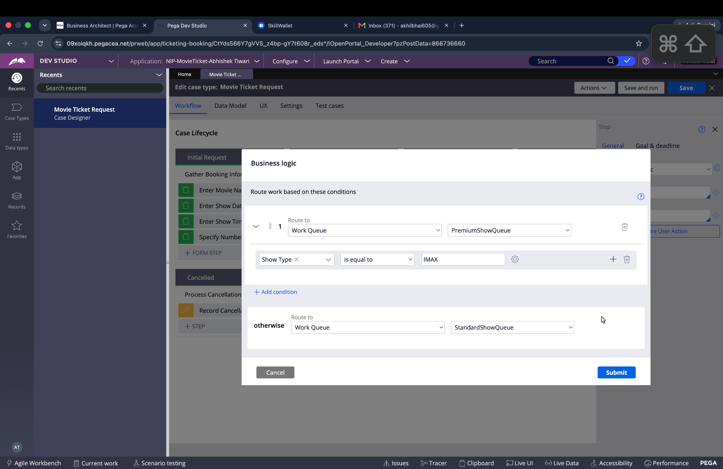
What I built for this (1–2 lines in your own words):
Configured show-type based routing so premium or IMAX bookings are handled separately from standard bookings.

Section 3 — About Your Application
These answers are checked against your screenshots. Write exactly what is in your application.

Q1. List your stages in the order they appear in your case lifecycle.
Stage names in order, separated by commas.
Booking Intake, Availability Check, Payment Processing, Booking Confirmation, Resolution
Q2. Name the data object(s) you created and the properties inside them.
Data object name and its properties.
Movie: Movie Name, Genre. Show: Show Date, Show Time, Seat Capacity. These reusable objects are associated with the Movie Ticket Request case.

Q3. What is the exact name and type of the rule you used to calculate Total Cost?
Provide:
• Rule Name
• Rule Type
• Properties used in the calculation
• Formula used
Rule Name: CalculateTotalCost
Rule Type: Declare Expression
Properties used: Ticket Price, Number of Tickets
Formula: Ticket Price × Number of Tickets

Section 4 — Your Understanding
Short, honest and specific answers score well.

Q4. What did Blueprint generate for you, and what did you add or change yourself afterwards?
Be specific about what was already there and what you built or modified on top.
Blueprint generated the initial case structure, stages, fields and basic workflow. I configured and refined the booking flow, availability, payment processing, confirmation and other required business logic.

Q5. Was there anything Blueprint created that you had to correct or configure further? Describe one example.
A real example from your own work.
I had to configure and refine the generated workflow and field behavior during testing so that the case stages and displayed booking information matched the project requirements.

Q6. Explain your case flow from creation to resolution, in order.
What happens first, who does what, when the case closes.
The case starts with Booking Intake, where movie, show and ticket details are captured. It then moves to Availability Check, followed by Payment Processing and Booking Confirmation. Finally, the case moves to Resolution after the booking is completed.

Q7. Pick two design choices you made in your application and explain why you made them.
For each design choice, provide:
• What you implemented
• Why you chose that approach
• What benefit it provides to the application
1. I separated Availability Check into its own stage so seat availability can be verified before further processing.
2. I used a separate Payment Processing stage so payment handling is separated from booking confirmation and the workflow is easier to manage.

Q8. What was the hardest part, and how exactly did you fix it?
Specific and honest. A real challenge scores much better than a generic answer.
The challenging part was testing the case across multiple stages and ensuring that the required values were displayed and calculated correctly. I tested the case step by step and refined the configuration when the expected behavior was not obtained.

Q9. If the approval step was only needed when Total Cost is above a certain amount, what would you change in your application?
Explain what you would change and where. You do not need to build this.
I would add a conditional decision before Booking Confirmation. If Total Cost exceeds the defined threshold, the case would go through approval; otherwise, the approval step would be skipped.

Q10. List three exact rule names from your application that you personally created or modified.
Include the rule name and rule type for each one (for example: CalculateTotalCost - Declare Expression).
CalculateTotalCost — Declare Expression; ProcessConfirmedBooking — Data Transform; BookingExecution_Flow — Flow.
Q11. List all personas used in your application.
List the persona names exactly as they appear in your application.
Customer, Booking Staff, Cinema Manager, Support Agent, Marketing Executive, Application Control Agent
Q12. List all work queues used in your application and explain when each one is used.
For each work queue, provide its exact name and the condition or type of work routed to it.
PremiumShowQueue — used for IMAX/premium or special screenings. StandardShowQueue — used for all other show types. BookingAgentQueue — used for the booking approval/work assignment shown in the case flow.
Before You Submit — Check These
Read through once before uploading.
1. Section 1 filled in. Application named as NIP-[Project]-[YourName]. Names match the actual application.
2. New Operator created in Pega with my full name. I logged in as that operator for all screenshots.
3. Only my chosen project section remains — the other project section is deleted.
4. All 10 user story screenshots are pasted and follow the operator, running-case, application, and rule-name evidence requirements.
5. Every question in Sections 3 and 4, including Q10, Q11, and Q12, is answered in my own words.
6. This file is named using the required format: ProjectName_FirstName_LastName.docx (for example, VehicleService_Ravi_Kumar.docx or MovieTicket_Ravi_Kumar.docx) and uploaded as required.

