**Components Used**

|  |  |  |
| --- | --- | --- |
| **Components Name** | **Specification** | **Quantity** |
| Voltage Regulator | LM317 IC | 1 |
| Diode (D1-D6 ) | 1N4007 | 6 |
| Resistance (R1) | 240ohm | 1 |
| Variable Resistance (R2) | 5kohm | 1 |
| Capacitor (C1) | 2200uF | 1 |
| C2 | 0.33uF | 1 |
| C3 | 100uF | 1 |
| C4 | 10uF | 1 |
| Transformer (T1) | 18-0-18V, 2A | 1 |
| AC Supply | 230V, 50Hz | 1 |

**Technical Explanation**

**Block Diagram**

Transformer

Bridge Rectifier

Smoothing Capacitor

Voltage Regulator

Load

**Explanation**

Let us divide the whole process in 4 parts and understand them individually.

1. Stepping Down The Input Voltage

We have used an 18-0-18V, 2A step-down transformer which converts or steps down the wall outlet(which is 230V, 50Hz) into 18V. This is an important steps because, then only we can give it to the bridge rectifier circuit as input to convert it to DC.

2. Bridge Rectifier

A bridge rectifier is a simple circuit which converts AC to DC. It uses four diodes, two in forward bias and two in reverse bias. Here, we have used four 1N4007 diodes, also known as General Purpose Diodes. In this process, the 18V AC, coming from the transformer gets converted to 18V DC. But, this is not purely DC, it still has some AC part present in it, also known as ripples. The DC obtained here cannot be used for any application. So, to remove those ripples, we use capacitors.

3. Smoothening of DC

Using the following equations we decide the capacitance of capacitors which are used for the smoothing or the removal of ripples in the DC voltage obtained after rectification. Here, we have used two capacitors(in parallel) 2200uF and 0.33uF.

4. Voltage Regulation

The DC coming from filter circuits is fed to the voltage regulator IC. The IC that we are using here is LM317. It has 3 pins, 1 – Adjust, 3 – Input, 2 – Output. Input is given on Pin 3, a potentiometer, here 5k ohm. The range of IC is from 1.2V to 37V. We can give it to the input and obtain the desired output by adjusting the potentiometer connected to Pin 1. We can get the output from 1V to 18V by adjusting the potentiometer. The diodes D5, D6 are used to protect the IC from getting damaged. The capacitor C4 is very important, otherwise the IC starts working as an oscillator.

**C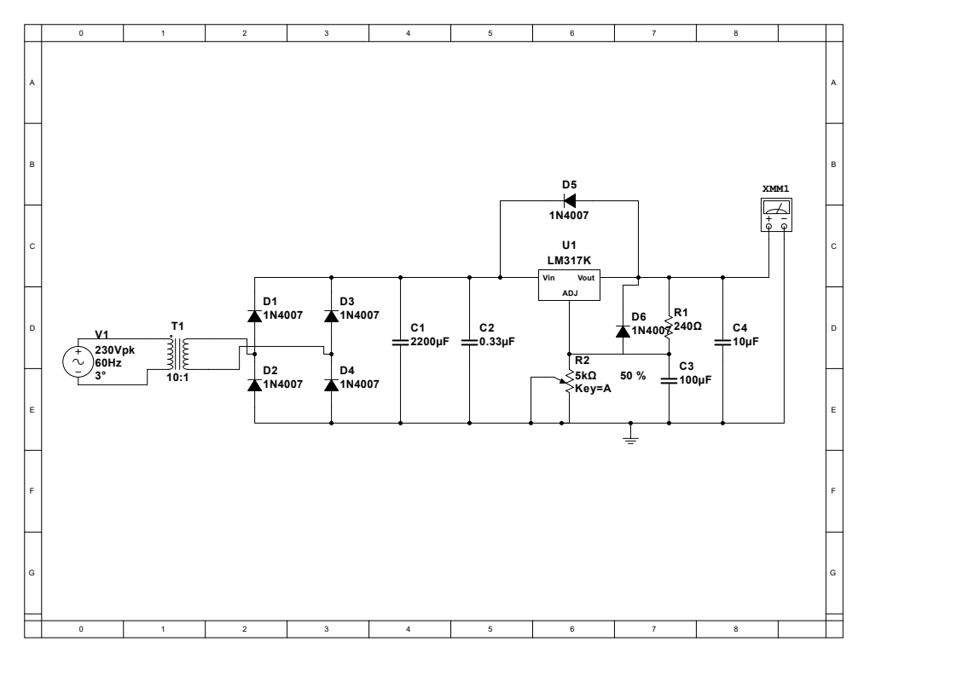ircuit Diagram**

**MultiSim Simulation Output**

