**Configuring Email and slack Alerts for Critical System Thresholds**

**Objective:** To establish an email notification system in Grafana for alerting engineers   
when critical system metrics exceed predefined thresholds by configuring the necessary   
Grafana settings

**Tools required:** Linux operating system

**Prerequisites:** Refer to Demos 01 and 02 of Lesson 04 for installing Grafana and configuring Prometheus as a data source

Steps to be followed:

1. Set an app password through your Gmail account
2. Configure SMTP settings in the Grafana configuration file
3. Configure a contact point in the Grafana dashboard
4. Configure Notification policies
5. Configure alert rules and verify the email alert notifications

**Step 1: Set an app password through your Gmail account**

1. Navigate to Gmail using the following link to create an app password and then click on **Create and manage your app passwords**:

**https://support.google.com/mail/answer/185833?hl=en**

You need to enable two step verification then only you will be able to generate app password

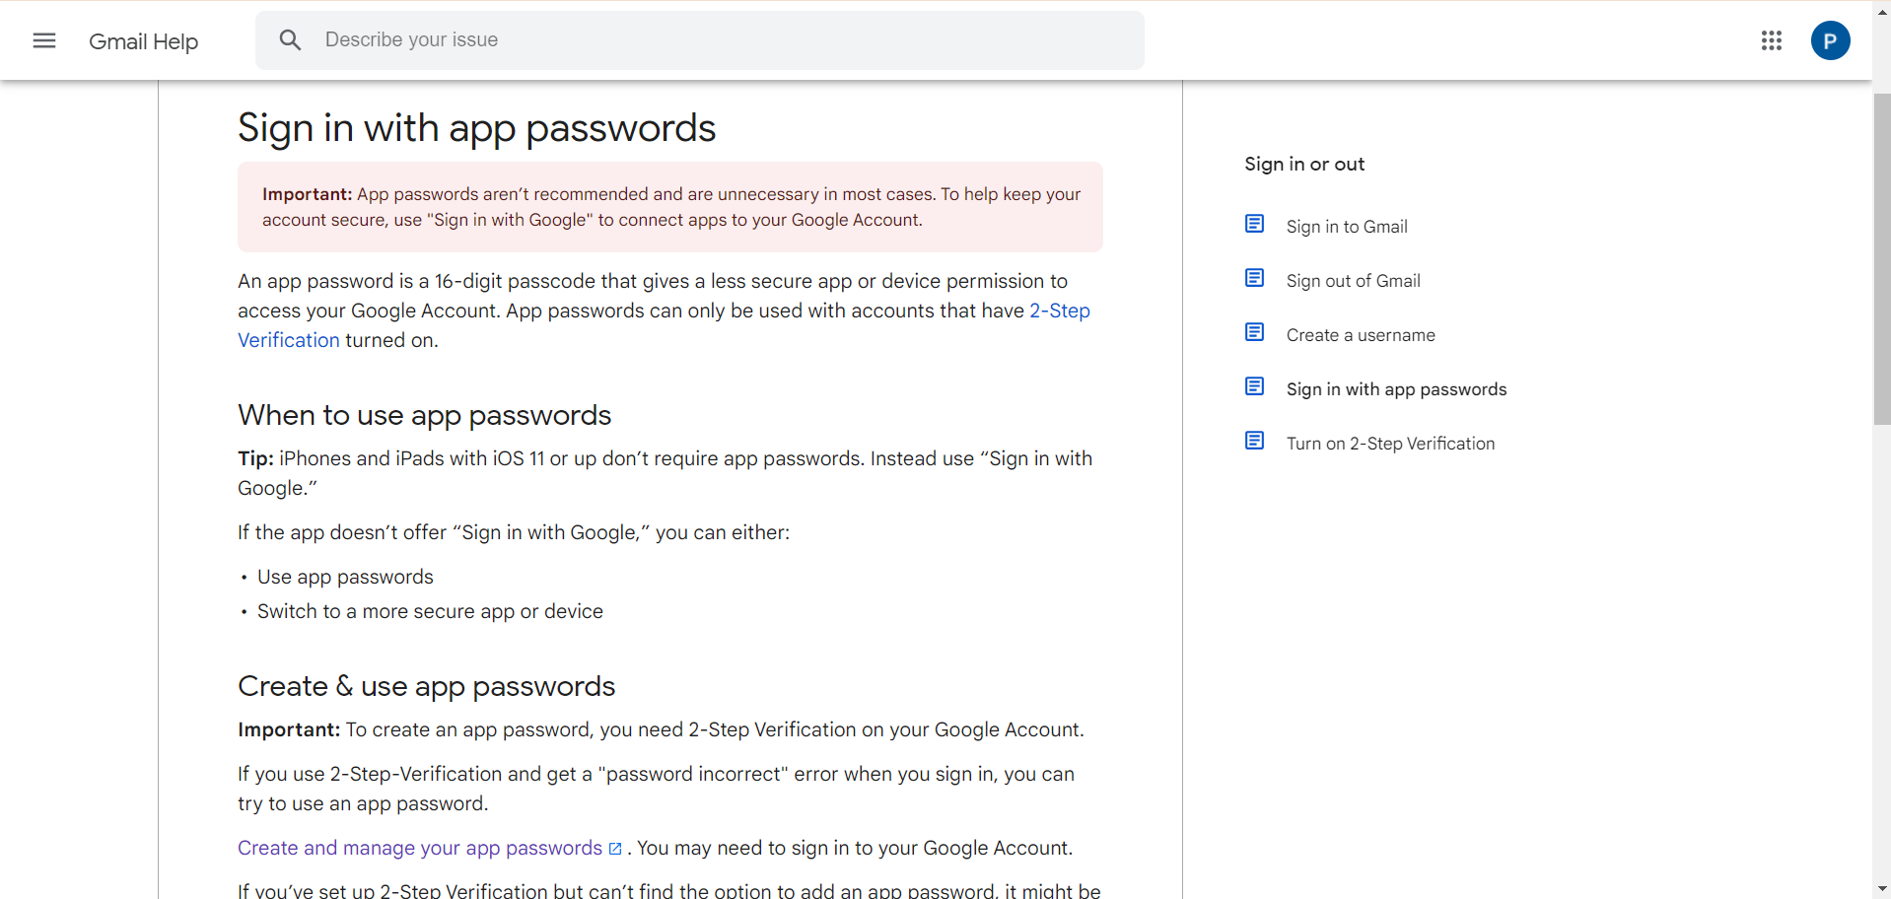

1. Provide the **App name** and click on **Create**

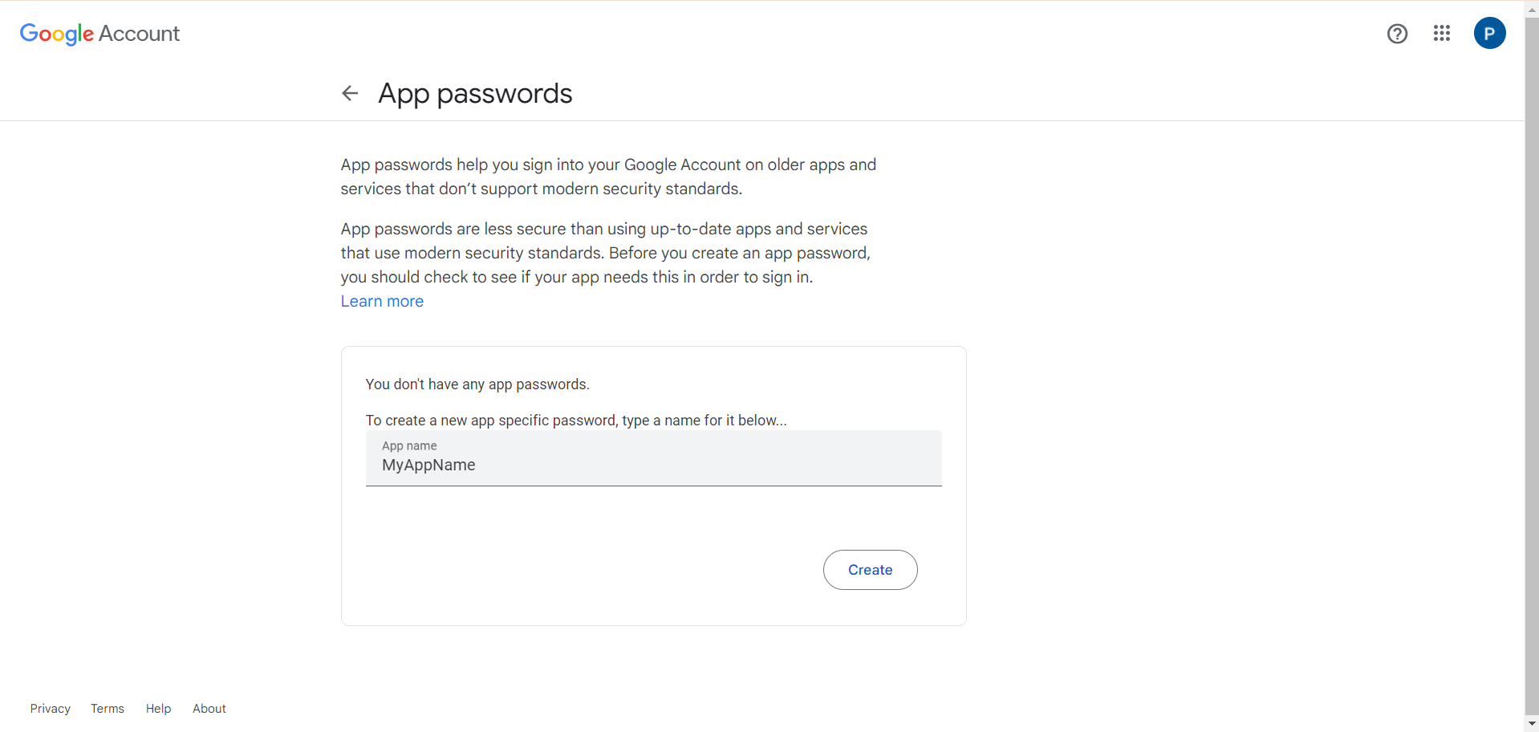  
  
A 16-character password will be generated.

1. Click on **Done**

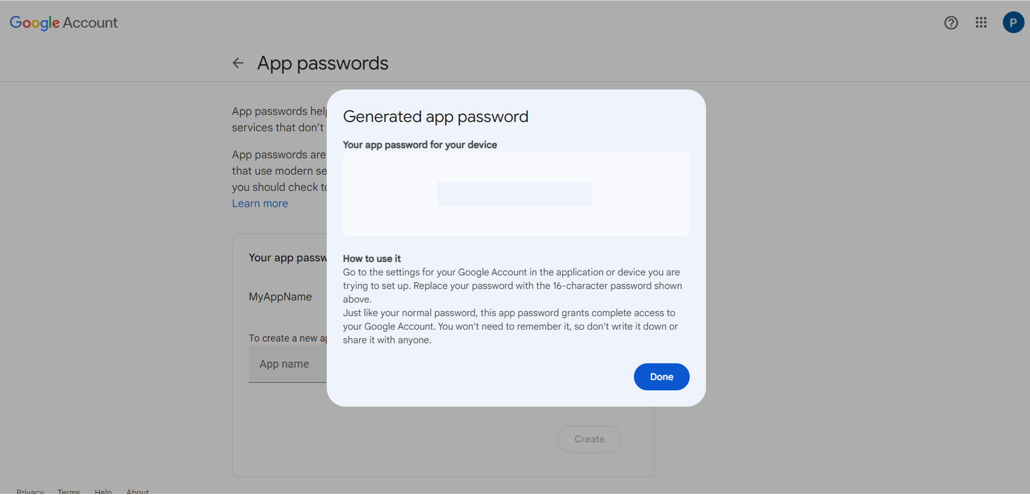

**Note:** The app password is in the format of **abcd efgh ijkl mnop**, but when typing it, do not use spaces; it should be **abcdefghijklmnop**.

1. For security reasons, remove the app password after use by clicking on the **delete** icon

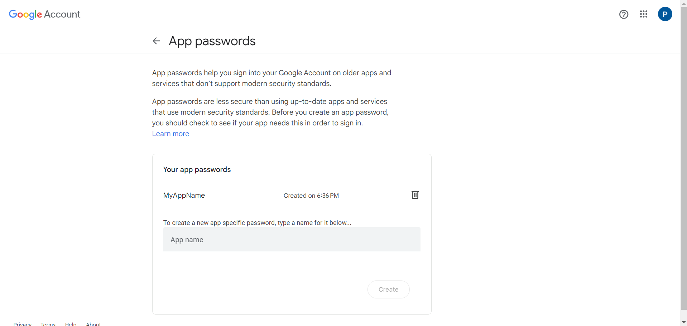

**Step 2: Configure SMTP settings in the Grafana configuration file**

1. Open the terminal and run the following command to edit the SMTP settings in the **grafana ini** file:

Go to your Grafana directory

Go inside conf directory

vi defaults.ini

The ini file appears as shown below:

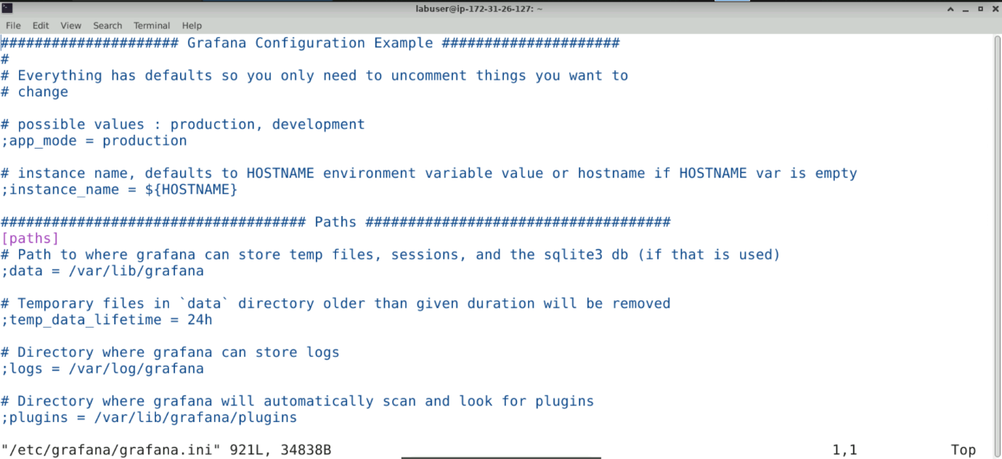

**Go at bottom till you see smtp**

1. Find the **[smtp] section** in the file that appears as shown below:

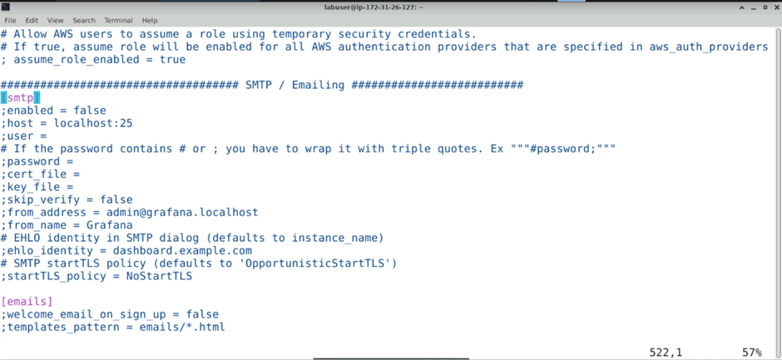

1. Configure the SMTP settings by updating the field values as follows:

**[smtp]**

**enabled = true**

**host = smtp.gmail.com:587**

**user = <your_email@gmail.com>**

**password = <your_gmail_app_password>**

**skip_verify = true**

**from_address = <your_email@gmail.com>**

**from_name = Grafana**

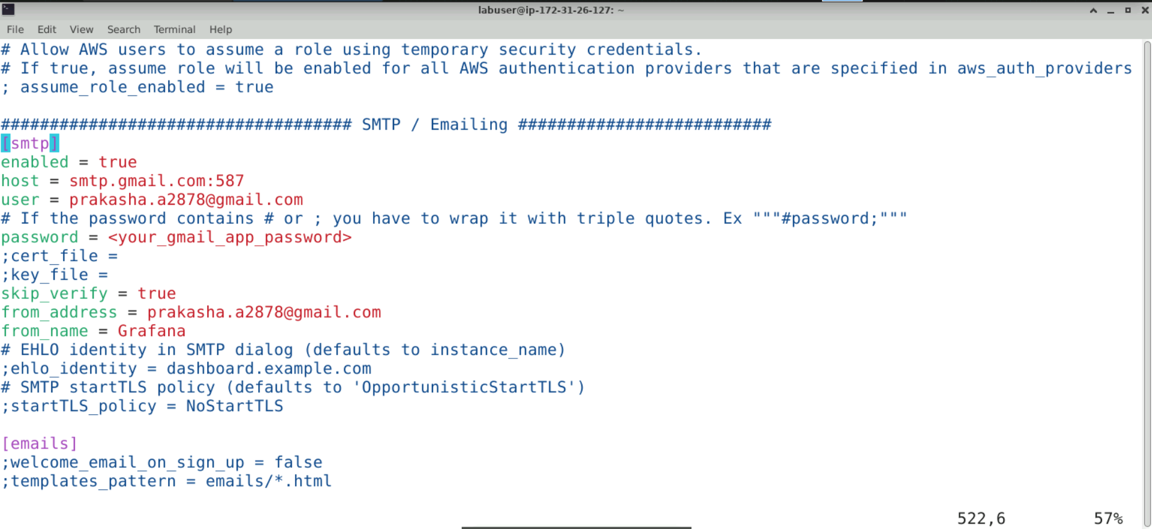

**Note:** Remove the comments before updating the values. Replace **<your_gmail_app_password>** with the password created in **Step 1**, and **<**[**your_email@gmail.com**](mailto:your_email@gmail.com)**>** with the actual email address to which the alert will be sent

1. Execute the following command to restart Grafana:

ps aux | grep grafana

kill -9 pid(which you got above)

cd ..

(refresh the machine brwser)

cd binary

./grafana-server

1. Open the preferred browser and enter the URL **http://publicip:3000** to open the Grafana UI as shown below:

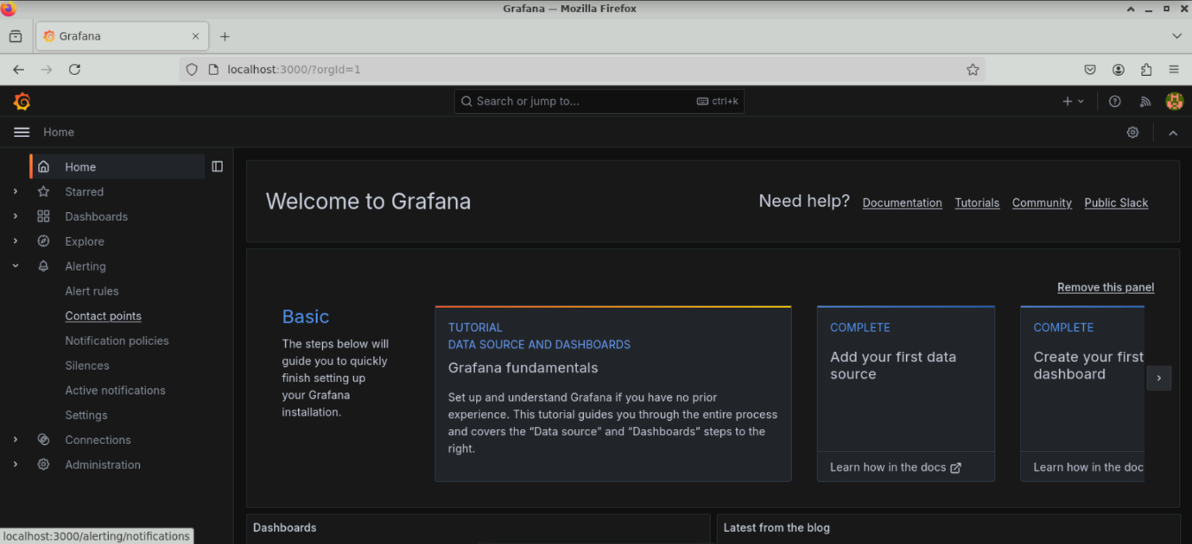

**Note:** Make sure that Prometheus is running before starting the Grafana server

**Step 3: Configure a contact point in the Grafana dashboard**  
Go to Grafana

Alerts -> notification channels

## Configure Email Notification (SMTP)

Follow these steps to enable email notifications in Grafana:

1. Navigate to the Grafana installation directory and then to the 'conf/' folder.
2. Copy the default configuration file into a custom one:  
    cp defaults.ini custom.ini
3. Open custom.ini in a text editor (e.g., vi custom.ini).
4. Locate the [smtp] section and configure SMTP settings.
5. Example configuration for Gmail:  
   [smtp]  
   enabled = true  
   host = smtp.gmail.com:587  
   user = yourgmail@gmail.com  
   password = <app-password>  
   from_address = yourgmail@gmail.com  
   from_name = Grafana  
   skip_verify = true
6. Save the file and restart Grafana:  
    ./bin/grafana-server web
7. Login to Grafana → Alerting → Contact points → Add contact point → Select Email → Test.

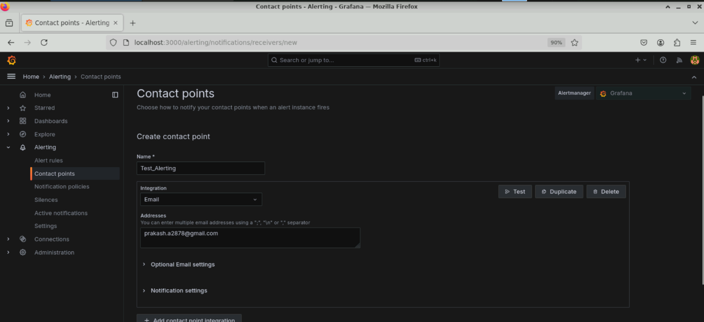

1. Click on **Send test notification**

## 2. Configure Slack Notification (Incoming Webhook)

Follow these steps to enable Slack notifications in Grafana:

1. In your browser, go to: https://slack.com/apps/A0F7XDUAZ-incoming-webhooks
2. Add Incoming Webhook to your Slack workspace.
3. Choose the Slack channel (e.g., #new-channel) and click Allow.
4. Copy the generated Webhook URL (example: https://hooks.slack.com/services/T00000000/B00000000/XXXXXXXX).
5. Open Grafana → Alerting → Notification channels → Add channel.
6. Set Name (e.g., Slack-Alerts) and Type = Slack.
7. Paste the Webhook URL into the Webhook field.
8. In Recipient, enter the Slack channel name (e.g., #new-channel).
9. Click Save & Test → you should see a test notification in your Slack channel.

## 3. Testing Notifications

After configuration, always test notifications:  
- For Email: Use 'Send test notification' in Email contact point.  
- For Slack: Use 'Save & Test' in Slack notification channel.  
  
If the test succeeds, you are ready to attach these notifications to alert rules.