Fully managed Kubernetes cluster infrastructure:

Amazon EKS is a managed service that makes it easy for you to use Kubernetes on AWS without needing to install and operate your own Kubernetes infrastructure.

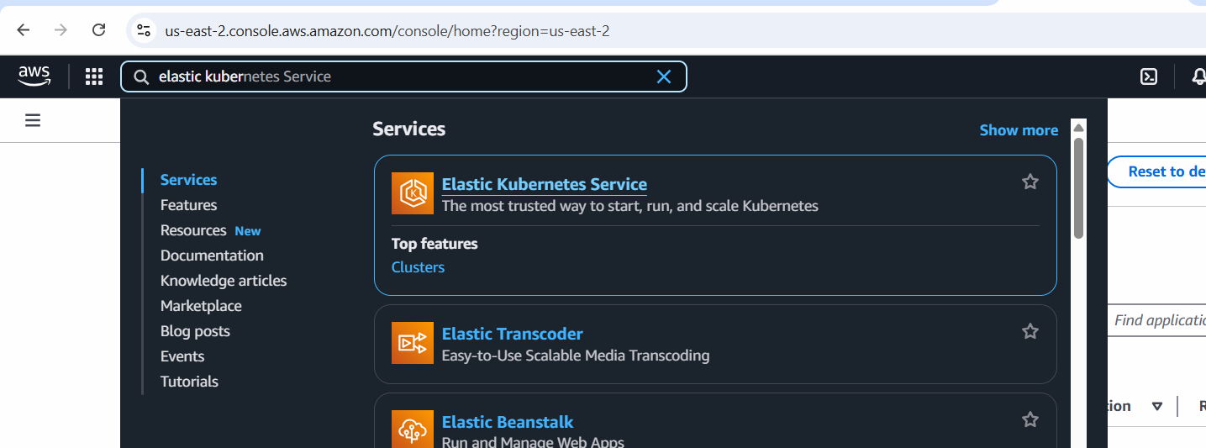

Click on Create Cluster

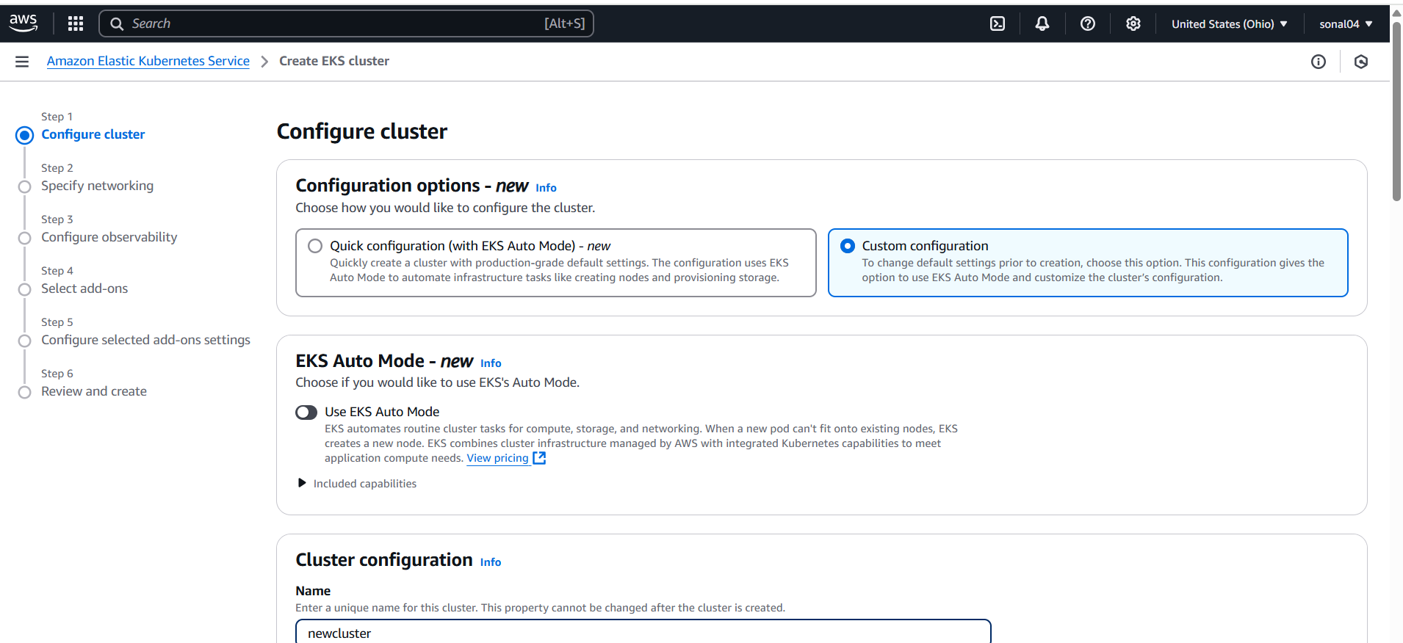

Create an IAM role:

Go to role—create role—aws services—select EKS –sleect eks cluster

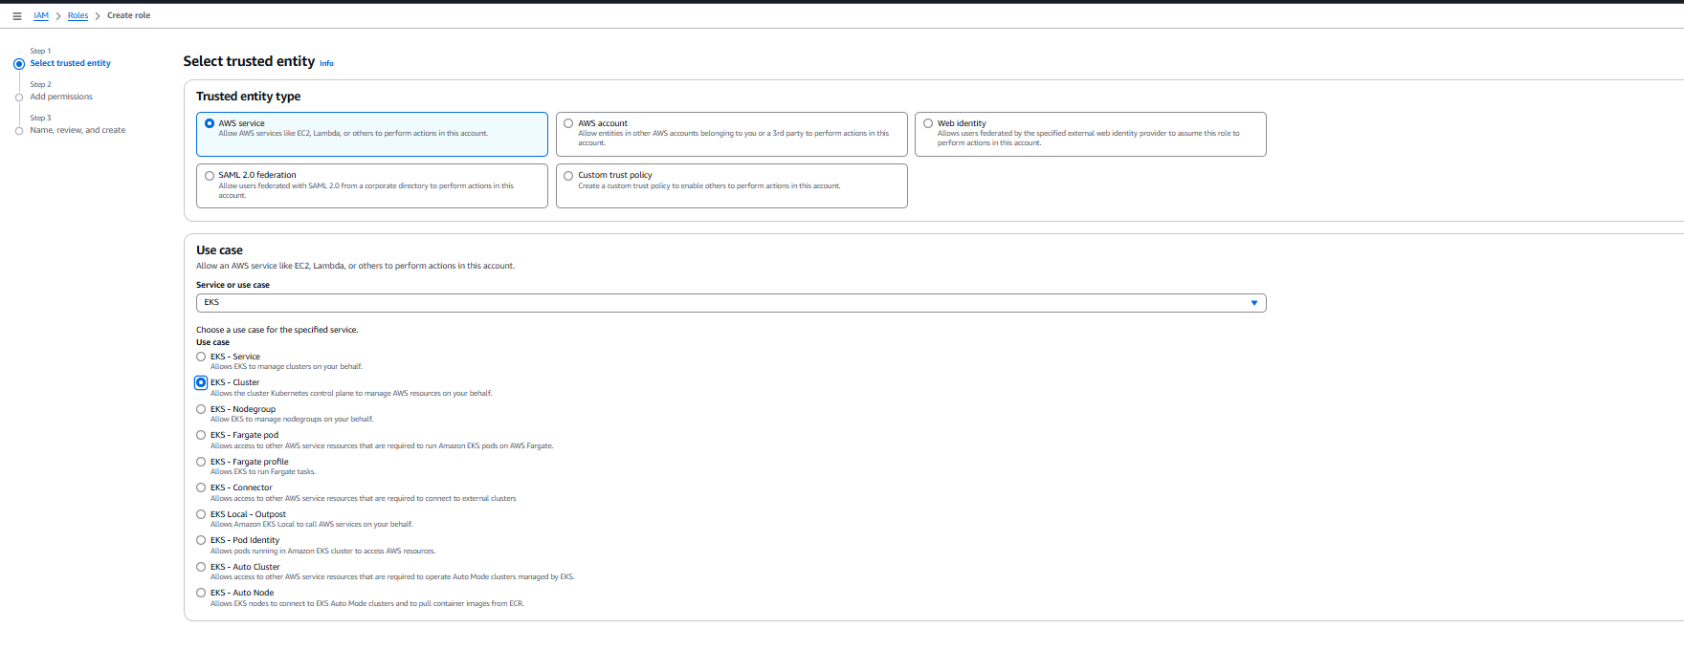

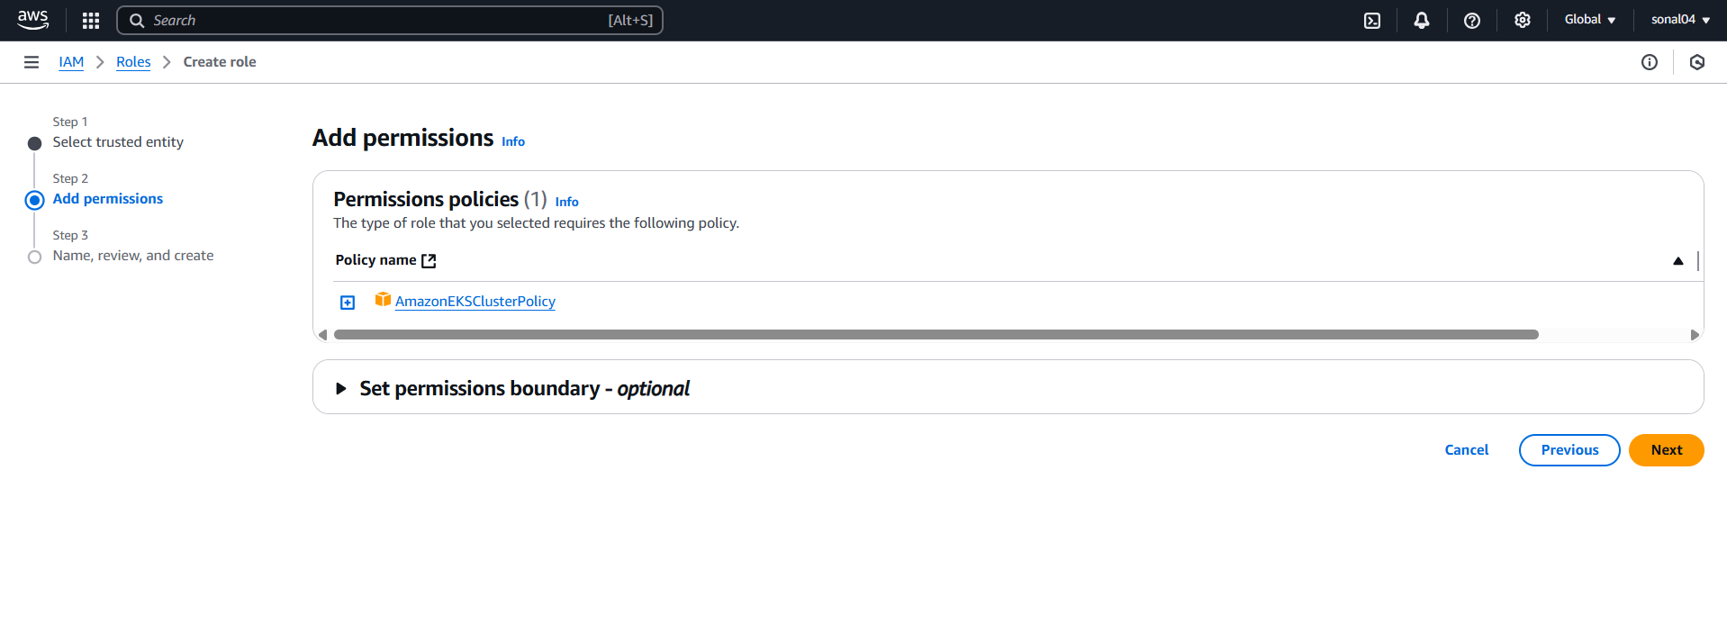

Give role name

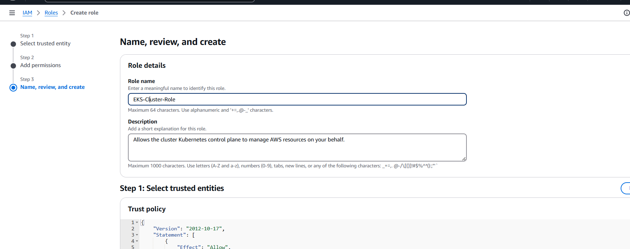

Click on create role

Leave default network, subnet and

Create a new security group for the default network

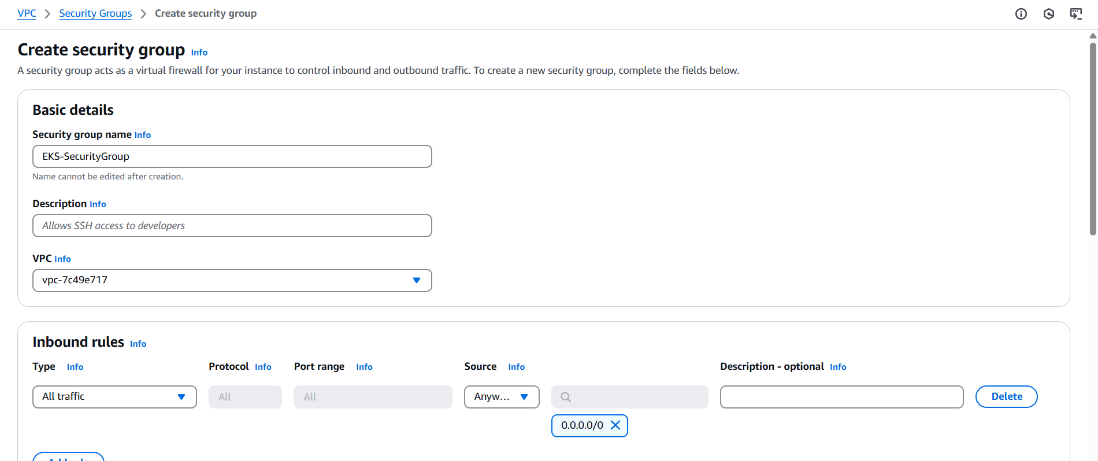

Select that security group in the eks cluster

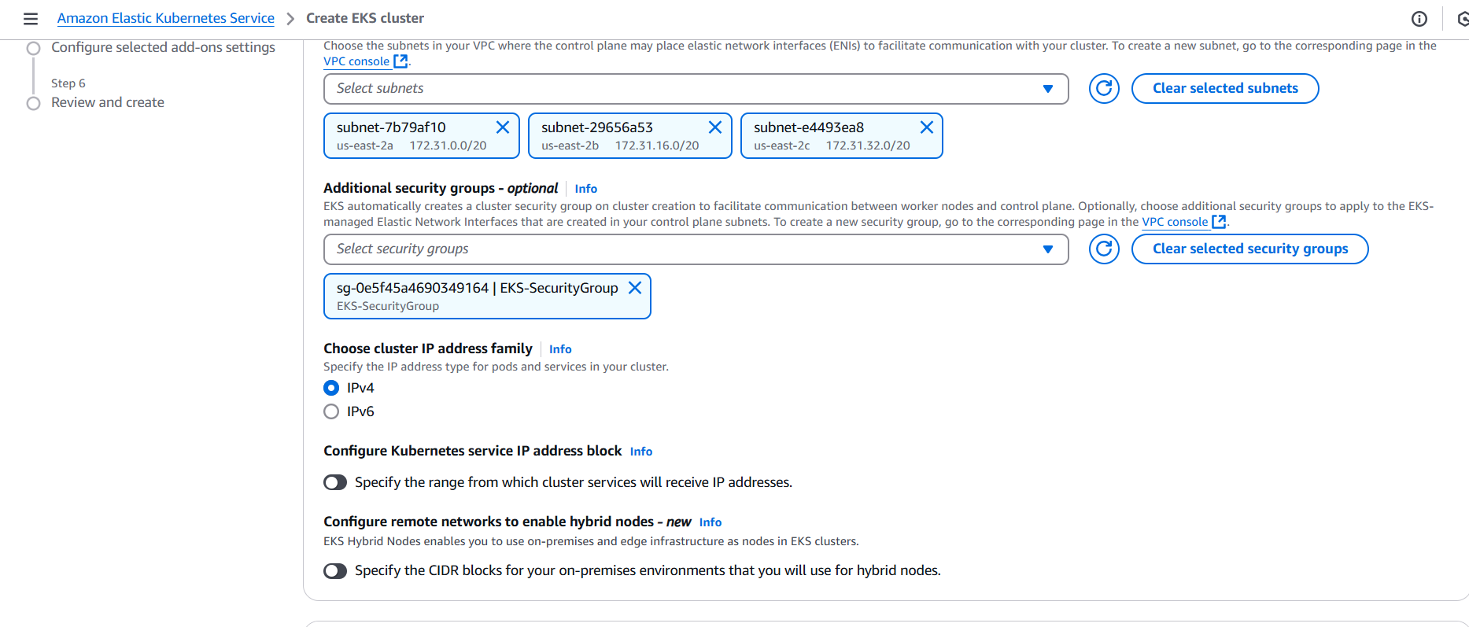

Press next 🡪press next 🡪 leave addon as default 🡪 press next 🡪 click on create

It will take 10 misn to create cluster—we will wait

We will create an NodeGroup now 🡪

Click on Cluster 🡪 click on Compute 🡪 click on node group

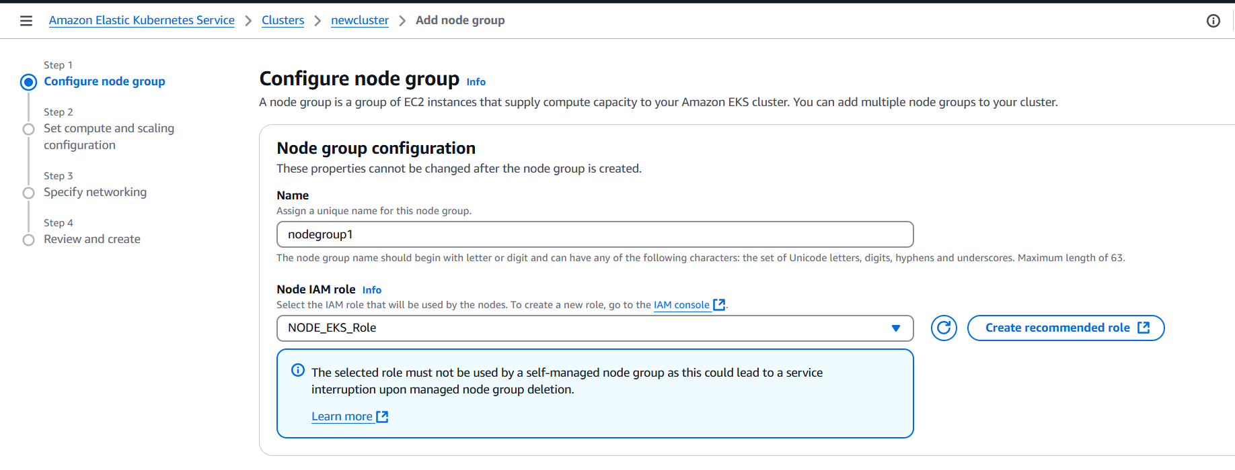

Create a IAM role for node group and select 3 policy

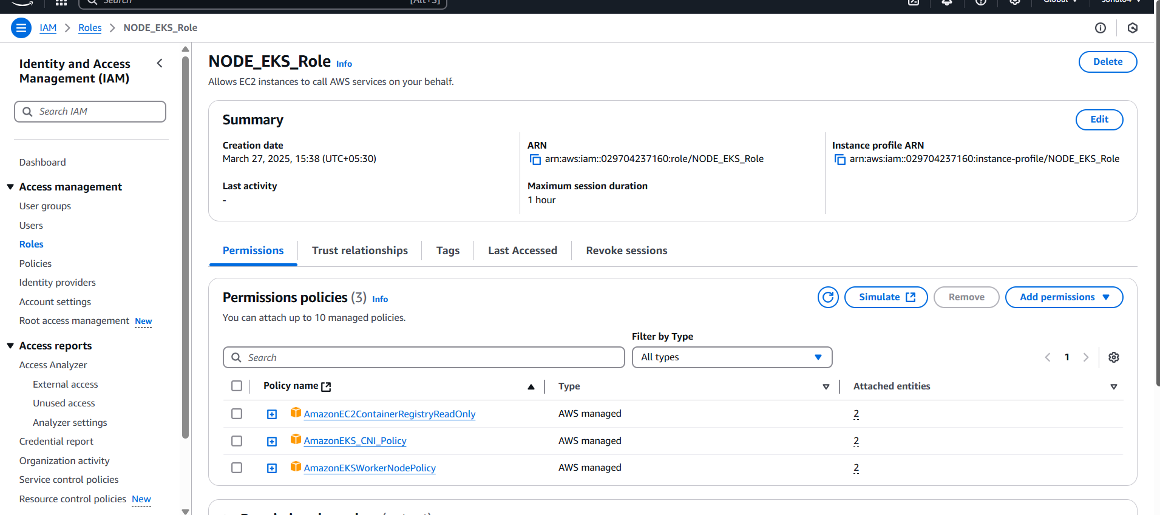

In EKS node group select the role



Press next

Sleect AMI as amazon linux 2

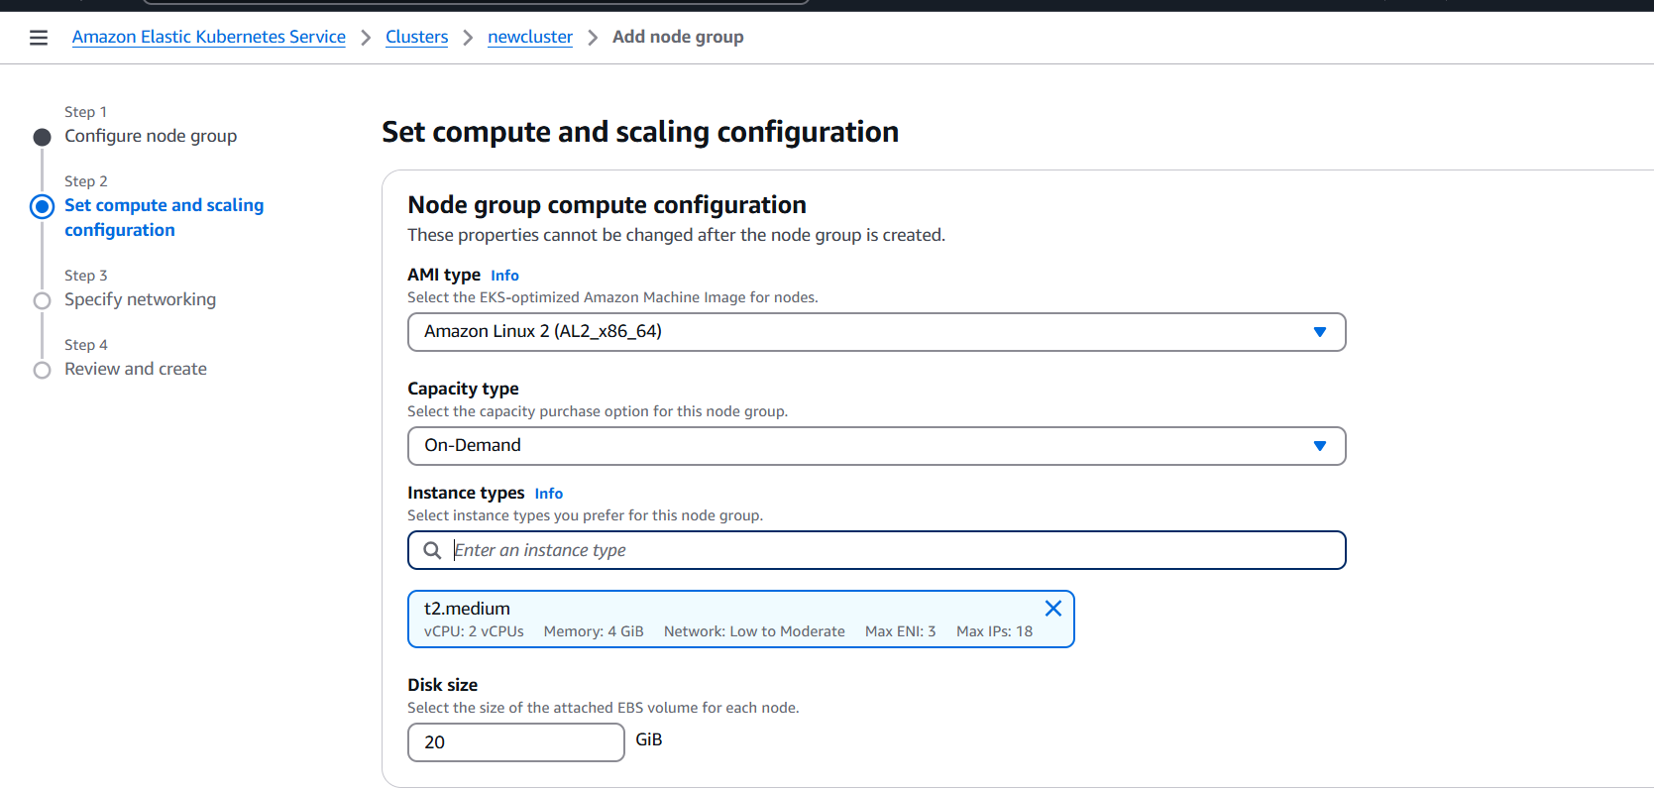

Press next – click on create 🡪 it will take 5 mins to complete

Meanwhile create a aws amazon linux 2023 machine to connect to cluster with all traffic enabled

# Install aws cli

curl "https://awscli.amazonaws.com/awscli-exe-linux-x86_64.zip" -o "awscliv2.zip"

apt install unzip

unzip awscliv2.zip

sudo ./aws/install

# Install kubectl

curl -LO "https://dl.k8s.io/release/$(curl -L -s https://dl.k8s.io/release/stable.txt)/bin/linux/amd64/kubectl"

chmod +x ./kubectl

mv ./kubectl /usr/local/bin

kubectl version --client

Connect to cluster via aws cloud shell

Click on shell button in aws dashboard, next to bell icon

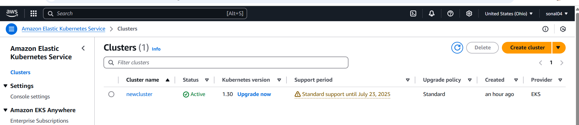

Lets first create access key and secret access key

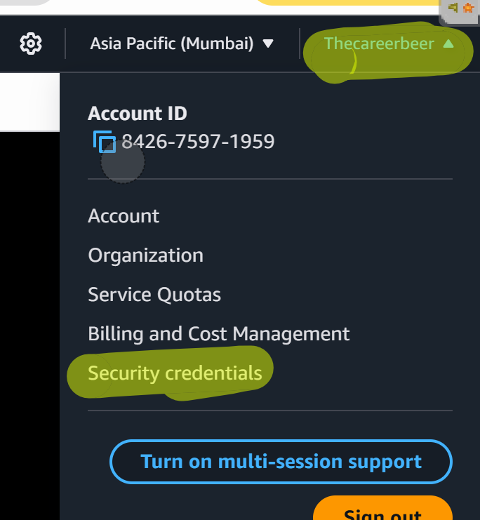

generate access key ….copy them

# go back to ur machine

aws configure

# put access key and secret access key and press enter for other things like region etc

Now connect to cluster using the command

# aws eks --region us-east-2 update-kubeconfig --name newcluster

