**A Presentation Report**

On

**“Fitness Portal”**

Submitted in partial fulfillment of the requirement of University of Mumbai

Submitted By

## Nachiket More Karan Pagare

## Vipul Gupta

Under Guidance of **Prof. Sarita Khedikar**

## Third Year In Computer Engineering



**Department of Computer Engineering Smt. Indira Gandhi College of Engineering** Affiliated to University of Mumbai.

Mumbai (M.S.)

(2018 – 2019)

# CERTIFICATE

This is to certify that seminar entitled “**Fitness Portal**” has been carried out by the team under my guidance in partial fulfilment of the Third year Computer Engineering of Mumbai University, Mumbai during the academic year 2018-19 and successfully completed the report as prescribed by university of Mumbai.

|  |  |
| --- | --- |
| **Names of the student** | **Roll No** |
| Nachiket More | 35 |
| Karan Pagare | 40 |
| Vipul Gupta | 18 |

Place : Ghansoli Date :

### Prof. Sarita Khedikar (Internal Guide )

**ACKNOWLEDGEMENT**

The completion of any inter-disciplinary project depends upon cooperation, co-ordination and combined efforts of several sources of knowledge. We are grateful to Prof. Sarita Khedikar

for his even willingness to give us valuable advice and direction; whenever we approached him with a problem .We are thankful to him for providing immense guidance for this project. I have taken efforts in this project. However, it would not have been possible without the kind support and help of many individuals and organizations. I would like to extend my sincere thanks to all of them.

I am highly indebted to Prof. Sarita Khedikar for their guidance and constant supervision as well as for providing necessary information regarding the project & also for their support in completing the project.

I would like to express my gratitude towards my parents & member of Smt.Indira Gandhi College of Engineering for their kind co-operation and encouragement which help me in completion of this project. My thanks and appreciations also go to my colleague in developing the project and people who have willingly helped me out with their abilities.

# Abstract

Physical activity, along with proper nutrition, is beneficial to people of all ages, backgrounds, and abilities. Being Physically active and fit holds utmost importance especially among today’s younger generation who is busy enjoying the luxuries of mobile, laptop and TV at an alarming rate and aren’t active and spirited on a daily basis. Being involved in electronic devices ain’t bad until and unless it is used as a source of entertainment for a limited time. In order to enjoy the beauty of life and to experience it to the fullest you must start getting involved in physical activities or sports. Being young, students have a lot of potential to develop a hobby that keeps their fitness regulated for the lifetime.

Physical fitness is one of the most important factors that allow us to lead a healthy and active life. A physical fitness program not only improves the health and power of the body but also the entire life style. Maintaining physical fitness is a difficult task for most of the people because of the pressure and strain that they face daily. A person who is physically fit will be more confident in public places because they feel more comfortable than others who are not fit.

# Table of Contents

Sr.No. Title

List of Figures vii

1. Introduction 1
   1. Introduction and Motivation 1
   2. Problem Definition 3
   3. Aim and Objectives 4
   4. Scope 5
2. Analysis and Design 11
   1. Use Case Diagram of the system 12
   2. E-Learning Website 16

2.2.1 Preview of E-Learning Website (Library) 17

3 Technologies used 26

3.1 Hardware 26

3.1 Software 26

1. Result 32
2. Conclusion and Future Work 33
   1. Conclusion 33
   2. Future Work 33

References 34

# Introduction

### Introduction and Motivation.

The body mass index, or BMI, is a calculation used to determine your level of body fat. In some cases, it can help a doctor determine your overall fitness and your risk of developing chronic diseases. Still, BMI is not the only factor your doctor considers, and it isn’t a completely reliable assessment for every body type.

Generally, if you’re at a healthy weight, your body mass index should fall between 18.5 and 24.9, notes the National Heart, Lung and Blood Institute. If your BMI is below 18.5, you could be underweight. On the other hand, a BMI greater than 25.0 is categorized as overweight, while a score above 30 is considered obese.

While BMI is a starting point to evaluate your health, it isn’t flawless. For example, it doesn’t account for gender, and women tend to have more body fat than men. So as a woman, even if your body mass index is in the normal range, you could still have a high percentage of body fat. The calculation also doesn’t account for muscle mass. Muscle weighs more than fat, so if you lift weights and have toned muscles, your BMI could be high even if you’re not overweight. The test also doesn't account for genetic factors, bone density or your activity level, or take into consideration the fact that thinness doesn't necessarily equal healthiness.

# Problem Definition

A body mass index in the low range signals that you could be malnourished. Maybe your body isn’t properly absorbing nutrients or maybe you’re just not getting enough calories to support your activity level. Conversely, having a BMI on the higher end alerts your physician that your risks of heart disease, diabetes and certain cancers are higher than someone with a normal BMI. Your doctor might set you up with a registered dietitian, who can help you get your weight back on track and reduce your risk of developing health problems.

We hope to build a platform that provides a way to calculate Body Mass Index and suggest necessary daily calorie intake By allowing the user to have full control on the data or information, the user can grasp at his or her comfort level. Also due to the interactive nature of the platform the user will not get bored.

# Aims and Objectives

BMI is a measure of your general health and is based on your height and weight ratio. If your BMI is high, you may have an increased risk of developing certain diseases including:

* high blood pressure
* heart disease
* high cholesterol and blood lipids (LDL)
* Type 2 Diabetes
* sleep apnea
* osteoarthritis
* female infertility
* gastroesophageal reflux (GERD)
* urinary stress incontinence

# Scope

## A BMI value that ranges from 18.5 to 24.9 is considered to be healthy. A person having a BMI value which is less than 18.5 is considered to be overweight, and a person with a BMI value ranging from 25 to 29.9 is considered to be underweight. BMI values that are over 30 indicate obesity.

## The BMI formula

The current BMI calculator divides a person's weight by their height to the power of 2, or squared:

**BMI = weight (kg) / height 2**

According to most criteria accepted around the world:

* A BMI of 18.49 or below means a person is underweight
* A BMI of 18.5 to 24.99 means they are of normal weight
* A BMI of 25 to 29.99 means they are overweight
* A BMI of 30 or more means they are obese

A Diet Chart is used by many individuals to keep a track of their daily meals. Diet Charts help you to decide and plan your daily meal with healthy recipes, as well as fixed timings so that you are able to keep a track of your weight. You may use a diet chart to gain or lose weight, or even just to ensure that you maintain your healthy weight. A diet chart indicates how much of which nutrient you should take every day.

Eating healthy food is very important for maintaining a healthy lifestyle. Food is important to produce the energy that we require for our daily functioning. A healthy diet, which is full of nutrients that we need daily, is quite important for our physical as well as mental health at every stage of life. A healthy diet promotes healthy functioning of the body, which reduces our risks for developing chronic diseases, as well as increases our life expectancy.

A diet chart is very useful to keep a track of your daily food intake. Ultimately, it helps you to assess the amount of protein, carbohydrates as well as fats that you may have consumed in a day, week or month. Thus, it helps you to understand and maintain a healthy nutrient intake in your daily life. A diet chart is simple and easy to use. Instead of having to check the calo ries for each and every item you eat, you can simply follow a diet chart to be assured that you are maintaining the calorie limit that you require.

As discussed above, BMI is a helpful and non-invasive tool that helps you to understand where you fall in the healthy weight spectrum. BMI helps you to understand whether your diet chart should be geared towards you gaining weight, losing weight or maintaining your current weight. BMI is a helpful tool since it takes your height into consideration in relation to your weight.

.

# Analysis and Design

### Use Case Diagram

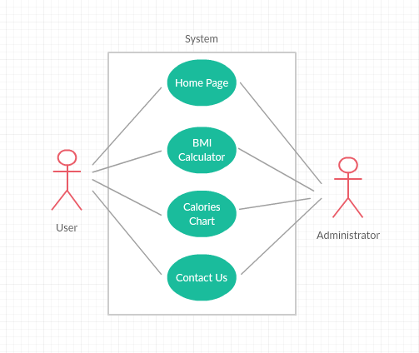

**Documentation Of Use case Diagram:**

1. **User**

User role: User

User functions:

* 1. Calculate bmi b) View calories chart c) Giving Feedback.

# Preview of E-Learning Website

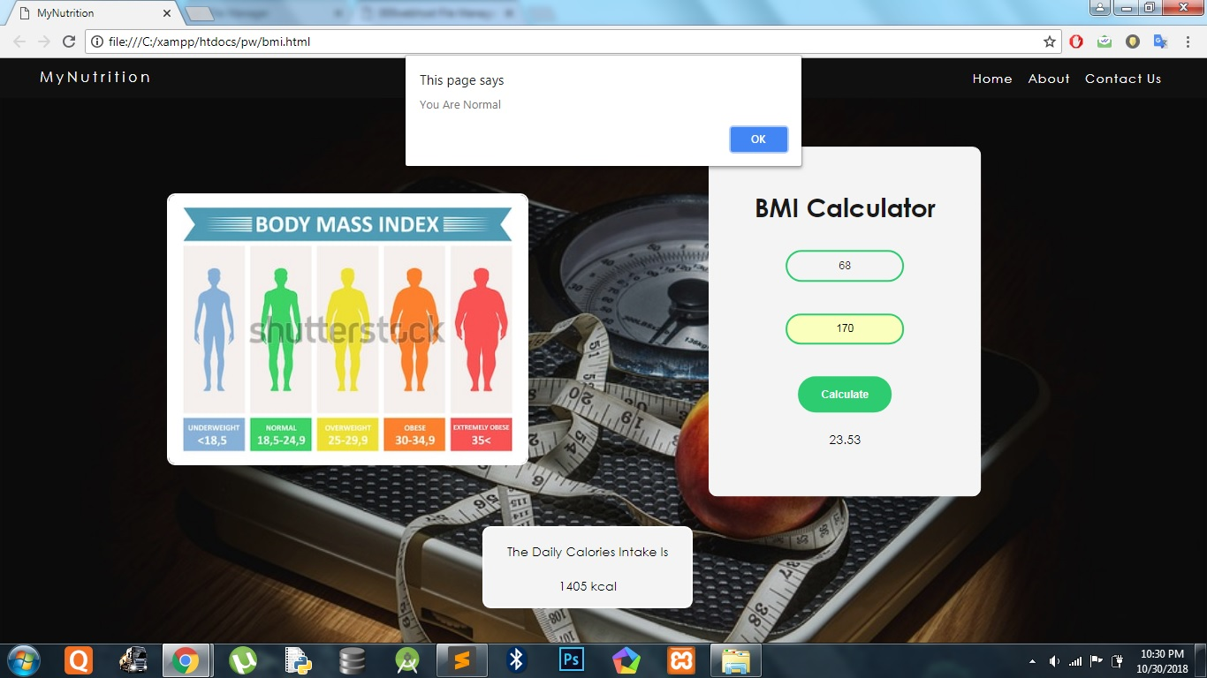

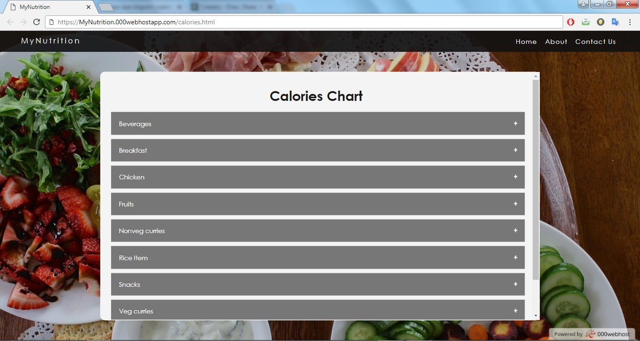

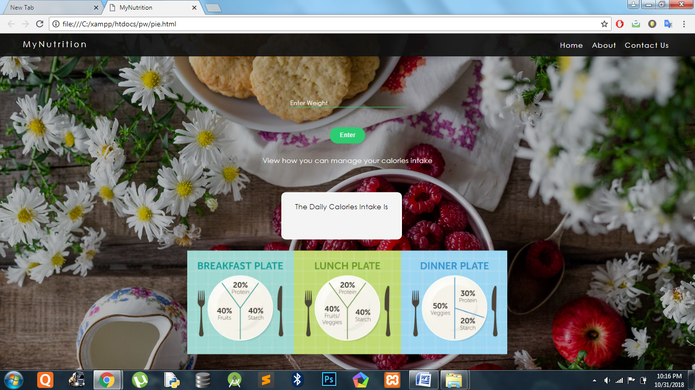



# Technologies used

* 1. **Hardware** Desktop / Laptop PC Web camera

## 3.2 Software

The software we use to build the Augmented Reality modules is Adobe Flash Professional CS6. We use Flash programming as well as Action Script 3.0 to build the Flash screens that display the Augmented Reality models. Besides that we also use a text editor Notepad ++ for the entire web programming, that involves HTML, CSS, PHP, and JavaScript.

Adobe Flash Professional CS6 Notepad ++

Maya (3D Modelling) Sublime Text Editor Photoshop CS6 Dreamweaver CS6

Browsers: Google Chrome, Mozilla Firefox, Internet Explorer, Apple Safari

# Result

We successfully implemented a Fitness Portal which calculates the BMI of the user and suggests necessary Calorie intake per day.

We created a database that stores the user info and allows the user to login to the website and contact the Company owing the website if any complaints or queries.

# Conclusion and Future Work

## Conclusion

We successfully implemented an Fitness Prtal website that allows the users to calculate bmi and view calories chart. The user can view the bmi along with guide to make diet suitable to them.

## Future work

In the near future we plan to expand the number of libraries and topics provided through the website. Apart from that also improve the videos with better animation and textures. We plan on balancing the orientation of the website by providing some key insight features and tools for User to keep track of health progress.

**List of future implementations**: New libraries and topics.es

. Insight tools and features for teachers and educators.

Convert the current design to make it more responsive and device friendly. Include convenient offline and online assistance and resources.

## Refereces

## www.google.com

www.youtube.com