The Bakery Store

# Q.1 Trends!

## Hourly Trends

### Number of Customers visiting every hour of day

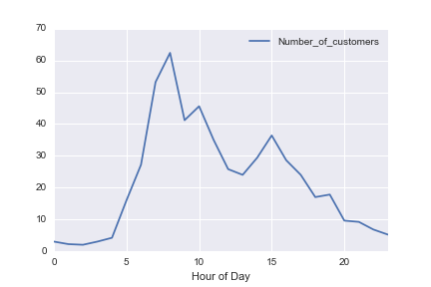

The trend here is very evident. There is negligible rush in the morning until 5AM. The amount of customers visiting peaks between 6-12 hours from starting the shop, that is, approximately 6AM to 12AM. Which means the shop is busiest at the time of breakfast and afternoon snack.

### Average Revenue per customer

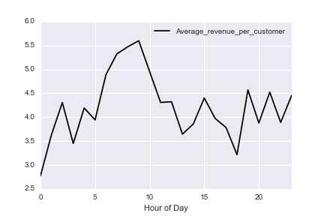

Average revenue is relatively stable, where it peaks at $5.6 around 7-8AM. So, the amount eaten by a person is the highest for the morning breakfast. Otherwise, it is constant at around $3.5-$4.5 per person.

### Total Revenue (Number of customers X Revenue per customer)

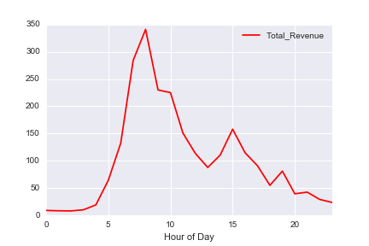

Finally, we have the data of daily average of the revenue on hourly basis. This is the most important aspect of the trend and as expected from the previous two trends, most of the revenue that we are earning is between 6AM and 12AM.

**Highlights of hourly Trends:**

* 1. **56% of the total revenue is generated between 6AM to 12 AM**
  2. **96% of the revenue is generated between 6AM to 5PM**
  3. **First 5 hours constitute to only 5% of the revenue**
  4. **Last 4 hours constitute to only 5% of the revenue**

# Q.2 Maximum Profitable Hour

Answer:

* 8AM-9AM is the hour where average profit over the week is maximum
* Profit of $209 is earned on an average over the week in that time frame

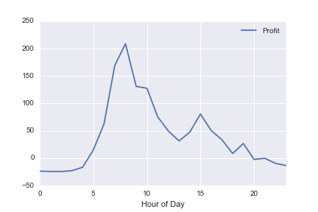

Given plot depicts the trend of profit every hour of the day.

**It is very important to note that the shop is in loss for the first 5 hours and the last 4 hours. (Which can be explained from the sales trends from Q1)**

# Q.3 My plan to run the shop

I would like to start with pointing out a few facts –

1. The shop is in loss from 12:00PM to 5:00AM
2. The shop is in loss from 8:00 PM to 12:00PM
3. No of hours remaining in a day = 24 – 9 = 15 hours

First of all, I will keep the shop closed when it is in loss. At least until I figure out a strategy to make profit out of it. Now, if I decide to share the shop-keeping time between Karl and I, I have 15 hours to cover. I can work for 8 hours a day and let Karl work for 8 hours a day, I have an hour to spare. I can still pay for Karl for 8 hours and send him to promote the pastry shop.

Depending on the response, I can open the shop at 6AM, thereby losing one of the profitable hours. But, I will earn extra time for Karl to promote the shop. 2 hours a day seems to be a reasonable time to start the experiment. Also, I will send Karl for promotion in the hours when the sales are the least. This will be my **short term plan to test how promotion works**.