

Shri Ramdeobaba College of Engineering & Management

**Department of Computer Science and Engineering**

**Hand Writing Board – Online tool used as a means of interactive communication using images.**

***Abstract***

***Process***

# ***Flowchart* *Conclusion***

This is an application which can be used for two way communication. In the world of the pandemic where the face to face meeting and classes are affected this application can be used to communicate in this situation. The application provides a feature where one member has to create a room and other member join the room. Both image and text chat option are available in the application. During the meeting or class members can in real time share the image of the sheet where one is writing or drawing. Also one can take a picture of the sheet and the picture is shared with all member. For the creation of room firebase was used. When we click a photo we need to erase the background, for this we used binarization. Using the binarization technique we eliminated the white background of the picture so that only the written or drawn part is visible. One the image is binarized it is send to the members. Then anyone who wants to append his/her side in the same image can do so which is implemented by image overlay method. Thus the members interaction can be a two way communication

***Aim and Objectives***

Design and implementation of an application that can easily and interactively communicate in real time with anyone who has white paper, black pen, and smartphone.

***Technology & Tools***

 

  

The project is divided into the following major parts –

Step 1 -

Create a room.Other member join the room.After the meeting is started one can chat with other members and also send images in other tab which is visible in the room it self.

Step 2 -

ChatRoom – ImageRoom. In ChatRoom you can chat as usual.In ImageRoom you can send images likes flowgraph..Click the photo and send it.

Step 3 -

Send a binarized image to all users who open same room.Transparentize the white part of binarized image and display camera image under the binarized image.The camera capture is binarized again, and the two binarized images are overlaid.This process can be repeated many times.those images.

Step 4 –

Send images from your camera to users of room.You can now control which images are displayed on your camera or on the other party’s camera.

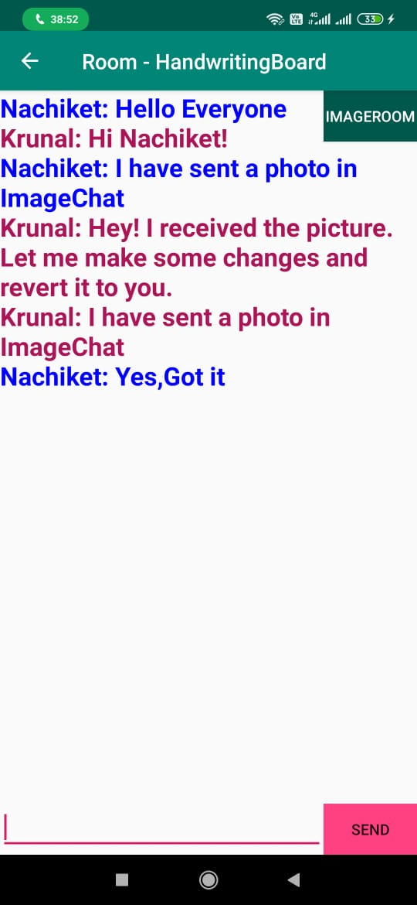 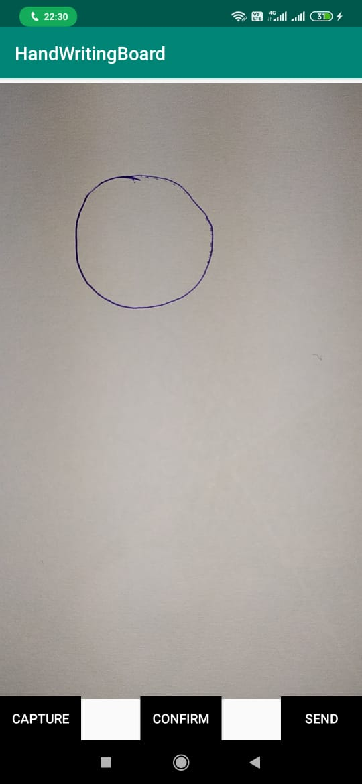

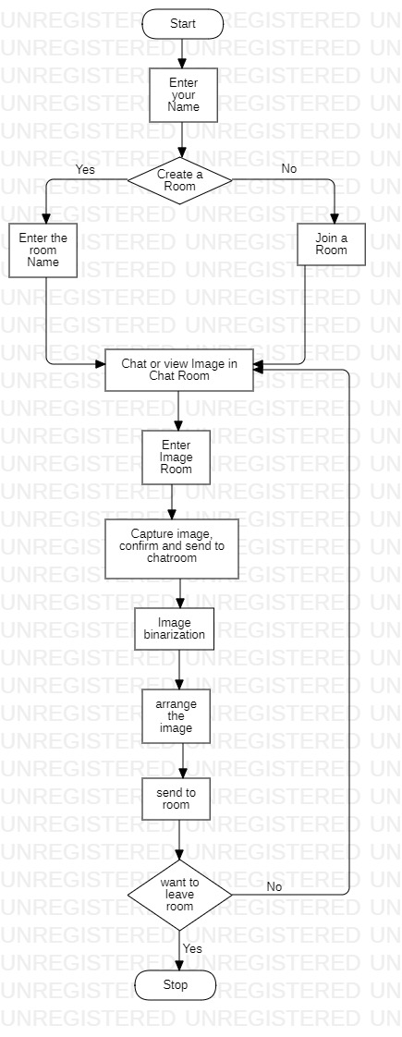

Rather than single direction correspondence like on-request conveyance, this application can without much of a stretch and very much impart progressively with any individual who has white paper, dark pen, and cell phone.

***Acknowledgements***

Dr. M.B. Chandak Prof. V. Bongirwar

Computer Science and Engineering,

Shri Ramdeobaba College of Engineering & Management

# ***Group Members***

# Krunal Pande (42) Kunal Khadkeshwar (43) Nachiket Satpute (46)

# Pranshu Singh (51)

# Yash Gupta (78)

Computer Science and Engineering,

Shri Ramdeobaba College of Engineering & Management

