Contour Neurovascular System Data Request
We are developing a continuous sizing model for Contour and request the minimum non-proprietary information needed to represent device geometry, deployment performance, and clinical size selection.
Please confirm our current understanding
Public Stryker information and clinical literature describe Contour as a circular, dual-layer construct with 72 wires per layer, radiopaque DFT wire technology, and one proximal marker. The current range comprises 5, 7, 9, 11, and 14 mm devices; the 5–9 mm devices use a 0.021 inch microcatheter and the 11–14 mm devices a 0.027 inch microcatheter.
• Please confirm that these specifications remain correct for every current SKU and correct any inaccuracies.
• Please identify differences in wire count, wire diameter, braid pattern, materials, mesh density, or free shape between device sizes.
• Please confirm whether the current 0.021 inch 5-9 mm implants are geometrically and mechanically equivalent to the earlier 0.027 inch versions, and identify relevant design revisions.
• Please confirm that the published sizing ranges are current and provide the applicable IFU or sizing-chart revision.
1 Geometry and deformation
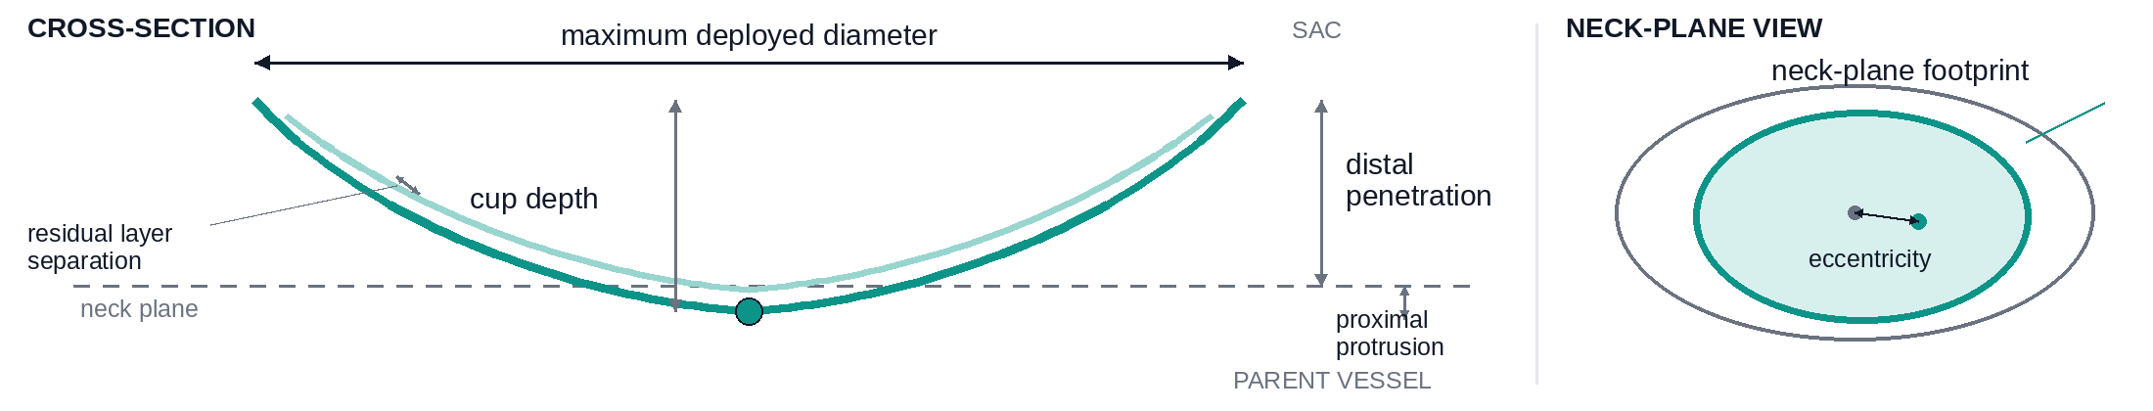
Definitions Maximum deployed diameter is the widest outer span after release; cup depth is the rim-to-deepest-point distance; neck-plane footprint is the outline and area projected over the ostium; distal penetration and proximal protrusion are measured from the neck plane into the sac and parent vessel; eccentricity is the offset between device and neck centers; residual layer separation is the maximum final gap between mesh layers.
• For each SKU, provide the measured free-state outer diameter, cup height or depth, radial profile, marker position, manufacturing tolerances, and measurement conditions.
• Provide a lookup table or validated function for deployment across the recommended range of maximum equatorial width and major and minor neck diameters, using the dimensional definitions shown above.
• Please include sample number and variability. CAD is welcome, but a CSV of radial profiles and deployed measurements would be sufficient.
2 Expected deployment performance
• Report neck area covered, percentage coverage, maximum uncovered peripheral gap, apposition, and protrusion into the parent vessel.
• Provide the expected or acceptable ranges for opening and contact force, migration resistance, and layer separation. If numerical force data cannot be shared, a recommended, acceptable, borderline, or unacceptable classification for each size–anatomy combination would be useful.
• Define the quantitative or visual signs of inadequate opening, instability, undersizing, and excessive oversizing, including the persistent teardrop or double-layer configuration.
3 Clinical sizing and acceptance rules
• Define how maximum equatorial width and neck dimensions should be measured, including imaging modality, projections, irregular or elliptical necks, rounding, and measurement uncertainty.
• Explain which variable takes precedence and the target and maximum acceptable oversizing. Please include boundary examples such as width/neck 5.0/4.5 mm, 7.0/5.5 mm, and 8.0/7.0 mm, where two sizes appear eligible.
• State how aneurysm height, angulation, branches arising from the neck, lobulation, or partial thrombosis modify selection or exclude treatment.
• Provide pre-detachment criteria for adequate coverage, apposition, protrusion, marker position, layer separation, stability, branch patency, and contrast stasis, together with rules for redeploying, upsizing, downsizing, or abandoning Contour.
Preferred delivery format Current IFU and sizing algorithm plus tabular data with units, test conditions, sample number, variability, and tolerances. Normalized or categorical data are acceptable where detailed design data are confidential.

