|  |
| --- |
| **Implementation of a control system over a robotic arm** |

I. Martínez Capella, E. Urendes Jiménez

Degree in Biomedical Engineering, CEU San Pablo, Madrid, Spain, i.martinez66@usp.ceu.es

Summary

The aim of the present project is the improvement of an upper limb orthosis, oriented at the elbow joint, developed during a master’s degree. The orthosis was already able to assist in movements of flexion and extension of the arm. This work has been focused on implementation of the rotation of the forearm.

# Introduction

An orthosis is a medical device used to modify the functional and structural characteristics of the neuromuscular and skeletal system of the patient [ref]. While prothesis replace the affected body part, orthoses are used to correct the deformity or aid in the function of an already existing structure. Orthoses can be classified according to their function in four types: stabilizing (they hold a position and avoid non-desired movements), dynamic (they assist in the movement of a paralyzed limb), corrective (they rectify a skeletal deformity) and protective (they keep the alignment of an injured limb) [1].

The demand for orthoses designed so that they can be used without fatigue in both domestic and clinical settings is rising [2]. Among these, the ones oriented to the upper limb can have a major impact in the improvement of the quality of life [3] and economic capacity of the patients, since the upper limb is fundamental when interacting with the environment and working.

One characteristic of orthoses is that they are made in a personalized way for the user’s particular anatomy and needs. 3D printing technologies have revolutionized the field of orthoses in this aspect, due to the decrease in costs derived from materials. Specially with children, whose size varies continuously as they grow up. The use of 3D printed transitional orthoses represents a great advance [4].

This work is based on a previous orthosis developed in the master’s degree in the CEU San Pablo University (Máster Universitario en Ingeniería Biomédica). The device was 3D printed and was able to assist in the flexion and extension of the arm, movements performed by the biceps braquii and the triceps brachii, respectively. The control was exerted using proportional myoelectric control.

The objective of this project was to modify the orthoses in order to extend the number of movements it can assist with. The movement chosen has been the rotation of the forearm, that is, its supination and pronation. The pronator teres and pronator quadratus are the muscles responsible for the pronation of the forearm by pulling on the radius. Similarly, the supinator and the biceps brachii supinate the forearm [5].

The rest of the paper is structured in the following way: in section 2, the 3D design of the device is explained; section 3 discusses the electric components and the behaviour of the orthosis; section 4 deals with the results obtained; finally, section 5 presents the main conclusions and the future work.

# 3D design

Like the previous version of the orthosis, the new one has been designed with a CAD software (FreeCAD) and printed using a Witbox 3D printer and PLA filaments. In Figure 1 the complete 3D model is shown, whereas Figure 2 shows a detailed view of the new joint mechanism, which consisted of a straight bar with two fittings in the earlier model. The orthosis can be divided in two main parts, A and B, corresponding to the pieces attached to the arm and the forearm, respectively, through the use of velcro straps, that can be adjusted according to the individual needs.

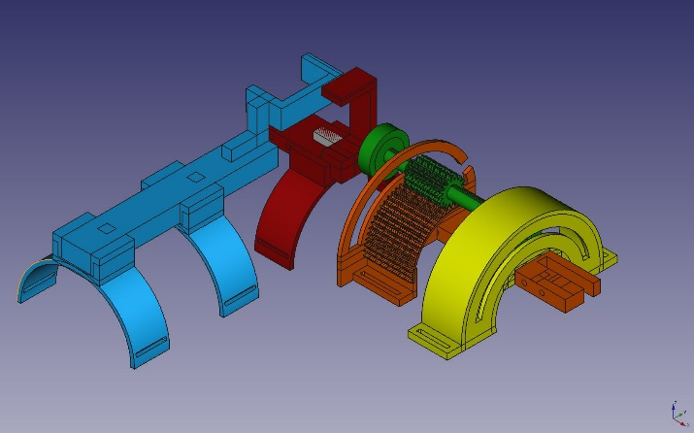

*Figure 1. 3D model of the complete orthosis, divided in the following pieces: A (blue), B.1 (red), B.2 (green), B.3 (orange) and B.4 (yellow).*

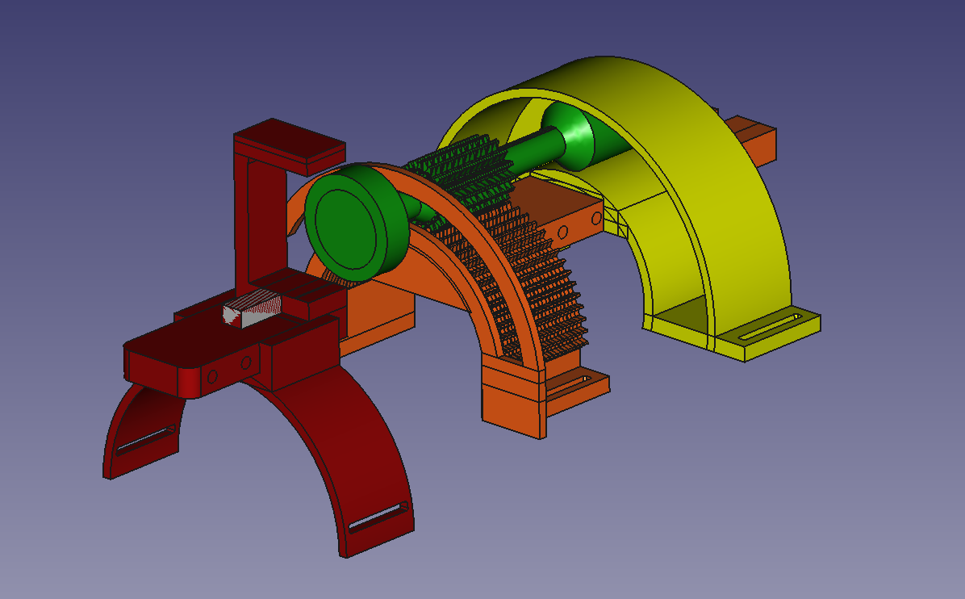

*Figure 2. Detailed view of the pronation/supination mechanism. Pieces: B.1 (red), B.2 (green), B.3 (orange) and B.4 (yellow).*

The first joint mechanism is in charge of the elbow. It performs the movements of flexion and extension of the arm. A servomotor is placed at the end of the arm piece A and its complementary part is attached to the forearm piece B.1. This way, when the signal is received, the servomotor rotates the forearm with respect to the arm. The signal used to control this movement is an EMG signal resulting from the biceps contraction. One contraction flexes the arm and another extends it.

The second joint mechanism has been developed through a process od trial and error and is used to perform the pronation and supination of the forearm. The forearm piece is divided in four different parts:

* B.1: Is the complementary piece of the elbow servomotor and the servomotor of the forearm.
* B.2: Is the complementary piece of the second servomotor and transmits the rotation movement, through a cylindrical gear, to piece B.3.
* B.3: It is attached to the forearm. It has a gear complementary to the one of B.2 and an arch that surrounds it to keep the gears from distancing.
* B.4: It is coupled to the forearm and to B.3. It consists of an arch that holds B.2 aligned with B.3 as the rotation takes place. A screw also keeps the end of B.2 against B.4 through an arched opening in the latter.

The rotation of the forearm is controlled by an EMG signal coming from the contraction of the forearm muscles as the hand is closed. Similarly to the first joint mechanism, one contraction rotates the arm in one way and a second one reverts the movement. When a signal is received, the servomotor rotates its external cylinder. The movement is transmitted to the complementary part, which is attached to B.2. As B.2 starts to rotate, the movement is transmitted through the gear interaction to B.3. B.4 also rotates since it is attached to B.3. Finally, the rotation movement is transmitted to the forearm by B.3 and B.4. The arches of B.3 and B.4 hold the mechanism in place, avoiding B.2 and the B.3 from distancing due to the curvature of the forearm. The arches also limit the possible angle of rotation.

The last piece of the orthosis is a surface where the electronics are attached, also by using velcro straps. The piece is coupled to A.

# Electronic components

The orthosis movements are controlled using EMG signals coming from the contraction of the forearm muscles and the biceps. Three main electronic components take part in this action, a diagram of which can be seen in Figure 3.

The first one is a pair of EMG amplifiers. They pick up the EMG signal using surface electrodes (two per muscle group and one for reference). The signal enters the circuit through an audio jack and is sent to an instrumentation amplifier. The signal is filtered and amplified with a gain G expressed in (1), where RG is the gain resistor.

$G=\frac{5*{10}^{4}}{R_{G}}+1$ (1)

The next one is an Arduino Micro microcontroller. It is responsible for receiving the amplified EMG signals and, if they surpass a certain threshold, activating the servomotors to perform the movement.

The last component is a pair of servomotors which carry out the motion of the arm.

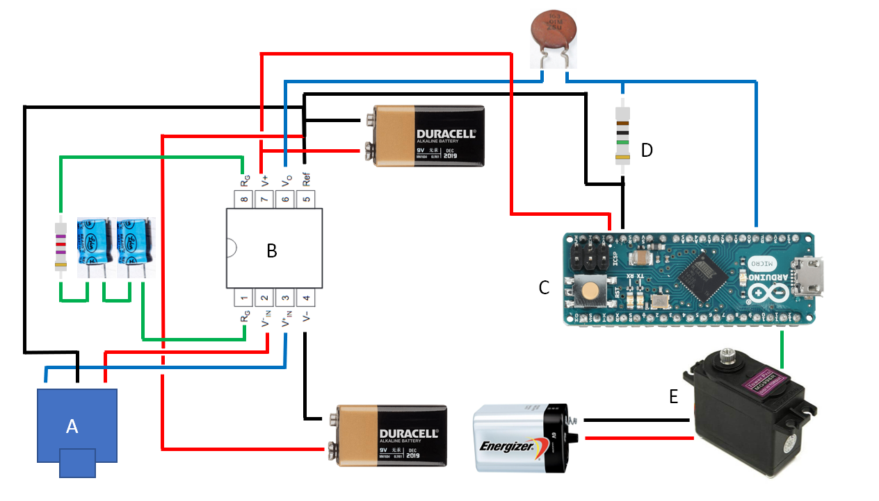

*Figure 3. Diagram of the orthosis electronic components. Composed of: A-EMG jack, B-instrumentation amplifier INA128P, C-Arduino Micro, D-gain resistor RG, E-servomotor. Note that, for clarity purposes, only one EMG amplifier circuit and one servomotor have been represented.*

The forearm muscles and the biceps are functionally related, so the contraction of one also activates the other. This could cause a problem, making both servomotors work simultaneously when only one was targeted. In order to avoid this, different values of RG have been chosen for each EMG amplifier, so that the two thresholds to surpass are clearly separated. To check that the system works correctly, ten contractions habe been recorded for each muscle group, five measuring the signal when the contraction is intended and five, when the contraction is a result of the other muscle group activation. The top five values have been selected for each measurement, resulting in the top twenty-five values which represent the maximum contraction values for voluntary and involuntary contraction. The mean of these twenty-five values has been obtained and compared. The results can be seen in Table 1.

|  |  |
| --- | --- |
| Signal | Top 25 values mean |
| Voluntary forearm | 180.6 |
| Involuntary forearm | 63.28 |
| Voluntary biceps | 386.16 |
| Involuntary biceps | 265 |

*Table 1. Results from the comparison of the top mean signals obtained when a voluntary and involuntary contraction of each muscle group is recorded.*

We can see that there is a noticeable difference between the values of an active and a passive contraction of each muscle group. Since the forearm contraction is exerted by pressing the hand, the use of a force sensitive resistor located in the palm was considered. However, after seeing that the EMG signal would suffice, this possibility was dismissed.

The flexion/extension of the arm and the pronation/supination of the forearm are performed completely once a valid signal is read. That is, the orthosis will conduct a complete movement from the starting to the end position with the need of only one contraction and will hold the final position. One contraction will result in one motion and another, in its opposed one. This is done in order to avoid having to maintain the muscle contracted throughout all the movement, allowing the patient to relax and not to fatigue when the orthosis is flexed.

# Results

El documento debe tener como máximo **4 páginas de longitud\***

# Conclusions

The objective of the project has been fulfilled. The previous orthosis model has been improved by the addition of a completely new joint mechanism that allows for the pronation and supination of the forearm. The new mechanism is controlled using EMG signals and it has been tested that it can be used simultaneously with the other joint mechanism, without both signals interfering with each other.

As future work, more improvements in the orthosis can be made. The fittings of piece A can be made adjustable, so they can be placed at different positions of the piece, allowing for more comfort for the patient. It may also be interesting to replace the servomotors by conventional motors, since servomotors have a limited angle of rotation (up to 180º) and the forearm rotation could benefit of some more. Finally, more joint mechanism can be added to extend the functionality of the orthosis.

The 3D model, Arduino code, electronic diagrams and the rest of the materials are all available for anyone to access in a GitHub repository [6].

Acknowledgements

Finally, we would like to thank the Escuela Politécnica Superior for the materials and 3D printers used in the creation of this device. We also want to express our gratitude to Raúl Blanco González for his help throughout the process.

References

1. Tipos de órtesis, Órtesis (n.d.), Wikipedia. https://es.wikipedia.org/wiki/%C3%93rtesis#Tipos_de_ortesis (Accessed: January 2019).
2. Stewart, A. M., Pretty, C. G., Adams, M., and Chen, X. (2017). Review of upper limb hybrid exoskeletons. *IFAC-PapersOnLine 5*0, 15169–15178. doi: 10.1016/j.ifacol.2017.08.2266
3. Frisoli, A., Solazzi, M., Loconsole, C., and Barsotti, M. (2016). New generation emerging technologies for neurorehabilitation and motor assistance. Acta Myol. 35, 141–144.
4. Zuniga, J. M., Dimitrios, K., Peck, J. L., Srivastava, R., Pierce, J. E., Dudley, D. R., Salazar, D. A., Young, K. J., … Knarr, B. A. (2018). Coactivation index of children with congenital upper limb reduction deficiencies before and after using a wrist-driven 3D printed partial hand prosthesis. *Journal of neuroengineering and rehabilitation*, *15*(1), 48. doi:10.1186/s12984-018-0392-9
5. Pronation/Supination by Tim Taylor, Innerbody webpage. https://www.innerbody.com/image/musc03.html (Accessed: January 2019).
6. Ignacio Martínez Capella, 3D printed elbow and forearm orthosis, (2019), GitHub repository, https://github.com/nachomcapella/3D-printed-elbow-and-forearm-orthosis.git