**[Denny_247](https://codefights.com/profile/Denny_247)** posted a shortest solution challenge

5

Andy got some tasks from his teacher, one of them is Andy must convert all of the decimal to binary. Andy is too lazy to do them so he asks for your help to make a program that can solve his task. Test case 1: In : 1 Out : 1 Test case 2: In: 2 Out: 10 Test case 3: In: 3 Out:11

[Show Less](javascript:void(0);)

**Input 1 (decimal)** → integer :

Range : 1<=decimal<=10^9

**Output** → string :

output the binary of the decimal

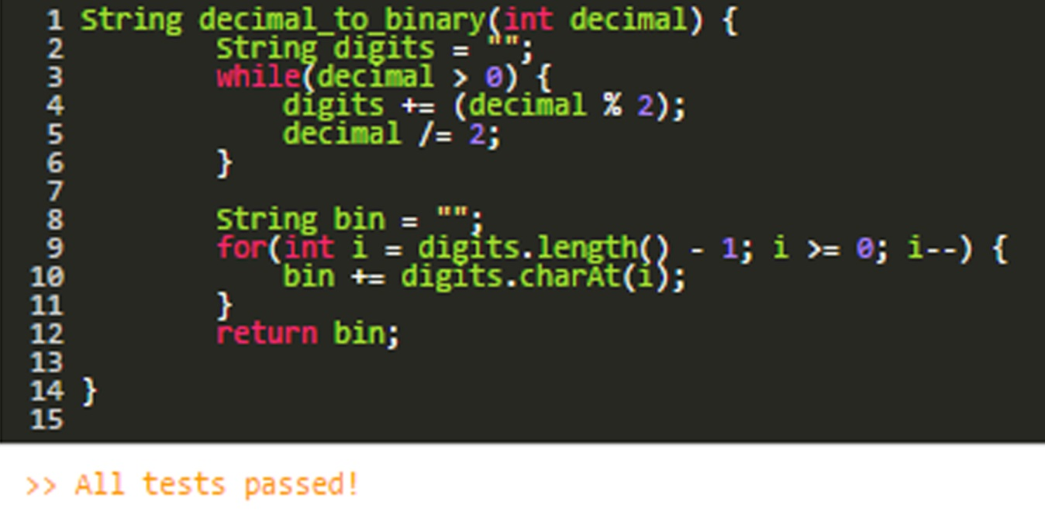

--EN C++ ACEPTADO—

std::string decimal_to_binary(int decimal) {

std::string digits = "";

while(decimal > 0){

digits.insert(digits.begin(), (decimal % 2) + '0');

decimal /= 2;

}

return digits;

}