You are given a string s containing uppercase Latin letters ['A'-'Z']. Each letter can divide a plane into region(s). For example, letter 'A' divides a plane into 2regions, when 'L' divide into just one.

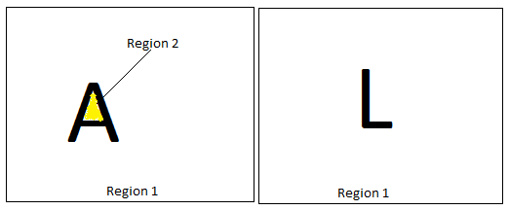

You need to count the number of regions each letter in the given string divides the plane into, and return their sum.

**Example**  
For s=CODEFIGHTS the output should be 12.  
'O' and 'D' divide the plane into 2regions, other letters (CEFIGHTS) divide the plane into one region each, so the total number of regions is 2 + 2 + 1 * 8 = 12.

* **[input] string s**
  + 1 ≤ |s| ≤ 1000
* **[output] integer**

<https://codefights.com/challenge/3gaozHYGXooA7XonH>

#include <iostream>

#include <stdio.h>

int regionCount(std::string s) {

int sum = 0;

for(int i =0; i < s.length(); i++) {

if(s[i] == 'A') {

sum+=2;

}else if(s[i] == 'B'){

sum +=3;

}else if(s[i] == 'C'){

sum+=1;

}else if(s[i] == 'D') {

sum+=2;

}else if(s[i] == 'E') {

sum+=1;

}else if(s[i] == 'F'){

sum+=1;

}else if(s[i] == 'G'){

sum+=1;

}else if(s[i] == 'H'){

sum+=1;

}else if(s[i] == 'I'){

sum+=1;

}else if(s[i] == 'J') {

sum+=1;

}else if(s[i] == 'K'){

sum+=1;

}else if(s[i] == 'L'){

sum+=1;

}else if(s[i] == 'M'){

sum+=1;

}else if(s[i] == 'N'){

sum+=1;

}else if(s[i] == 'O'){

sum+=2;

}else if(s[i] == 'P'){

sum+=2;

}else if(s[i] == 'Q'){

sum+=2;

}else if(s[i] == 'R'){

sum+=2;

}else if(s[i] == 'S'){

sum+=1;

}else if(s[i] == 'T'){

sum+=1;

}else if(s[i] == 'U'){

sum+=1;

}else if(s[i] == 'V'){

sum+=1;

}else if(s[i] == 'W'){

sum+=1;

}else if(s[i] == 'X'){

sum+=1;

}else if(s[i] == 'Y'){

sum+=1;

}else if(s[i] == 'Z'){

sum+=1;

}

}

return sum;

}

int main(){

return 0;

}