You guys should probably know the simple y = sin(x)equation.

Given a range of x [start, end], your mission is to calculate the total signed area of the region in the xy-plane that is bounded by the sin(x) plot, the x-axis and the vertical lines x = start and x = end. The area above the x-asix should be **added** to the result, and the area below it should be **subtracted**.

**Example**

* For start = 0 and end = 10, the output should be  
  sinArea(start, end) = 1.83907.

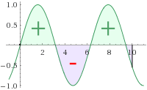

* For start = 4 and end = 6, the output should be  
  sinArea(start, end) = -1.61381.

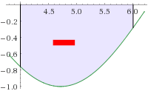

**Input/Output**

* **[time limit] 3000ms (cs)**
* **[input] integer start**

*Constraints:*  
-3·106 < start < 3·106

* **[input] integer end**

*Constraints:*  
-3·106 < start ≤ end < 3·106

* **[output] float**

The signed area.

Your answer will be considered correct if its absolute error doesn't exceed 10-5.

<https://codefights.com/challenge/L7EqDZzBuE5twLtAD>

using System;

using System.Collections.Generic;

using System.Linq;

using System.Text;

namespace ConsoleApplication1

{

class Program

{

static double sinArea(int start, int end)

{

return -Math.Cos(end) - (-Math.Cos(start));

}

static void Main(string[] args)

{

Console.WriteLine(sinArea(0, 10));

Console.ReadLine();

}

}

}