As children, we all have tried to solve this hardcore puzzle in which one has to calculate the number of squares in a strange figure, haven't we? Well, now we are the CodeFighters, so this puzzle goes to the whole new level!

Your task is to implement an algorithm that finds the number of squares in a large n × n square grid.

**Example**

For n = 3, the output should be  
squaresInGrid(n) = 14.

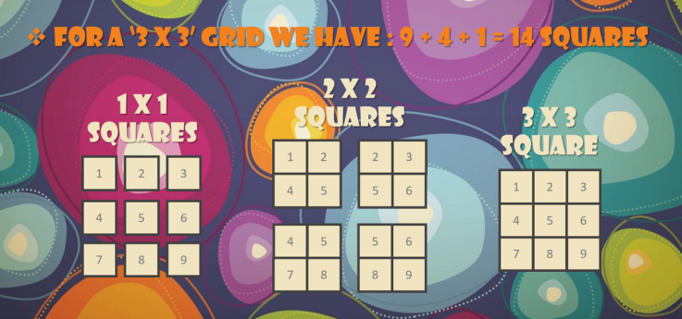

**Input/Output**

* **[time limit] 3000ms (cs)**
* **[input] integer n**

The size of the grid.

*Constraints:*  
0 ≤ n ≤ 500.

* **[output] integer**

The number of squares in the grid.

<https://codefights.com/challenge/j7PAwfkajJu2A5ybP/main>

<https://www.quora.com/How-do-you-calculate-the-number-of-squares-in-an-n-x-n-square-grid>

https://qph.ec.quoracdn.net/main-qimg-58223d18ec7217eebf922e1294253961?convert_to_webp=true

static int squaresInGrid(int n)

{

return (n * (n + 1) * (2 * n + 1)) / 6;

}