Given a square matrix of integers, your task is to determine whether or not it's symmetric along its main diagonal.

Example

* For n = 3 and
* inputMatrix = [[0,1,2],
* [1,5,3],
* [2,3,4]]

the output should be symmetricalMatrix(n, inputMatrix) = true.

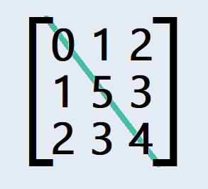

This matrix is symmetric along the main diagonal!

* For n = 3 and
* inputMatrix = [[0,0,0],
* [0,0,0],
* [1,0,0]]

the output should be symmetricalMatrix(n, inputMatrix) = false.

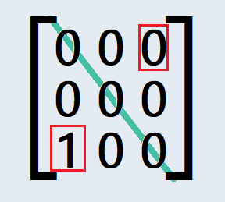

This matrix is not symmetric (the 0and 1 don't match up).

Input / Output

* **[execution time limit] 3 seconds (cs)**
* **[input] integer n**

An integer representing the number of rows and columns in the matrix.

*Guaranteed constraints:*  
1 ≤ n ≤ 100

* **[input] array.array.integer inputMatrix**

A square matrix of integers.

*Guaranteed constraints:*  
inputMatrix.length = n  
inputMatrix[i].length = n  
0 ≤ inputMatrix[i][j] ≤ 104

* **[output] boolean**
  + Return true if inputMatrix is symmetric along the main diagonal, and false otherwise.

**[C#] Syntax Tips**

// Prints help message to the console

// Returns a string

**string** **helloWorld**(**string** name) {

Console.Write("This prints to the console when you Run Tests");

**return** "Hello, " + name;

}

<https://app.codesignal.com/challenge/q5WHJQTyiL4XERsBL>

using System;

using System.Collections.Generic;

using System.Linq;

using System.Text;

using System.Threading.Tasks;

namespace ConsoleApp1

{

class Program

{

static bool symmetricalMatrix(int n, int[][] inputMatrix)

{

for (int i = 0; i < n; i++)

{

for (int j = i + 1; j < n; j++)

{

//Console.WriteLine(i + " " + j);

if(inputMatrix[i][j] != inputMatrix[j][i])

{

return false;

}

}

}

return true;

}

static void Main(string[] args)

{

int[][] inputMatrix = {

new int[] {0, 1, 2 },

new int[] { 1,5,3},

new int [] {2,3,4}

};

Console.WriteLine( symmetricalMatrix( 3, inputMatrix));

Console.ReadLine();

}

}

}