Diseño Batalla Naval

Diagrama de clases
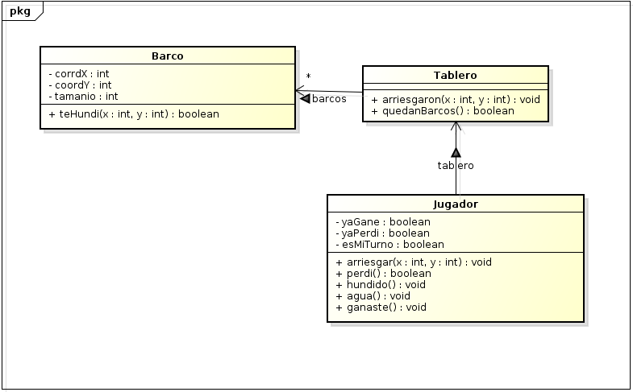

Diagrama de secuencia

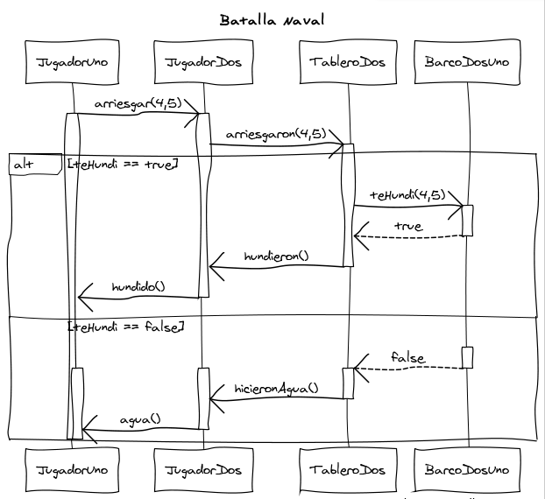

Scenarios Cucumber

Feature: Batalla naval

Scenario: Win
Given jugador2 has one boat left
When I sink his boat
Then I win

Scenario: Sink
Given It is my turn
When I sink his boat
Then It is my turn

Scenario: Miss
Given It is my turn
When I miss
Then It is his turn

Step Definitions

Given /jugador2 has one boat left/ do
jugador1 = Jugador.new([Bote.new(5,5)])
jugador2 = Jugador.new([Bote.new(4,6)])
end

When /I sink his boat/ do
jugador2.arriesgar(4,6)
end

Then /I win/ do
assert_true self.yaGane
end

Given /It is my turn/ do
jugador1 = Jugador.new([Bote.new(4,2), Bote.new(5,5)])
jugador2 = Jugador.new([Bote.new(4,6), Bote.new(2,1)])
jugador1.esMiTurno = true
jugador2.esMiTurno = false
end

When /I sink his boat/ do
jugador2.arriesgar(4,6)
end

Then /It is my turn/ do
assert_true jugador1.esMiTurno
end

When /I miss/ do
jugador2.arriesgar(10,10)
end

Then /It is his turn/ do
assert_false jugador1.esMiTurno
end

