**The Effects of Compact Development on Travel Behavior, Energy Consumption and GHG Emissions: Lessons from Neighborhoods in Phoenix Metropolitan Area**

Wenwen Zhang1, Subhrajit Guhathakurta 2

1Graduate student (Georgia Institute of Technology), wzhang300@gatech.edu

2Professor (Georgia Institute of Technology), subhro.guha@coa.gatech.edu

Keywords: compact development, travel behavior, energy consumption, GHG

**ABSTRACT**

Suburban growth in the U.S. urban regions has been defined by large subdivisions of single-family detached units. This growth is made possible by the mobility supported by automobiles and an extensive highway network. These dispersed, highly automobile-dependent developments have generated a large body of work examining the socioeconomic and environmental impacts of suburban growth on cities. The particular debate that this study addresses is whether suburban residents are more energy intensive in their travel behavior than central city residents. If indeed suburban residents have needs that are not satisfied by the amenities around them, they may be traveling farther to access such services. However, if suburbs are becoming like cities with a wide range of services and amenities, travel might be contained and no different from the travel behavior of residents in central areas. This paper will compare the effects of long term suburban growth on travel behavior, energy consumption, and GHG emissions through a case study of neighborhoods in central Phoenix and the city of Gilbert, both in the Phoenix metropolitan region. Motorized travel patterns in these study areas will be generated using 2001 and 2009 National Household Travel Survey (NHTS) data to calibrate and run a four-step transportation demand model. Energy consumption and GHG emissions, including both Carbon Dioxide (CO2) and Nitrous Oxide (N2O) for each study area will be estimated based on the corresponding trip distribution results. The final normalized outcomes will not only be compared spatially between Phoenix and Gilbert within the same year, but also temporally between year 2001 and 2009 to determine how the differential land use changes in those places influenced travel.

**1 INTRODUCTION**

In early 1990s, the upsurge of new urbanism movement triggered the debate regarding the relationship between urban forms and travel behavior. Some early 1990s studies posited the positive relationship between new urbanism and the reduction of Vehicle Miles Traveled (VMT). Peter Calthrope (1993) noted that VMT can be expected to be reduced by 57%, if the grid network could be implemented. McNally and Ryan (1993) also proposed a similar report regarding how driving behavior could be discouraged in a grid road network system. Randall Crane (1996) argued that although the travel distance could be reduced after the implementation of the neotraditional design methods, there was a possibility that the effect of travel length reduction would be offset by a higher motor trip generation frequency. Hence the successive empirical studies focused on exploring the relationship between built environment characteristics and actual individual VMT reductions.

Several different study approaches have been developed to establish the quantitative relationship between urban form and travel behavior since mid-1990s. Ordinary Least Square (OLS) multiple regression model was a widely employed approach to determine the elasticities between travel behavior and explanatory variables. The explanatory variables were later summarized by Cervero and Kockelman (1997) as the “D” variables: Density, Design and Diversity. Some structural models based on micro-economic theories were developed to connect built environment and travel behavior with intermediate variables. Boarnet and Crane (2001) attempted to connect land use and travel behavior using travel cost variables. The most recent approach proposed by Crane (2011) were models based on the demand of travelers, which was controlled by three factors: tastes, resources and prices. The results from this type of structural model studies indicated that the compact development could indeed reduce travel speed or travel distance, which would possibly lead to reduced individual VMT. Another type of structural model was introduced to connect land use type and travel behavior through household vehicle ownership variables. This kind of model was expected to control the “self-selection” effect, which was concerned in many early studies (Bhat and Guo, 2007; Brownstone and Golob 2009). The results from these studies revealed that by controlling the self-selection effect, higher residential density could still reduce household VMT generation. However, the above mentioned models were not able to reveal the intertwined relationship among different land use variables and travel variables. Hence, the Structural Equation Models were introduced to explore such complicated relationships. The study results from this type of research indicated a negative relationship between development density and VMT (Veronique & Frank, 2009). The national level study from Ewing’s team also suggested that the density could have a positive effect on VMT reduction in urbanized areas (Ewing et al., 2013).

Although quite a few study approaches have been developed in the past two decades, little light has been shine on how travel pattern is likely to evolve together with land use pattern variations. Some studies involved quasi-longitudinal study to explore the casual relationship between land use patterns and travel behavior. Instead of using longitudinal panel data, Cao’s group collected data at one time point, with variables regarding the changes in travel behavior overtime. Their study was established on community level. However, it is also extremely important to monitor the evolution trajectory of travel behavior and built environment at a regional scale over time. Therefore, in this paper we will use 2001 and 2009 NHTS for Phoenix Metropolitan area to compare the changes over the study period. Although the NHTS is not a longitudinal survey, the result from this study can still provide intuitive information in the aspect of temporal change of relationship between built environment and travel behavior.

**2 STUDY AREAS AND DATA SOURCE**

**2.1 Study Areas**

Our study was based on the change in motorized travel behavior in Phoenix Metropolitan area over the study period 2001-2009. The Metropolitan region was selected as the macro-area to analyze the regional travel pattern, as it would be unfeasible to estimate inter and intra zonal travel behavior without larger study context. The Phoenix Metro is located in the State of Arizona in the southwest of the United States, with an area of 11193.7 square miles. The total population within the region increased rapidly by 896901 from 2001 to 2009. The motorized travel behavior was analyzed at the TAZ (Transportation Analysis Zone) level. We further identified two study areas in this region that are located within the Phoenix urban core and the suburban city of Gilbert to determine the impact of compact development on motorized travel behavior in urban and suburban areas, respectively. The selection process was based on the development patterns and the size of the areas. The Phoenix Metropolitan area and the study areas are illustrated in Figure 1. Despite the fact that the two study areas represent only a portion of the cities, they were named as “*Phoenix*” and “*Gilbert*” separately in this study.

Figure 1: Phoenix and Gilbert Study Areas

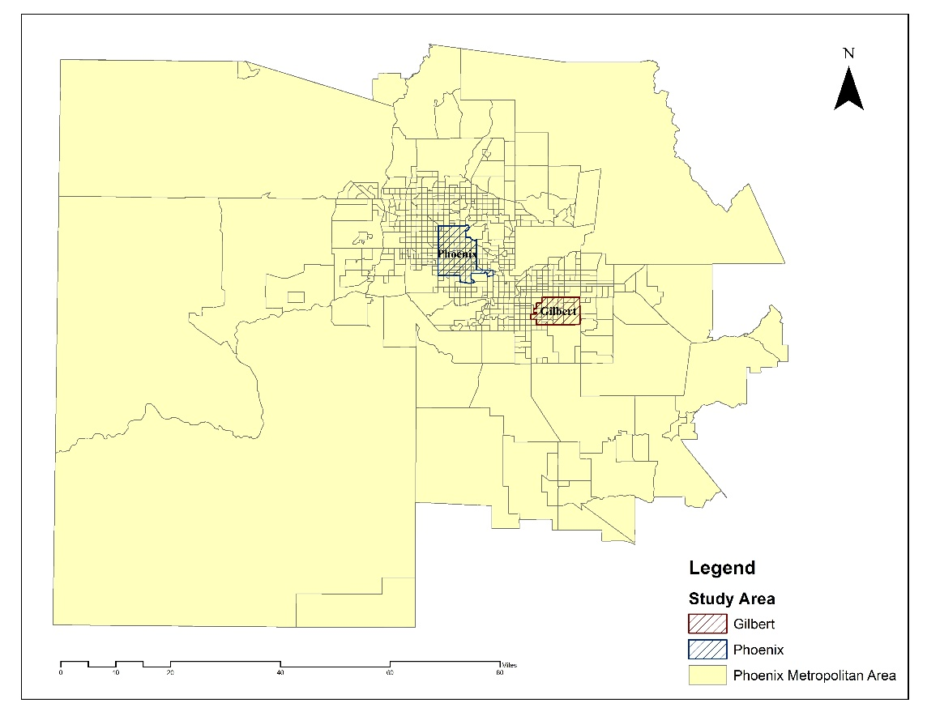

Source: Adapted by Author

The two specific study areas, *Phoenix* and *Gilbert*, are comparable in size but have different land use patterns and growth trajectories, as tabulated in Table 1. *Gilbert* experienced substantially more intensive development during the study period. However, by the end of 2009, the population and employment densities in *Phoenix* were still significantly higher. In 2009, the employment density in *Phoenix* was more than six times higher than thatin *Gilbert*.

Table 1: Average density information for Phoenix and Gilbert in 2001 and 2009



**2.2 Data Source**

We used National Household Travel Survey (NHTS) data to estimate trip generation rates by household categories for Home-based Work (HBW) and Home-based Shopping (HBSH) trips. NHTS is a periodic national household level travel survey aiming at facilitating transportation planners and policy makers. For 2001, we used the 2001 NHTS transferability National files to generate trip production for the entire study region. This dataset was adapted by Federal Highway Association (FHWA) using 2001 NHTS, City Transportation Planning Package data (CTPP) and American Community Survey (ACS) data. One of the major reasons for using this dataset was that the published 2001 NHTS data doesn’t include household location information, rendering it unfeasible to estimate trip production rates for our metropolitan region. Additionally, the 2001 survey with only 498 households statewide is not sufficient to prepare the cross classification tables. In 2002, Maricopa Association of Governments (MAG) also conducted a travel survey. We didn’t’ apply this survey in trip production process, as the data collection and process procedures are different from NHTS. But the MAG survey result was used to estimate vehicle compositions for our study areas. We used the 2009 NHTS provided by Maricopa Association of Governments (MAG) for Phoenix Metropolitan area to estimate trip production rates for each type of households. This survey with 4707 sampled households is quite sufficient to establish the cross classification tables. We established the census tract level households distribution table based on 2009 ACS data (5-year estimates) and 2008 CTPP data, so that the result will be more comparable to the 2001 transferability NHTS data.

The trip attraction process mainly relied on the 2000 and 2010 Phoenix Metropolitan area disaggregated employment data from MAG. The employment from 2000 was classified with 2-digit Standard Industrial Classification (SIC) code, while the 2009 data was marked with 6-digit North American Industry Classification System (NAICS) code. To perform trip distribution process, we used and 2010 Phoenix Metropolitan area road network data from MAG.

**3 STUDY APPROACHES**

**3.1 Motorized Travel Behavior Estimation Model**

### *3.1.1 Trip production*

We used cross classification method to estimate trip productions in this study. Due to data quality limitations, slightly different procedures were applied in 2001 and 2009 trip production processes. For 2001, we employed the NHTS transferability table to estimate HBW and HBSH productions with the following formula:

Where,

*i*, is the index for trip purposes, such as HBW, HBSH, HBSO, HBO and NHB;

*x*, is the index for household size;

*y*, is the index for vehicle ownership;

*k*, is the index for census tract;

*Vehicle trip generation rate* is the generation rate for all trip purpose;

*Trip adjustment index* is the estimated proportion of certain trip purpose.

We prepared the 2009 HBW and HBSH trip generation rates table using NHTS data. The sampled households were separated into groups by household size, vehicle ownership, and number of workers. The vehicle trip generation rates for each homogenous household group were then calculated by trip purpose using the following formula.

Where,

*i,* is the index for trip purposes, such as HBW, HBSH, HBSO, HBO and NHB;

*x*, is the index for household size;

*y*, is the index for household vehicle ownership;

*z*, is the index for household number of workers.

We also estimated the number of household within each homogenous household group for the entire study region with 2009 ACS, 2008 CTPP. We then assessed the 2009 trip production using the following formula:

Where,

*i*, is the index for trip purposes, such as HBW, HBSH, HBSO, HBO and NHB;

*x*, is the index for household size;

*y*, is the index for vehicle ownership;

*z*, is the index for household number of workers;

*k*, is the index for census tract;

*Vehicle trip generation rate* is the generation rate for certain trip purpose;

To validate the trip production process, we compared output trip purpose distributions against the original NHTS data, as illustrated in Figure 2. The results suggest that there are more discrepancies between 2001 production results and NHTS data, especially for HBSH and HBO trips. Three possible reasons may attribute to such differences: 1) The 2001 NHTS data is un-weighted; 2) 2001 sample size is limited; 3) The trip generation rate was not directly generated from NHTS, but provided by transferability table. The 2009 production results are more comparable to the weighted NHTS results, as the differences are controlled within 5%.

Figure 2: Comparison between trip production result and NHTS data

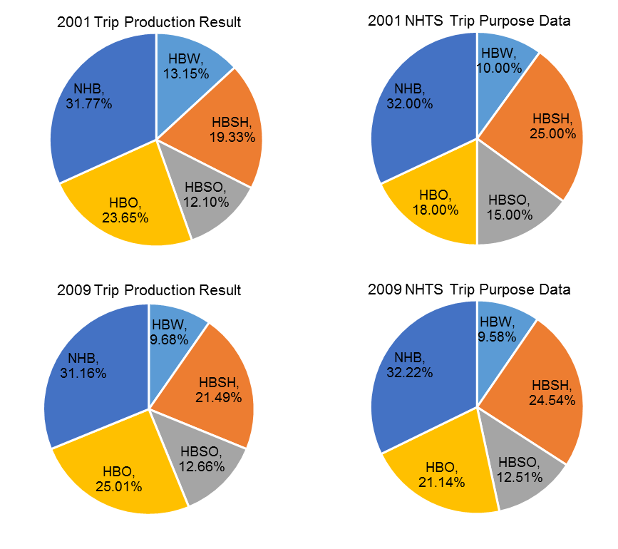

Source: Adapted by Author based on 2001 and 2009 NHTS data

### *3.1.2 Trip Attraction*

In this study, we estimated the HBW and HBSH trip attractions by reallocating the total of production results to each TAZ using disaggregated employment data from MAG. We estimated HBW and HBSH trip attractions based on total employment and retail employment number separately. The commonly employed regression method is not feasible in this research, as the trip destination locations are not available. However, the conventional linear regression method does indicate a linear relationship between disaggregated employment and the number of trip attractions, which validate our approach. We further used coefficients from NCHRP 716 report and several other MPOs to validate our attraction results. The coefficients were calculated and tabulated in Table 2 and 3.

Table 2: HBW Trip Attraction per Total Employment for 2001 and 2009

|  |  |  |  |  |  |
| --- | --- | --- | --- | --- | --- |
| Year | HBW Attractions | Trip Attraction /Employment | Results from other sources | | |
| NCHRP 716 | SCAG1 | MIC2 |
| 2001 | 931269 | 1.0792 | 1.200 | 1.075 | 1.18 |
| 2009 | 1035907 | 0.759 |

Table 3: HBSH Trip Attraction per Retail Employment for 2001 and 2009

|  |  |  |  |  |
| --- | --- | --- | --- | --- |
| Year | HBSH Attractions | Trip Attraction /Retail Employment | Results from other sources | |
| SCAG1 | MIC2 |
| 2001 | 1368502 | 10.901 | 9.260 | 8.420 |
| 2009 | 2548982 | 9.740 |

1. Data Source: Southern California Association Government (SCAG).
2. Data Source: Duluth-Superior Metropolitan Institute of Council (MIC).

### *3.1.3 Trip Distribution*

We identified road hierarchy and Free Flow Speed (FFS) for each road segment based on standards from *National* Cooperative Highway Research Program (NCHRP) 365 Report. The road network hierarchy classification was based on the road types and road length, as tabulated in Table 4. The identification of FFS relied heavily on the location of segments, as shown in Table 5. Hence, we separated the location of road segments into four location categories: rural, suburban, urban and Central Business District (CBD). The classification of locations was based on the population and employment densities (Plessis, 2001; Albrecht, 2006). The standarads are listed in Table 6.

Table 4: Road Hierarch Identification Standards



Table 5: Free Flow Speed (FFS) Assignment Standard



Table 6: TAZ location Identification Method





We generated the travel time costs between each pair of Origin and Destination TAZs by aggregating travelling time and terminal time at both ends of the trips together. The shortest travel time between different TAZ centroids was selected as the inter-zonal travel time. The intra-zonal travel time was calculated using the formula listed below. The estimation of terminal times was made based on the location of origins and destinations, as displayed in Table 7. All the time costs were expressed in the unit of minutes. We prepared different travel time cost matrices for study years 2001 and 2009.

Where:

*Zonal Area,* is the TAZ area expressed in square miles;

*Intrazonal Speed,* can be achieved in the Table 7.

*Terminal Time,* can be achieved from Table 7, based on the location of TAZs.

Table 7: Intra-zonal Free Flow Speed and Terminal Time Look up Table



We applied gravity model with localized Gamma function to generate the trip distribution results. To validate the distribution process, the model output travel time distributions were compared with the original NHTS data, as illustrated in Figure 3. We also conducted Chi-square goodness of fit tests to determine whether the differences were statistically significant. The test results were all above 0.99, indicating that the null hypothesis (the distributions of *TransCAD* output and NHTS data are the same) cannot be rejected.

Figure 3: HBW and HBSH Travel Time Comparison

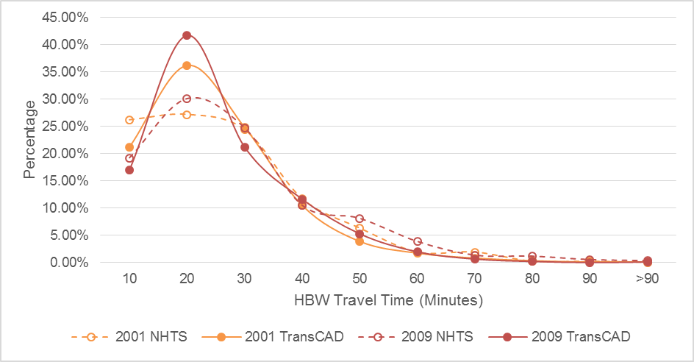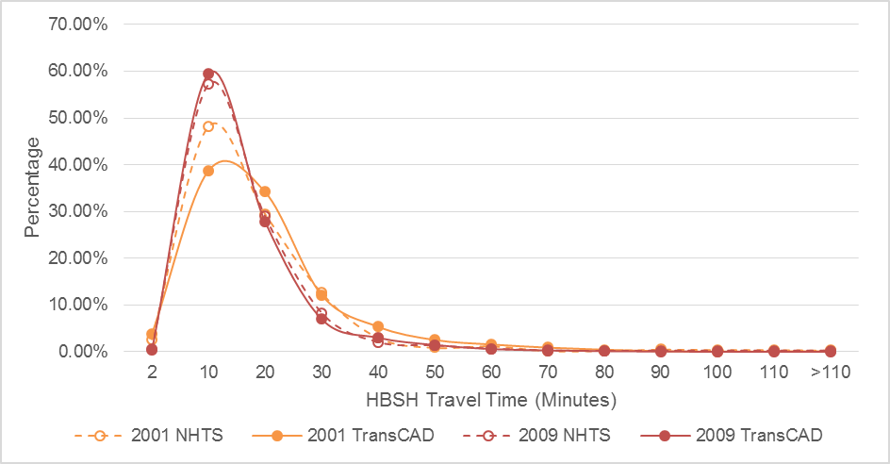Source: Adapted based on 2001 and 2009 NHTS Data

To analyze the travel patterns for those areas, we divided the trips from distribution results into three categories: 1) trips that originate and end within the study area, also called “Intra” trips; 2) trips that originate outside each of the study areas but end in either of them, also called “Inter-in” trips; and 3) trips that originate in either of the study areas but end outside their boundaries, also called “Inter-out” trips.

**3.2 Energy Consumption Model**

With the Vehicle Mile Travelled (VMT) data from trip distribution process, we further estimated energy consumptions in our urban and suburban study areas with local vehicle inventory data and Mile per Gallon (MPG) data from U.S. Environmental Protection Agency (EPA). As displayed in Figure 4, the vehicle type distribution results reveal that suburban residents occupy fewer automobiles while more SUVs and pickup trucks. Based on the assumption that every vehicle has the equal probability to be used in a given trip, we estimated the energy consumption with the following formula:

Where,

*k*, is index for vehicle type;

*n*, is the total number of vehicle categories.

Figure 4: Study Areas Vehicle Compositions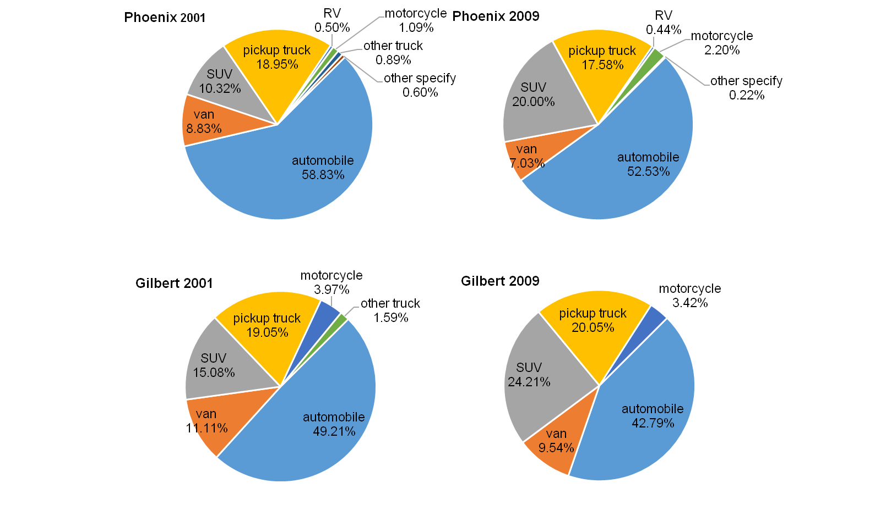

Source: 2002 MAG Survey and 2009 NHTS

**3.3. GHG Emissions Model**

In GHG emissions model, we calculated both Carbon Dioxide (CO2)and Nitrous Oxide (N2O) emissions. We estimated CO2 emission based on gasoline consumption and N2O emission based on VMT and vehicle type classified by fuel type and manufacture year, as shown in Table 8. The detailed calculation formula for CO2 and N2O emissions is listed as follow:

Where,

, is the emission standard for vehicle type I, can be retrieved from table 8;

, is the regional portion of vehicle type i;

, is the total number of vehicle type.

Table 8: Vehicle Type Classification Standards for Nitrous Oxide Emission Calculation



The final GHG emissions results were expressed in the unit of Carbon Dioxide equivalent, commonly written as CO2e (EPA, 2013), using the following formula:

**4 RESULTS**

**4.1 Suburbanization in Phoenix Metropolitan Area**

From 2001 to 2009, a significant amount of development took place in the suburban areas of Phoenix Metropolitan region. The total employment number within the region has increased by 56.3% from 0.87 million to over 1.36 million. For *Phoenix* study area, the sum of employment declined slightly by 4.5%, from 0.27 million to 0.26 million. While in *Gilbert* the growth rate was 125.6%, from 16 thousands to 36 thousands. The growth was particularly intensive in the southeastern part of *Gilbert*. Additionally, the growth rate in *Gilbert* surpassed the regional average by 69.3%.

During the study period, the variation pattern of retail service was quite similar with the variation pattern for total employment, as shown in Figure 5. The growth rate for retail service within the region was 130%. *Gilbert* experienced dramatic growth in retail service from 2001 to 2009. The number of retail employment in *Gilbert* increased from 1.8 thousands to 5.7 thousands. The service in *Phoenix*, however, deteriorated significantly by 21.3%, from 21 thousands to around 17 thousands. *Gilbert* study area seems to be the center of retail service growth in the southeastern part of the metropolitan region. Therefore, the change of portion of retail service employment was more significant compared with the change of total employment within the region.

Figure 5: Employment Changes in *Phoenix* and *Gilbert*

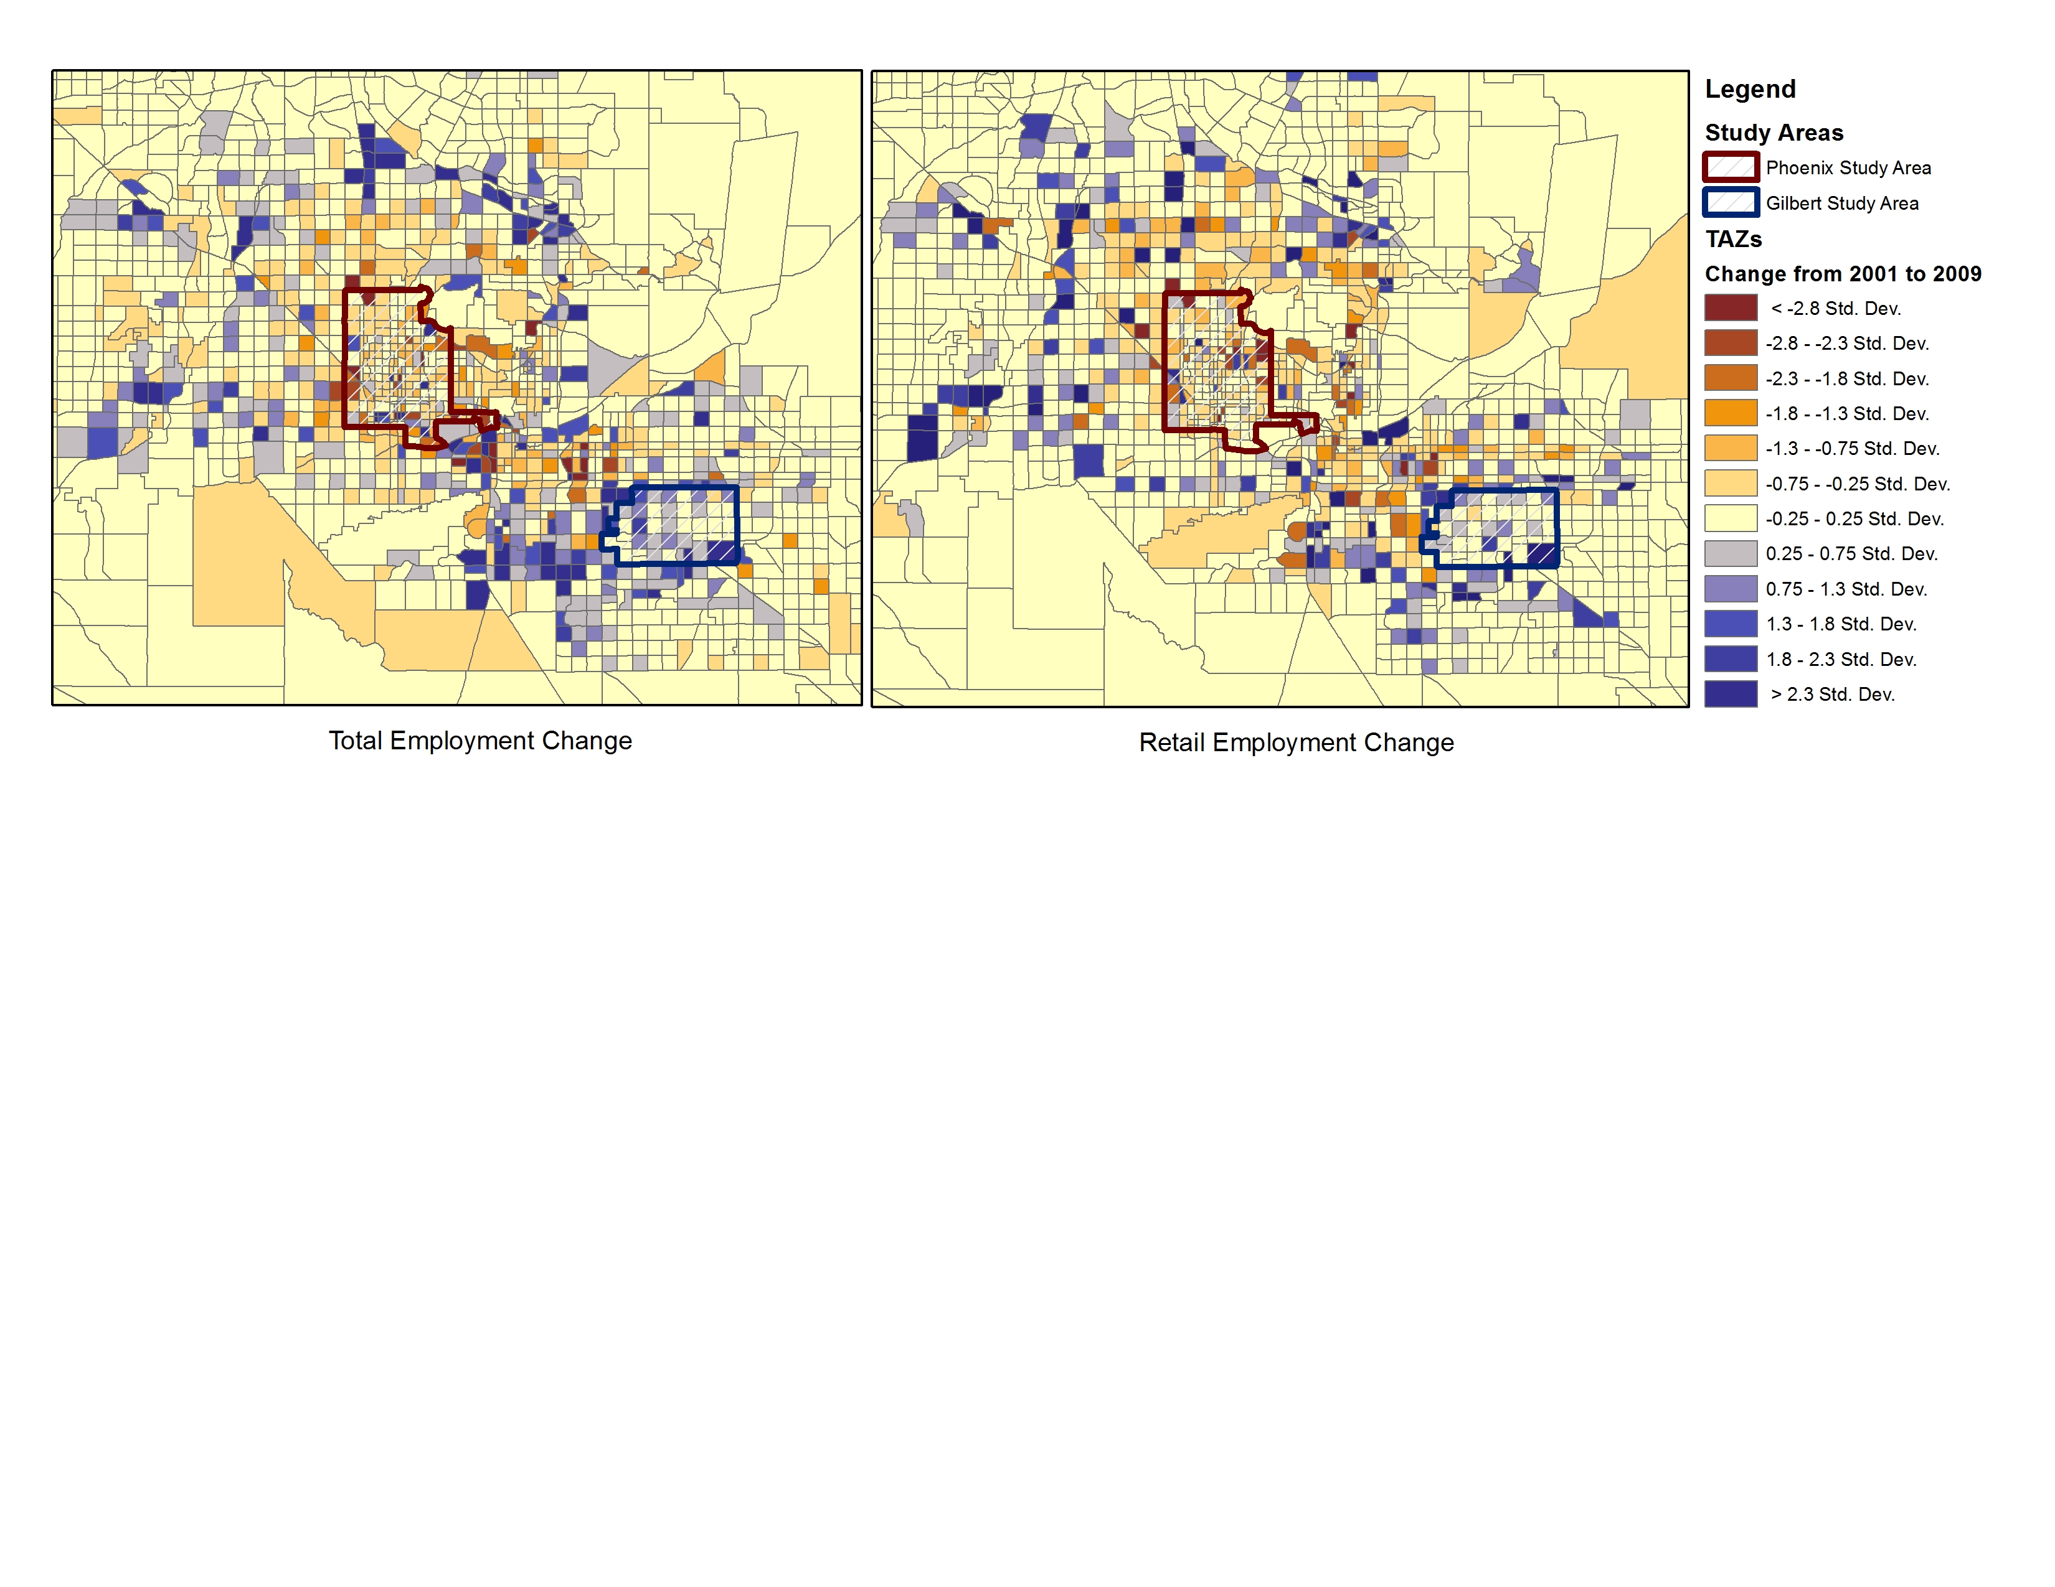

Source: Adapted based on 2001 and 2009 employment data from MAG

Due to the slight differences in the variation patterns for total employment and retail service employment, we also expected the HBW and HBSH travel behaviors to evolve in different manners. The commuting and shopping travel behavior variation patterns are further discussed separately in the following two sections.

**4.2 Variations for Commuting Travel Patterns**

The study results reveal that suburbanization process can influence commuting travel behavior and energy use pattern for urban and suburban residents in different manners. First of all, the composition of commuting trip type evolved differently in urban *Phoenix* and suburban *Gilbert,* as illustrated in Figure 6. *Phoenix* study area showed a very clear decline trend in proportion of Intra trips, due to the drop of local job opportunities. The severe decrease was also reflected in the increase of inter-out commuting trips. Additionally, *Phoenix* study area turned out to be less appealing to outside residents. Despite the fact that the regional population increased over time, the frequency of inter-in trip declined slightly from 1.73 million in 2001 to 1.70 million in 2009. The trip type composition result for suburban Gilbert, however, indicated that the proportion of Inter-in trips increased dramatically by 162.02%. The intensive development in *Gilbert* also helped the area to maintain the number of intra commuting trips, as the decrease was less significant compared with *Phoenix* study area. However, we found that the compact development didn’t manage to control the fraction of inter-out trips, as *Gilbert* habitants continued to generate more inter-out trips over study period.

Figure 6: Commuting Trip Compositions for Phoenix and Gilbert Study Areas



Source: Adapted by authors

The spatial distribution of energy flow associated with inter-in commuting trips also varied in different ways for urban and suburban areas. The spatial distributions of Inter-in energy flow results indicated that more energy flowed into *Gilbert* neighborhoods in 2009, as illustrated in Figure 7. The most significant growth took place at 7-10 miles range and 31-34 miles range away from *Gilbert*. While it remained stable for *Phoenix* study area during the study period. There was hardly any growth for energy flow within 12 miles radius.

Figure 7: HBW Inter-in Energy Spatial Distribution Variations



Source: Adapted by authors

The HBW results summary for local residents in Phoenix and Gilbert study areas also provided evidence that suburbanization can influence local travel behaviors, as shown in Table 9. The results indicated that the variations in travel patterns were more significant in *Phoenix* study area. In *Phoenix*, the average trip length increased by 126%, while it merely amplified by 32% in *Gilbert*. As a result, the average trip length for both study areas converged at approximately 16-17 miles in 2009. Such outcome suggested that due to the deterioration of local businesses, more Phoenix habitants were forced to commute to further TAZs to work. As a result, the individual HBW VMT grew by 110% in *Phoenix.* The growth speed almost doubled that from *Gilbert* neighborhoods. The energy consumption difference between urban Phoenix and suburban Gilbert was reduced from 0.11 to 0.01 gallon per person per day. The variation pattern of local GHG footprint mirrored that of energy consumption. The difference of daily GHG emissions between two study areas was reduced by 0.91 Kg of CO2e per person. Despite the fact the difference between Phoenix and Gilbert neighborhoods was significantly reduced over time, Gilbert residents remained to be more energy intensive with larger GHG footprint in 2009. By comparing the individual VMT change with the energy consumption change, we found that the advancement in vehicle technology was able to offset the increase of individual VMT in suburban *Gilbert*, as the individual energy consumption and GHG footprint remained stable, while the individual VMT increased from 3.86 to 4.32 miles overtime.

Table 9: Local Residents Commuting Travel Patterns Summary



Source: Adapted by authors

The higher ratio between Inter-out and Intra trips revealed that both urban and suburban residents made more Inter-out trips over time. The spatial distribution of inter-out trips destinations for both study areas suggested that the majority of growth occurred between 10 to 40 miles range, as shown in Figure 8. This implies that more residents were likely to commute to suburban businesses to work. Suburban growth, on the one hand, reduced local VMT to some extent, but on the other hand it also encouraged longer commuting trips for other neighborhoods regional wide.

Figure 8: HBW Inter-out Energy Spatial Distribution Variations



Source: Adapted by authors

**4.3 Variations for Shopping Travel Patterns**

As suburban *Gilbert* became the new retail service center in southeastern part of the metropolitan region, the changes in shopping patterns were more significant compared with commuting travel patterns. Suburban *Gilbert* successfully attracted more inter-in trips from outside neighborhoods in 2009, as the number of estimated inter-in shopping trips increased dramatically from 8229 to 62205. Additionally, the total number of intra trips in *Gilbert* also increased slightly over time. However, the more condensed retail facilities didn’t control the total amount of inter-out trips, as the number of this type of trips continued to increase by 82.7% over study period. However, compared with the 302.6% of increase in urban *Phoenix*, such increase was rather small.

Figure 9: Shopping Trip Compositions for Phoenix and Gilbert Study Areas



Source: Adapted by authors

Although the amount of inter-in trips increased over study time for both study areas, the energy consumption associated with inter-in trips evolved in different ways for urban and suburban areas. For inter-in trips that attracted to *Phoenix* area, the energy consumption declined from 2001 to 2009, despite the fact that the frequency of trips increased. Such result suggested that *Phoenix* study area may lost customers in remote TAZs over study period. The decline may also be attributed to the advanced vehicle technology and the improvement in the road network. For inter-in trips attracted to Gilbert neighborhoods, the associated energy flow increased as anticipated. More energy was consumed by residents within 40 miles radius to *Gilbert*.

Figure 10: HBSH Inter-in Energy Spatial Distribution Variations



Source: Adapted by authors

The suburbanization of retail service in Phoenix Metropolitan area reversed the travel patterns for residents from *Phoenix* and *Gilbert* study areas. The average trip length in *Phoenix* increased from 3.97 miles in 2001 to 7.96 miles in 2009. Meanwhile, residents in *Gilbert* seemed to make shorter shopping trips, as the average trip length declined by 15% over study period. Although *Gilbert* residents continued to generate more inter-out trips, the total VMT merely increased by 6%, which is marginal compared with the 188% increase in *Phoenix* area. Such increase in VMT in *Gilbert* was offset by the vehicle technology advancement. The individual energy consumption and GHG emissions in *Gilbert* actually declined by 6% over study period. As a result, in 2009 *Gilbert* residents turned out to be less energy intensive compared with urban *Phoenix* residents.

Table 10: Local Residents Shopping Travel Patterns Summary



Source: Adapted by authors

Figure 11: HBSH Inter-out Energy Spatial Distribution Variations



Source: Adapted by authors

Both urban *Phoenix* and suburban *Gilbert* residents continued to generate higher portion of inter-out shopping trips. The ratio of inter-out and intra trips for Phoenix study area increased by 818%, while it creased by 61% for Gilbert. The energy flow associated with inter-out shopping trips revealed that Phoenix residents produced dramatically more shopping trips to areas at 6-30 miles away. While, in Gilbert more shopping trips were attracted to areas at 25-40 miles range. This phenomenon indicated that both *Phoenix* and *Gilbert* neighborhoods residents traveled more frequently to other suburban areas within the region to shop.

**5 CONCLUSIONS AND DISCUSSIONS**

This study employed 2001 and 2009 NHTS datasets to explore the relationship between compact development, travel behavior, and motorized travel associated energy consumption and GHG emissions. We estimated HBW and HBSH motorized travel behavior for residents from urban Phoenix and suburban Gilbert neighborhoods using the four-step model over study period. Although the survey data is not longitudinal panel data, this study still provides insightful results regarding the relationship between compact development and travel behavior.

First, we found that suburban growth did have an impact on people’s travel behaviors. Additionally, the suburbanization process can influence urban and suburban habitants in significantly different ways. As suburbs grew and diversified, the difference in travel behavior between people living in suburban and urban areas became smaller. In the case of HBW travel, the individual VMT, energy consumption and GHG emissions converged at similar level in 2009. In 2001, Gilbert residents with higher individual commuting VMT was more energy intensive. While, in 2009 suburban Gilbert residents surpassed urban residents by only 0.01 Gallon per day. In the case of HBSH travel, suburbanization of retail service reversed the travel patterns for residents from urban and suburban areas. In 2009, suburban Gilbert habitants with shorter shopping trips turned out to be less energy intensive than urban Phoenix habitants. Gilbert residents used to consume approximately 200% more energy in 2001, when the retail services were less accessible.

Second, we found that compact development was likely to encourage longer commuting and shopping trips at a regional scale. With the decline of employment opportunity and amount of retail service within urban Phoenix area, more residents were forced to travel longer distance to suburban areas to satisfy their daily demands. For suburban Gilbert residents, the compact development didn’t manage to reduce the proportion of inter-out trips. Based on our results, the intensive local development was only able to maintain the commuting and shopping trips within 19 and 25 miles radius separately. Suburban residents seemed to travel to other suburban areas approximately 25 to 40 miles away to work and shop in 2009.

Further, based on the individual energy consumption results, we found that under certain circumstances, the advancement of vehicle technology was likely to offset of the increase in individual VMT. In the case of HBW travel for suburban Gilbert habitants, despite the fact that the individual VMT increased from 3.86 to 4.32 miles per person, the individual energy consumption and GHG emissions were able to remain stable as 0.21 Gallon per day per person and 1.95 Kg of CO2e per day per person.

This study, however, is not quantitative nor does it clarify the nature the relationship between built environment and travel behavior. More sophisticated spatial regression models will be developed in the future to determine the elasticities between urban forms based variables and travel behavior variables over study period.

**REFERENCES**

Baht, C.R. & Sudeshna, S., & Naveen, E., ‘The impact of demographics, built environment attributes, vehicle characteristics, and gasoline prices on household vehicle holdings and use’ *Transportation Research Part B*, 43, pp.1-18. ScienceDirect, EBSCOhost, viewed 1 May 2013.

Boarnet., M. G. & Crane, R., ‘The influence of land use on travel behavior: specification and estimation strategies’ *Transportation Research Part A*, *35*823-845. ScienceDirect, viewed 3 May 2013.

Brownstone, D., & Golob, T., ‘The impact of residential density on vehicle usage and energy consumption’ *Journal Of Urban Economics*, *65,* pp. 91-98. ScienceDirect, viewed 3 May 2013.

Calthorpe, P., ‘*The next American metropolis: ecology, community, and the American dream / Peter Calthorpe; guidelines with Shelley Poticha’* New York: Princeton Architectural Press, c1993. ScienceDirect, viewed 3 May 2013.

Cao, X., Mokhtarian, P. L.,Handy, S. L., ‘Do changes in neighborhood characteristics lead to changes in travel behavior? A structural equations modeling approach?’ *Transportation 2007 (34)*, pp. 535-556. ScienceDirect, viewed 3 May 2013.

Cervero, R., & Kockelman, K., ‘Travel demand and the 3Ds: Density, diversity, and design’ *Transportation Research Part D*, *2*(3), pp.199-219. ScienceDirect, viewed 1 May 2013.

Crane, R., ‘Cars and drivers in the new suburbs’ *Journal Of The American Planning Association*, *62*(1), 51. ScienceDirect, viewed 1 May 2013.

Crane, R. & Guo, Z., ‘*Toward a second generation of land-use/travel models: theoretical and empirical frontiers’* Oxford University Press, c2013. ScienceDirect, viewed 16 May 2013.

Ewing, Reid; Hamidi, Shima; Nelson, Arthur C.; Grace, James B. ‘Combined Effects of Compact Development, Transportation Investments, and Road User Pricing on Vehicle Miles Traveled in Urbanized Areas’, 92th TRB Conference.

McNally, M. G., & Ryan, S. S., ‘Comparative Assessment of Travel Characteristics for Neotraditional Designs’ *Transportation Research Record*, (1400), 67. ScienceDirect, viewed 1 May 2013.

Plessis, V., Beshiri, R. and Bollman, R. ‘Definitions of “Rural”’, *Statistics Canada*, ScienceDirect, viewed 1 May 2013.

Transportation Research Board., 1998. NCHRP Report 365: Travel Estimation Techniques for Urban Planning. [online] Available at:

<http://ntl.bts.gov/lib/21000/21500/21563/PB99126724.pdf> [Accessed 23 January 2013].

Transportation Research Board., 2012. NCHRP Report 716: Travel Demand Forecasting: Parameters and Techniques [online] Available at:

<http://onlinepubs.trb.org/onlinepubs/nchrp/nchrp_rpt_716.pdf> [Accessed 23 March 2013].

Veronique Van, A, & Frank, W n.d., 'Car ownership as a mediating variable in car travel behavior research using a structural equation modeling approach to identify its dual relationship', *Journal Of Transport Geography*, 18, pp. 65-74, ScienceDirect, viewed 16 May 2013.