公会喂价程序快速搭建手册

# 1 环境介绍

在ubuntu 16.04或者18.04的环境上，均由于安装的python2或者python3或者openssl的问题导致编译错误或者执行错误，所以为了规避环境错误，直接上了ubuntu 20.04。

在ubuntu20.04上不再预装python2，系统直接python3起步，所以不需要做任何操作。我用的是vultr上的环境，用其他的应该也是一样的。

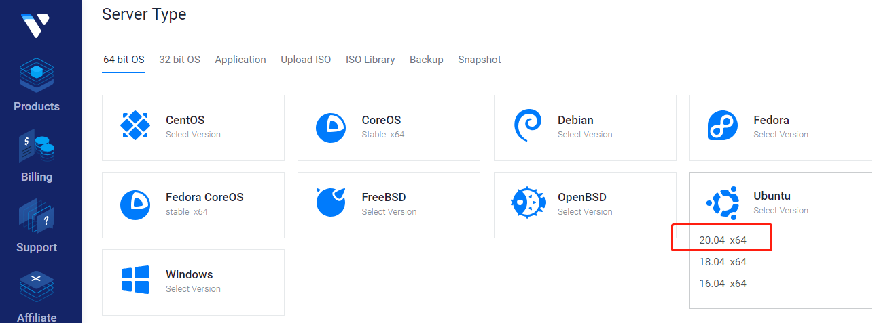

**Currently Installed:** Ubuntu 20.04 x64

# 2 操作过程

## 系统相关软件安装

**命令：**

apt-get update

apt-get install python3-setuptools

apt install python3-pip

pip3 install sqlalchemy

**操作实例：**

root@vultr:~# apt-get install python3-setuptools

Reading package lists... Done

Building dependency tree

Reading state information... Done

The following additional packages will be installed:

python3-distutils python3-lib2to3

Suggested packages:

python-setuptools-doc

The following NEW packages will be installed:

python3-distutils python3-lib2to3 python3-setuptools

0 upgraded, 3 newly installed, 0 to remove and 40 not upgraded.

Need to get 544 kB of archives.

After this operation, 2,555 kB of additional disk space will be used.

Do you want to continue? [Y/n] y

Get:1 http://archive.ubuntu.com/ubuntu focal/main amd64 python3-lib2to3 all 3.8.2-1ubuntu1 [74.1 kB]

Get:2 http://archive.ubuntu.com/ubuntu focal/main amd64 python3-distutils all 3.8.2-1ubuntu1 [140 kB]

Get:3 http://archive.ubuntu.com/ubuntu focal/main amd64 python3-setuptools all 45.2.0-1 [330 kB]

Fetched 544 kB in 1s (939 kB/s)

Selecting previously unselected package python3-lib2to3.

(Reading database ... 107002 files and directories currently installed.)

Preparing to unpack .../python3-lib2to3_3.8.2-1ubuntu1_all.deb ...

Unpacking python3-lib2to3 (3.8.2-1ubuntu1) ...

Selecting previously unselected package python3-distutils.

Preparing to unpack .../python3-distutils_3.8.2-1ubuntu1_all.deb ...

Unpacking python3-distutils (3.8.2-1ubuntu1) ...

Selecting previously unselected package python3-setuptools.

Preparing to unpack .../python3-setuptools_45.2.0-1_all.deb ...

Unpacking python3-setuptools (45.2.0-1) ...

Setting up python3-lib2to3 (3.8.2-1ubuntu1) ...

Setting up python3-distutils (3.8.2-1ubuntu1) ...

Setting up python3-setuptools (45.2.0-1) ...

root@vultr:~# apt install python3-pip

过程省略…

root@vultr:~/bitshares-pricefeed# pip3 install sqlalchemy

过程省略…

## 确认python3的版本与SSL导入

**命令：**

python3 -V

Python3

import ssl

**操作实例**：

root@vultr:~# python3 -V

Python 3.8.2

root@vultr:~# python3

Python 3.8.2 (default, Jul 16 2020, 14:00:26)

[GCC 9.3.0] on linux

Type "help", "copyright", "credits" or "license" for more information.

>>> import ssl

>>>

按ctrl+d就可以退出python

## 一键搭建喂价环境

1、从键盘敲很轻（见证人barefoot-witness）那里或者其他人那里获取三个文件，并拷贝到自己的服务器上，一般直接拷贝到cd ~目录下就行。

**注意**：一定要校验一下md5值，防止获取了恶意的代码

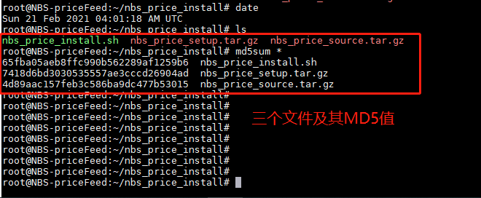

2、执行脚本，一键安装

使用如下命令，直接执行脚本即可

./nbs_price_install.sh

## 编译代码

**命令：**

cd bitshares-pricefeed

python3 setup.py install

**操作实例：**

root@vultr:~# cd bitshares-pricefeed/

root@vultr:~/bitshares-pricefeed# python3 setup.py install

中间过程省略，最终结果如下

…

Using /usr/lib/python3/dist-packages

Searching for idna==2.8

Best match: idna 2.8

Adding idna 2.8 to easy-install.pth file

Using /usr/lib/python3/dist-packages

Finished processing dependencies for bitshares-pricefeed==0.0.10

## 喂价发布

如下图所示，发布喂价前，有如下两个文件需要修改，baip2.yaml中把见证人换成你自己的即可。nbs_price.sh是周期发布喂价执行脚本，这里需要你把见证人的私钥填上就可以执行发布了。建议使用screen工具，后台运行该脚本就可以了。

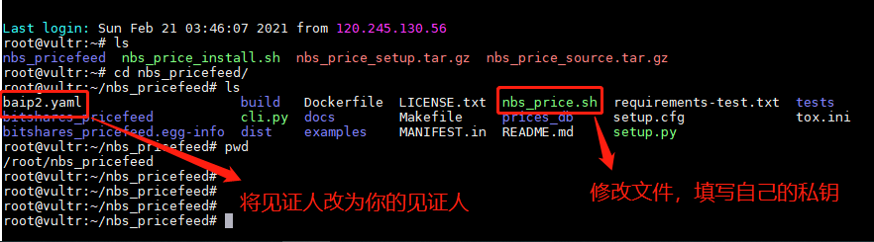

修改完成后，直接执行如下命令，发布喂价：

