|  |
| --- |
| YILDIZ TECHNICAL University |
| VİBRATION MEASUREMENT |
| Measuring Vibrations Using an Accelerometer and Gyroscope |
|  |
|  |
| **Kadircan KURTULUŞ;Yasin ÇOŞGUN;Murat YAPICI** |

**12/11/2018**

|  |
| --- |
|  |

**MECHATRONICS**

# Introduction

Now a day’s vibration measurement is necessary because vibration of any system or its parts affects the result. Vibration monitoring is becoming an established technique for managing the maintenance of system. System condition monitoring is the process of monitoring the condition of a system with the intent to predict mechanical wear and failure. Vibration, temperature and noise measurement is becomes necessary to state the system condition. For this reason, a system was developed to analyze vibration in this project.

# Problem approach/Design

In this project, Arduino, IMU (inertial measurement unit) and C # for vibration analysis were used. In order to best measure the vibration, both an accelerometer and a gyroscope were used from IMU.

## What is an IMU

## An inertial measurement unit (IMU) is an electronic device that measures and reports a body's specific force, angular rate, and sometimes the magnetic field surrounding the body, using a combination of accelerometers and gyroscopes, sometimes also magnetometers.

## What is an accelometer?

Accelerometers measure the static (gravity) or dynamic (abrupt acceleration or stop) acceleration. The value obtained from the sensor can be expressed as m / s2 or g-force. In applications, it is generally expressed as gravity. If you are not in space or within the scope of any gravitational field, a gravity force of 1g acts on the sensor. The sensor continuously measures the gradient due to gravity. The measurement scale is expressed as ± 1g, ± 2g, ± 4g ... and there are varieties that can measure one, two and three axes. 2g scale was used in this project and we made measurements in 3 axes. To obtain the angular position with the accelerometer, we are going to determine the position of the gravity vector (g-force) which is always visible on the accelerometer. This can easily be done by using an atan2 function.This can be also done by asin function. But this time angle can not be obtained when the (sensor.ax , sensor.az) value is bigger then 1.

void AccAciOku(){

acc_x = -180 * atan2(sensor.az , sensor.ay) / 3.14;

acc_y = -180 * atan2(sensor.ax , sensor.az) / 3.14;

acc_z = 180 * atan2(sensor.ax , sensor.ay) / 3.14;

}

In the following output, when the arcsin function is used on x axis, the expression nan appears.

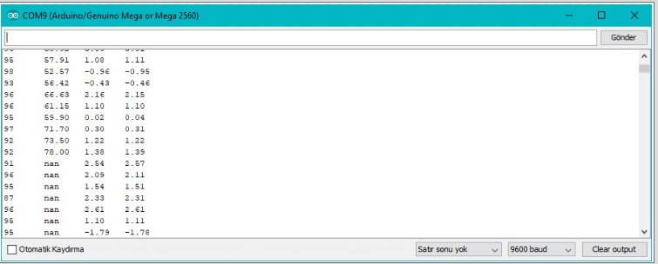

## What is a gyroscope?

A gyroscope is a device used for measuring or maintaining [orientation](http://www.wikizeroo.net/index.php?q=aHR0cHM6Ly9lbi53aWtpcGVkaWEub3JnL3dpa2kvT3JpZW50YXRpb25fKGdlb21ldHJ5KQ) and [angular velocity](http://www.wikizeroo.net/index.php?q=aHR0cHM6Ly9lbi53aWtpcGVkaWEub3JnL3dpa2kvQW5ndWxhcl92ZWxvY2l0eQ). It is a spinning wheel or disc in which the axis of rotation is free to assume any orientation by itself. When rotating, the orientation of this axis is unaffected by tilting or rotation of the mounting, according to the [conservation of angular momentum](http://www.wikizeroo.net/index.php?q=aHR0cHM6Ly9lbi53aWtpcGVkaWEub3JnL3dpa2kvQ29uc2VydmF0aW9uX29mX2FuZ3VsYXJfbW9tZW50dW0). In the project, we took the integral of the angular velocity obtained from the gyroscope and reached the angle and measured the vibration.

Integral difference equation : C(n) = 0.0005[r(n)+r(n-1)]+C(n-1)

Code:

sensor.read_gyro();

gyro_x1 = sensor.gx / 131.0;

delay(LAG);

gyro_x2 = sensor.gx / 131.0;

ang_x = LAG * 0.0005 * (gyro_x2 + gyro_x1) + ang_x;

## Wiring Descriptions/Design

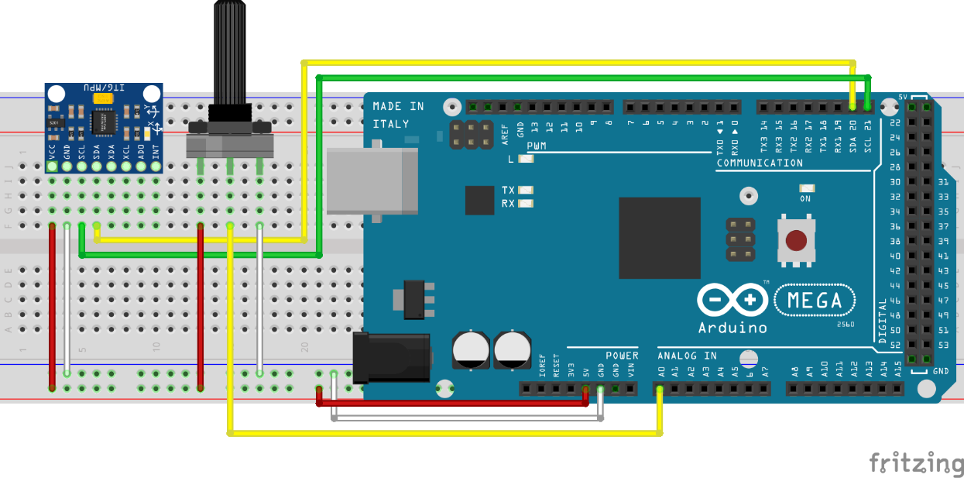

# Implementation/Results

When looking for the best way to make use of a IMU-sensor, thus combine the accelerometer and gyroscope data. So in this project both the accelerometer and gyroscope data used for the same purpose: obtaining the angular position of the object. The gyroscope can do this by integrating the angular velocity over time. To obtain the angular position with the accelerometer, the Arduino code needs to determine the position of the gravity vector (g-force) which is always visible on the accelerometer. But both sensors have their own problem. The problem with the acceloremeters is; as an accelerometer measures all forces that are working on the object, it will also see a lot more than just the gravity vector. Every small force working on the object will disturb our measurement completely. The accelerometer data is reliable only on the long term, so a "low pass" filter has to be used. The problem with the gyroscope is; because of the integration over time, the measurement has the tendency to drift, not returning to zero when the system went back to its original position. The gyroscope data is reliable only on the short term, as it starts to drift on the long term. So a "high pass" filter has to be used.

## Solving Both Problems And Using IMU With A Filter

Building the complimentary filter; this filter uses  the data from the gyroscope on the short term, because it is very precise and not susceptible to external forces. On the long term, it gets the data from the accelerometer, as it does not drift. In it's most simple form, the filter looks as follows:

Angle = 0.98*(angle+gyroData*dt)+ 0.02*accData;

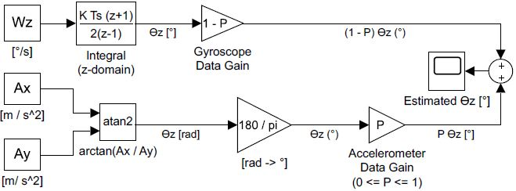

The function "Filtre" has to be used in an infinite loop. Every iteration the x,y and z angle values are updated with the new gyroscope values by means of integration over time. The filter then checks if the magnitude of the force seen by the accelerometer has a reasonable value that could be the real g-force vector. If the value is too small or too big, that means it is a disturbance. Afterwards, it will update the x,y and z angles with the accelerometer data by taking 98% of the current value, and adding 2% of the angle calculated by the accelerometer. This will ensure that the measurement won't drift, but that it will be very accurate on the short term.

## Result

As shown in the figure below, the measured vibration using the filter gives smoother results.

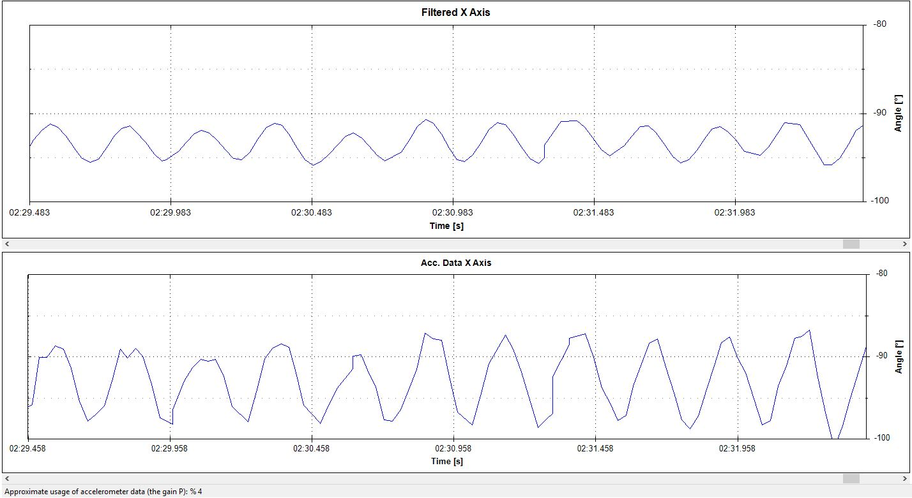

# Conclusion

In conclusion, with the help of the complimentary filter, measurements of the accelerometer and gyroscope used together for a better, more reliable results.

# Personal Comment

We try to get a more accurate angle by filtering the noisy data coming from the accelerometer and the gyroscope to complement each other and use this angle to measure angular vibration.

# Reference List

<http://www.pieter-jan.com/node/7>

<https://www.livescience.com/40103-accelerometer-vs-gyroscope.html>

<https://engineeringinsider.org/gyroscope-working/>

<https://www.azosensors.com/article.aspx?ArticleID=252>

<https://www.xsens.com/tags/imu/>

http://www.starlino.com/imu_guide.html