**Spam Detector (TF-IDF) — Project Report v2**

Generated on 2025-08-12 20:17

# Executive Summary

I observed that using **Logistic Regression** with class weights, tuned at t=0.57, improves recall and F1 on test vs Naive Bayes (t=0.13). Final: Acc 98.84%, ROC-AUC 0.998, PR-AUC 0.991, FP=2, FN=7.

# Data & EDA

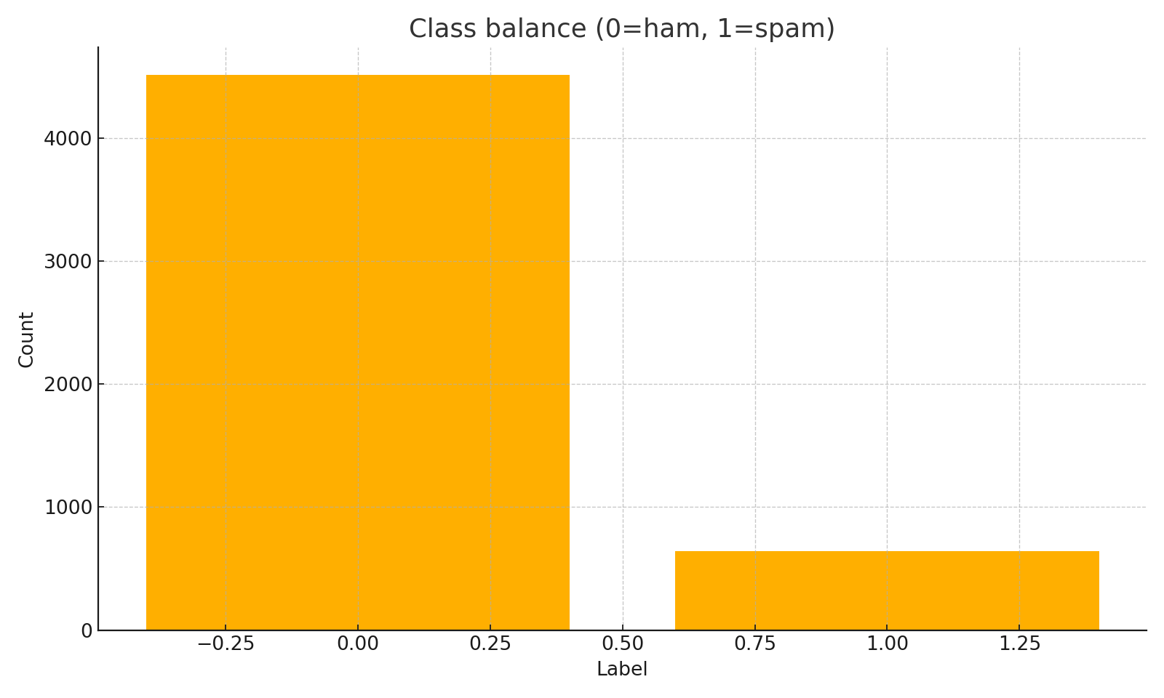

Class balance.

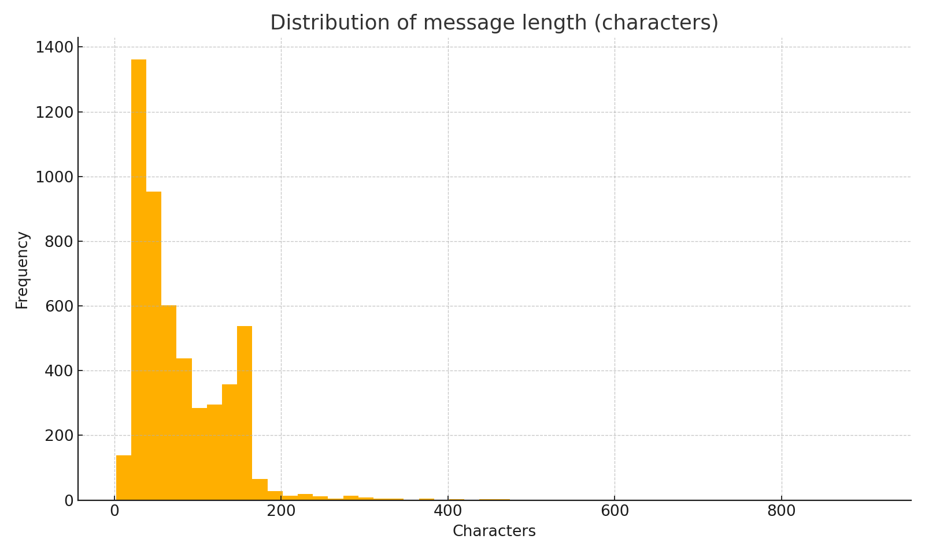

Message length distribution.

# Validation snapshots

|  |  |  |  |  |  |
| --- | --- | --- | --- | --- | --- |
| **Model** | **t** | **P(spam)** | **R(spam)** | **F1(spam)** | **Confusion** |
| NB | 0.50 | 1.000 | 0.680 | 0.810 | [[677,0],[31,66]] |
| NB | 0.13 | 0.989 | 0.887 | 0.935 | [[676,1],[11,86]] |
| LR | 0.50 | 0.919 | 0.938 | 0.929 | [[669,8],[6,91]] |
| LR | 0.57 | 0.968 | 0.928 | 0.947 | [[674,3],[7,90]] |

# Test comparison

|  |  |  |  |
| --- | --- | --- | --- |
| **Metric** | **NB (t=0.13)** | **LR (t=0.57)** | **Notes** |
| Accuracy | 0.9793 | 0.9884 |  |
| Spam Precision | 0.9762 | 0.9780 |  |
| Spam Recall | 0.8542 | 0.9271 | LR halves FN (14→7) at same FP=2 |
| Spam F1 | 0.9111 | 0.9519 |  |
| ROC-AUC | 0.982 | 0.998 |  |
| PR-AUC | 0.949 | 0.991 |  |
| Confusion | [[676, 2], [14, 82]] | [[676, 2], [7, 89]] |  |
|  |  |  |  |

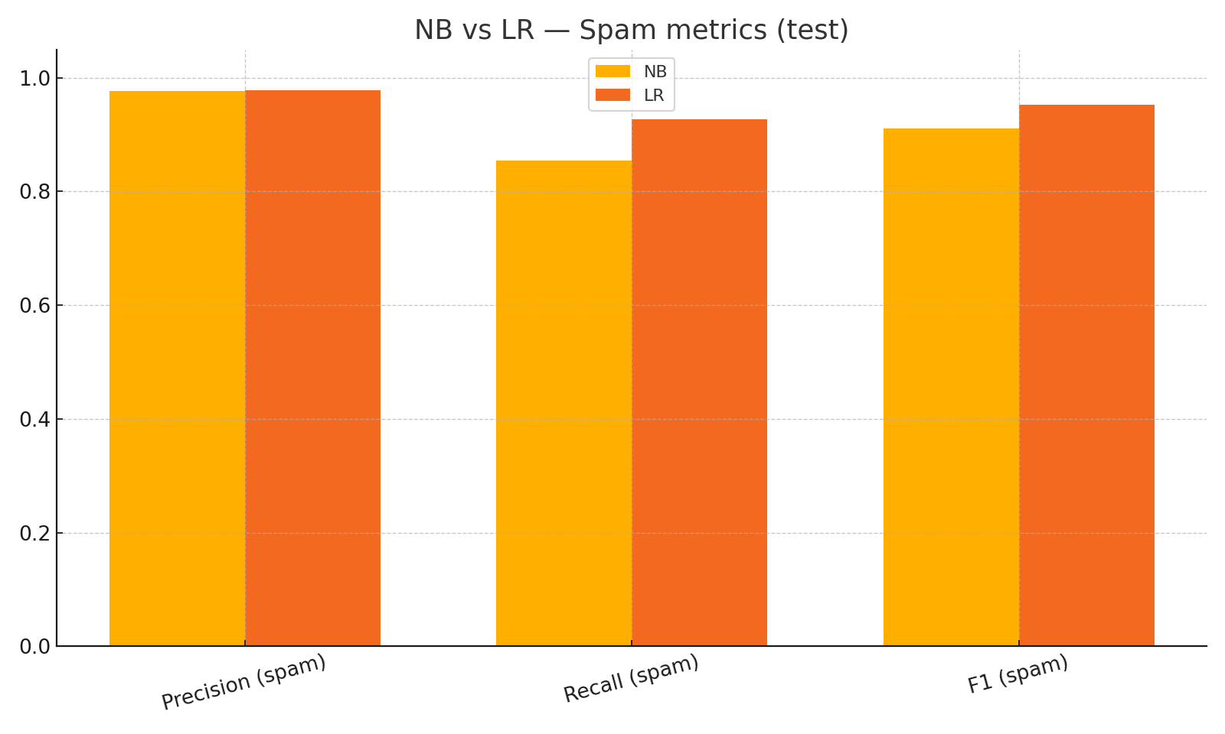

Spam metrics on test (NB vs LR).

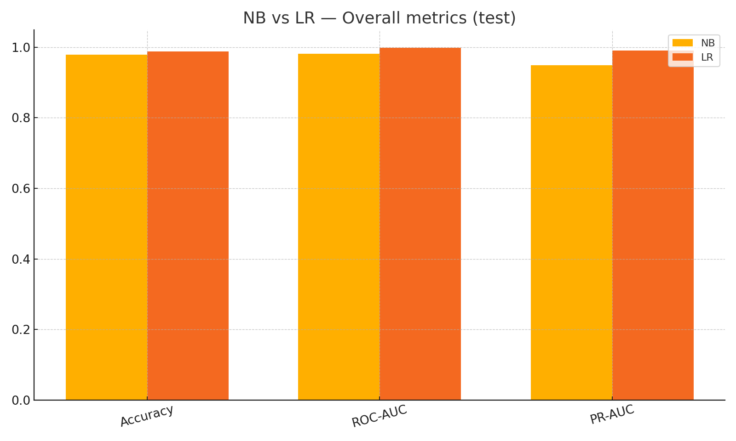

Overall metrics on test (NB vs LR).

# Decision & Deployment

Default to LR @ t=0.57. App updated with a NB/LR toggle; push artifacts to a permanent host (e.g., Hugging Face Spaces).