Spam Detector (SMS/Email) — End-to-End ML Project Report

Generated on 2025-08-12 11:06

# Executive Summary

We built a supervised text classifier to detect spam using TF-IDF features and a Multinomial Naive Bayes model. After cleaning and stratified splitting, we tuned the decision threshold on the validation set to t=0.13. On the held-out test set, we achieved accuracy 97.9%, ROC-AUC 0.982, and PR-AUC 0.949 with only 2 false positives and 14 false negatives (spam recall ≈ 0.85).

# 1) Problem & Data

**Goal:** Classify a short message as SPAM (1) or HAM (0).

**Dataset:** Kaggle SMS spam dataset (cleaned to spam_clean.csv).

Rows (cleaned): 5,158 | Spam: 642 | Ham: 4,516 | Spam %: 12.45%

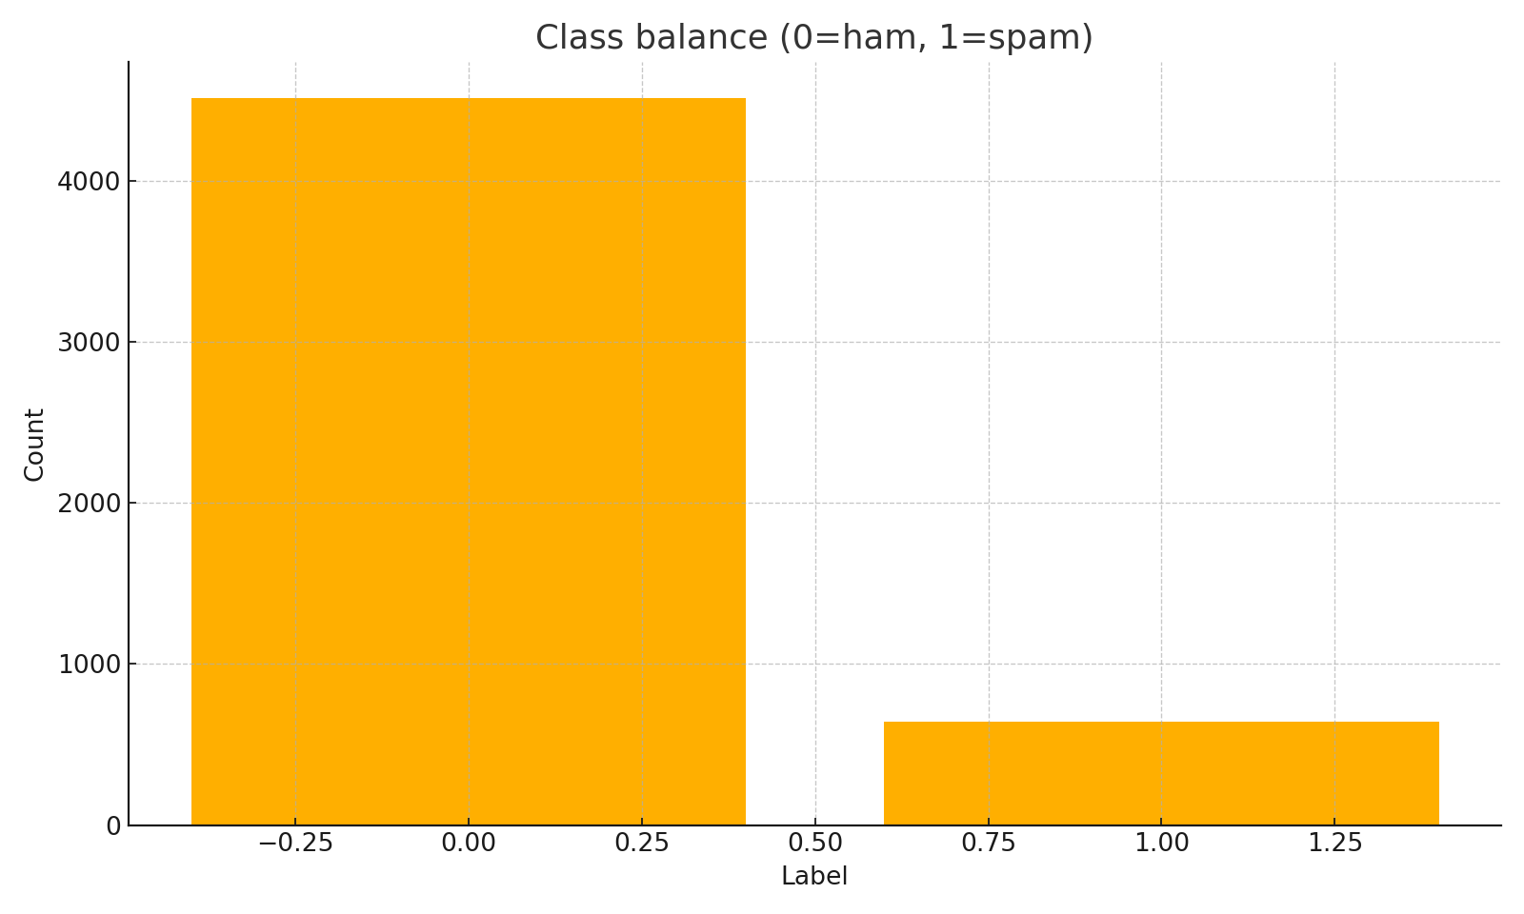

Figure 1. Class balance (imbalanced: ~12.5% spam).

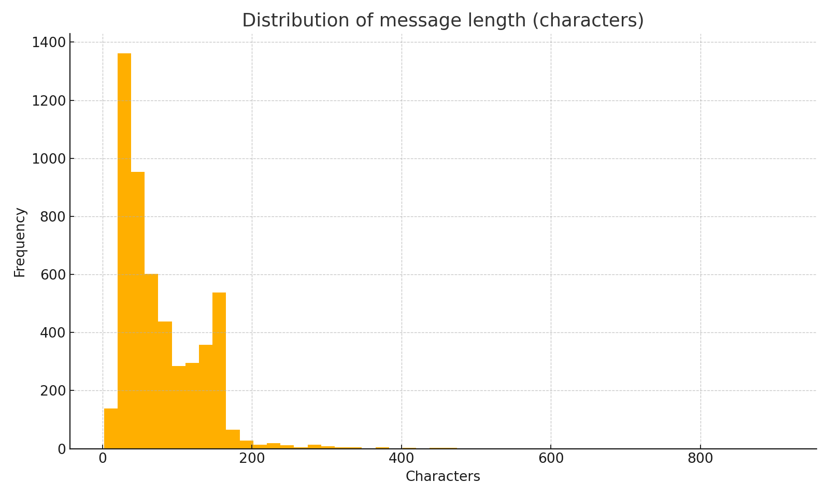

Figure 2. Message length distribution (characters).

# 2) Ingestion & Cleaning — Why and How

• Robustly read CSV (handled encodings).

• Standardized columns to text + label (1=spam, 0=ham).

• Dropped unnamed columns and 414 exact duplicate messages to reduce leakage/noise.

• Basic EDA to understand imbalance and length distribution.

# 3) Splitting Strategy — Avoiding Leakage

Stratified three-way split (70% train, 15% validation, 15% test) with fixed random seed.

|  |  |  |
| --- | --- | --- |
| Split | Rows | Spam % |
| Train | 3610 | 12.44% |
| Val | 774 | 12.53% |
| Test | 774 | 12.40% |

All splits ≈ overall spam rate (12.45%), confirming stratification worked.

# 4) Features & Model — Why These Choices

• TF-IDF with n-grams (1–2) and min_df=2 to balance signal and noise; bigrams capture phrases like “claim now”.

• No stop-word removal; in short texts, common words can carry signal via bigrams.

• Multinomial Naive Bayes for sparse text and strong baseline performance.

Validation vocabulary size: 8699 features.

# 5) Validation & Threshold Tuning

Default threshold (0.50) was too conservative (missed many spam). Tuned threshold on validation to maximize F1.

|  |  |  |  |  |  |
| --- | --- | --- | --- | --- | --- |
| Setting | t | Spam Precision | Spam Recall | Spam F1 | Confusion (rows=actual) |
| Default | 0.50 | 1.000 | 0.680 | 0.810 | [[677, 0], [31, 66]] |
| Best F1 | 0.13 | 0.989 | 0.887 | 0.935 | [[676, 1], [11, 86]] |

# 6) Final Test Performance (Locked t=0.13)

|  |  |  |  |  |
| --- | --- | --- | --- | --- |
| Class | Precision | Recall | F1 | Support |
| Ham (0) | 0.9797 | 0.9971 | 0.9883 | 678 |
| Spam (1) | 0.9762 | 0.8542 | 0.9111 | 96 |

Confusion: [[676, 2], [14, 82]] | ROC-AUC: 0.9819 | PR-AUC: 0.9489

# 7) Error Analysis — What We Miss and Why

Counts → correct: 758, FN: 14, FP: 2.

Patterns in FNs: adult/premium-rate promotions using slang, shortcode pricing (e.g., “150p”), or odd encodings; word-only features can miss obfuscated tokens.

Mitigations: threshold sweep; add character n-grams; consider Logistic Regression with class weights.

# 8) Deployment — What & Why

Artifacts saved: spam_nb_tfidf.joblib (full sklearn pipeline) and threshold.json (decision t).

Demo: Gradio app returning (label, probability). Initial return-type bug fixed by returning a tuple to match two outputs.

# 9) Reproducibility & Good Practices

• Stratified splits with fixed random seed.

• No leakage: fit vectorizer/model on train; tune on validation; evaluate once on test.

• Removed duplicate messages to reduce leakage; saved versioned artifacts.

# 10) Next Steps

1) Add word + character n-gram TF-IDF; re-tune threshold.

2) Try Logistic Regression (class_weight='balanced'); compare with NB.

3) Add URL/phone masking and minimal normalization.

4) Package as FastAPI microservice; add logging & drift checks.