

*Alexandria University*

*Faculty of Engineering*

*Computer and Systems Engineering*

***Lab 3***

***Web Based Drawing App***

|  |  |
| --- | --- |
| ***Name*** | ***ID*** |
| ***Mariam Mohammed Ahmed*** | ***19017274*** |
| ***Yara Hossam Abdelaziz*** | ***19016871*** |
| **Nourhan Ahmed Arafa** | ***19016812*** |
| ***Nada Mohamed Ibrahim*** | ***19016782*** |

***How to run the code***

You need to import some packages, components, and decorators to run the program in a full phase.

* Front-End
* HttpClient: to allow sending requests to the server.
* Renderer2: to allow operations on the svg element.
* ViewChild: to look for the first element that matching the selector in the DOM.
* ElementRef: to permit direct access to the DOM.
* Injectable: to mark a class as available to be provided and injected as a dependency.
* FormModule: to allow extracting inputs from forms.
* Back-End
* java.util.Arraylist: to allow dealing with the objects in more familiar way than the array.
* org.springframework.boot.SpringApplication
* org.springframework.boot.autoconfigure.SpringBootApplication: to allow running spring application

***UML Diagrams***

* Factory Pattern in the Front End

* Factory Pattern in the Back End

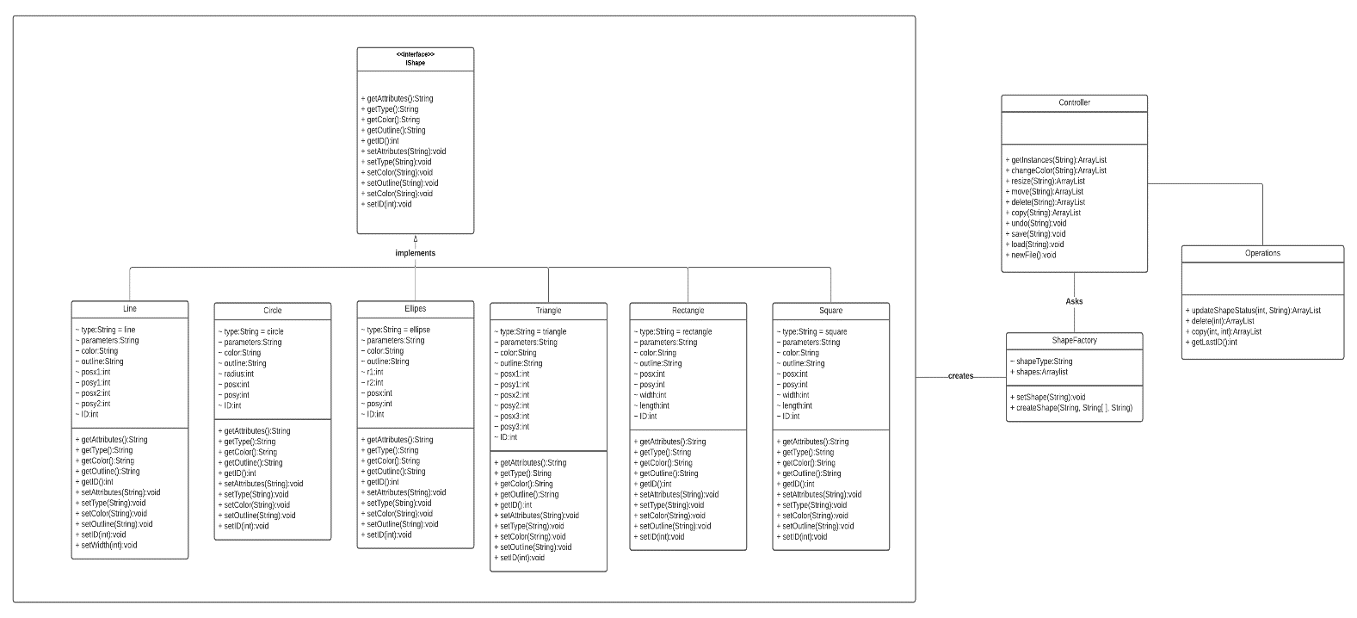

***Design Patterns***

* For the Front-End

We used the factory pattern to allow producing new shapes which are independent from each other, each one with its own attributes and behaviors.

* For the Back-End

The factory pattern was used to create new shapes of different classes.

***Design Decisions***

* The triangle’s resizing takes place at one point at a time.
* The triangle and the line can be selected from the terminal points only.
* When loading a file, undo/redo operations can be applied only to the new modified operations.

***Snapshots of the UI***

***How-To-Use***

* To Draw

You need to click on the icon of the shape to be drawn, then follow the next instructions:

* For all shapes except triangle
* You need to select 2 points.
* Select the first point on the board.
* Drag and select the second point.
* Triangle
* You need to select 3 points.
* Select the first point on the board to start drawing
* Move the line and select the second point.
* Move the line and select the third point.
* For selecting a shape in the following operation, you need to click on any point on the shape to be selected except the triangle and the line you need to select a terminal point.
* To Move
* Click on the move icon.
* Move the required shape by dragging and dropping it.
* To Resize
* Click on the resize icon
* Drag the shape until reaching the required size.
* To Copy
* Click on the copy icon
* Select the required shape.
* The copy will appear on the select shape.
* To Change the color

The following 2 operations are set together:

* To change the fill color
* Click on the fill icon.
* Choose a color
* Select a shape to change its color.
* To change the border color
* Click on the border icon
* Choose a color
* Select a shape to change its color.
* To create a new file
* Press the icon new
* To Upload a file
* Click on the open icon.
* Enter the file name, the path.
* Choose the file type either json or xml.
* Press submit.
* To clear the board
* Press the icon clear.
* To save a file
* Click on the open icon.
* Enter the file name and the path.
* Choose the file type either json or xml.
* Press submit