Confidentiality Detector
A local hybrid transformer-and-rules check that blocks sensitive information before a prompt reaches an external LLM

Programme: OLO Academy AI Engineering Bootcamp: Capstone Project, Track F
Document: Final technical report: draft for team review
Team: [PENDING: names of the two team members]
Date: 26 October 2026
System reported: R3 (r2_e3b_positive) + rules v3, strict mode; frozen 24 October 2026 (code commit 4907107)
Repository state: documentation commit ebf362d plus the uncommitted documentation of 26 October 2026

Status of this draft. Every number in this report is taken from evidence files already in the repository (Appendix B). No new experiment, evaluation or model inference was run to write it. Items marked [PENDING: …] need input from the team. The frontend and FastAPI integration is reported by a team member and is not yet verified in the repository (Section 11).
Contents
1. Project overview, Track F, target users and problem statement 3
1.1 Problem statement 3
1.2 The system in brief 3
1.3 Track F and project context 3
1.4 Target users 4
2. Research motivation and success criteria 4
3. Dataset: provenance, licences, preprocessing and splits 5
3.1 Source data 5
3.2 Annotation policy 5
3.3 Splits and their roles 5
3.4 Augmentation and generated data 6
3.5 Licences and sharing 6
4. System architecture 7
5. Regex baseline and the final hybrid approach 8
5.1 Development-time comparison, Round 1 8
5.2 Development-time ablation of the final system 9
6. Fine-tuning methodology, BIO alignment and preprocessing 10
7. Experiments and model-selection process 10
8. R3 selection rationale 11
9. Final evaluation on challenge_v2: methodology and results 12
9.1 Protocol, as executed 12
9.2 Results 13
9.3 Independent versus development results 14
9.4 Limitations of the benchmark 14
10. Error analysis and significant failure modes 14
11. Application architecture and FastAPI integration status 16
12. Model artifacts and reproducibility 16
13. Responsible AI, privacy, ethics and limitations 17
13.1 Privacy by design 17
13.2 Security, usability and fairness 17
13.3 Limitations 17
13.4 Disclosure of AI assistance 17
14. Conclusion and future work 17
15. Team contributions 18
16. References 18
Appendix A. Glossary of metrics and terms 20
Appendix B. Evidence index 20
Appendix C. Items pending team input 20
Appendix D. Identity of the frozen checkpoint 21

Abstract
Employees increasingly paste workplace text into external large language model (LLM) services, which risks the accidental disclosure of personal, financial and credential data. This project built Confidentiality Detector, a local pre-submission check that inspects an English prompt and returns BLOCK or ALLOW for 13 protected categories, with explanations that name categories but never values. The final system combines a fine-tuned multilingual BERT token classifier (R3) with deterministic validation rules (rules v3) under a fail-closed security policy. Development showed that the original synthetic validation F1 of 0.9925 was a measurement artefact (0.643 after correction), and that synthetic in-distribution scores (entity F1 0.984) greatly overstate performance on realistic text. A selection rule fixed before the Round 2 results selected R3; the system was then frozen and evaluated once per mode on challenge_v2, an independently authored, sealed benchmark of 400 synthetic cases. In the primary strict mode it allowed 2 of 200 protected cases (False ALLOW 1.0%) but blocked 70 of 200 harmless cases (False BLOCK 35.0%), with entity micro F1 0.677 and document-level BLOCK F1 0.846. Most false blocks fall on harmless look-alike identifiers such as tracking, order and invoice numbers. The detector is a research prototype and is not production-ready.

1. Project overview, Track F, target users and problem statement

1.1 Problem statement
Generative AI assistants have become part of everyday office work: employees paste e-mails, support tickets, logs, code and meeting notes into them to summarise, rewrite or debug. When such text contains personal data (names, contact details, social security numbers), financial data (card numbers, IBANs, account numbers) or credentials (usernames, passwords), sending it to an external service discloses it outside the organisation's control. Most such disclosures are accidental rather than malicious. The problem addressed here is therefore: given a prompt that an employee is about to send to an external LLM, decide locally, before it leaves the organisation, whether it contains protected information, and explain the decision without repeating the sensitive values.

1.2 The system in brief
Confidentiality Detector runs in-process on the organisation's own machine; no text is sent to any service during inspection. It finds information in exactly 13 categories (Table 1). It blocks the prompt if any is found and allows it otherwise. A decision lists the categories, their counts and character positions, never the values. On an inspection error, or on an input longer than 100,000 characters, it fails closed (BLOCK) with an explanation that states the real reason.
Table 1. The 13 protected categories (docs/POLICY.md §2) and what is explicitly out of scope.
Group | Labels | Explicitly out of scope
Identity and contact | FIRSTNAME, LASTNAME, USERNAME, EMAIL, PHONENUMBER, STREET, SSN | API keys, access tokens, private keys; one-time codes and PINs
Financial | CREDITCARDNUMBER, CREDITCARDCVV (only with contextual evidence), IBAN, ACCOUNTNUMBER | BIC/SWIFT, routing and sort codes; order, ticket, invoice and tracking numbers
Credentials and network | PASSWORD, IPV4 | IPv6, MAC addresses, IMEIs, crypto addresses; other languages, files, deliberately obfuscated text

1.3 Track F and project context
This is the team's capstone project for the OLO Academy AI Engineering Bootcamp, Track F. [PENDING: one-sentence description of Track F as given in the official capstone brief.] The instructors confirmed that a vector database is not required for this project, so none is used. The team started with three members; one member withdrew during the bootcamp, the instructors were informed, and the remaining two members completed the work (Section 15).
The project began with an Arabic, regex-centred scope based on the mabahboh/sitr-arabic-pii dataset [24] (archive/scope_original.md). By 19–20 October 2026 (the English EDA notebook) the team had moved to English text and the ai4privacy/pii-masking-200k dataset. The early Arabic work is preserved unchanged as project history and is not part of the final system.

1.4 Target users
- Employees who use external AI assistants and need a fast, understandable warning before sensitive information leaves the organisation.
- IT and security administrators who deploy the check locally and need predictable, fail-closed behaviour and value-free logs.
- Privacy and compliance staff who need to know what the check protects, how well, and what it does not cover.

2. Research motivation and success criteria
Three observations from the early work motivated the design. First, regular expressions are precise for structured identifiers with checksums or fixed formats, but blind to context-dependent categories such as names, usernames and passwords. Second, an off-the-shelf PII framework such as Microsoft Presidio [9] has no recogniser for several of the target categories (PASSWORD, USERNAME, CVV, STREET). Third, a transformer fine-tuned for token classification [1] can learn context, but synthetic scores can mislead: the original notebook's token-level seqeval [8] validation F1 of 0.9925 proved to be a metric artefact (Section 7). The text-anonymisation literature likewise stresses evaluating actual disclosure risk rather than token-level accuracy [15].
The work therefore addressed three research questions:
- RQ1. Does a hybrid of a fine-tuned transformer and deterministic rules leak less than rules alone and than the transformer alone, and at what cost in false blocks?
- RQ2. How far do synthetic in-distribution scores overstate performance on realistic, hand-written text?
- RQ3. How does the selected system, frozen in advance, perform on an independent benchmark that its developers never saw?
Table 2. Success criteria as fixed in the repository before the final evaluation.
Criterion | Definition | Where it is fixed
Leakage first | minimise False ALLOW (protected text let through); report it with a 95% Wilson interval | docs/POLICY.md §1, §5
Friction second | report False BLOCK alongside; no false-block budget was invented | docs/POLICY.md §5–6
Pre-registered selection | leakage non-inferiority, a measured benefit, and no in-distribution regression, fixed before any Round 2 result | docs/METHODOLOGY.md §6
Independent final test | a frozen system, a sealed benchmark from a separate author, evaluated once per mode; strict declared primary | docs/CHALLENGE_V2_SPEC.md; configs/inference/frozen_system.json
Privacy of the detector | local inference only; no values in outputs or logs | docs/POLICY.md §7; automated tests
Fail closed | BLOCK on inspection errors and oversized inputs | docs/POLICY.md §5 (decision D)
No numerical pass mark for the independent benchmark was declared before it was evaluated. Its results (Section 9) are therefore reported as measured, not as pass or fail against a target.

3. Dataset: provenance, licences, preprocessing and splits

3.1 Source data
The training and in-distribution evaluation text comes from ai4privacy/pii-masking-200k [3], a synthetic, template-generated PII dataset of 209,261 records in four languages, with labels generated by the source. The team's original EDA notebook filtered language == "en", giving 43,501 English records with 56 source labels (data/raw/english_pii_43k.jsonl, sha256 1a7aac12…). The file was downloaded from an intermediate Hugging Face copy at revision 7c22e681…, whose repository name was not recorded. A dataset audit (reports/history/INVESTIGATION.md §2) found that the data is easy in ways real text is not. Half of the validation target values occur verbatim in training (96–98% of first and last names), and 63% of validation entities follow a two-word context that already precedes the same label in training. Values are unrealistic (only 10.3% of card numbers pass the Luhn check [18]; 51% of SSNs have 11 digits), there are no target-free documents, and long documents are essentially absent.
These findings are why the project added format augmentation, generated difficult positives and hard negatives, hand-written development sets and, finally, an independently authored benchmark.

3.2 Annotation policy
Source labels are mapped to the 13 targets by an explicit, versioned label policy (labels.py). Every annotation is a character span on the original text; subword labels are derived from it.
Table 3. Label policy versions (docs/DATA_PIPELINE.md §2).
Policy | Rule | Used by
v1 (original notebooks) | every non-target entity ignored (label -100): neither trained nor scored | original checkpoint-4352
v2 | out-of-scope entities become O (trained and scored as hard negatives); IP with an IPv4 value becomes IPV4; MIDDLENAME and MASKEDNUMBER ignored | Round 1 (E1, E2)
v3 (final) | v2, plus a CVV needs contextual evidence; otherwise ignored (15.8% of training CVVs) | Round 2 and the final system

3.3 Splits and their roles
The team's original splitting notebook produced a record-level 80/10/10 split (seed 42) with template-leakage handling: 34,802 / 4,350 / 4,349 documents. The record ids are frozen in data/splits/original/ and were never changed. No exact or normalised duplicate crosses the splits, and fewer than 1% of validation and test documents reach a TF-IDF similarity of 0.5 to training. Table 4 and Figure 1 summarise every dataset by its role; the full inventory, with counts, identities and sharing limits, is docs/DATASETS.md.
Table 4. Datasets by machine-learning role (counts verified against split files, manifests, training summaries and the seal).
Role | Dataset | Documents | Notes
Training | original train split (policy v3) + format-A augmented copies + B_train | 34,802 + 12,196 + 2,687 = 49,685 | final model R3; 49,689 training windows
Validation | original validation split | 4,350 (3,017 BLOCK / 1,154 ALLOW / 179 ambiguous) | epoch selection in every run; rule tuning
Model selection | dev_v1, hand-written | 135 (56 / 75 / 4) | used once, for the Round 2 selection
Development testing | original test split and its slices, test_format_shift, test_long, validation_long, synth_A_heldout, synth_B_heldout, challenge_v1 (+ overlays) | test: 4,349 (3,055 / 1,068 / 226) | never tuned on, but test and several others served as pass/fail gates or were analysed in depth
Final independent evaluation | challenge_v2 | 400 (200 / 200 / 0) | hidden from the developers; evaluated once per mode
The original test split is not an untouched final test. It was never used for training or epoch selection, but it was reported in every round, served as a non-inferiority gate in the Round 2 selection rule, was the source of two gate and analysis sets (test_format_shift, test_long), and one early rules version's per-class output on it was inspected once. It is therefore reported as a development test set. The only final, independent test is challenge_v2.
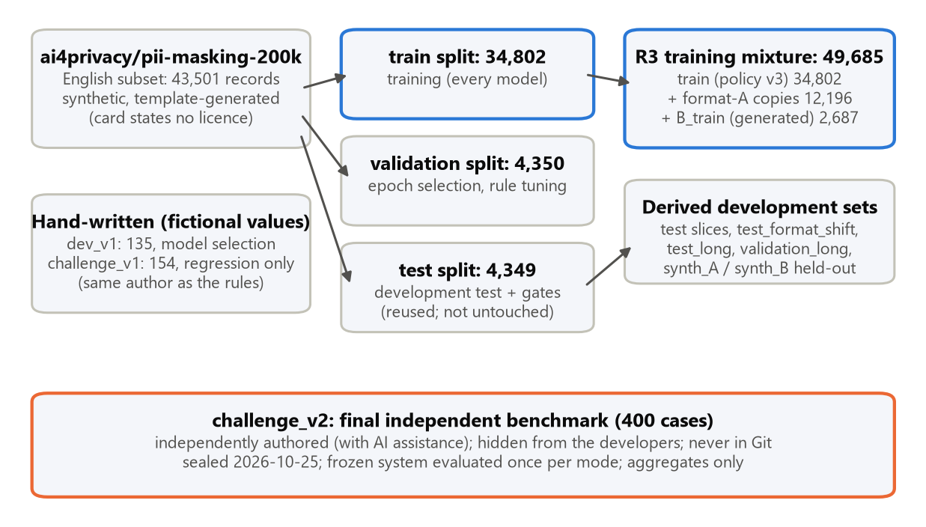
Figure 1. Data lineage and roles. Blue: training data; orange: the independent benchmark. Counts in documents.

3.4 Augmentation and generated data
- Round 1 augmentation (format family A). About half of the target-bearing training documents are copied with their target values re-rendered in other realistic formats (perturb.py; 12,196 copies under policy v3). Spans are re-mapped by construction. A different renderer (format family B, never trained on) produces the held-out set test_format_shift.
- Round 2 generated data (synth.py, generator round2-v1, seed 2026; 48 template families, 142 templates): A_train, 3,173 hard negatives (tracking, order and ticket numbers, versions, short numbers and similar look-alikes), and B_train, 2,687 difficult positives (lowercase names, credentials in JSON/YAML/SQL/CLI, CVVs with context). One whole template family per value group (11 of 48) is held out as synth_A_heldout (960, all ALLOW) and synth_B_heldout (776, all BLOCK).
- Quality gates and known overlap. Generated documents must pass scope, CVV-evidence and unannotated-name checks, and a contamination guard removes documents similar to dev_v1/challenge_v1 (maximum similarity reached 0.20). However, 20% of synth_B_heldout target values also occur in B_train (shared value pools), which flatters B-trained models such as R3.

3.5 Licences and sharing
Table 5. Licences and sharing restrictions.
Asset | Licence or terms | How it is shared
ai4privacy/pii-masking-200k and everything derived from it (augmented copies, synthetic evaluation sets) | the dataset card states no licence (checked 25 Oct 2026); redistribution is unresolved | kept out of Git; rebuilt locally from the raw file
Base model google-bert/bert-base-multilingual-cased [2] | Apache-2.0 | downloaded from Hugging Face for training only
Fine-tuned R3 checkpoint | a derivative of the above | private Google Drive folder; not in Git; no Git LFS
Generated data, hand-written dev_v1 and challenge_v1 | project-authored, fictional values; the repository has no licence file yet | hand-written sets and manifests in Git; bulk generated data rebuilt locally
challenge_v2 | private to its author and the team | never in Git; only four aggregate files are shared

4. System architecture
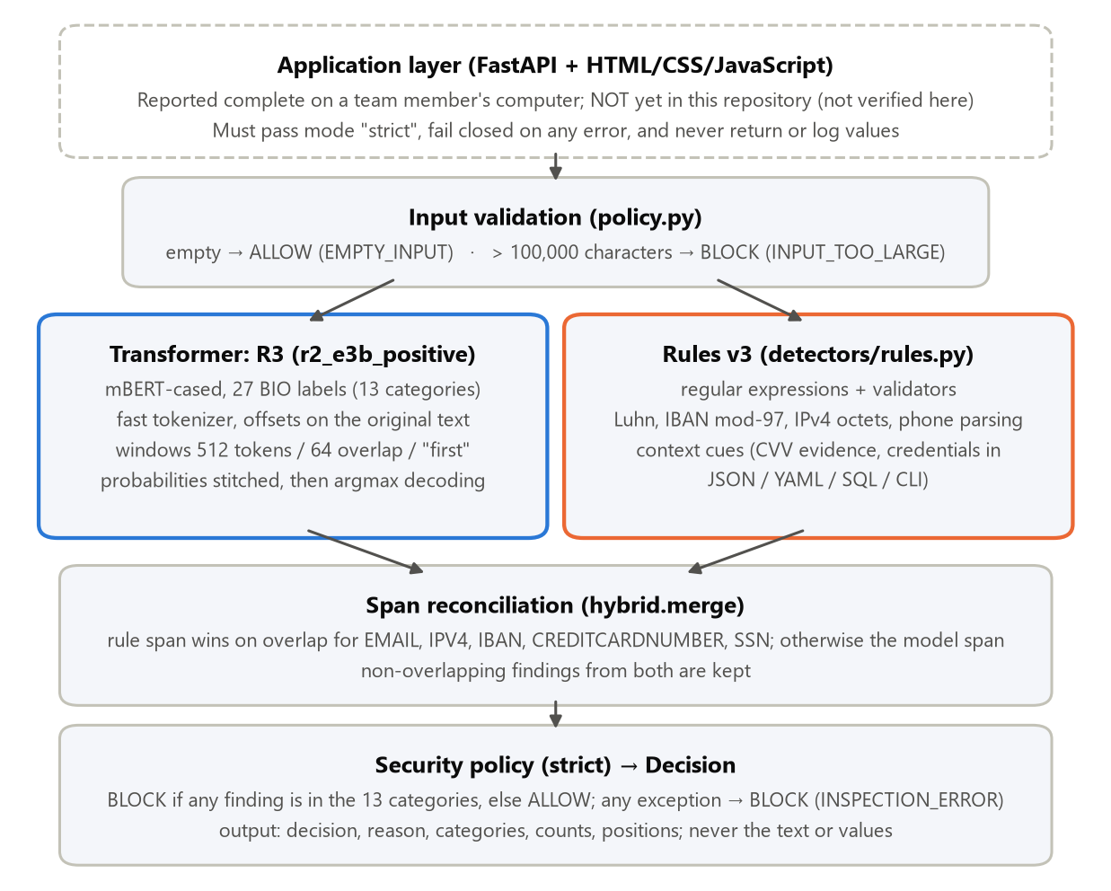
Figure 2. Inference architecture of the frozen detector. The dashed application layer is reported by a team member but not yet present in the repository.
A prompt passes through input validation and then through two detectors in parallel (Figure 2). The transformer tokenises the original text with character offsets, predicts BIO labels in sliding windows of 512 tokens with 64 tokens of overlap, stitches the token probabilities onto the whole document and then decodes spans, so an entity crossing a window boundary is one span. The rules (rules v3) combine regular expressions with validators (Luhn, IBAN mod-97 [19], IPv4 octet ranges, phone-number parsing [21]) and context cues. Reconciliation (hybrid.merge) gives the rule span priority on overlap for EMAIL, IPV4, IBAN, CREDITCARDNUMBER and SSN, whose boundaries the validators fix exactly; otherwise the model span wins, and non-overlapping findings from both are kept. The security policy blocks if any finding lies in the 13 categories.
Two security modes exist (configs/inference/policy.json). strict (argmax decoding + rules v3) is the primary product mode, and the application passes it explicitly. maximum (token threshold 0.05 + rules v3) is a secondary, experimental mode kept for reproducibility; it is never offered to users.
Properties are tested in the repository: offsets refer to the input characters; an entity past the first window is found; the policy fails closed; neither outputs nor logs contain values. Round 1 measurements on the development laptop's CPU (i7-1260P) give about 37 ms median per short prompt (p95 219 ms) and 0.6–2.9 s for documents of 600–1,000 tokens; the rules take under 1 ms, and the model occupies 709 MB on disk. Inference needs no GPU or network: weights load with local_files_only=True.

5. Regex baseline and the final hybrid approach
The repository contains four kinds of detector, which must not be confused (Table 6; full audit in reports/BASELINE_AUDIT.md).
Table 6. Baseline and final detectors, kept apart.
Detector | What it is | Evaluated?
A. Historical regex baseline (16 Oct 2026, commit 142f268) | 4 regex labels for the original Arabic scope (private_email, Saudi private_phone, national_id, iqama), Arabic-Indic digit normalisation, 7 unit tests. Removed at the scope change (e93b2cd); recoverable from Git history | Not evaluated. No dataset run is recorded; its benchmark notebook was empty. Not comparable with the final system (different language, labels and data)
B. Rule-based detectors rules_v1 → v2 → v3 | English, 13 labels: regex + validators + context cues; names and streets are left to the model. rules v3 is frozen in detectors/rules.py; its changes were decided on validation and dev_v1 | Development sets only
C. Transformer only (NER-only) | mBERT token classifier, argmax, no rules | Development sets only
D. Final hybrid system | R3 + rules v3 + policy, strict | Development sets and the independent challenge_v2
The final rules v3 is not the original baseline: it is a separate English detector written after the scope change. The off-the-shelf Presidio [9] (spaCy en_core_web_lg [10], minimum score 0.3) served as a second baseline in Round 1; its PERSON entity has to be split heuristically into first and last names, so its document-level results are the fairer comparison.

5.1 Development-time comparison, Round 1
Round 1 compared rules, Presidio, three transformers and the hybrid on the same label-policy-v2 evaluation files, with paired exact McNemar tests [13] on per-document correctness (Table 7, Figure 3). The hand-written challenge_v1 was written by the rules' author and its failures were later studied, so it is development evidence only.
Table 7. Round 1 comparison (exact-span entity F1; document False ALLOW / False BLOCK rates). Source: reports/history/ROUND1_REPORT.md §3.
Detector | Kind | test F1 | test FA / FB | format shift F1 / FA | challenge_v1 F1 | challenge_v1 FA / FB
rules_v2 | rules only | 0.485 | 54.4% / 0.2% | 0.544 / 47.1% | 0.636 | 28.3% / 1.7%
Presidio (min score 0.3) | off-the-shelf | 0.582 | 21.6% / 15.3% | 0.610 / 21.8% | 0.720 | 21.7% / 11.7%
original checkpoint-4352 | model only | 0.641 | 0.0% / 72.8% | 0.436 / 4.2% | 0.538 | 9.8% / 48.3%
E1 (policy v2) | model only | 0.984 | 0.1% / 1.0% | 0.566 / 10.5% | 0.652 | 19.6% / 20.0%
E2 (+ format augmentation) | model only | 0.984 | 0.1% / 1.1% | 0.603 / 2.8% | 0.728 | 7.6% / 16.7%
E2 + rules_v2 | hybrid | 0.983 | 0.1% / 1.3% | 0.754 / 2.2% | 0.805 | 2.2% / 18.3%
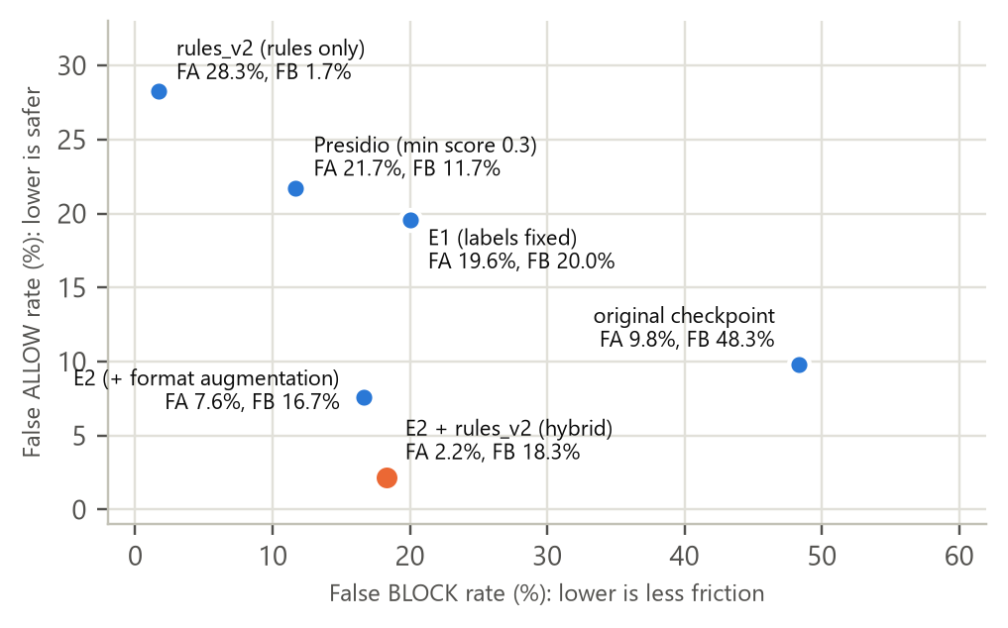
Figure 3. Leakage versus friction on challenge_v1 (92 BLOCK / 60 ALLOW documents), Round 1. Development evidence only.
The hybrid leaked least on both held-out sets; it leaked less than Presidio (discordant documents 1 versus 19, p < 0.001) and than the original model (p = 0.039). The rules alone were the most precise detector but missed names and context-dependent values, leaking 28% of challenge_v1 and 54% of the synthetic test documents.

5.2 Development-time ablation of the final system
Table 8. Rules v3 only, R3 transformer only and R3 + rules v3 (strict) on the same label-policy-v3 files: entity F1 · False ALLOW · False BLOCK (counts). Sources: reports/evidence/runs_v3/rules_v3/metrics.json, reports/evidence/final_system_metrics_r3.json.
Set (BLOCK / ALLOW documents) | Rules v3 only | R3 model only | R3 + rules v3 (strict)
test (3,055 / 1,068) | 0.481 · 1,677 · 1 | 0.985 · 3 · 10 | 0.984 · 3 · 11
test_format_shift (3,055 / 0) | 0.539 · 1,463 · — | 0.746 · 46 · — | 0.804 · 45 · —
test_long (45 / 28) | 0.341 · 29 · 0 | 0.877 · 2 · 5 | 0.865 · 2 · 5
synth_B_heldout (776 / 0) | 0.844 · 160 · — | 0.833 · 2 · — | 0.857 · 0 · —
synth_A_heldout (0 / 960) | — · — · 11 | — · — · 664 | — · — · 664
dev_v1 (56 / 75) | 0.676 · 18 · 1 | 0.649 · 0 · 27 | 0.685 · 0 · 27
challenge_v2 (200 / 200) | Not evaluated | Not evaluated | 0.677 · 2 · 70
On development data the answer to RQ1 is consistent: the rules alone rarely over-block but leak 21–64% of protected documents; the transformer alone catches far more; and the hybrid has the lowest leakage on unseen formats and difficult positives at about the transformer's false-block level. Rules v3 was tuned on validation and dev_v1, and R3 was selected on dev_v1, so the dev_v1 row is optimistic for both.
[PENDING: Baseline comparison — requires team approval before further evaluation.] No rules-only or transformer-only result exists on the independent challenge_v2; only the frozen hybrid was evaluated there, as pre-declared. The baseline audit recommends not running further configurations on the sealed benchmark (reports/BASELINE_AUDIT.md §6–7). If the team keeps this position, replace this placeholder with that statement.

6. Fine-tuning methodology, BIO alignment and preprocessing
The backbone is google-bert/bert-base-multilingual-cased (mBERT) [1, 2], the model of the team's original notebooks. It was kept fixed throughout: the confirmed weaknesses were data-coverage failures, and in-distribution F1 was already about 0.98, so a backbone change was not justified by the evidence (docs/METHODOLOGY.md §1).
- Tokenisation. A fast tokenizer with offset mapping on the original, un-normalised text, so offsets always refer to input characters.
- BIO alignment [6, 7]. 27 labels (B- and I- for each of the 13 categories, plus O). A subword inside a target span gets B-/I-; inside a hard-negative span, O. A subword inside an ignore span, straddling a span boundary or overlapping two annotations is ignored (-100). A target with any ignored token is ignored entirely, so no half-labelled entity is trained or scored.
- Training windows. At most 510 subword tokens plus [CLS]/[SEP]; each window re-reads up to 32 tokens of left context labelled -100, so every token is supervised exactly once. 95.0% of R3's tokens were supervised.
- Inference windows. 512 tokens, 64 overlap, first stitching (Section 7). Every token is predicted by exactly one window; probabilities are stitched before decoding.
- Evaluation. Character spans on the whole document (never per window): exact-span micro P/R/F1, relaxed overlap scores, "caught by any type" recall, an error taxonomy, and document-level BLOCK/ALLOW metrics.
Table 9. Training recipe of the final model R3 (checkpoints/r2_e3b_positive/training_summary.json).
Setting | Value | Setting | Value
Optimiser | AdamW [11], linear schedule, gradient clipping 1.0 | Learning rate / epochs | 2e-5 / 2
Batch / weight decay / warm-up | 16 / 0.01 / 10% | Precision / seed | fp16 mixed precision [12] / 42
Training documents / windows | 49,685 / 49,689 | Epoch selection | best validation entity F1: epoch 2, 0.9858
Checkpoint check | selected epoch reloaded from disk and re-scored (reload_ok) | Hardware and time | Google Colab T4 GPU; 883 s
Software (training) | Python 3.13.15, torch 2.11.0+cu130, Transformers 5.20.1 [4, 5] | Software (inference, frozen) | Python 3.13.0, torch 2.14.1 (CPU), Transformers 5.19.0
The recipe is that of the original notebook (Hugging Face Trainer). Two training-code defects were found: load_best_model_at_end re-initialised LayerNorm weights in memory, so the new loop reloads the selected epoch from disk and checks its score; and the scheduler advanced on fp16-skipped steps, a negligible deviation common to all runs and fixed for future runs.

7. Experiments and model-selection process
Each experiment changed one factor relative to its parent, and its result decided the next step. Results are reported at three levels that are never mixed: model (transformer only), hybrid (model + rules) and system (the full pipeline with the policy in a mode). On every development document, system strict equals hybrid.
Table 10. Experiment ladder: what each step tested, what happened, and why it mattered.
Step | What was tested | Result | Why it mattered
Metric correction | re-score the original checkpoint with out-of-scope entities visible (document-level spans) | validation F1 0.9925 → 0.643 (precision 0.476); 5,117 false positives on out-of-scope look-alikes; 74.5% of target-free documents blocked | the headline score was an artefact of policy v1; evaluation was rebuilt
E1: label policy v2 | train out-of-scope entities as O | synthetic precision fixed (test F1 0.984), but challenge_v1 leakage rose 9.8% → 19.6% (p = 0.004) | the original model looked robust only because it flagged almost everything
E2: format augmentation | add format-family-A copies | held-out-format leakage 10.5% → 2.8%; challenge_v1 19.6% → 7.6% (p = 0.003) | format diversity generalises; E2 became the baseline
E2 + rules_v2 | add deterministic rules | challenge_v1 False ALLOW 2.2%, False BLOCK 18.3% | the hybrid was the safest Round 1 system
Operating point | token threshold chosen on validation | t = 0.05: challenge_v1 False ALLOW 0%, False BLOCK 25.0% | a real leak-versus-friction trade-off that synthetic validation cannot settle; became the maximum mode
Round 2: R1–R4 | policy v3; + hard negatives (R2); + difficult positives (R3); + both (R4) | Section 8 | data-centric fixes for the remaining errors
Checkpoint verification | re-run R3 locally on CPU | all 18,425 archived predictions reproduced (identical spans, probabilities within 2.2e-5) | the local checkpoint is the evaluated model
Window study | centered stitching, 256- and 128-token windows | no candidate changed a decision on validation_long; 512/64/first kept | pre-registered rule; test_long favoured shorter windows but was report-only
IPv4 validation gate | drop model IPV4 spans that are not valid addresses | criteria met, but a probe showed spaced or mistyped addresses turning BLOCK into ALLOW; rejected, code removed | a format check must not let a possibly sensitive value through
Freeze | fingerprint weights, policy, rules and code | frozen 24 Oct 2026 20:43, code commit 4907107 | the final evaluation could only run on this exact system
Rates are compared with exact McNemar tests on paired documents, and False ALLOW / False BLOCK rates carry Wilson 95% intervals [14]. With 50–100 documents per class, differences of fewer than about five documents are usually not significant, and this is reported rather than hidden.

8. R3 selection rationale
The Round 2 selection rule was written before any Round 2 result existed (docs/METHODOLOGY.md §6). Every candidate was scored as model + rules v3 with argmax decoding against its parent, on: leakage non-inferiority (dev_v1, synth_B_heldout, test_format_shift); a benefit (dev_v1 or the held-out families); and no regression on test. R4 could be preferred only if R2 and R3 both passed the leakage criterion.
Table 11. Outcome of the pre-registered rule (reports/evidence/round2_selection.json).
Candidate vs parent | Leakage non-inferiority | Benefit | No regression | Result
R1 (policy v3) vs R0 | pass (dev_v1 FA 3 vs 5) | not required (label fix) | pass | pass
R2 (+ hard negatives) vs R1 | fail: synth_B_heldout FA 26 vs 0 (p = 3×10⁻⁸); dev_v1 5 vs 3 | dev_v1 FB 8 vs 24 | pass | fail
R3 (+ difficult positives) vs R1 | pass (dev_v1 0 vs 3; format shift 45 vs 68, p = 0.0003) | dev_v1 FA 0 < 3 | pass (F1 −0.001) | pass: selected
R4 (+ both) vs R1 | pass (dev_v1 3 vs 3) | dev_v1 FB 12 vs 24 (p = 0.004) | pass | pass, but ineligible
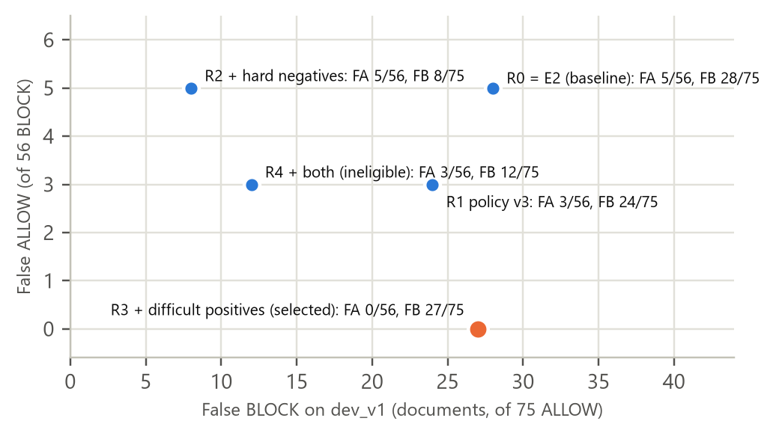
Figure 4. Round 2 candidates on dev_v1, system strict (56 BLOCK / 75 ALLOW). R3 is the only candidate with no observed leak.
The rule worked as designed, but its trade-off is explicit. R4 would have more than halved false blocks (dev_v1 12 versus 27 of 75, p = 0.0003; held-out hard negatives 187 versus 664 of 960), at the cost of significantly more leakage on unseen value formats (67 versus 45 of 3,055, p = 0.001). Choosing R4 would have meant re-weighting security against usability, a product decision that would have had to be taken before the independent evaluation; it was not taken. Against the Round 1 system (R0 = E2 + rules), R3 is a security improvement rather than a usability one: dev_v1 False ALLOW 0 versus 5 of 56 (p = 0.06), format-shift leakage 45 versus 61 (p = 0.014), and False BLOCK unchanged (27 versus 28).
Table 12. Operating points of R3 + rules v3 on dev_v1 (reports/history/ROUND2_REPORT.md §8).
Decoding | Minimum span score | False ALLOW / 56 | False BLOCK / 75
argmax (strict) | 0 | 0 | 27
argmax | 0.9 | 2 | 19
argmax | 0.99 | 3 | 13
token threshold 0.1 | 0 | 0 | 31
token threshold 0.05 (maximum) | 0 | 0 | 32
strict was declared the primary mode because it is the only point with no observed leak that does not add false blocks. Every precision setting traded leaks for usability, and 68% of R3's false-positive spans on dev_v1 scored at least 0.9, so no threshold separates them from true positives.

9. Final evaluation on challenge_v2: methodology and results

9.1 Protocol, as executed
- Authorship. challenge_v2 was written and annotated independently of the developers, with AI assistance, following the handoff specification docs/CHALLENGE_V2_HANDOFF.md (v1.0). It was not written and annotated entirely by hand by the team. The developers never saw the cases, the detector's output on them or any per-case result.
- Freeze before data. The system was frozen on 24 October 2026 (configs/inference/frozen_system.json: sha256 of every checkpoint file, the policy and 12 inference-code files, the windows and the runtime versions). The evaluation tooling was then hardened (commit c8300ec) without touching the detector.
- Seal and single evaluation. The file was validated and sealed on 25 October 2026 at 17:38 (sha256 e3f7408185878e8a053eb8748f97c16c5da06b82859d9afda50a3320eb020f8c). strict was evaluated once at 17:48 (primary, pre-declared), then maximum once at 18:00 (secondary). The ledger holds exactly these two entries, each recording the frozen identity and a fingerprint of the predictions.
- No change afterwards. The system was not modified in response to the results; any change would require a new independent set.
Table 13. challenge_v2 composition (aggregates only; SEAL.json and the result files).
Item | Value
Cases | 400: 200 BLOCK, 200 ALLOW, 0 ambiguous
Gold target entities | 236 across all 13 labels (FIRSTNAME and LASTNAME 31 each, PHONENUMBER and SSN 15 each, every other label 16)
Look-alike annotations | 166 spans of 25 out-of-scope types (tracking, version, API key, …)
Tags | structured 171; lookalike 152 (110 ALLOW); difficult-positive 80; long 72; unfamiliar-format 72; oos-secret 21; all tagged enterprise
Lengths | 328 cases ≤ 1,000 characters; 72 long cases > 3,000 characters; none in between

9.2 Results
Table 14. challenge_v2 results of the frozen R3 + rules v3 (reports/challenge_v2/result_r2_e3b_positive_{strict,maximum}.json). Entity metrics are exact-span micro averages; document metrics treat BLOCK as the positive class.
Metric | strict (primary) | maximum (secondary)
Entity micro F1 | 0.677316 | 0.618076
Entity precision | 0.543590 | 0.471111
Entity recall | 0.898305 | 0.898305
Entity TP / FP / FN | 212 / 178 / 24 | 212 / 238 / 24
Document (BLOCK) F1 | 0.846154 | 0.834382
Document precision | 0.738806 | 0.718412
Document recall | 0.990000 | 0.995000
False ALLOW (95% Wilson CI) | 2/200 = 1.0% (0.3–3.6%) | 1/200 = 0.5% (0.1–2.8%)
False BLOCK (95% Wilson CI) | 70/200 = 35.0% (28.7–41.8%) | 78/200 = 39.0% (32.5–45.9%)
Accuracy; confusion TP / FN / FP / TN | 0.820; 198 / 2 / 70 / 130 | 0.8025; 199 / 1 / 78 / 122
Gold entities overlapped by a finding of any type | 0.983 | 0.987
Entity-level metrics measure whether each protected value is found with the right label and exact boundaries; document-level metrics measure the BLOCK/ALLOW decision that the user experiences. The two diverge because a document is blocked as soon as any one finding is made: 98.3% of gold entities were overlapped by some finding, so most of the 24 exact-span misses still led to a correct BLOCK. maximum brought no measurable security benefit (the same entity recall; one fewer False ALLOW, with overlapping intervals) for 8 more false blocks and 60 more false-positive entities, confirming the choice of strict.
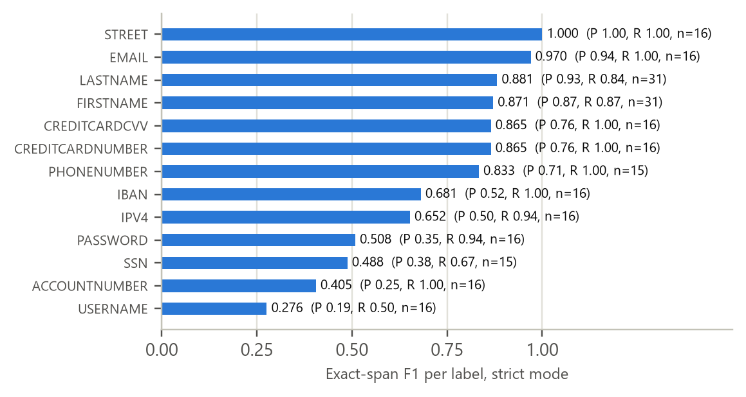
Figure 5. Per-label exact-span F1 on challenge_v2, strict mode (support 15–31 per label).

9.3 Independent versus development results
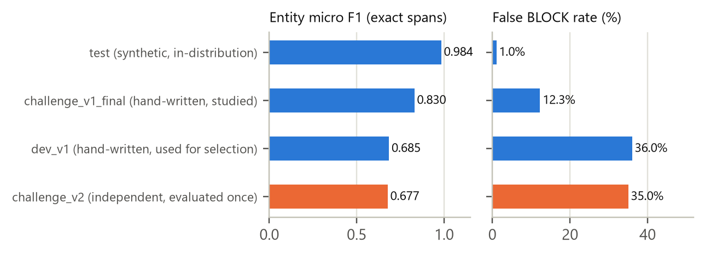
Figure 6. The synthetic-to-realistic gap (strict). Blue: development evidence; orange: the independent benchmark.
The independent result agrees closely with the hand-written development set dev_v1 (entity F1 0.677 versus 0.685; False BLOCK 35% versus 36%), so the selection set was a fair proxy and its warning about false blocks is confirmed on independent text (RQ3). It is far below the synthetic in-distribution score of 0.984, which measured the source distribution rather than realistic prompts (RQ2). challenge_v1_final looks better because its failures were studied during development.

9.4 Limitations of the benchmark
- It is a synthetic, constructed challenge set, not a representative sample of real enterprise traffic. Its composition is highly regular, and its 50/50 class balance is a design choice; the real share of protected prompts, and hence the practical cost of a 35% False BLOCK rate, is unknown.
- One author (with AI assistance), one evaluation, one training seed; the intervals cover sampling noise in these 400 cases only. Subgroups are small (4–6 ALLOW cases per look-alike type; 21 oos-secret cases; 2 False ALLOWs), and causes are inferred from aggregates because per-case details were deliberately withheld. Similarity to the training data was not reported.

10. Error analysis and significant failure modes
False BLOCK is the dominant error, and it sits on look-alike identifiers. In strict, 64 of the 70 false blocks are among the 110 ALLOW cases tagged lookalike (58%), against 6 of the other 90 ALLOW cases (7%); 124 of the 178 entity false positives (70%) lie on annotated look-alikes (Figure 7).
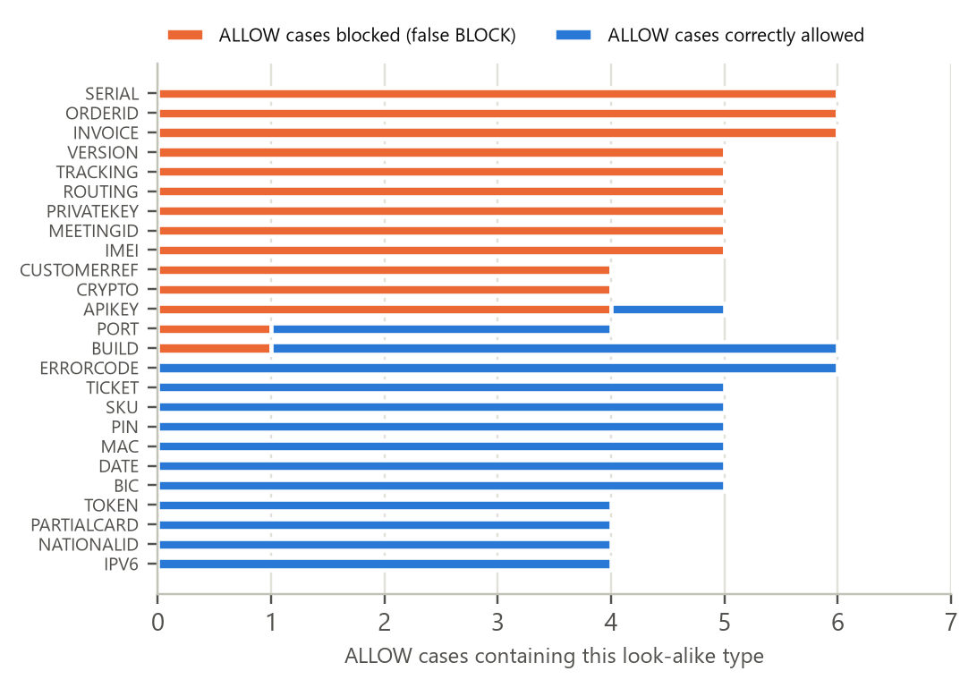
Figure 7. challenge_v2 ALLOW cases by look-alike type, strict mode. A case can contain several types, and another finding may have caused a block, so per-type rates are indicative only.
- Long digit and alphanumeric identifiers (tracking, serial, order, invoice, routing and meeting numbers) are taken for ACCOUNTNUMBER, IBAN or SSN: tracking numbers alone caused 36 false positives (21 ACCOUNTNUMBER, 15 IBAN). The same weakness appeared on dev_v1 (all 27 false blocks are on cases tagged as hard negatives; none of the 10 ordinary prompts was blocked) and on the held-out hard-negative families (664 of 960 blocked).
- Version strings with four dotted numbers are taken for IPV4 (14 false positives).
- Out-of-scope secrets. API keys are predicted as PASSWORD (19 false positives), crypto addresses as PASSWORD and private keys as ACCOUNTNUMBER; 9 of the 12 ALLOW cases tagged oos-secret are blocked. Blocking a secret is safe for confidentiality, but it is friction outside the 13 categories, and policy decision F counts it as an error.
- Harmless values that rarely misfire: dates, error codes, PINs, SKUs, tickets, BIC codes, MAC and IPv6 addresses, national ids and partial cards caused no false positive.
- Leakage is low but not zero. strict allowed 2 of 200 protected cases, tagged difficult-positive, long and unfamiliar-format (tags overlap). USERNAME is the weakest label (recall 0.50, precision 0.19); SSN values are often found with the wrong boundaries or type.
- Long documents. On the 72 long cases, strict had 1 False ALLOW (of 27 BLOCK) and 10 False BLOCKs (of 45 ALLOW). Development analysis traced long-input errors to tokens just before a window cut (predicted without right context) and to window positions beyond 128 tokens, which training barely covered (99.7% of supervised tokens sat at positions 0–127).
- Known gaps from fictional probes with RFC 5737 documentation addresses [20] (no evaluation set contains them): defanged IPv4 addresses ([.], (dot)) and comma-separated octets are not detected; leading-zero addresses are blocked under the wrong label.
- Thresholds cannot remove these errors: most false-positive spans are high-confidence model predictions (68% of R3's dev_v1 false positives score ≥ 0.9). The Round 2 hard-negative data (R4) reduced them substantially but was not eligible under the pre-registered rule (Section 8).
Error taxonomy (strict; maximum in brackets): of the 24 missed entities, 15 (15) are type confusions, 5 (6) boundary errors and 4 (3) entirely missed; of the false positives, 124 (158) lie on look-alikes, 32 (54) are spurious, 17 (19) are type confusions and 5 (7) boundary errors.

11. Application architecture and FastAPI integration status
The detector exposes a small, tested Python interface. ConfidentialityDetector.load(model_dir, policy_path, device="cpu") loads the checkpoint once (about 0.7 GB in memory) and refuses missing or mismatched weights. inspect(text, "strict") returns a Decision whose to_dict() holds the decision, reason, mode, categories and findings (start, end, label, source, score), and never the text or values. A command-line interface returns exit code 0 for ALLOW, 10 for BLOCK and 2 when the detector cannot be loaded.
Table 15. Integration status: what is verified in the repository and what is only reported.
Component | Status | Evidence
Detector package, CLI, policy, value-free logging | verified in the repository; frozen | src/confidentiality_detector/; docs/INTEGRATION.md §2; automated tests (162 on 25 Oct 2026; not re-run for this report)
Identity check on a second computer | verified tooling | scripts/check_frozen_identity.py (no model run, no evaluation data)
HTML/CSS/JavaScript frontend and FastAPI backend [23] | reported complete by a team member on that member's computer; not yet pushed; not verified here | none in the repository; endpoints and request formats not yet documented
Integration duties (strict mode, fail closed, no values, replaced 422 handler, serialised calls) | specified, not yet verified | docs/INTEGRATION.md §3–5
API-equals-direct-inference consistency test | planned | docs/INTEGRATION.md §7
Manual integration and demo tests (34 cases) | template ready; not executed | docs/INTEGRATION_TEST_PLAN.md
The integration is planned to arrive on a feature branch that leaves src/confidentiality_detector/ and configs/inference/ unchanged and passes a consistency test (API decision, reason, categories and positions equal to direct inference). A network failure, timeout, unparsable response or unavailable detector must end in BLOCK in the frontend. The manual test plan is acceptance testing and demo preparation; it is not an ML evaluation.

12. Model artifacts and reproducibility
- Checkpoint. Six files, 709 MB of weights (sha256 dc0fdca5…; full identities in Appendix D). They are not in Git, and Git LFS is not used; they are shared through a private Google Drive folder whose link is deliberately not recorded. Training-run archives and Colab bundles are identified by sha256 in reports/ARTIFACTS.md.
- Frozen identity. frozen_system.json hashes every checkpoint file, the policy, the 12 inference-code files, rules v3 and the windows, plus runtime versions pinned by uv.lock [22]. scripts/check_frozen_identity.py confirms on any computer that the detector is the same (checkpoint bytes, policy, rules, windows, code content).
- Data and limits. Raw third-party data is not in Git; generated and evaluation sets rebuild deterministically from it (all 19 files byte-identical on 24 October 2026). Byte-level re-verification (verify-frozen) works only on the freezing computer (line endings, Python patch level); cross-computer decisions are expected to match but are unmeasured; one training seed per configuration, so the stored checkpoint is the reproducibility anchor.

13. Responsible AI, privacy, ethics and limitations

13.1 Privacy by design
Inspection runs locally with no network access, and the model loads only from a local folder. Outputs and logs carry categories, counts and positions but never values; even value shapes are withheld, because a password's length is itself sensitive. All training and evaluation data is synthetic or fictional: phone numbers use the reserved 555-01xx range, cards are public test or generated numbers, IBANs are specimens or generated with valid checksums, and names are invented except deliberate public figures. The independent benchmark tooling never prints case text.

13.2 Security, usability and fairness
- Security first, at a measurable cost. The design minimises leakage, and the system fails closed. In return, about one harmless prompt in three was blocked on the independent benchmark. In practice this would cause friction and could push users towards workarounds; it is the main reason the system is not ready for deployment.
- Public figures. By policy, names of public figures are protected names, so a harmless request such as summarising a famous scientist's work is blocked. This is an intended cost, not counted as an error.
- Fairness. Names are learned from English-centred synthetic data. Behaviour on names from other cultures and on other languages has not been measured, so detection quality may differ across groups of people.

13.3 Limitations
- Not production-ready. No real employee prompts have been evaluated; every number comes from synthetic, hand-written or independently authored synthetic data, with one independent benchmark, one training seed and latency measured on one laptop CPU.
- Not adversarially robust. Deliberately split, encoded or obfuscated values will usually pass; the target is accidental disclosure.
- Scope. English only; 13 categories; API keys, tokens and other secrets are out of scope. Fail-closed protection holds only if the calling application honours BLOCK on errors.
- Licensing. The training dataset's card states no licence, so redistribution of derived data and of the fine-tuned weights is unresolved.

13.4 Disclosure of AI assistance
Generative AI assistance was used in this project and is disclosed here. The repository's commits from 24 October 2026 onwards, which contain the detector package, the Round 1–2 pipeline, the analyses, the freeze tooling and the documentation, carry a co-author trailer for an AI coding assistant (Claude, used through Claude Code). The challenge_v2 benchmark was authored independently of the developers with AI assistance. This report was drafted with AI assistance from the repository's evidence files. [PENDING: team to confirm the extent of AI assistance in each part of the work and in the final editing of this report.]

14. Conclusion and future work
The project delivered a local, fail-closed detector for 13 categories of sensitive information, with a documented and frozen identity and an independent evaluation. RQ1: on development data, combining a fine-tuned transformer with deterministic rules gave the lowest leakage: the rules alone leaked 21–64% of protected documents, while the hybrid leaked none on dev_v1 and the fewest on unseen formats. No component-level comparison exists on the independent benchmark. RQ2: synthetic in-distribution scores were a poor guide: entity F1 fell from 0.984 on the synthetic test to 0.685 on hand-written text, and the original 0.9925 was a metric artefact. RQ3: on the independent challenge_v2 the frozen system leaked 1.0% of protected cases but blocked 35.0% of harmless ones (BLOCK F1 0.846, entity F1 0.677), mostly on look-alike identifiers.
The following are recommendations, not completed work:
- Reduce false blocks with data rather than thresholds (the R4 recipe is the evidence), under a new pre-registered rule, a new development set and a new independent benchmark, since challenge_v2 is now used.
- Collect a governed sample of real prompts with consent and a privacy review, annotated by two people with measured agreement; then run a shadow deployment that logs decisions without text.
- Train the final configuration with at least three seeds and report the variance; build a larger long-document validation set; measure latency on target hardware.
- Merge and verify the frontend and FastAPI integration, run the consistency and manual acceptance tests, and clarify the dataset licence before any release of the weights.

15. Team contributions
The team began with three members; one withdrew during the bootcamp and the instructors were informed. The two remaining members completed the project. Table 16 lists only what the Git history records. Commit authorship shows who committed, not necessarily who did the work: Colab training runs, coordination with the independent benchmark author and the frontend and API work are not visible in the commit list.
Table 16. Contributions recorded in the Git history (by account handle).
Git handle | Commits | Recorded work
nada00kh | 5 | initial commit and project structure (7 Oct); Arabic scoped EDA (17 Oct); English ai4privacy EDA notebook (19–20 Oct)
n3gm | 13 | environment setup (7 Oct); initial data exploration (9 Oct); historical regex baseline and original scope (16 Oct); mBERT splitting, alignment and fine-tuning notebooks (21 Oct); seven AI-co-authored commits (24–25 Oct): detector package, Rounds 1–2, freeze, challenge_v2 tooling and final documentation
(not in the repository) | — | HTML/CSS/JavaScript frontend and FastAPI integration, reported complete on a team member's computer
[PENDING: member names, the mapping of names to Git handles, and an agreed description of each member's contributions (including the frontend/API integration, Colab training, evaluation and report writing). Do not finalise this section from the commit list alone.]

16. References
[1] Devlin, J., Chang, M.-W., Lee, K., & Toutanova, K. (2019). BERT: Pre-training of deep bidirectional transformers for language understanding. In Proceedings of NAACL-HLT 2019 (pp. 4171–4186).
[2] Google. bert-base-multilingual-cased [Model card]. Hugging Face. https://huggingface.co/google-bert/bert-base-multilingual-cased (Apache-2.0).
[3] ai4privacy. pii-masking-200k [Dataset card]. Hugging Face. https://huggingface.co/datasets/ai4privacy/pii-masking-200k (card checked 25 October 2026: no licence stated).
[4] Wolf, T., et al. (2020). Transformers: State-of-the-art natural language processing. In Proceedings of EMNLP 2020: System Demonstrations (pp. 38–45).
[5] Paszke, A., et al. (2019). PyTorch: An imperative style, high-performance deep learning library. In Advances in Neural Information Processing Systems 32.
[6] Ramshaw, L. A., & Marcus, M. P. (1995). Text chunking using transformation-based learning. In Proceedings of the Third Workshop on Very Large Corpora.
[7] Tjong Kim Sang, E. F., & De Meulder, F. (2003). Introduction to the CoNLL-2003 shared task: Language-independent named entity recognition. In Proceedings of CoNLL-2003.
[8] Nakayama, H. (2018). seqeval: A Python framework for sequence labeling evaluation. https://github.com/chakki-works/seqeval
[9] Microsoft. Presidio: Data protection and de-identification SDK. https://github.com/microsoft/presidio
[10] Honnibal, M., Montani, I., Van Landeghem, S., & Boyd, A. (2020). spaCy: Industrial-strength natural language processing in Python. Zenodo. https://doi.org/10.5281/zenodo.1212303
[11] Loshchilov, I., & Hutter, F. (2019). Decoupled weight decay regularization. In Proceedings of ICLR 2019.
[12] Micikevicius, P., et al. (2018). Mixed precision training. In Proceedings of ICLR 2018.
[13] McNemar, Q. (1947). Note on the sampling error of the difference between correlated proportions or percentages. Psychometrika, 12(2), 153–157.
[14] Wilson, E. B. (1927). Probable inference, the law of succession, and statistical inference. Journal of the American Statistical Association, 22(158), 209–212.
[15] Lison, P., Pilán, I., Sánchez, D., Batet, M., & Øvrelid, L. (2021). Anonymisation models for text data: State of the art, challenges and future directions. In Proceedings of ACL-IJCNLP 2021 (pp. 4188–4203).
[16] Mitchell, M., et al. (2019). Model cards for model reporting. In Proceedings of the Conference on Fairness, Accountability, and Transparency (FAT* '19) (pp. 220–229).
[17] Gebru, T., et al. (2021). Datasheets for datasets. Communications of the ACM, 64(12), 86–92.
[18] Luhn, H. P. (1960). Computer for verifying numbers. U.S. Patent No. 2,950,048.
[19] ISO 13616-1:2020. Financial services: International bank account number (IBAN), Part 1: Structure of the IBAN. International Organization for Standardization.
[20] Arkko, J., Cotton, M., & Vegoda, L. (2010). IPv4 address blocks reserved for documentation (RFC 5737). IETF.
[21] Drysdale, D. python-phonenumbers: Python port of Google's libphonenumber. https://github.com/daviddrysdale/python-phonenumbers
[22] Astral. uv: Python package and project manager [Documentation]. https://docs.astral.sh/uv/
[23] Ramírez, S. FastAPI [Documentation]. https://fastapi.tiangolo.com/
[24] mabahboh. sitr-arabic-pii [Dataset]. Hugging Face (used only in the project's early, abandoned Arabic exploration).
Project documents cited throughout (for example docs/METHODOLOGY.md, reports/FINAL_REPORT.md) are files in the team's repository; Appendix B maps each claim to its evidence file. The model card in reports/FINAL_REPORT.md §9 follows [16]; docs/DATASETS.md follows the spirit of [17].

Appendix A. Glossary of metrics and terms
Term | Meaning
False ALLOW (FA) | a protected (gold BLOCK) document that the system allows; the rate is over gold BLOCK documents. The primary security metric
False BLOCK (FB) | a harmless (gold ALLOW) document that the system blocks; the rate is over gold ALLOW documents. The friction metric
Document (BLOCK) precision / recall / F1 | BLOCK is the positive class; ambiguous documents are excluded and counted
Entity exact (strict) P/R/F1 | a predicted span counts only if start, end and label all match a gold span; micro-averaged over labels
Relaxed / overlap recall | same label and any overlap; credits boundary errors, never type errors
Caught (any type) | share of gold entities overlapped by any prediction; the leakage-relevant entity measure
Look-alike / hard negative | an out-of-scope value that resembles a target (order number, version, API key); any prediction on it is a false positive
Model / hybrid / system level | transformer only / transformer + rules / the full pipeline with the security policy in a mode
Wilson interval; McNemar test | 95% confidence interval for a proportion [14]; exact paired test on per-document correctness [13]

Appendix B. Evidence index
Claim or number in this report | Evidence file
challenge_v2 results, look-alike and tag breakdowns | reports/challenge_v2/result_r2_e3b_positive_strict.json, …_maximum.json, SEAL.json, LEDGER.jsonl
R3 model-only, hybrid and system metrics on development sets | reports/evidence/final_system_metrics_r3.json; reports/FINAL_REPORT.md §3
Rules v3-only metrics | reports/evidence/runs_v3/rules_v3/metrics.json
Round 1 comparison and McNemar tests | reports/history/ROUND1_REPORT.md; reports/evidence/round1_analysis.json
Round 2 runs, selection and operating points | reports/history/ROUND2_REPORT.md; reports/evidence/round2_system_eval.json, round2_selection.json, operating_points_r2_e3b_positive__rules_v3_dev_v1.json
Original 0.9925 and its correction; dataset audit | reports/history/INVESTIGATION.md; reports/evidence/dataset_audit.json
Window study; IPv4 gate; checkpoint verification | docs/METHODOLOGY.md §7–8; reports/evidence/window_study_r2_e3b_positive.json, ipv4_gate_study.json, checkpoint_verification_r2_e3b_positive.json
Training recipe and data of R3 | checkpoints/r2_e3b_positive/training_summary.json; configs/experiments/r2_e3b_positive.json
Datasets, counts and roles | docs/DATASETS.md; docs/DATA_PIPELINE.md §0; data/eval_v3/manifest.json; data/synth/round2/manifest.json
Baseline history | reports/BASELINE_AUDIT.md; Git commits 142f268, e93b2cd
Frozen identity and artifacts | configs/inference/frozen_system.json; reports/ARTIFACTS.md; docs/INTEGRATION.md

Appendix C. Items pending team input
- Team member names and the agreed contribution statement (title page, Section 15).
- The official one-sentence description of Track F (Section 1.3).
- The team's decision on the missing baseline comparison on challenge_v2 (Section 5.2); the audit recommends no further evaluation.
- Confirmation of the extent of AI assistance (Section 13.4).
- Integration status once the teammate's frontend and FastAPI branch is pushed and the consistency and manual tests have been run (Section 11).
- Optional: the reason for moving from the Arabic to the English scope (Section 1.3), if the instructors expect it.

Appendix D. Identity of the frozen checkpoint
Table 17. The frozen checkpoint r2_e3b_positive (configs/inference/frozen_system.json; docs/INTEGRATION.md §1.2).
File | Bytes | sha256
model.safetensors | 709,157,780 | dc0fdca52f9e144b4017cb8eb37d8cef0d366b5b9619c519a782102ef32850c6
config.json (architecture, 27 BIO labels) | 2,139 | f5132da68b978b176383f7ee25d86215727701a9a05aeb534ea9746d6d29a13e
tokenizer.json | 2,919,362 | bf1b59b7b11c95f194f51708d918eea378e09d05f84c0e1656dc5180e8117088
tokenizer_config.json | 352 | 9cd988573a9588a6085cd353eeefa09b803dba75b03f58d0c1d302aad3078193
training_summary.json (provenance) | 3,737 | 072fd554519ad1041309027e29ba74781dcf7a94b188aad26f1d3e8e0036c704
history.json (provenance) | 1,671 | c0d0760b591b7a32a883406c9c815c36dc6d009b3301aa9a5ff79baab7428f91

