WASHQ
Detecting confidential information locally before text reaches external AI services
Confidentiality Detector: a hybrid transformer-and-rules system and its local demonstration application

Programme: OLO Academy AI Engineering Bootcamp: Capstone Project, Track F
Team: [PENDING: full names of the two team members]
Document: Final submission report (a detailed technical report is kept as a separate reference)
Date: 30 October 2026
Abstract
Employees increasingly paste workplace text into external large language model (LLM) services, which risks the accidental disclosure of personal, financial and credential data. This project developed Confidentiality Detector, a local check that inspects English text before it is shared and returns BLOCK or ALLOW for 13 protected categories, and WASHQ, a local web application that presents the decision together with a masked preview. The evaluated core combines a fine-tuned multilingual BERT token classifier (R3) with deterministic English validation rules (rules v3) under a fail-closed security policy. Development showed that the original validation F1 of 0.9925 was a measurement artefact (0.643 after correction) and that synthetic in-distribution scores (entity F1 0.984) greatly overstate performance on realistic, hand-written text (0.685). A model-selection rule fixed before the second experimental round chose R3; the system was then frozen and evaluated once on Challenge v2, an independently authored and sealed benchmark of 400 synthetic documents. In the primary strict mode it allowed 2 of 200 protected documents (False ALLOW 1.0%) but blocked 70 of 200 harmless ones (False BLOCK 35.0%), with a document-level BLOCK F1 of 0.846 and an entity-level exact-match F1 of 0.677. Most false blocks fall on harmless look-alike identifiers such as tracking and order numbers. WASHQ additionally contains a small Saudi regular-expression extension for demonstration only; it was not evaluated. The system is a research prototype, not a production security control.
Contents
1. Problem statement and target users 2
2. Motivation and project objectives 3
3. Data sources, preprocessing and dataset splits 3
4. Proposed hybrid architecture 5
5. Model training and methodology 6
6. Baselines and experiments 6
7. R3 model selection and justification 7
8. Independent Challenge v2 evaluation 8
9. Error analysis and limitations 10
10. WASHQ application and integration 11
11. Responsible AI and privacy considerations 13
12. Conclusion and future work 13
13. Team contributions 14
14. References 14
Appendix A. Training and inference configuration 15
Appendix B. Glossary of metrics 15
Appendix C. Evidence and detailed documentation 15

1. Problem statement and target users
Generative AI assistants are now part of everyday office work: employees paste e-mails, support tickets, logs, code and meeting notes into them to summarise, rewrite or debug. When such text contains personal data, financial identifiers or credentials, sending it to an external service discloses it outside the organisation's control, usually by accident rather than intent. The problem addressed in this project is therefore: given a text that an employee is about to share with an external AI service, decide locally, before it leaves the computer, whether it contains protected information, and explain the decision without repeating the sensitive values.
The project has two layers. Confidentiality Detector is the research core: a detector for exactly 13 categories in English text (Table 1), developed and evaluated in this project. WASHQ is the local web application built around it for the capstone demonstration (Section 10).
Table 1. The 13 protected categories and what is explicitly out of scope.
Group | Protected labels | Explicitly out of scope
Identity and contact | FIRSTNAME, LASTNAME, USERNAME, EMAIL, PHONENUMBER, STREET, SSN | API keys, access tokens, private keys; one-time codes and PINs
Financial | CREDITCARDNUMBER, CREDITCARDCVV (only with contextual evidence), IBAN, ACCOUNTNUMBER | BIC/SWIFT, routing and sort codes; order, ticket, invoice and tracking numbers
Credentials and network | PASSWORD, IPV4 | IPv6 and MAC addresses; other languages, files and deliberately obfuscated text
Three groups of users are targeted:
- Employees who use external AI assistants and need a fast, understandable warning before sensitive information leaves the organisation.
- IT and security administrators who run the check locally and need predictable, fail-closed behaviour and logs that contain no sensitive values.
- Privacy and compliance staff who need to know what the check protects, how well, and what it does not cover.
The work is the capstone project of the OLO Academy AI Engineering Bootcamp, Track F. The team began with three members; one member withdrew during the bootcamp, the instructors were informed, and the remaining two members completed the project. The instructors confirmed that a vector database is not required for this project, so none is used. The project first explored an Arabic, regular-expression-centred scope; that direction was abandoned in favour of English text and a learned model, and its material is archived as project history only.

2. Motivation and project objectives
Three observations from the early work shaped the design. First, regular expressions are precise for structured identifiers with checksums or fixed formats, but blind to context-dependent categories such as names, usernames and passwords. Second, an off-the-shelf PII framework such as Microsoft Presidio [1] has no recogniser for several target categories (PASSWORD, USERNAME, CVV, STREET). Third, a transformer fine-tuned for token classification [2] learns context, but its scores on synthetic data can be misleading; the text-anonymisation literature likewise stresses measuring actual disclosure risk rather than token-level accuracy [3]. A hybrid of a learned model and deterministic rules therefore looked promising, provided that it was evaluated on text unlike its training data. The project pursued four objectives:
- RQ1 (design). Does a hybrid of a fine-tuned transformer and deterministic rules leak less than either component alone, and at what cost in false blocks?
- RQ2 (evaluation). How far do synthetic in-distribution scores overstate performance on realistic, hand-written text?
- RQ3 (independent test). How does the selected system, frozen in advance, perform on an independent benchmark that its developers never saw?
- O4 (application). Deliver a local application that applies the decision safely: it fails closed on errors, never stores or logs sensitive values, and explains decisions by category.
The success criteria were fixed before the final evaluation: minimise False ALLOW (protected text let through) first; report False BLOCK (harmless text blocked) alongside it without inventing a target; select the final model with a pre-registered rule; and test it once on a sealed benchmark. No numerical pass mark was declared for that benchmark, so its results are reported as measured rather than as pass or fail.

3. Data sources, preprocessing and dataset splits

3.1 Source data and why it was not sufficient
Training text comes from ai4privacy/pii-masking-200k [4], a synthetic, template-generated PII dataset. The team's exploration notebook kept the English records (43,501 of 209,261) and mapped the 56 source labels to the 13 targets. An audit found that the data is easy in ways real text is not: half of the validation target values occur verbatim in training (96–98% of first and last names); 63% of validation entities follow a two-word context that already precedes the same label in training; values are unrealistic (only 10.3% of card numbers pass the Luhn check [5]); there are no documents without targets; and long documents are essentially absent. These findings explain the rest of the data work: format augmentation, generated hard cases, hand-written development sets and, finally, an independently authored benchmark.

3.2 Annotation policy and splits
Every annotation is a character span on the original text, and a versioned label policy maps source labels to the targets. The original notebooks (policy v1) ignored all non-target entities, so look-alike values such as order numbers were neither trained nor scored. Policy v2 turned out-of-scope entities into explicit negatives, and policy v3, used for the final model, additionally requires contextual evidence before a three- or four-digit number is labelled as a card security code (CVV).
The original record-level 80/10/10 split (seed 42, with template-leakage handling) gives 34,802 training, 4,350 validation and 4,349 test documents; the record identifiers were frozen and never changed. Table 2 and Figure 1 summarise every dataset by its role. The original test split is reported as a development test set rather than an untouched final test: it was never used for training, but it served as a gate in the model-selection rule and as the source of derived analysis sets. The only final, independent test is Challenge v2.
Table 2. Datasets by role (documents; BLOCK / ALLOW where relevant).
Role | Dataset | Documents | How it was used
Training | original train split (policy v3) + format-augmented copies + generated difficult positives | 34,802 + 12,196 + 2,687 = 49,685 | training of the final model R3
Validation | original validation split | 4,350 | epoch selection; tuning of the rules
Model selection | dev_v1, hand-written by the team | 135 (56 / 75, 4 ambiguous) | used once, for the Round 2 selection
Development testing | original test split and derived sets (format shift, long documents, held-out generated families); challenge_v1 | test: 4,349 | reported in every round; never trained on, but not untouched
Independent evaluation | Challenge v2 | 400 (200 / 200) | hidden from the developers; evaluated once per mode
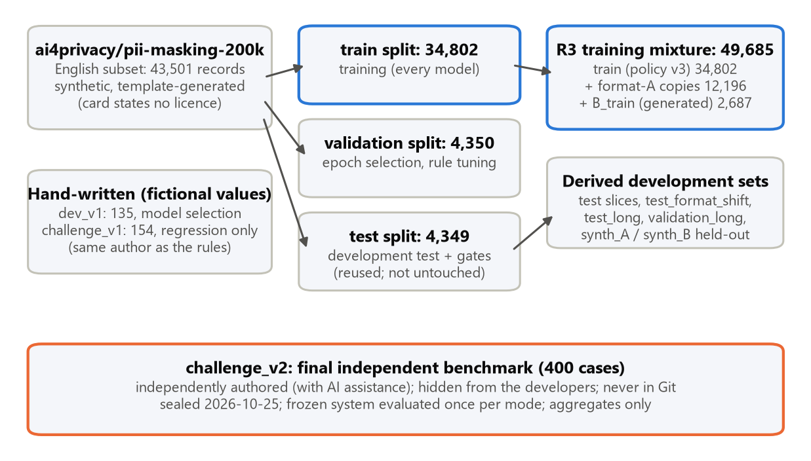
Figure 1. Data lineage and roles. Blue: training data; orange: the independent benchmark. Counts in documents.

3.3 Augmentation and generated data
- Format augmentation. About half of the target-bearing training documents were copied with their values re-rendered in other realistic formats (12,196 copies), with spans re-mapped by construction. A different renderer, never trained on, produced the held-out format-shift test set.
- Generated hard cases. A seeded generator (48 template families) produced 3,173 hard negatives (tracking, order and ticket numbers, versions and similar look-alikes) and 2,687 difficult positives (lowercase names, credentials in JSON, YAML, SQL and command lines, CVVs with context). Whole template families were held out for evaluation: 960 harmless and 776 protected documents.
- Known limitations. Some value pools are shared between generated training and held-out data (20% of the held-out difficult-positive values also occur in training), which flatters models trained on them, including R3. The dataset card states no licence, so derived data and the fine-tuned weights are kept out of the public repository; the base model, mBERT [6], is Apache-2.0.

4. Proposed hybrid architecture
The detector runs two complementary detectors on the same text and reconciles their findings (Figure 2). The transformer tokenises the original text with character offsets, predicts BIO labels in sliding windows of 512 tokens with 64 tokens of overlap, stitches the token probabilities across windows and only then decodes spans, so an entity that crosses a window boundary remains one span. The English rules v3 combine regular expressions with validators (Luhn, IBAN mod-97 [7], IPv4 octet ranges and phone-number parsing [8]) and context cues, for example for credentials written in JSON, YAML, SQL or command lines.
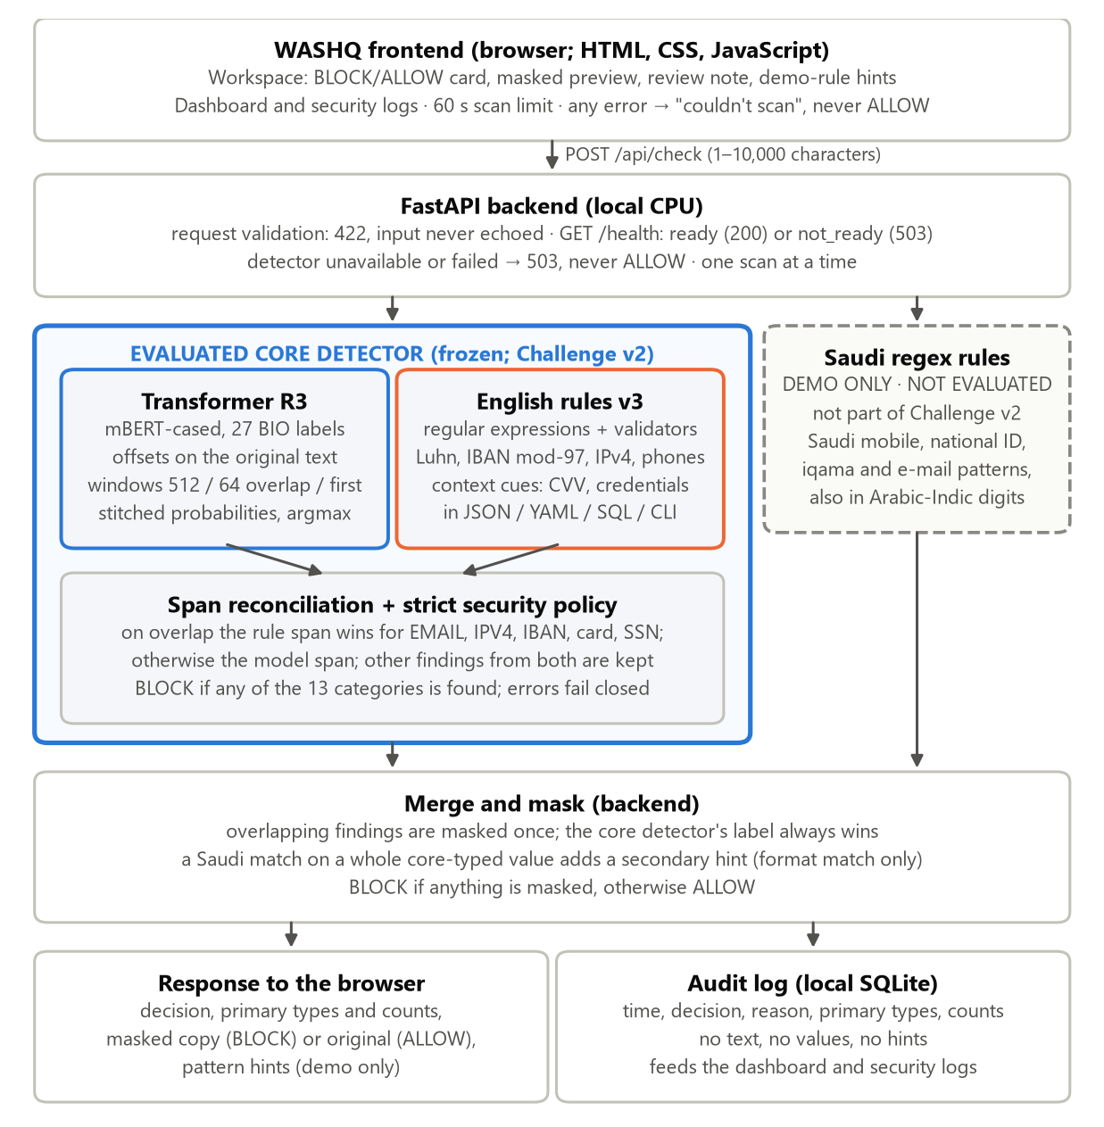
Figure 2. System architecture of WASHQ. The blue container is the evaluated core detector (frozen R3 + English rules v3, strict mode). The dashed Saudi regex rules are a demo-only extension of the application and were not evaluated.
Reconciliation gives the rule span priority on overlap for EMAIL, IPV4, IBAN, CREDITCARDNUMBER and SSN, whose boundaries the validators fix exactly; otherwise the model span wins, and non-overlapping findings from both detectors are kept. The security policy blocks if any finding lies in the 13 categories and fails closed (BLOCK) on any inspection error. Two modes exist: strict (argmax decoding plus the rules) is the product mode used by WASHQ, and maximum (a low token threshold of 0.05 plus the rules) is retained for research only and is never offered to users.
The design follows from Section 2: validators make the rules precise where formats are well defined, and the model supplies the context needed for names, usernames, passwords and streets, which no pattern captures reliably. Inspection is local and needs no GPU or network connection; the model is loaded only from a local folder, and outputs carry categories, counts and positions, never the values themselves.

5. Model training and methodology
The backbone is google-bert/bert-base-multilingual-cased (mBERT) [2, 6], the model of the team's original notebooks, fine-tuned with Hugging Face Transformers and PyTorch [9, 10]. It was kept fixed throughout: the confirmed weaknesses were data-coverage failures, and in-distribution F1 was already about 0.98, so the evidence did not justify a change of backbone.
- BIO alignment [11, 12]. There are 27 labels: B- and I- for each category, plus O. Subword labels are derived from the character spans through the tokenizer's offset mapping. A subword that straddles a span boundary or overlaps two annotations is ignored (label -100), and a target with any ignored token is ignored entirely, so no half-labelled entity is trained or scored.
- Windows. Training windows hold at most 510 subword tokens and re-read up to 32 tokens of left context without supervision, so every token is supervised exactly once (95.0% of R3's tokens were supervised). Inference uses 512-token windows with 64 tokens of overlap.
- Training recipe. AdamW [13], learning rate 2e-5, 2 epochs, effective batch size 16, weight decay 0.01, 10% warm-up and fp16 mixed precision [14] with seed 42, on a Google Colab T4 GPU. The epoch with the best validation entity F1 was reloaded from disk and re-scored before use (Appendix A).
- Evaluation. Character spans on whole documents, never per window: exact-match entity precision, recall and F1, plus document-level BLOCK/ALLOW metrics. Results are reported at three levels that are never mixed: model (transformer only), hybrid (model plus rules) and system (the full pipeline with the security policy).
Rates are compared with exact McNemar tests on paired documents [15], and False ALLOW and False BLOCK rates carry 95% Wilson intervals [16]. With 50–100 documents per class, differences of fewer than about five documents are usually not significant, and this is stated where it matters.

6. Baselines and experiments

6.1 Baselines
Four kinds of English detector were compared: rules only (rules_v2 in Round 1 and rules v3 in the final ablation; names and streets are deliberately left to the model), the off-the-shelf Presidio framework [1] with spaCy en_core_web_lg [17] (minimum score 0.3), the transformer only, and the hybrid of transformer and rules. Presidio lacks recognisers for several target categories and its PERSON entity must be split heuristically into first and last names, so its document-level results are the fairer comparison. All comparisons in this section are development experiments.

6.2 Round 1: correcting the evaluation and the training data
Round 1 started from one finding: the original notebook's validation F1 of 0.9925 was an artefact of label policy v1. Re-scored with out-of-scope entities visible and at document level, the same checkpoint reached only 0.643, with 5,117 false positives on look-alike values and 74.5% of target-free documents blocked. The evaluation was rebuilt, and each later experiment changed one factor:
- E1: label policy v2. Training out-of-scope entities as negatives fixed synthetic precision (test entity F1 0.984), but leakage on the hand-written challenge_v1 rose from 9.8% to 19.6% (p = 0.004): the original model had looked robust only because it flagged almost everything.
- E2: format augmentation. Leakage fell from 10.5% to 2.8% on the unseen format family and from 19.6% to 7.6% on challenge_v1 (p = 0.003). Format diversity generalises, so E2 became the base model.
- E2 + rules. Adding deterministic rules gave the safest Round 1 system (challenge_v1 False ALLOW 2.2%, False BLOCK 18.3%).
- Operating point. A token threshold of 0.05 removed the remaining challenge_v1 leaks but raised False BLOCK to 25.0%. This leak-versus-friction trade-off cannot be settled on synthetic validation data; the setting became the secondary maximum mode.
Table 3. Round 1 development comparison: exact-span entity F1 and document False ALLOW (FA) / False BLOCK (FB) rates.
Detector | Kind | test F1 | test FA / FB | format-shift FA | challenge_v1 FA / FB
rules_v2 | rules only | 0.485 | 54.4% / 0.2% | 47.1% | 28.3% / 1.7%
Presidio (minimum score 0.3) | off-the-shelf | 0.582 | 21.6% / 15.3% | 21.8% | 21.7% / 11.7%
original notebook checkpoint | transformer only | 0.641 | 0.0% / 72.8% | 4.2% | 9.8% / 48.3%
E1 (label policy v2) | transformer only | 0.984 | 0.1% / 1.0% | 10.5% | 19.6% / 20.0%
E2 (+ format augmentation) | transformer only | 0.984 | 0.1% / 1.1% | 2.8% | 7.6% / 16.7%
E2 + rules_v2 | hybrid | 0.983 | 0.1% / 1.3% | 2.2% | 2.2% / 18.3%
The hybrid leaked least on both held-out sets, significantly less than Presidio (discordant documents 1 versus 19, p < 0.001) and than the original model (p = 0.039). The rules alone were the most precise detector but missed names and context-dependent values. challenge_v1 was written by the rules' author and its failures were studied, so it is development evidence only.

6.3 Ablation of the final system
Table 4 compares the final components on the same label-policy-v3 development files.
Table 4. Development ablation: entity F1 · False ALLOW · False BLOCK (document counts).
Set (BLOCK / ALLOW documents) | Rules v3 only | R3 transformer only | R3 + rules v3 (strict)
test (3,055 / 1,068) | 0.481 · 1,677 · 1 | 0.985 · 3 · 10 | 0.984 · 3 · 11
format shift (3,055 / 0) | 0.539 · 1,463 · – | 0.746 · 46 · – | 0.804 · 45 · –
long documents (45 / 28) | 0.341 · 29 · 0 | 0.877 · 2 · 5 | 0.865 · 2 · 5
held-out difficult positives (776 / 0) | 0.844 · 160 · – | 0.833 · 2 · – | 0.857 · 0 · –
held-out hard negatives (0 / 960) | – · – · 11 | – · – · 664 | – · – · 664
dev_v1, hand-written (56 / 75) | 0.676 · 18 · 1 | 0.649 · 0 · 27 | 0.685 · 0 · 27
The pattern is consistent: the rules alone rarely over-block but leak 21–64% of protected documents; the transformer alone catches far more; and the hybrid has the lowest leakage on unseen formats and difficult positives at about the transformer's false-block level (RQ1). Rules v3 was tuned on validation and dev_v1, and R3 was selected on dev_v1, so the dev_v1 row is optimistic. The 664 false blocks on held-out hard negatives foreshadow the main weakness found later.
No rules-only or model-only evaluation was conducted on Challenge v2; the sealed benchmark was reserved for the predeclared frozen hybrid system. Component comparisons were performed on development sets.

7. R3 model selection and justification
Round 2 targeted the remaining error types with data rather than thresholds. Starting from R1 (E2 retrained under label policy v3), three candidates added generated data: R2 with hard negatives, R3 with difficult positives and R4 with both. The selection rule was written before any Round 2 result existed. Each candidate was scored as model plus rules v3 in strict mode against its parent on three criteria: leakage non-inferiority (dev_v1, held-out difficult positives, format shift), a measurable benefit (dev_v1 or the held-out families), and no regression on the synthetic test. R4 could be preferred only if R2 and R3 both passed the leakage criterion.
Table 5. Outcome of the pre-registered selection rule (FA = False ALLOW, FB = False BLOCK, document counts).
Candidate (vs parent) | Leakage non-inferiority | Benefit | No regression | Result
R1: policy v3 (vs Round 1 base) | pass (dev_v1 FA 3 vs 5) | not required | pass | pass
R2: + hard negatives (vs R1) | fail: held-out positives FA 26 vs 0 (p = 3×10⁻⁸) | dev_v1 FB 8 vs 24 | pass | fail
R3: + difficult positives (vs R1) | pass: dev_v1 FA 0 vs 3; format shift 45 vs 68 (p = 0.0003) | dev_v1 FA 0 < 3 | pass (F1 −0.001) | selected
R4: + both (vs R1) | pass (dev_v1 FA 3 vs 3) | dev_v1 FB 12 vs 24 (p = 0.004) | pass | ineligible (R2 failed)
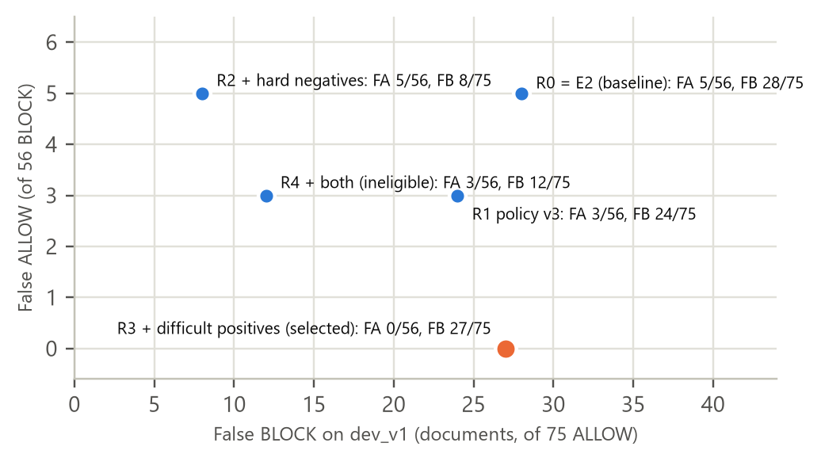
Figure 3. Round 2 candidates on dev_v1, system strict (56 BLOCK / 75 ALLOW documents). Development evidence; R3 is the only candidate with no observed leak.
R3 was the only candidate that passed every criterion (Table 5, Figure 3). The trade-off is explicit: R4 would have more than halved false blocks (dev_v1 12 versus 27 of 75, p = 0.0003; held-out hard negatives 187 versus 664 of 960) at the cost of significantly more leakage on unseen value formats (67 versus 45 of 3,055, p = 0.001). Choosing R4 would have meant re-weighting security against usability, a product decision that would have had to be taken before the independent evaluation; it was not. Compared with the Round 1 system, R3 is a security improvement rather than a usability one: dev_v1 False ALLOW 0 versus 5 of 56, format-shift leakage 45 versus 61 (p = 0.014), and False BLOCK unchanged (27 versus 28).
Three further decisions completed the selection. Strict was declared the primary mode because it was the only operating point on dev_v1 with no observed leak that did not add false blocks; 68% of R3's false-positive spans scored at least 0.9, so no confidence threshold separates them from true findings. A window study (centred stitching, 256- and 128-token windows) changed no decision on the long-document validation set, so the pre-registered 512/64 windows were kept, and a proposed IPv4 validation gate was rejected because a probe showed spaced or mistyped addresses turning BLOCK into ALLOW. Finally, the local checkpoint reproduced all 18,425 archived predictions, and the complete system (weights, rules, policy, windows and inference code) was frozen on 24 October 2026, before the benchmark was sealed.

8. Independent Challenge v2 evaluation

8.1 Protocol
- Independent authorship. Challenge v2 was written and annotated independently of the developers, with AI assistance, following a written specification. The developers never saw the cases, the detector's output on them or any per-case result.
- Freeze, seal, evaluate once. The detector was frozen on 24 October 2026 and the benchmark file was sealed on 25 October. Strict (primary, declared in advance) and then maximum (secondary) were each evaluated once; an append-only ledger holds exactly these two evaluations.
- No change afterwards. The system was not modified in response to the results; any change would require a new independent benchmark.
Challenge v2 contains 400 synthetic documents (200 BLOCK, 200 ALLOW) with 236 protected entities covering all 13 labels and 166 annotated look-alike values of 25 out-of-scope types. 152 documents contain look-alikes (110 of them ALLOW), 171 are structured text and 72 are long documents of more than 3,000 characters.

8.2 Results
Table 6. Challenge v2 results of the frozen R3 + rules v3. Entity metrics are exact-span micro averages; document metrics treat BLOCK as the positive class.
Metric | Level | strict (primary) | maximum (secondary)
Entity F1 (precision / recall) | entity | 0.677 (0.544 / 0.898) | 0.618 (0.471 / 0.898)
BLOCK F1 (precision / recall) | document | 0.846 (0.739 / 0.990) | 0.834 (0.718 / 0.995)
False ALLOW (95% Wilson interval) | document | 2/200 = 1.0% (0.3–3.6%) | 1/200 = 0.5% (0.1–2.8%)
False BLOCK (95% Wilson interval) | document | 70/200 = 35.0% (28.7–41.8%) | 78/200 = 39.0% (32.5–45.9%)
Accuracy | document | 0.820 | 0.8025
The two levels answer different questions. Entity metrics measure whether each protected value is found with the right label and exact boundaries; document metrics measure the BLOCK/ALLOW decision that the user experiences. They diverge because a document is blocked as soon as any one finding is made: 98.3% of the protected entities were overlapped by some finding, so most of the 24 exact-match misses still led to a correct BLOCK. The maximum mode brought no measurable security benefit (the same entity recall and one fewer False ALLOW, with overlapping intervals) for 8 more false blocks, which confirms the choice of strict.
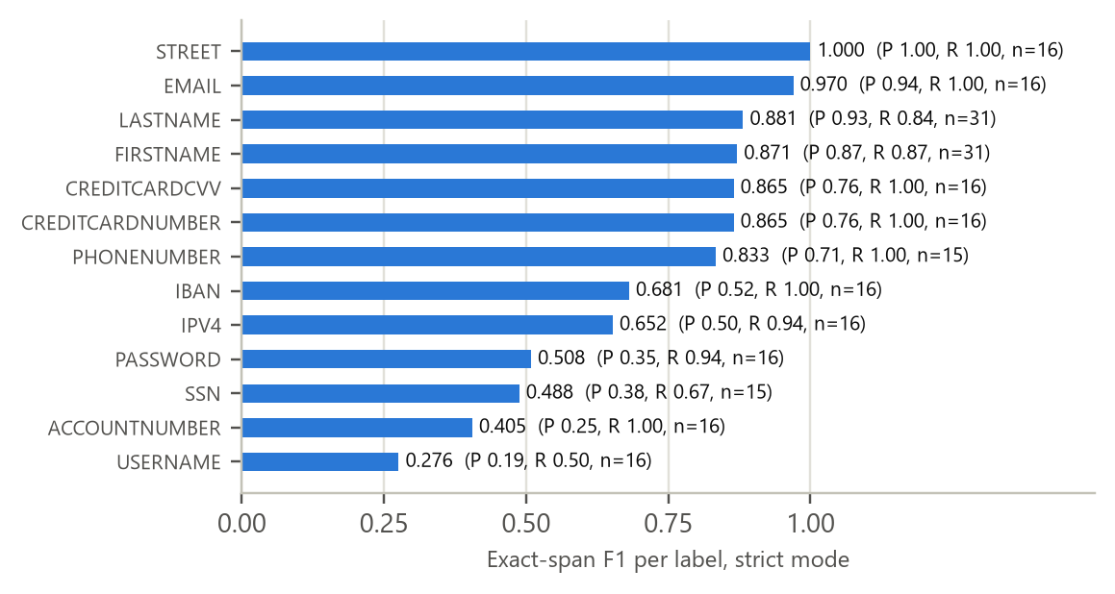
Figure 4. Per-label exact-span F1 on Challenge v2, strict mode (15–31 protected entities per label).
Per label (Figure 4), validator-backed and well-formed categories score highest (STREET 1.000, EMAIL 0.970), while the weakest labels suffer mainly from false positives: ACCOUNTNUMBER has perfect recall but precision 0.254, and USERNAME is the weakest overall (F1 0.276, recall 0.50).

8.3 Development versus independent results
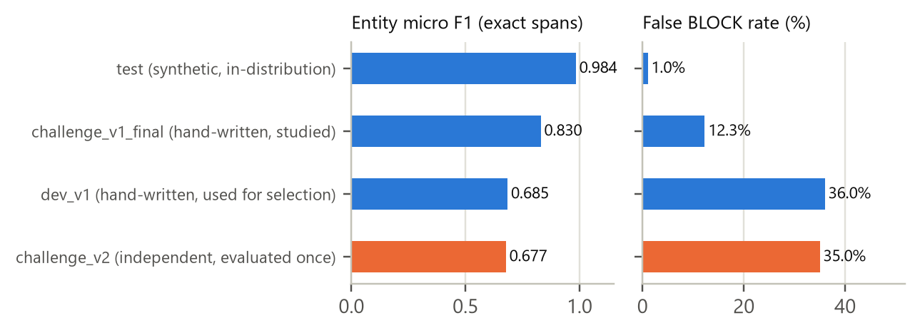
Figure 5. The synthetic-to-realistic gap, strict mode. Blue: development evidence; orange: the independent benchmark. The sets are not directly comparable; the figure shows the direction of the gap.
As Figure 5 shows, the independent result agrees closely with the hand-written development set dev_v1 (entity F1 0.677 versus 0.685; False BLOCK 35% versus 36%), so the selection set was a fair proxy and its warning about false blocks is confirmed on independent text (RQ3). Both are far below the synthetic in-distribution score of 0.984, which measured the source distribution rather than realistic prompts (RQ2).

9. Error analysis and limitations

9.1 Error analysis
False BLOCK is the dominant error, and it concentrates on look-alike identifiers. In strict mode, 64 of the 70 false blocks occurred among the 110 ALLOW documents that contain look-alikes (58%), against 6 of the other 90 ALLOW documents (7%), and 124 of the 178 false-positive entities (70%) lie on annotated look-alikes (Figure 6).
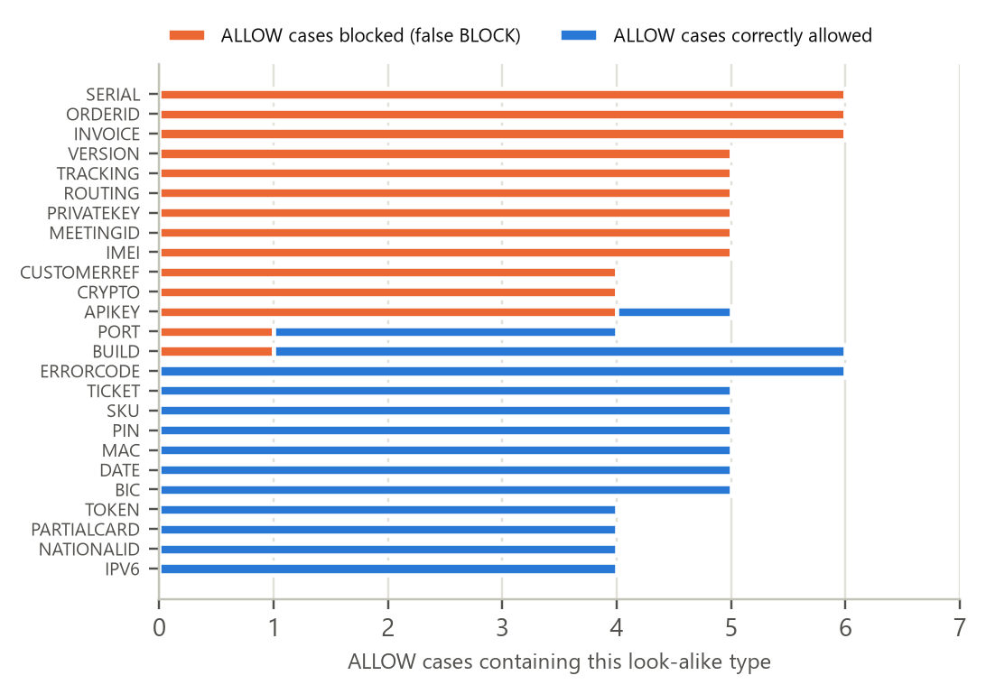
Figure 6. Challenge v2 ALLOW documents by look-alike type, strict mode. A document can contain several types and another finding may have caused a block, so per-type rates are indicative only.
- Long identifiers. Tracking, serial, order, invoice, routing and meeting numbers are taken for ACCOUNTNUMBER, IBAN or SSN; tracking numbers alone caused 36 false positives. The same weakness appeared on dev_v1 and on the held-out hard negatives (664 of 960 blocked).
- Versions and out-of-scope secrets. Four-part version strings are taken for IPV4 (14 false positives), and API keys are predicted as PASSWORD (19 false positives). Blocking a secret protects confidentiality but adds friction outside the defined scope.
- Leakage is low but not zero. Strict allowed 2 of 200 protected documents; the aggregate tags place them among difficult-positive, long and unfamiliar-format cases.
- Long documents. On the 72 long documents, strict made 1 False ALLOW (of 27 protected) and 10 False BLOCKs (of 45 harmless). Development analysis traced long-input errors to tokens just before a window cut and to positions that training barely covered.
- Thresholds do not help. Most false-positive spans are high-confidence predictions, so the remedy is more representative data, as the R4 experiment showed, rather than a threshold.

9.2 Limitations
- Synthetic evidence only. No real employee prompts were evaluated. Challenge v2 is a constructed, class-balanced benchmark from one author (with AI assistance), evaluated once with one training seed, so the real-world cost of a 35% False BLOCK rate is unknown.
- Small subgroups. Per-type and per-tag results rest on a handful to a few dozen documents, and causes are inferred from aggregates because per-case results were deliberately withheld.
- Not adversarially robust. Deliberately split, encoded or obfuscated values usually pass; the target is accidental disclosure.
- Scope. English text and 13 categories only; API keys, tokens and other secrets are outside the defined scope.
- Not production-ready. The system is a research prototype; its usability at this false-block rate and its latency on target hardware have not been established.

10. WASHQ application and integration
WASHQ wraps the frozen detector in a local web application for the demonstration (Figure 2). Everything runs on one computer: a static HTML, CSS and JavaScript frontend served locally, and a FastAPI [18] backend that loads the detector once at start-up and runs it on the CPU. Text is never sent to an external service. Table 7 separates the evaluated core from the behaviour added for the demonstration.
Table 7. Evaluated core versus demo and application behaviour in WASHQ.
Component | What it does | Evaluation status
Core detector: R3 + English rules v3, strict mode | finds the 13 categories in English text; decides BLOCK or ALLOW | development sets and the independent Challenge v2 (Sections 6–8)
Saudi regex rules (demo only) | four regular expressions for Saudi mobile numbers, national ID numbers (10 digits starting with 1), iqama numbers (starting with 2) and e-mail addresses, also in Arabic-Indic digits; reused from the team's early, abandoned exploration | not evaluated; not part of Challenge v2; no Arabic language understanding
Merging, masking and pattern hints | masks every finding once; the core label always takes precedence; adds a secondary hint when a Saudi pattern matches a whole core-typed value | software tests only
Fail-closed handling, readiness check, audit log, dashboard | never shows a failed scan as ALLOW; stores metadata only | software tests and manual checks

10.1 How a scan is answered
The workspace sends the text (1–10,000 characters) to POST /api/check. The backend runs the core detector in strict mode, which is fixed in code and never taken from a request, and then the Saudi rules. Overlapping findings are merged and masked once with placeholders such as [PERSON_NAME], and the core detector's label always takes precedence. If anything is masked, the answer is BLOCK and the workspace shows the masked preview with the note “Review the masked text before sharing. Automatic masking may miss sensitive information.”; otherwise the answer is ALLOW and the original text is returned. Where a Saudi pattern matches a whole value that the core detector typed differently, a separate field adds a secondary explanation, for example “Account number: also matches a Saudi national ID pattern (demo rule)”. A hint is a format match, not proof of a genuine identifier, and it never changes the decision, the counts or the masked text.
Masking is only as complete as detection. Challenge v2 measured the core detector's decisions and spans, not the masked copy, and 24 of 236 protected entities were not found with exact boundaries. A preview may therefore still contain sensitive values, which is why the user is asked to review it.

10.2 Fail-closed behaviour and operation
- Invalid requests are rejected with HTTP 422 and a fixed message that never repeats the input.
- If the detector cannot be loaded or fails during a scan, the backend answers 503 and returns no text. GET /health reports readiness (200 ready, 503 not_ready) from the in-memory state, without running the model.
- The frontend treats a network error, an error status, a malformed answer or a scan longer than 60 seconds as “couldn't scan”, never as ALLOW, and ignores late answers. The limit is about five times the slowest scan measured at the 10,000-character limit on a laptop CPU (about 11 seconds).
- An audit log stores only metadata (time, decision, reason, primary types and counts); the admin dashboard and security logs are built from it. There is no sign-in, because the application is a local prototype.

10.3 Verification
Table 8. Verification of the application (30 October 2026). These are software and acceptance checks, not a statistical evaluation of the model.
Check | Result
Detector tests (frozen package) | 162 passed; identity check: checkpoint, rules, policy and inference code byte-identical to the frozen record
Backend tests (API, masking, Saudi extension, real checkpoint) | 263 passed; 3 expected failures that document known gaps of the Saudi rules on their own
Frontend client tests | 7 passed (time limit, network errors, malformed answers)
Running server, 38 new fictional inputs | every answer equals direct strict inference plus the documented Saudi additions; the decision differed from the core detector's on 1 input (a Saudi mobile number in Arabic-Indic digits)
Manual browser checks by the team (observed) | “Name + ID”: BLOCK with person names, an account number and a Saudi national-ID hint · German IBAN: BLOCK as IBAN, no hint · Saudi mobile in Arabic-Indic digits: BLOCK, phone number · clean English prompt: ALLOW · dashboard: 4 scans, 3 BLOCK and 1 ALLOW, with category counts · backend stopped: scan failure shown, not ALLOW
Full manual test checklist | not yet completed

[PENDING: screenshot of the WASHQ workspace: BLOCK result for the “Name + ID” sample, showing the masked preview, the types, the demo-rule hint and the review note] | [PENDING: screenshot of the WASHQ admin dashboard after the browser test (4 scans: 3 BLOCK, 1 ALLOW)]
Figure 7. WASHQ workspace (left) and admin dashboard (right). [PENDING: replace the placeholders with screenshots from the team's browser test]

11. Responsible AI and privacy considerations
- Privacy by design. Inspection is local, with no network access, and the model loads only from a local folder. Responses and logs carry categories, counts and positions but never values; even value shapes are withheld, because a password's length is itself sensitive. All training and evaluation data is synthetic or fictional (reserved 555-01xx phone numbers, public test card numbers, specimen IBANs, invented names).
- Security first, at a measurable cost. The design minimises leakage and fails closed. In return, about one harmless text in three was blocked on the independent benchmark; in practice this friction could push users towards workarounds, and it is the main reason the system is not ready for deployment.
- Human oversight. The masked preview supports, but does not replace, the user's judgement, and the interface says so explicitly.
- Public figures and fairness. By policy, names of public figures are protected, so a harmless request about a famous scientist is blocked; this is an intended cost. Names were learned from English-centred synthetic data, and behaviour on names from other cultures has not been measured. The Saudi rules match number and e-mail formats only and provide no Arabic language understanding.
- Licensing. The training dataset's card states no licence, so the fine-tuned weights and derived data are shared privately and not redistributed. The detector's model card follows the structure proposed by Mitchell et al. [19].
- Disclosure of AI assistance. Generative AI assistance was used in this project. An AI coding assistant (Claude, used through Claude Code) co-authored repository commits from 24 October 2026 onwards (detector package, experiment pipeline, analyses, freeze tooling and documentation) and assisted with the application verification and with drafting this report. Challenge v2 was authored independently of the developers with AI assistance. [PENDING: team to confirm the exact extent of AI assistance in each part of the work, including the frontend and backend, and in the final editing of this report.]

12. Conclusion and future work
The project delivered a local, fail-closed detector for 13 categories of sensitive information, a documented and frozen model identity, an independent evaluation and a working local application. RQ1: on development data, combining a fine-tuned transformer with deterministic rules gave the lowest leakage; the rules alone leaked 21–64% of protected documents, while the hybrid leaked none on dev_v1 and the fewest on unseen formats. No component-level comparison exists on the independent benchmark. RQ2: synthetic in-distribution scores were a poor guide; entity F1 fell from 0.984 on the synthetic test to 0.685 on hand-written text, and the original 0.9925 was a metric artefact. RQ3: on the independent Challenge v2, the frozen system leaked 1.0% of protected documents but blocked 35.0% of harmless ones (BLOCK F1 0.846, entity F1 0.677), mostly on look-alike identifiers. O4: WASHQ applies the decision locally, fails closed and logs no values; its Saudi extension is a demonstration feature without evaluation.
The following are recommendations, not completed work:
- Reduce false blocks with data rather than thresholds (the R4 recipe is the evidence), under a new pre-registered rule, a new development set and a new independent benchmark, since Challenge v2 has now been used.
- Collect a governed sample of real prompts (with consent, a privacy review and double annotation), then run a shadow deployment that logs decisions without text.
- Train with several seeds and report the variance; build a larger long-document validation set; measure latency on the target hardware.
- Evaluate the Saudi extension on its own labelled data before making any claim about it, and add authentication before any multi-user deployment.

13. Team contributions
The team began with three members; one member withdrew during the bootcamp and the instructors were informed. The two remaining members completed the project. Table 9 records the agreed contributions.
Table 9. Team contributions.
Team member | Agreed contributions
[PENDING: full name of member 1] | [PENDING: agreed description of member 1's contributions]
[PENDING: full name of member 2] | [PENDING: agreed description of member 2's contributions]

14. References
[1] Microsoft. Presidio: Data protection and de-identification SDK. https://github.com/microsoft/presidio
[2] Devlin, J., Chang, M.-W., Lee, K., & Toutanova, K. (2019). BERT: Pre-training of deep bidirectional transformers for language understanding. In Proceedings of NAACL-HLT 2019 (pp. 4171–4186).
[3] Lison, P., Pilán, I., Sánchez, D., Batet, M., & Øvrelid, L. (2021). Anonymisation models for text data: State of the art, challenges and future directions. In Proceedings of ACL-IJCNLP 2021 (pp. 4188–4203).
[4] ai4privacy. pii-masking-200k [Dataset card]. Hugging Face. https://huggingface.co/datasets/ai4privacy/pii-masking-200k (checked 25 October 2026: no licence stated).
[5] Luhn, H. P. (1960). Computer for verifying numbers. U.S. Patent No. 2,950,048.
[6] Google. bert-base-multilingual-cased [Model card]. Hugging Face. https://huggingface.co/google-bert/bert-base-multilingual-cased (Apache-2.0).
[7] ISO 13616-1:2020. Financial services: International bank account number (IBAN), Part 1: Structure of the IBAN. International Organization for Standardization.
[8] Drysdale, D. python-phonenumbers: Python port of Google's libphonenumber. https://github.com/daviddrysdale/python-phonenumbers
[9] Wolf, T., et al. (2020). Transformers: State-of-the-art natural language processing. In Proceedings of EMNLP 2020: System Demonstrations (pp. 38–45).
[10] Paszke, A., et al. (2019). PyTorch: An imperative style, high-performance deep learning library. In Advances in Neural Information Processing Systems 32.
[11] Ramshaw, L. A., & Marcus, M. P. (1995). Text chunking using transformation-based learning. In Proceedings of the Third Workshop on Very Large Corpora.
[12] Tjong Kim Sang, E. F., & De Meulder, F. (2003). Introduction to the CoNLL-2003 shared task: Language-independent named entity recognition. In Proceedings of CoNLL-2003.
[13] Loshchilov, I., & Hutter, F. (2019). Decoupled weight decay regularization. In Proceedings of ICLR 2019.
[14] Micikevicius, P., et al. (2018). Mixed precision training. In Proceedings of ICLR 2018.
[15] McNemar, Q. (1947). Note on the sampling error of the difference between correlated proportions or percentages. Psychometrika, 12(2), 153–157.
[16] Wilson, E. B. (1927). Probable inference, the law of succession, and statistical inference. Journal of the American Statistical Association, 22(158), 209–212.
[17] Honnibal, M., Montani, I., Van Landeghem, S., & Boyd, A. (2020). spaCy: Industrial-strength natural language processing in Python. Zenodo. https://doi.org/10.5281/zenodo.1212303
[18] Ramírez, S. FastAPI [Documentation]. https://fastapi.tiangolo.com/
[19] Mitchell, M., et al. (2019). Model cards for model reporting. In Proceedings of the Conference on Fairness, Accountability, and Transparency (FAT* '19) (pp. 220–229).

Appendix A. Training and inference configuration
Table 10. Training recipe of R3 and the frozen inference configuration.
Setting | Value
Base model | google-bert/bert-base-multilingual-cased (mBERT), 27 BIO labels
Training data | 49,685 documents (49,689 training windows), label policy v3
Optimisation | AdamW, linear schedule, 10% warm-up, gradient clipping 1.0; learning rate 2e-5; 2 epochs; effective batch 16; weight decay 0.01; fp16; seed 42
Epoch selection | best validation entity F1 (epoch 2, 0.9858); selected epoch reloaded from disk and re-scored
Training hardware and time | Google Colab T4 GPU, 883 seconds
Inference | CPU, local files only; windows 512 tokens / 64 overlap / first; argmax decoding + rules v3 (strict)
Model size; measured latency | 709 MB of weights; about 37 ms median for a short prompt; 2–4 s for 10,000 English characters

Appendix B. Glossary of metrics
Table 11. Metrics and terms used in this report.
Term | Meaning
False ALLOW (FA) | a protected document that the system allows; the rate is over protected documents. The primary security metric
False BLOCK (FB) | a harmless document that the system blocks; the rate is over harmless documents. The friction metric
Document BLOCK precision / recall / F1 | decision-level metrics with BLOCK as the positive class
Entity exact-match P / R / F1 | a predicted span counts only if its start, end and label all match a protected span; micro-averaged over labels
Look-alike (hard negative) | an out-of-scope value that resembles a target, such as an order number, version string or API key
Model / hybrid / system level | transformer only / transformer + rules / the full pipeline with the security policy in a mode
Wilson interval; McNemar test | 95% confidence interval for a proportion; exact paired test on per-document correctness

Appendix C. Evidence and detailed documentation
Every number in this report is taken from evidence files in the team's repository; no new experiment, evaluation or model inference was run to write it. The detailed technical report (reports/Confidentiality_Detector_Capstone_Report.docx) contains the complete experiment tables, the dataset audit and the reproducibility records.
Table 12. Where the evidence for each part of this report can be found.
Topic | Repository file
Challenge v2 results and breakdowns | reports/challenge_v2/result_r2_e3b_positive_strict.json, …_maximum.json, SEAL.json, LEDGER.jsonl
Development metrics of R3, rules v3 and the hybrid | reports/evidence/final_system_metrics_r3.json; reports/evidence/runs_v3/rules_v3/metrics.json
Round 1 and Round 2 experiments and selection | reports/history/ROUND1_REPORT.md, ROUND2_REPORT.md; reports/evidence/round2_selection.json
Datasets, methodology, policy, baseline audit and model card | docs/DATASETS.md; docs/DATA_PIPELINE.md; docs/METHODOLOGY.md; docs/POLICY.md; reports/BASELINE_AUDIT.md; reports/FINAL_REPORT.md
Application, frozen identity and tests | backend/README.md; docs/INTEGRATION.md; docs/INTEGRATION_TEST_PLAN.md; configs/inference/frozen_system.json

