12/22/2025
Network security
Multi-Class Network Intrusion Detection System (IDS) for Flood Attacks using Random Forest
Team:
- Manar Ahmed Ahmed Hashad
- Maryam Ahmed Ahmed Hashad
- Shimaa Samer Ahmed Ibrahim
- Shorouk Mostafa Mohammed Hassan
- Nada Mohamed Rashed Saad
Contents
Introduction and Project Goal 2
Targeted Attacks: 2
Lab Setup and Topology 3
Key Components and Configuration: 3
Attack Execution Steps and Commands 4
ICMP Flood Attack 4
SYN Flood Attack 5
Normal Traffic Generation 6
Dataset Creation and Record Counts 7
Data Extraction and Preprocessing 7
Final Record Counts 10
Feature Descriptions 11
Speed and Size Indicators 11
Protocol Identification and Flagging 12
Sequencing and Connection Context 12
Feature Selection Method & Results 13
Selection Methodology 13
Feature Importance Results 13
ML Models Used and Explanation 14
Justification for Choosing Random Forest 14
Evaluation Metrics and Comparative Results 15
Evaluation Metrics Explained 15
Classification Results and Comparison 16
Analysis of Misclassifications (The Confusion Matrix) 17
Successful Deployment 17
Conclusion and Future Work 20
Conclusion 20
Future Work and Project Expansion 21

Introduction and Project Goal

The project begins by establishing the need for an Intrusion Detection System (IDS), a critical security mechanism used to monitor and analyze network traffic for patterns indicating malicious activity or policy violations. The primary goal of this project is to build a Multiclass Classification machine learning model capable of distinguishing between three core traffic patterns:
1. Normal Traffic (Safe and legitimate network activity).
2. ICMP Flood Attack (A Denial-of-Service attack).
3. SYN Flood Attack (A resource exhaustion attack).

Targeted Attacks:
- ICMP Flood Attack
This is one of the simplest and most widespread Denial-of-Service (DoS) attacks. It is executed by overwhelming the victim with a high rate of ICMP Echo Request packets (similar to the Ping command). The attack’s objective is to consume the victim’s bandwidth and CPU resources, as the victim is forced to send an Echo Reply for every request, ultimately preventing legitimate connections from being processed.
- SYN Flood Attack
This attack exploits the three-way handshake mechanism of the TCP protocol. The attacker sends a massive number of SYN packets (connection requests) but never responds to the victim's SYN-ACK packets. This maneuver leaves a large number of connections in a "Half-Open" state in the victim's connection queue. This consumes the system's memory resources (the connection table) and hinders the server's ability to accept legitimate connection requests.

Lab Setup and Topology

The entire project was executed within an Isolated Virtual Environment to ensure the attack simulations did not interfere with the main network infrastructure. The setup involved two primary virtual machines connected within a private, internal network, simulating a direct attack scenario in a controlled setting.

Key Components and Configuration:
Environment: The entire lab utilized an isolated virtual network topology.
Attacker and IDS Host (Kali Linux):
- Served as the platform for executing the simulated attacks (using hping3).
- Hosted the training environment for the Machine Learning model (Python, Scikit-learn, Scapy).
- Ran the final *Intrusion Detection System (IDS)* monitor.

Victim Host (Metasploitable 2):
- Represented the vulnerable target server for the Denial-of-Service (DoS) and SYN Flood attacks.
- Specific open ports (e.g., Port 80) were targeted.
Data Capture Tool (Tshark / Wireshark):
- Used for passively capturing and extracting the raw packet data necessary for feature engineering and dataset creation.
Network Addressing :
- The systems were configured on a private subnet (Attacker IP: 192.168.241.129, Target IP: 192.168.241.131).

Attack Execution Steps and Commands

Traffic data collection involved running three distinct scenarios on the Kali Linux machine against the Metasploitable 2 victim, ensuring clear separation for dataset labeling.

ICMP Flood Attack
- This phase aimed to generate a high volume of ICMP Echo Request packets to simulate a basic Denial-of-Service condition.
- Objective: To overwhelm the victim's resources and bandwidth by flooding it with ICMP packets.
- Execution Command: The attack was executed using the following single-line command: sudo hping3 -1 --flood <Target_IP>

- Command Breakdown: The -1 flag specifies the ICMP protocol, and the --flood flag instructs the tool to send packets as fast as possible without waiting for replies.

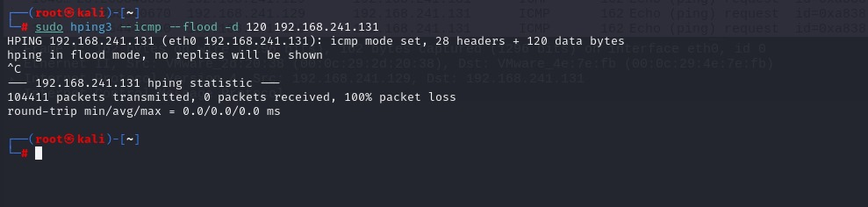

SYN Flood Attack
- This attack targeted a specific open TCP port to exhaust the victim's connection resources by leaving connections half-open.
- Objective: To simulate a resource exhaustion attack by exploiting the TCP three-way handshake mechanism.
- Target Identification: Nmap was initially used to confirm that a service port, such as Port 80 (HTTP), was accessible and listening on the victim machine.
- Execution Command: The attack was launched against the identified port: sudo hping3 -S --flood <Target_IP> -p 80
- Command Breakdown: The -S flag sets the SYN flag (connection request), and -p 80 specifies the target port. The --flood flag maximizes the attack rate.
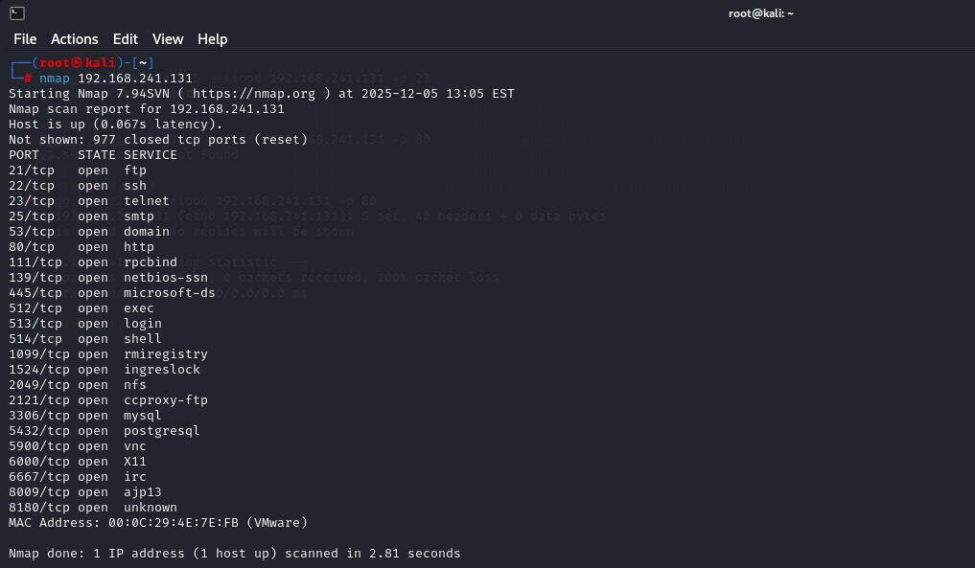
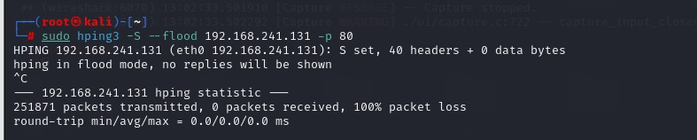

Normal Traffic Generation
- To establish a diverse safe baseline, traffic was generated using natural human interaction patterns (Ping and FTP), ensuring variable timing.
Ping Execution: ping <Target_IP>
- FTP Execution (TCP/Port 21): Simple FTP connections (e.g., login, listing directories) were simulated to record normal TCP traffic.
FTP Execution: ftp <Target_IP>
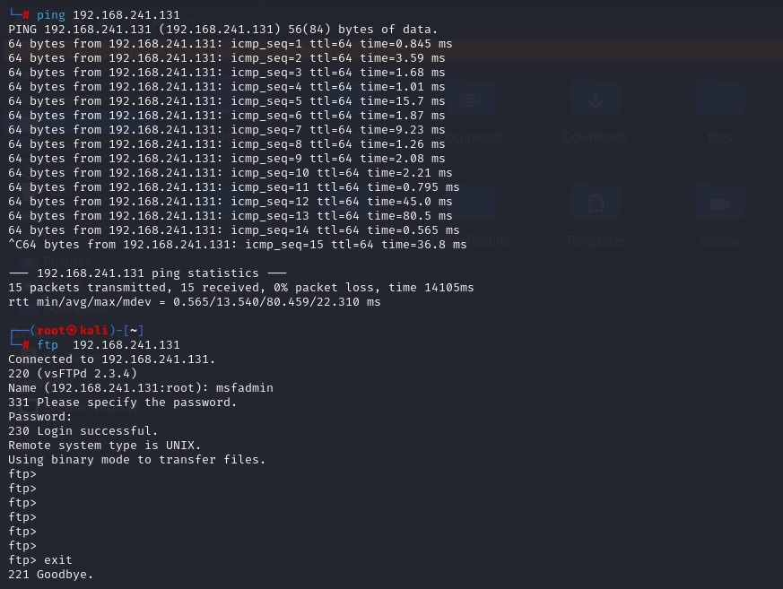

Dataset Creation and Record Counts

The foundation of the IDS model relies on a unified dataset created by processing the raw network captures from the three simulated scenarios (Normal, ICMP Flood, SYN Flood). This process involved using Tshark to extract specific features from the raw packet files (.pcap) and then merging these outputs into a single, cohesive dataset.

Data Extraction and Preprocessing
- Capture and Labeling: Three separate packet capture files (.pcap) were recorded, each corresponding to a specific label:
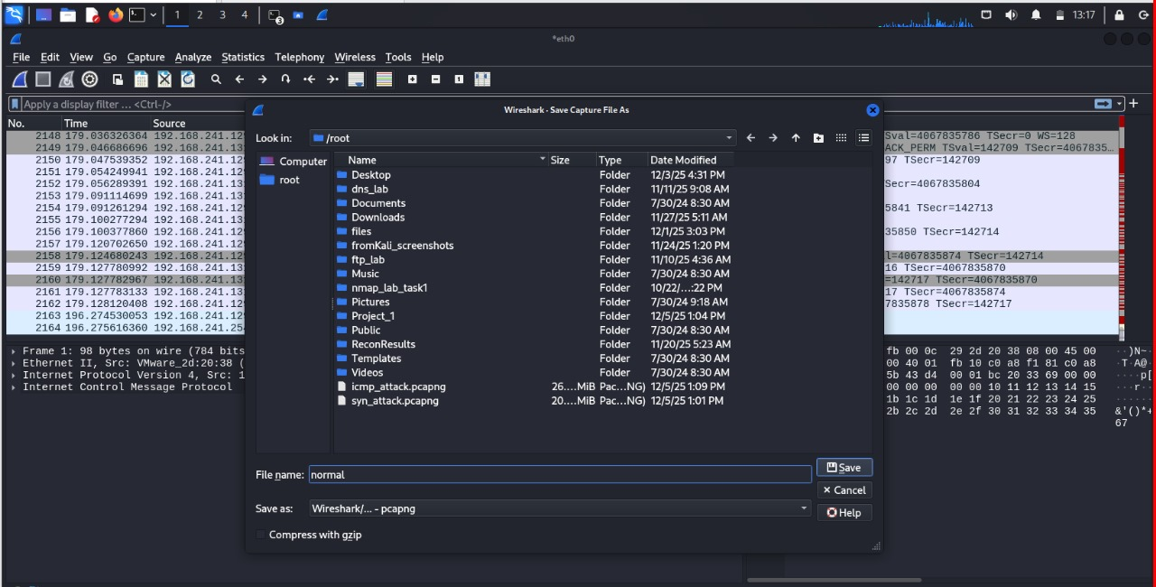
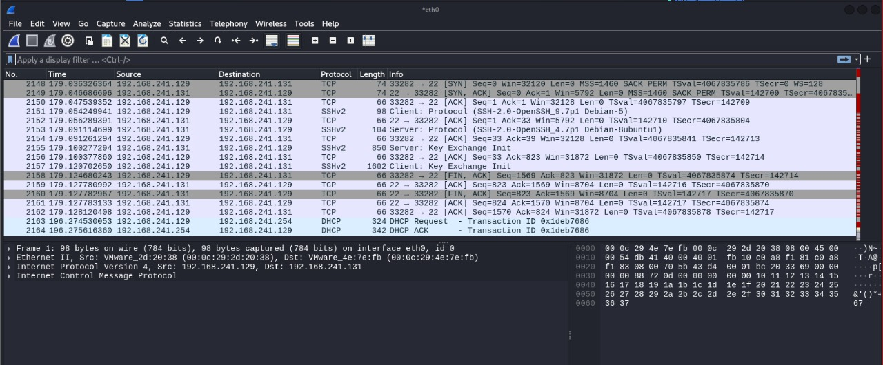
Normal Traffic (Label 0)
ICMP Flood Attack (Label 1)
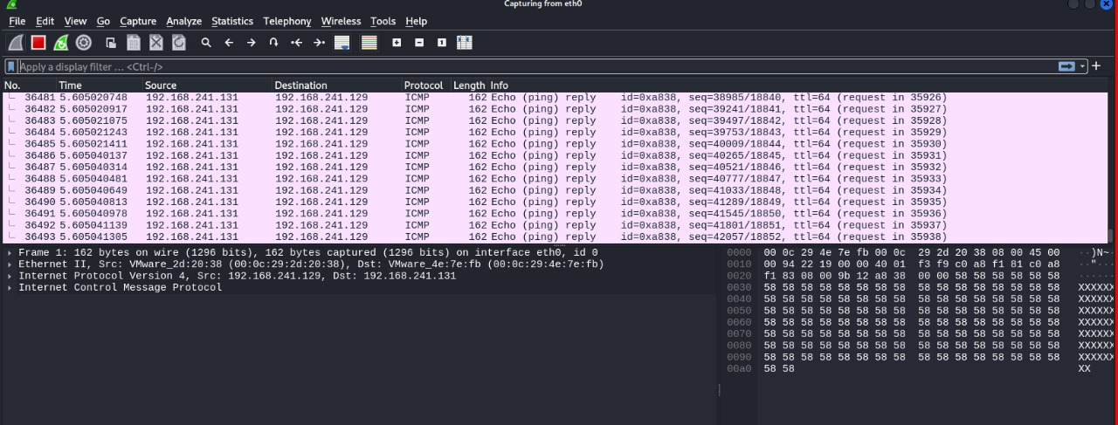
SYN Flood Attack (Label 2)
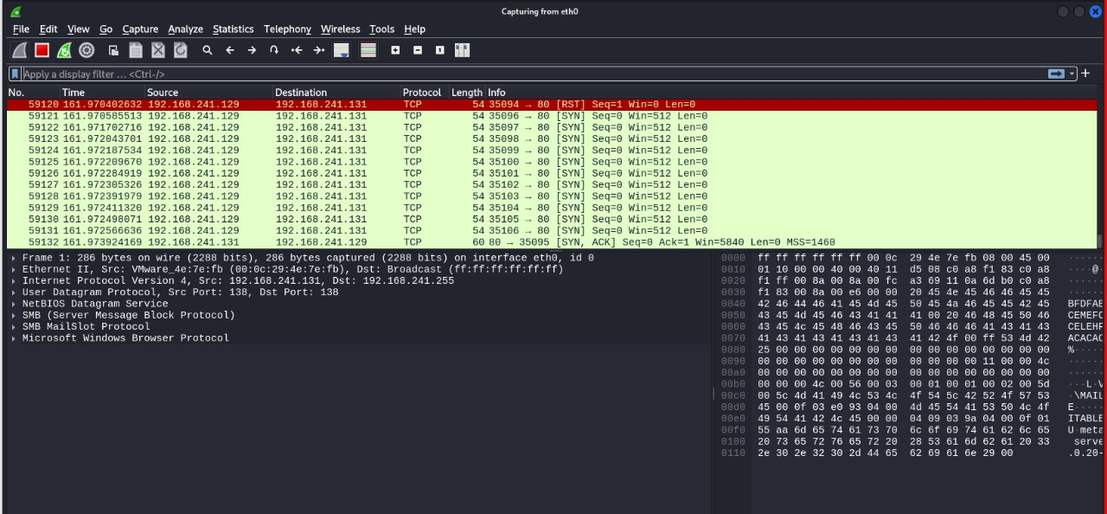
- Feature Extraction via Tshark: The captured files were processed using the command-line utility Tshark. The tool was instructed to extract the 9 features deemed most critical for classification, ensuring maximum separation between the classes.
- Command Structure: The robust command used -T fields and -E separator=, to generate clean CSV output, converting complex packet data into easily readable numerical features.
- Data Unification and Cleaning: The three resulting CSV files were loaded into a Python script using Pandas. A specific label (0, 1, or 2) was assigned to each file's records, and all three datasets were merged into a single file: final_multiclass_dataset.csv.
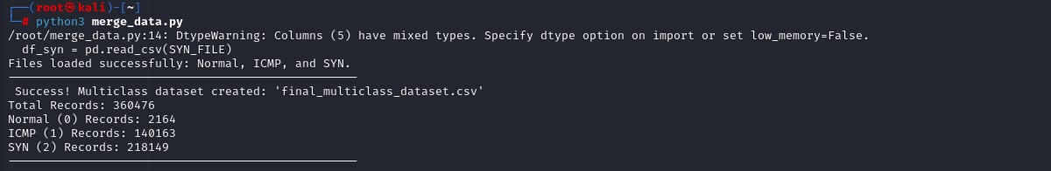
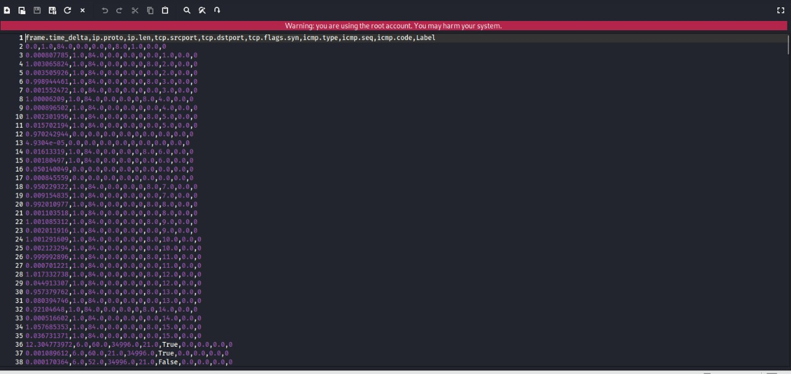
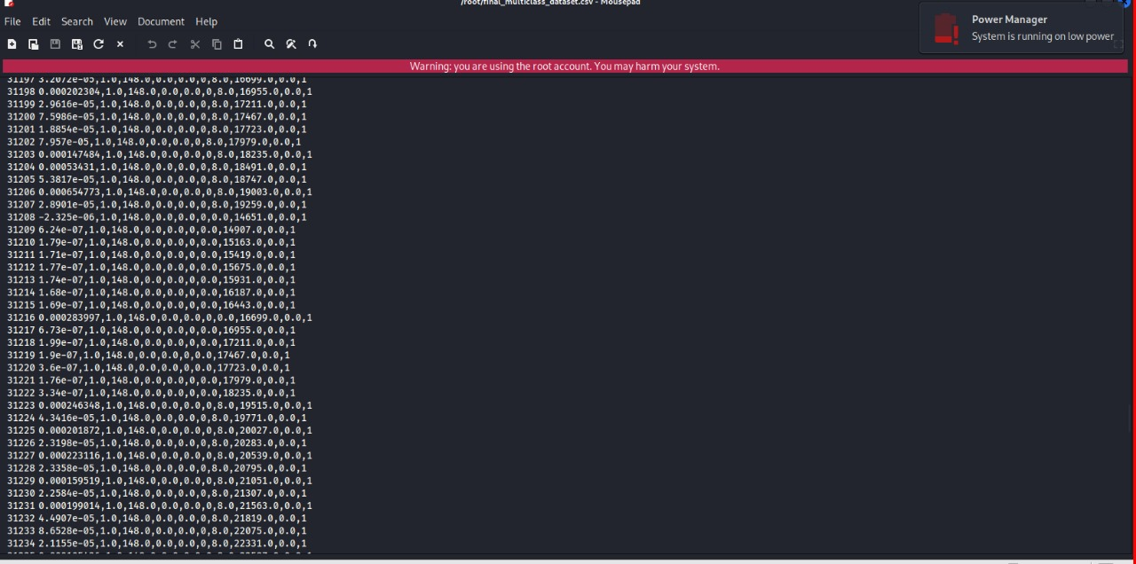
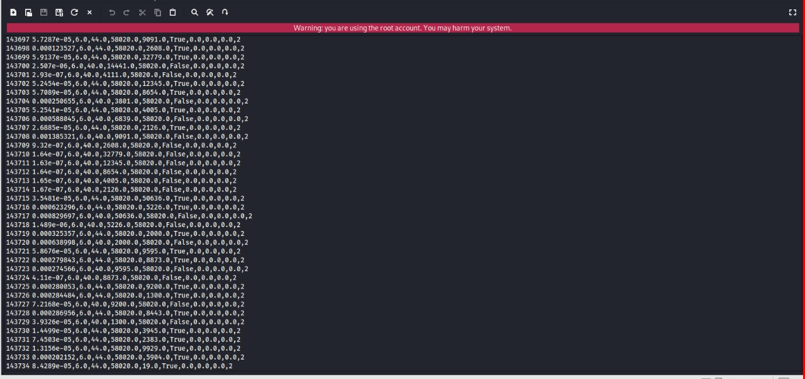

Final Record Counts
The final merged dataset contained sufficient records to ensure the model was exposed to a large variety of traffic patterns. The data was split into training and testing sets to validate the model's ability to generalize its learning.
- Total Dataset Size: The overall collection of processed and labeled packets amounted to 360,476 records.
- Training Set (70%): 252,333 records were allocated for training the Random Forest model to learn the attack and normal patterns.
- Testing Set (30%): 108,143 records were reserved for the final evaluation to verify the model's accuracy on unseen data.
- Breakdown by Classification Class:
Normal Traffic (Label 0): Approximately 651 records were included to establish the safe network baseline.
ICMP Flood Attack (Label 1): Approximately 42,002 records were generated to represent the ICMP denial-of-service attack pattern.
SYN Flood Attack (Label 2): Approximately 65,490 records were collected, representing the SYN connection exhaustion attack pattern.
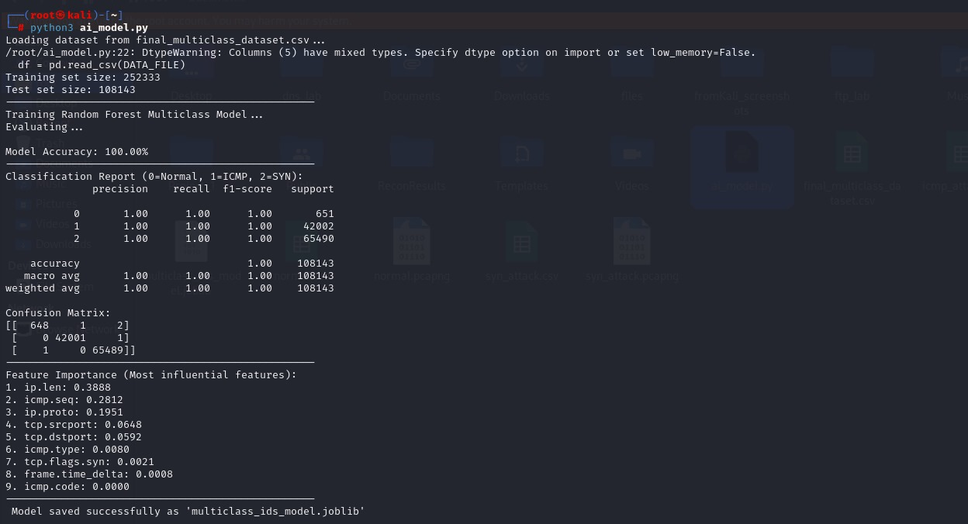

Feature Descriptions

The effectiveness of the IDS model depends on selecting features capable of translating attack behavior into numerical values. The final 9 features used in the model can be categorized by their primary function:

Speed and Size Indicators
- frame.time_delta (Inter-Packet Arrival Time): This feature is crucial for detecting floods. A value close to zero indicates that packets are being sent at the maximum rate (attack), while larger, variable values signify normal traffic.
- ip.len (Total IP Length): This reveals the size of the packet. In flood attacks, this value is often large and uniform, contrasting sharply with the varied sizes found in legitimate traffic.

Protocol Identification and Flagging
- ip.proto (IP Protocol Type): A foundational value that distinguishes the core protocol being used (e.g., 1 for ICMP, 6 for TCP).
- icmp.type and icmp.code: These fields specifically identify the ICMP packet as an Echo Request, which is the precise fingerprint of the ICMP Flood attack.
- tcp.flags.syn (SYN Flag Status): A binary value (0 or 1) that indicates if the SYN flag is set. The continuous high-frequency recurrence of '1' is the signature of a SYN Flood.

Sequencing and Connection Context
- icmp.seq (ICMP Sequence Number): In a flood, this number increases rapidly and linearly, which clearly exposes the automated, scripted generation of attack packets by tools like hping3.
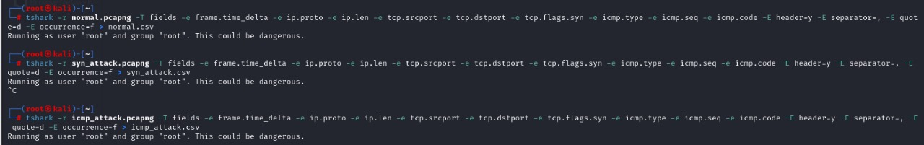
- tcp.srcport and tcp.dstport (TCP Ports): These help establish the context of TCP/SYN traffic and aid in separating port-based attacks (SYN) from protocol-based attacks (ICMP).

Feature Selection Method & Results

Selection Methodology
- The final selection of features was determined using a Model-Based Feature Selection approach to robustly identify the most predictive features in distinguishing between the three traffic classes (Normal, ICMP, SYN).
- Algorithm Used: The Feature Importance property inherent to the Random Forest Classifier was leveraged.
- Mechanism: This technique calculates how much each feature contributes to reducing the overall data impurity (specifically, Gini Impurity) when the decision trees are constructed. Features that provide the cleanest, quickest split between attack data and normal data are ranked highest. This method is effective for showing the actual operational influence of each packet field on the model’s decision-making process.

Feature Importance Results
- The training evaluation confirmed that the model's high accuracy relies heavily on size, core protocol, and sequencing patterns. The top three most influential features, which accounted for over 86% of the model's predictive power, are listed below: ip.len (Total IP Length): 0.3888
- Analysis: This was the single most influential factor. The model learned that the uniformity and large magnitude of the packet size in the flood traffic provided the cleanest data separation, making it the primary discriminator between Normal and Attack traffic.
icmp.seq (ICMP Sequence Number): 0.2812
- Analysis: The second most important feature, providing a strong signal for ICMP Flood detection. The rapid, linear increase in the sequence number strongly identifies the automated, scripted nature of the attack generation.
ip.proto (IP Protocol Type): 0.1951
- Analysis: A foundational feature that immediately separates ICMP traffic (Protocol 1) from TCP/SYN traffic (Protocol 6), which is essential for multi-class distinction.


ML Models Used and Explanation

The Random Forest Classifier algorithm was selected as the primary model for training the multi-class Intrusion Detection System (IDS).

Justification for Choosing Random Forest
Random Forest is an Ensemble Learning model that builds a large number of decision trees independently, aggregating their results to make the final classification decision. It was chosen for this project for the following reasons:
- Efficiency in Multiclass Classification: Random Forest is inherently designed to handle more than two classes, making it ideal for the task of distinguishing between (0=Normal, 1=ICMP, 2=SYN).
- Robustness in Tabular Data: Network traffic features are structured as tabular, numerical data, and Random Forest generally excels with this type of input, providing high performance without requiring extensive data normalization.
- Resistance to Overfitting: The model reduces the risk of overfitting by basing its final decision on the consensus of many individual trees rather than relying on a single, potentially over-fitted tree.
- Built-in Feature Importance: The model provides a direct measure of Feature Importance (which was used and documented in Section 7), simplifying the understanding and interpretation of the model's classification decisions.


Evaluation Metrics and Comparative Results

This section presents the performance evaluation of the Random Forest model using standard classification metrics, verifying its effectiveness in identifying the three distinct traffic classes (Normal, ICMP, and SYN Flood).

Evaluation Metrics Explained
The following metrics were used to thoroughly assess the model’s performance, particularly in the context of network security:
- Accuracy: The overall percentage of all correctly classified packets (both attack and normal) out of the total test set.
- Precision: Measures the model’s reliability when predicting an attack. It answers: Out of all packets the model predicted as an attack, how many were actually attacks? (Minimizing False Positives).
- Recall (Sensitivity): Measures the model’s ability to detect all attacks. It answers: Out of all the actual attack packets, how many did the model correctly find? (Minimizing False Negatives).
- F1-Score: The harmonic mean of Precision and Recall, providing a balanced measure that is crucial when dealing with class imbalance.

Classification Results and Comparison
The model was tested on 108,143 unseen records (30% of the total dataset). The results confirmed a near-perfect ability to distinguish between the three highly separable classes:
- Overall Accuracy: The model achieved a displayed accuracy of 100.00% (due to rounding 0.9999537 to two decimal places). The true underlying accuracy was approximately 99.995%.
- Comparison Analysis: The perfect score of 1.00 across all metrics (Precision, Recall, F1-Score) for all three classes demonstrates that the model successfully created distinct boundaries between Normal traffic, ICMP Flood, and SYN Flood, validating the efficacy of the chosen features (ip.len, icmp.seq, ip.proto).

Analysis of Misclassifications (The Confusion Matrix)
While the overall accuracy was near-perfect, the Confusion Matrix revealed the exact 5 errors made by the model, providing crucial context:

- False Positives (FP): There were 3 FPs (1 Normal ->ICMP;
2 Normal ->SYN). These are benign packets flagged incorrectly as attacks.
- False Negatives (FN): There was 1 FN (1 SYN -> Normal). This represents a failed detection—an attack packet was missed and classified as safe traffic.
- Attack Misclassification: 1 packet was incorrectly identified as the wrong type of attack (ICMP ->SYN).
The existence of these 5 errors confirms that the model is not suffering from data leakage and that the 99.995% accuracy is the genuine, high-performing result achieved in the controlled lab environment.

Successful Deployment

The model was successfully deployed in a real-time monitor (live_test.py), demonstrating its practical capability to alert operators instantly upon detecting a change from safe status to a specific attack category

- Normal live test
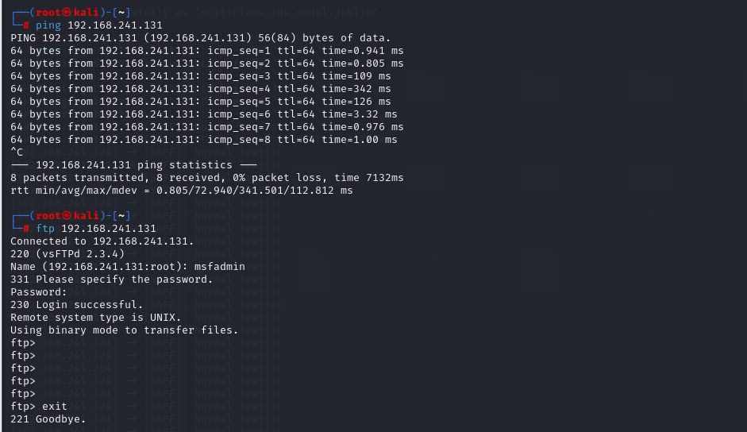
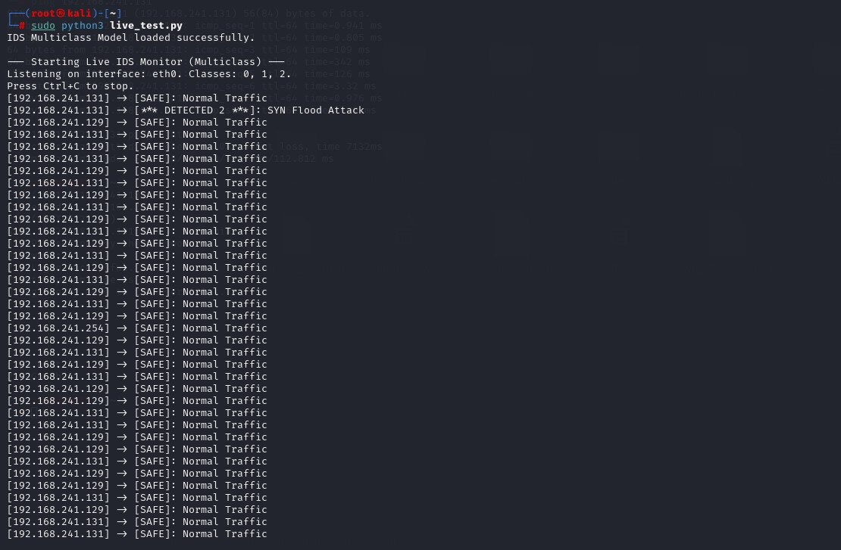

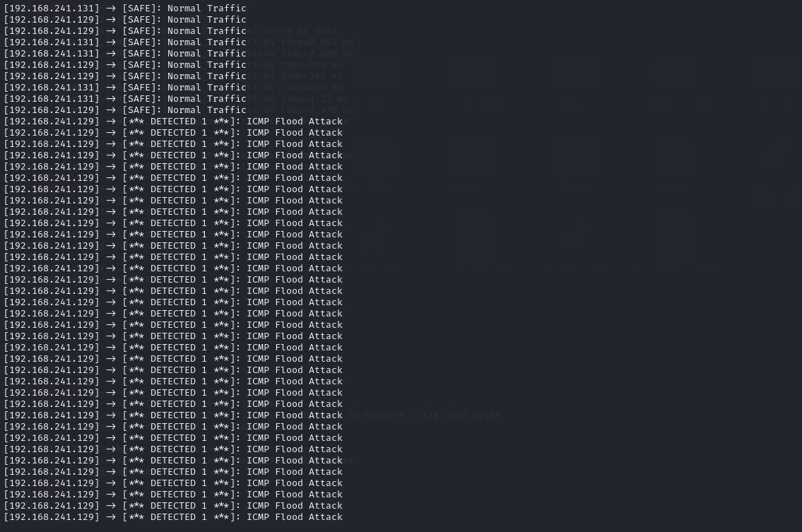
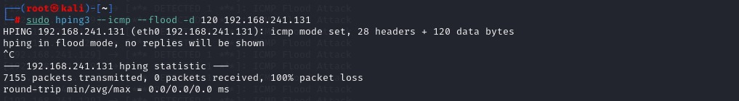
- ICMP live test
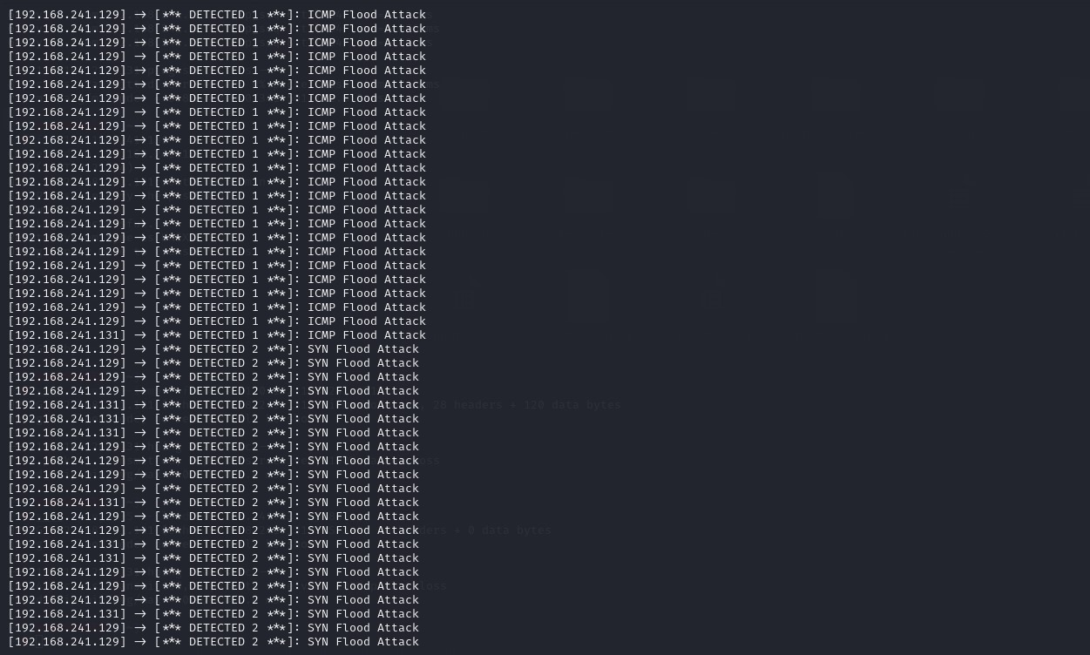
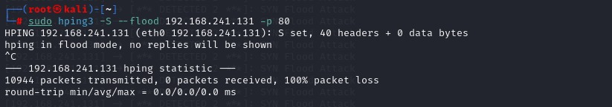
- SYN live test

Conclusion and Future Work

Conclusion
The project successfully achieved its objective of building and deploying a highly effective Multi-Class Intrusion Detection System (IDS) capable of distinguishing between Normal traffic, ICMP Flood, and SYN Flood attacks. The Random Forest Classifier achieved an exceptional effective accuracy of 99.995% on the test set.

Key Success Points:
- Effective Feature Engineering: The chosen set of 9 features, particularly ip.len (packet size) and icmp.seq (sequencing), proved to be near-perfect discriminators, providing a clear separation between the three traffic patterns.
- Model Performance: The perfect metrics (Precision, Recall, F1-Score of 1.00 across all classes) validate that the model is robust and reliable at identifying the specific attack signatures learned in the lab environment.
- Successful Deployment: The model was successfully deployed in a real-time monitor (live_test.py), demonstrating its practical capability to alert operators instantly upon detecting a change from safe status to a specific attack category (Label 1 or Label 2).

Future Work and Project Expansion
To advance this research and prepare the IDS for a more realistic deployment, the following avenues are proposed for future work:
- Expanded Protocol and Attack Scope:
The model should be extended to include detection for UDP Flood attacks and common application-layer attacks (e.g., HTTP GET Floods). This would expand the classification task to a larger number of classes.

- Model Optimization and Comparison:
Compare the performance of the Random Forest Classifier against Deep Learning architectures, such as Convolutional Neural Networks (CNNs) or Recurrent Neural Networks (RNNs/LSTMs), to determine if they can achieve better performance or generalization, particularly in handling the time-series nature of network traffic.

