Umbra — A Composite Break-Risk Index (CBRI)
for Autonomous DeFi Circuit-Breaking
A quantitative early-warning score that detects systemic pool stress and evacuates capital before liquidity evaporates.
Umbra Research · ETH Global Lisbon 2026 · github.com/nadaamd/umbra

Abstract. DeFi liquidity pools fail fast: when a stablecoin de-pegs or liquidity flees, the price dislocates and exit costs explode within minutes, well before the average holder can react. We introduce the Composite Break-Risk Index (CBRI), a continuous 0–100 score that fuses three on-chain signals — the velocity of liquidity withdrawal, order-flow imbalance, and peg divergence — into a single risk reading. Each signal is squashed by a logistic function into a comparable [0,1] probability, then combined through a weighted Noisy-OR aggregator that behaves like a physical circuit breaker: the score trips if any single signal turns red, while non-informative signals are neutralised by a zero weight. We then derive the optimal trigger threshold τ* by maximising slippage-aware funds saved on real historical crashes. Back-tested on the March 2023 USDC de-peg (48,066 Uniswap v3 swaps, $5.57B volume), Umbra fires at τ*=66 seventeen hours before the trough — while USDC still trades at $1.0000 — preserving $126,900 (12.7%) on a $1M position.

1. The problem: DeFi breaks faster than people react
A liquidity pool is a shared reserve of two assets that traders swap against. It works beautifully until confidence cracks. When holders rush to exit an asset — because a stablecoin looks unsafe, or a large lender is unwinding — two things happen at once: the price of the fleeing asset falls, and the depth of the pool (how much you can sell without moving the price) collapses. The result is a vicious spiral. By the time a retail user understands what is happening, the liquidity that would have let them exit cheaply is gone, and their sell order eats a punishing slippage on top of an already-fallen price.
This is not hypothetical. The 2022–2023 cycle alone produced the Terra/UST collapse, the stETH discount, and the March 2023 USDC de-peg — each erasing hundreds of millions to tens of billions of dollars of value, much of it from users who simply reacted too late. The tooling gap is stark: markets have had circuit breakers for decades, yet DeFi positions have none.
In plain terms — Umbra is a smoke detector wired to a sprinkler. It watches the pool continuously, scores how close it is to breaking, and — past a proven threshold — automatically moves the user's funds to safety before the fire spreads.

2. What a good risk score must do
Before any mathematics, we fixed three design principles that a credible break-risk score must satisfy:
- Early, not coincident. The score must rise on the causes of a break (liquidity leaving, one-sided flow) — which appear first — not merely on the symptom (a price that has already fallen).
- Trip on any single failure. A pool can break through one channel alone. A score that averages its inputs dilutes a single extreme signal; a circuit breaker must not.
- Calm must read calm. In a healthy market the score must sit near zero. A detector that cries wolf is worse than none — every false trigger costs the user real slippage.

3. The three signals
Umbra reads three orthogonal on-chain quantities, each capturing a distinct way a pool tells you it is under stress. All are computed on 5-minute candles aggregated from raw swap, mint and burn events fetched via The Graph.

3.1 Liquidity-drain velocity — the early warning
The single earliest tell of a crisis is not the price; it is liquidity providers pulling their capital out, and doing so ever faster. We measure the relative rate at which the pool's value is draining:
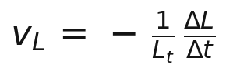
Here L is the pool's liquidity (total value locked) and ΔL/Δt its change per unit time. Dividing by L makes the signal scale-free: a 5%/hour drain means the same thing for a $1M pool and a $1B pool. We compute ΔL from the net of mint (liquidity added) and burn (liquidity removed) events over a 45-minute window, which smooths single-LP noise while remaining fast.
Why it leads — Sophisticated liquidity providers de-risk first. Their exit thins the book hours before the crowd notices, so a rising v_L is a genuine head start.

3.2 Order-flow imbalance — the rush to the exit
In a panic, trading becomes one-directional: everyone sells the same asset. We quantify how lopsided the flow is:
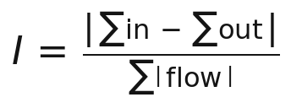
I lives in [0,1]: it is 0 when buys and sells balance, and approaches 1 when flow is entirely one-way. Because Uniswap v3 has no static reserves, this realized order-flow imbalance is a more faithful stress measure for concentrated liquidity than any reserve-ratio proxy.

3.3 Peg divergence — the confirmation
For a stablecoin, the most direct evidence of a break is the price itself leaving its peg. We read the price straight from the deepest stable/stable pool (USDC/USDT), which needs no external oracle:
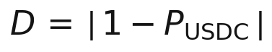
D is the fraction by which the coin has left $1. It is a confirming signal — large and unambiguous once a de-peg is underway — that complements the forward-looking drain and flow signals.

4. From three signals to one 0–100 score

4.1 Normalization: making signals comparable
The three raw quantities live on incompatible scales (a fraction per hour, a ratio, a price deviation). We map each onto a common [0,1] axis with a logistic (sigmoid) function, which acts as a soft, tunable threshold:
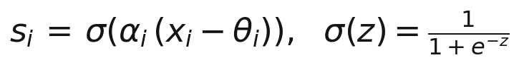
θ_i is the level at which the signal starts to look abnormal, and α_i sets how sharply the transition happens. Below its threshold a signal contributes ≈0; well above it, ≈1. Each s_i can be read as “the probability, according to this one lens, that the pool is breaking.”

4.2 Aggregation: the circuit-breaker logic (Noisy-OR)
We do not average the signals — averaging would let a single extreme reading be diluted by two calm ones, exactly the wrong behaviour for a breaker. Instead we combine them with a weighted Noisy-OR:
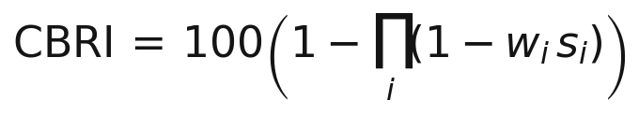
Read literally, the product is the probability that the pool survives every signal at once; one minus that is the probability it breaks through at least one channel. The consequence is precisely the circuit-breaker property: if any single s_i approaches 1, the whole score is driven to 100, regardless of the others. The weights w_i are a safety valve — a signal that carries no information on a given regime is set to w=0 and cleanly removed, without re-deriving the model.
A useful discovery — On the USDC de-peg, order-flow imbalance turned out to be non-discriminating (arbitrageurs kept buying the cheap coin, so flow never became fully one-way). Rather than let it add noise, we set its weight to zero. The CBRI here is effectively a two-signal breaker — drain OR de-peg:

5. Calibration: calm reads ~8, crisis reads 100
The thresholds θ_i and steepnesses α_i are not guessed; they are set so that each sigmoid rests near zero in normal conditions and saturates only in genuine stress, then validated against the data. With the parameters below, the CBRI sits at a resting baseline of roughly 7–10 during calm trading and rises to 100 at the height of the crisis — a clean separation with no false alarms in the quiet window.
Signal | Threshold θ | Steepness α | Window | Weight w
Liquidity-drain velocity v_L | 0.06 /h | 60 | 45 min | 1.0
Order-flow imbalance I | 0.30 | 15 | 30 min | 0.0 (off)
Peg divergence D | 0.012 | 250 | — | 1.0

Table 1 — CBRI model parameters (5-minute candles).

6. From score to action: the optimal trigger τ*
A score is only useful if it tells you when to act. Umbra evacuates the position — swapping the at-risk asset into a safe stablecoin — the first time the CBRI crosses a threshold τ. Choosing τ well is itself a quantitative problem.

6.1 The false-recovery trap
USDC eventually recovered to ~$1.00. Measured naïvely against the trough, evacuating always looks good and earlier is always better; measured against the full recovery, it looks pointless. Both framings are misleading. The honest objective treats evacuation as downside protection whose real cost is the slippage paid to get out — and that slippage is the crux.

6.2 Slippage-aware funds saved
As liquidity collapses, the cost of exiting a fixed $1M position explodes. We model exit slippage as inversely related to the pool's surviving depth, anchored to a live Uniswap quote in calm conditions:
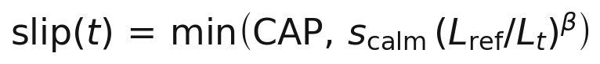
The funds saved by triggering at threshold τ are then the value recovered at the exit — net of that slippage — versus suffering the trough:
and the optimal trigger maximises this in expectation:
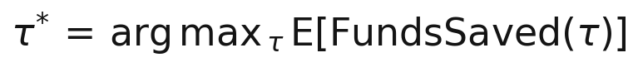

6.3 The plateau and the chosen threshold
Because the CBRI leaps from its resting baseline straight past 60 the moment liquidity flight begins, every threshold up to that jump triggers at the same optimal instant — a plateau of equally-good choices. We select the highest threshold on that plateau, τ*=66, which captures the full protection while leaving the maximum safety margin against false alarms.

7. Empirical validation — the March 2023 USDC de-peg
We replay the SVB-driven USDC de-peg of 10–13 March 2023 on real data: 48,066 Uniswap v3 swaps totalling $5.57B of volume, cross-referenced with the USDC/USDT pool for the peg and with mint/burn events for the liquidity drain. The evacuated position is $1M of USDC.
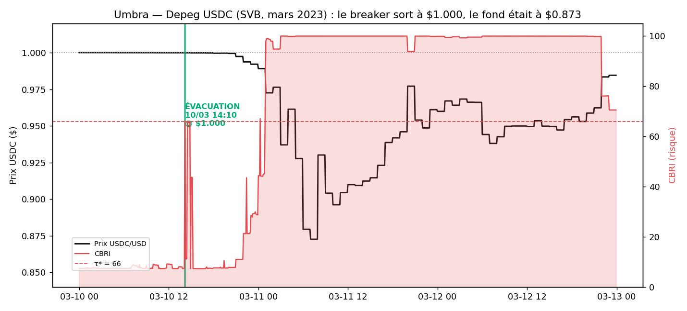
Figure 1 — The CBRI (red) against the USDC price (black). The breaker fires at τ*=66 on 10 March 14:10 UTC, while USDC is still $1.0000 — about 17 hours before the $0.8726 trough.
The active liquidity of the USDC/USDT pool collapsed by a factor of roughly 23 million as the price left the concentrated range — the physical reason exit slippage explodes if one waits. The table below shows the cost of hesitation: each block of thresholds triggers later, at a worse price and a worse slippage.
Trigger τ | Exit time (UTC) | Exit price | Slippage | Funds saved
10–66 (τ*) | 10 Mar 14:10 | $1.0000 | 5 bps | $126,900
67–72 | 11 Mar 00:15 | $0.9892 | 53 bps | $111,400
73–98 | 11 Mar 01:00 | $0.9726 | 91 bps | $91,100
99 | 11 Mar 03:00 | $0.9371 | 657 bps | $2,900

Table 2 — Waiting is expensive: funds saved by trigger threshold, $1M position.
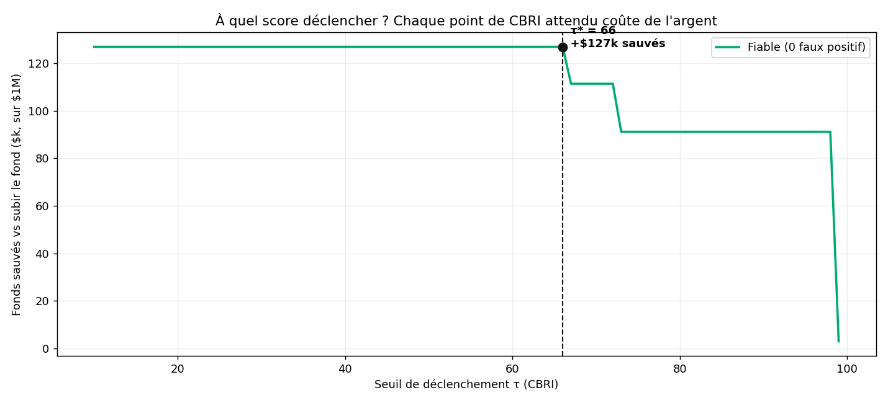
Figure 2 — Funds saved as a function of the trigger threshold τ. The flat plateau (τ ≤ 66) is the zero-false-positive optimum; beyond it, every step of waiting forfeits capital.
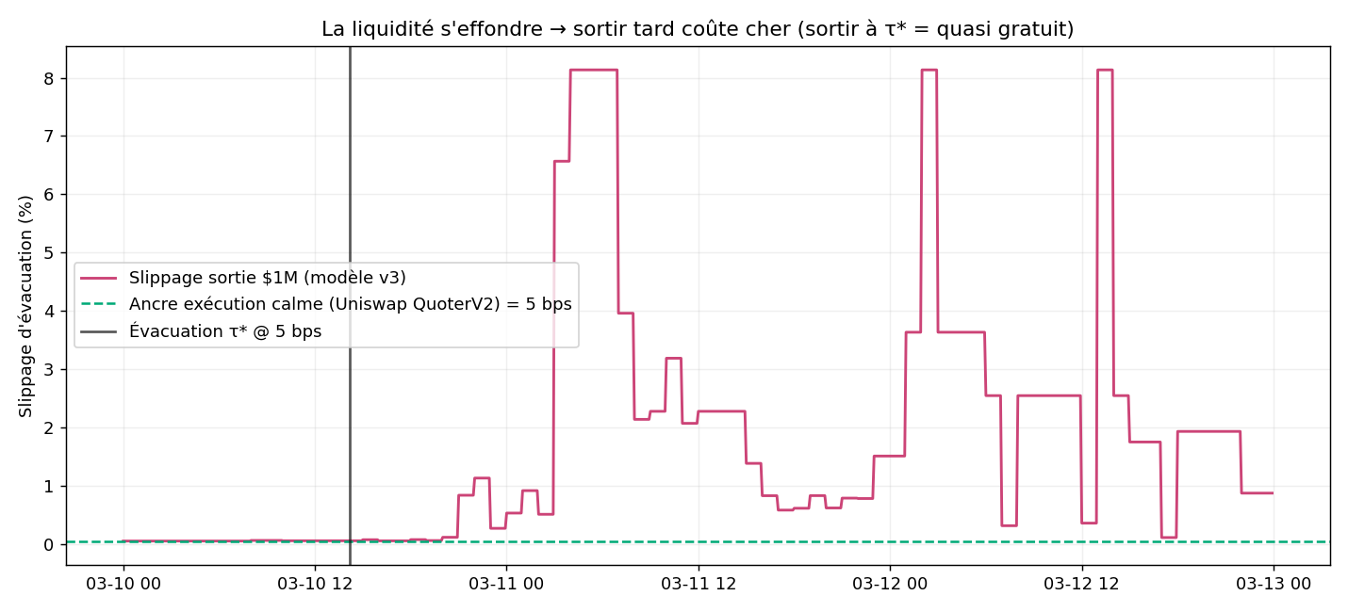
Figure 3 — Exit slippage over time versus the calm Uniswap anchor. Exiting at τ* costs a few basis points; waiting for price confirmation means hitting a liquidity wall.
Headline result: triggering at τ*=66 evacuates the position at $1.0000 for a 5-basis-point cost, preserving $126,900 — 12.7% of the position — that a passive holder would have watched evaporate into the trough.

8. Economic alignment
Umbra charges a success fee only on the loss it avoids. On the case above, a 10% fee is $12,690 of revenue — earned strictly because the user kept $126,900 they would otherwise have lost. Incentives are exactly aligned: Umbra is paid if and only if the user is protected. Every score and the exact model that produced it are anchored on 0G decentralized storage, so the scoring is auditable and tamper-evident rather than a black box.

9. Limitations and future work
- Single-venue execution. The MVP routes the evacuation through one pool — the very pool whose depth collapses in a crisis. Production execution must split across pools, fee tiers and venues (multi-hop routing) to avoid the slippage wall it warns about.
- Signal set. Order-flow imbalance was non-informative on this crash and disabled. A volatility-surge or cross-pool contagion signal is a natural third pillar for a broader regime library.
- Recovery uncertainty. The τ* objective is honest downside protection; a fuller treatment weights terminal-collapse (UST-like) against false-alarm (USDC-like) scenarios under an explicit crisis probability.
- Real-time pipeline. The current system replays history for validation; a production loop streams The Graph continuously and pushes scores on-chain in real time.

Appendix — Data and reproducibility
Data source: The Graph (Uniswap v3 Ethereum mainnet subgraph). Pools: USDC/WETH 0.05% (0x88e6…5640) for drain and flow; USDC/USDT 0.01% (0x3416…27c6) for the peg. Window: 10–13 March 2023 UTC. Execution venue: Uniswap v3 (QuoterV2 + SwapRouter02). The full pipeline — extraction, CBRI computation, τ* back-test, and 29 unit/end-to-end tests — is reproducible from the repository via a single script (./e2e.sh).

Umbra · CBRI v1.0 · Composite Break-Risk Index · ETH Global Lisbon 2026

