**Dereqment of Computer Engineering**



**Cairo University**

**Faculty of Engineering**

**Control Engineering**

**Project**

**Submitted to**

Dr. Meena Elia Samouil Girgis

Eng. Youssef Hassan Mohamed

**Submitted by**

|  |  |  |
| --- | --- | --- |
| **Name** | **Sec** | **BN** |
| **Shredan Abdullah kamal** | **1** | **33** |
| **Nada osman Abdalaziz** | **2** | **30** |

**Req 1 :**

dynamic equations:

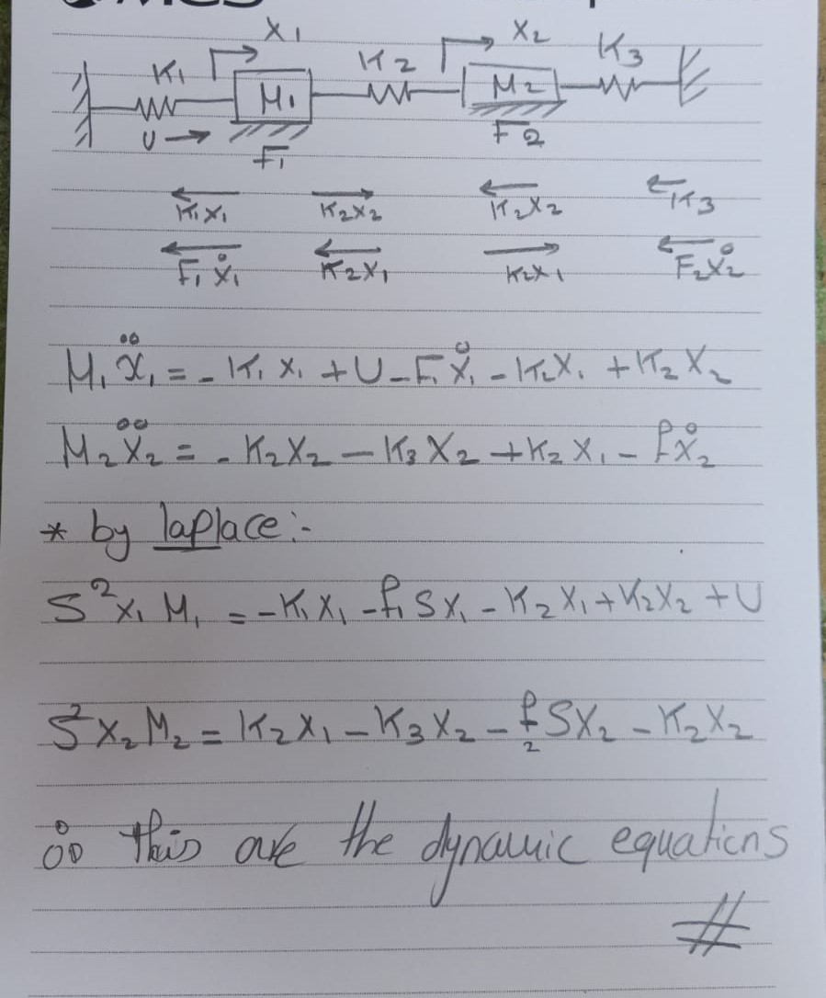

BlockDiagram:

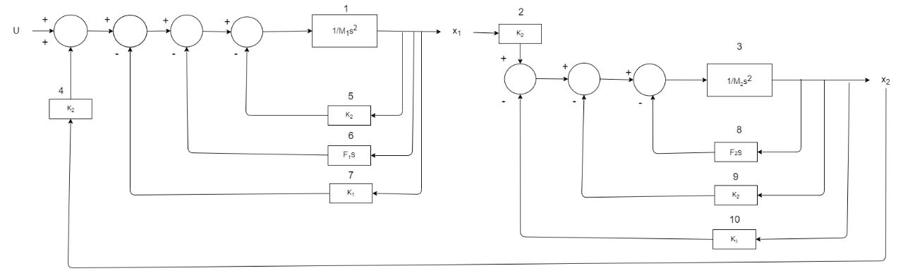

# **Req2:**

Transfer Functions:

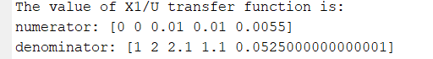

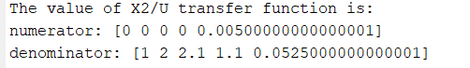

# **Req3:**

both systems are stable

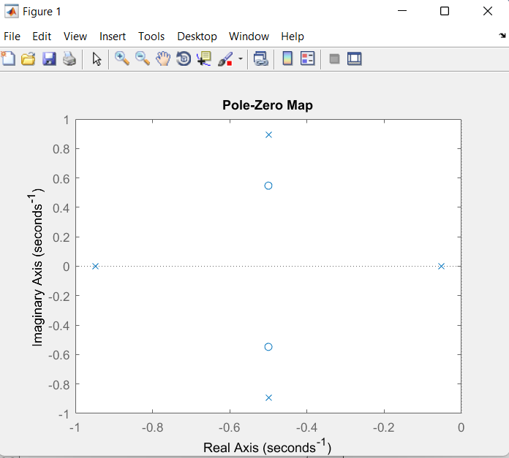

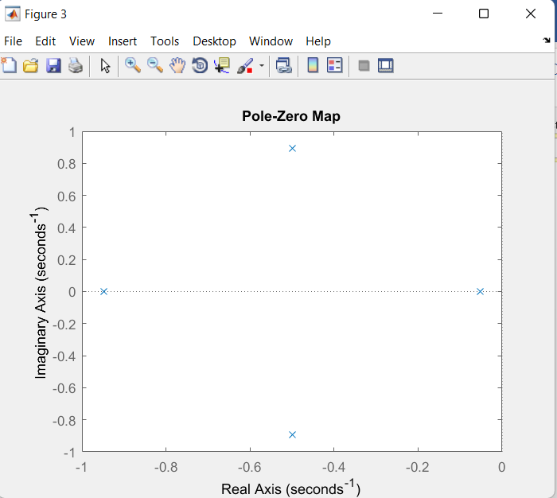

# **Req 4 :**

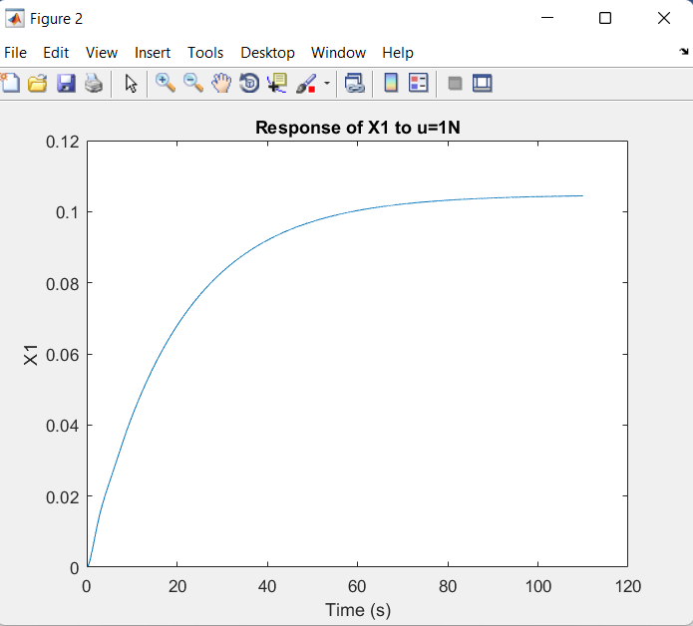

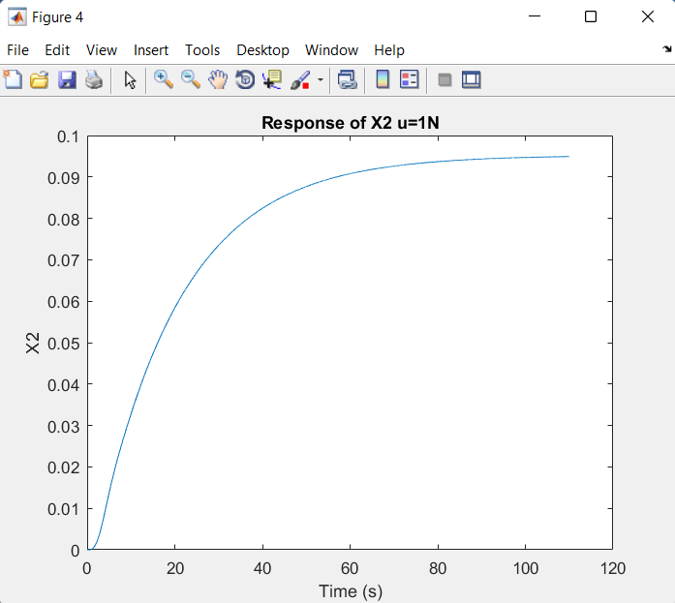

SteadyStateValues:



**Req 5:**

from the hint, here We used unity feedback H(S)=1



**Req 6:**

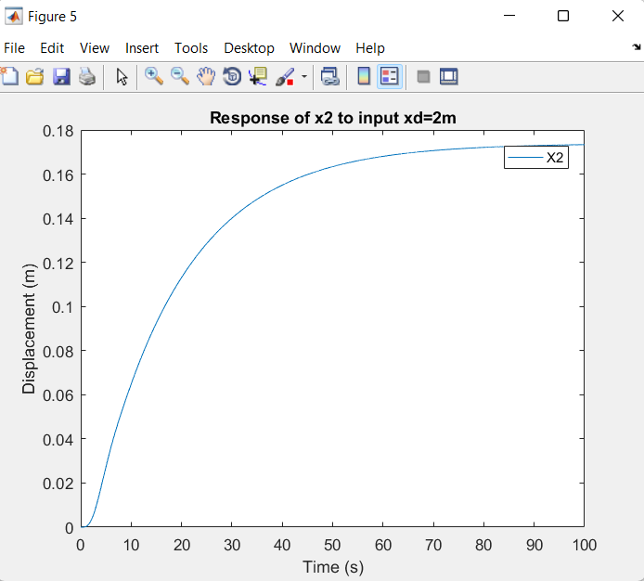

# **Req7:**

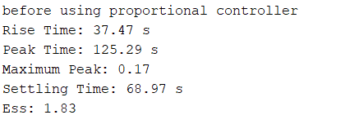

# **Req 8:**

Kp=1

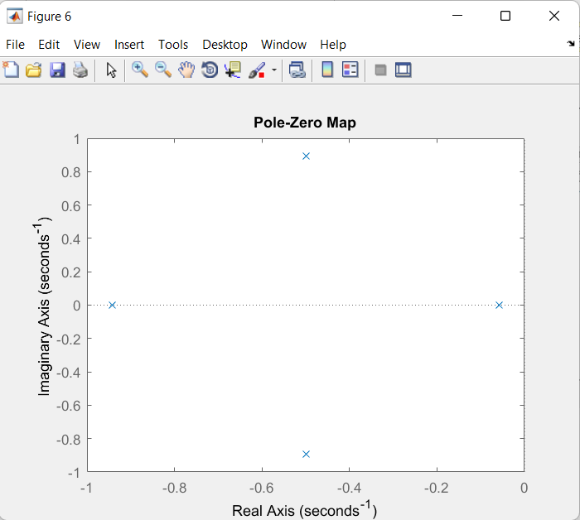

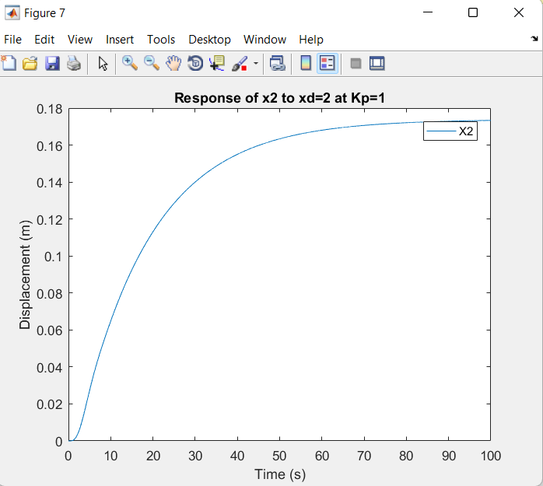

Transient Response:

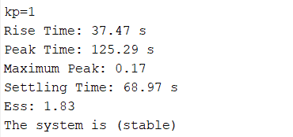

Kp=10

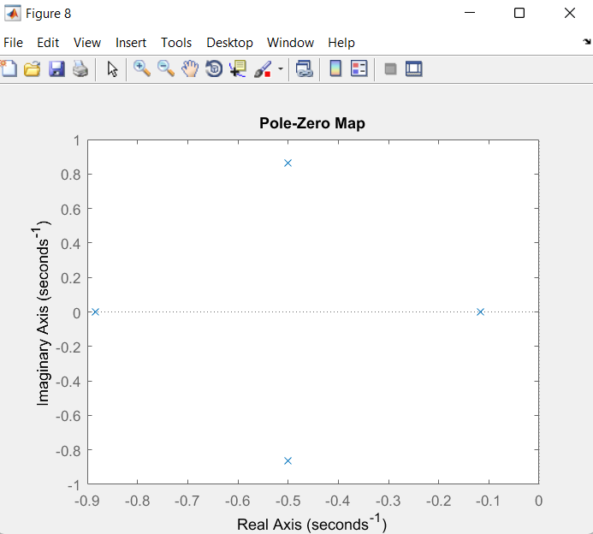

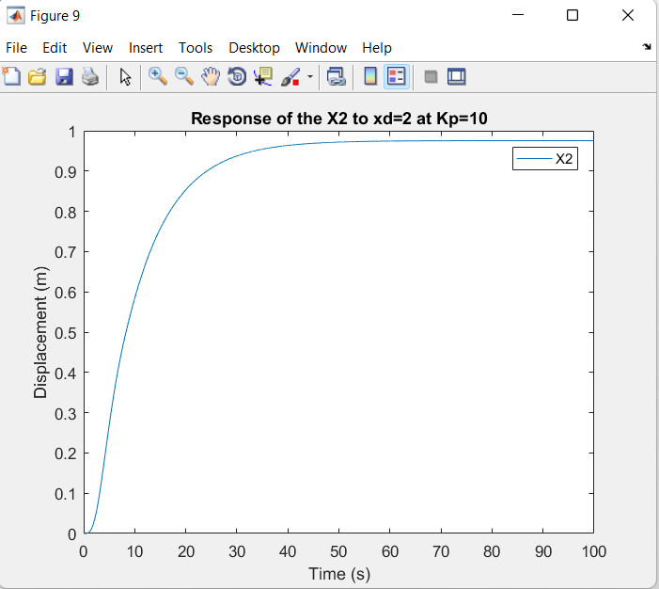

Transient Response:

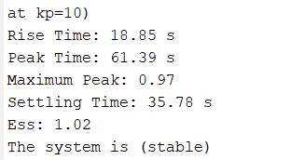

Kp=100

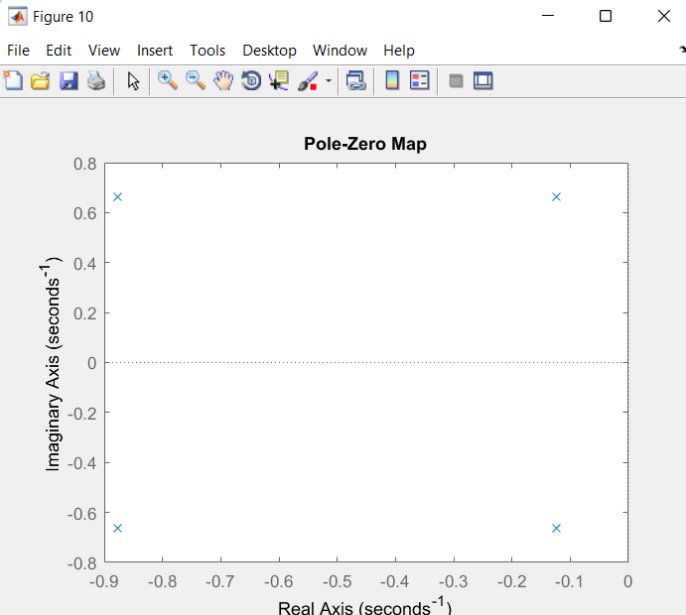

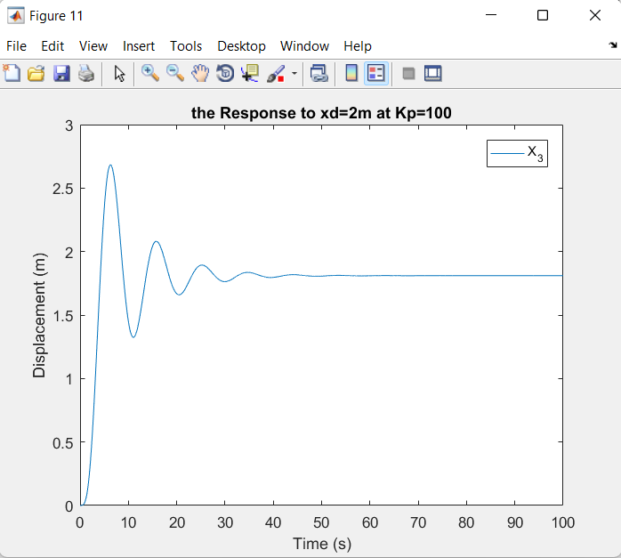

Transient Response:

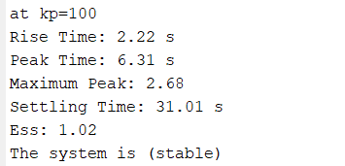

Kp=1000

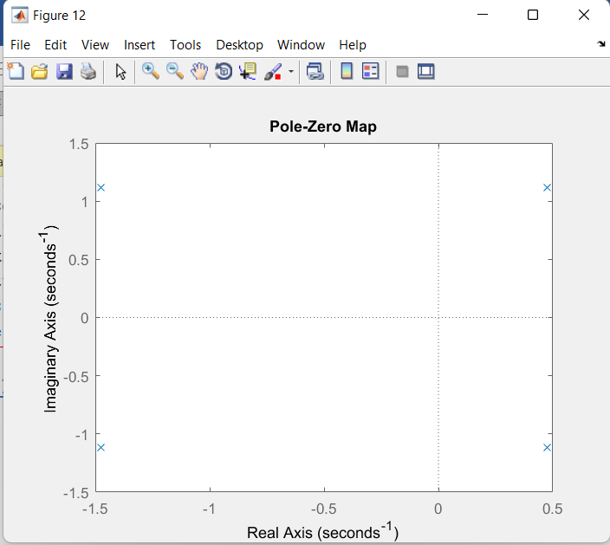

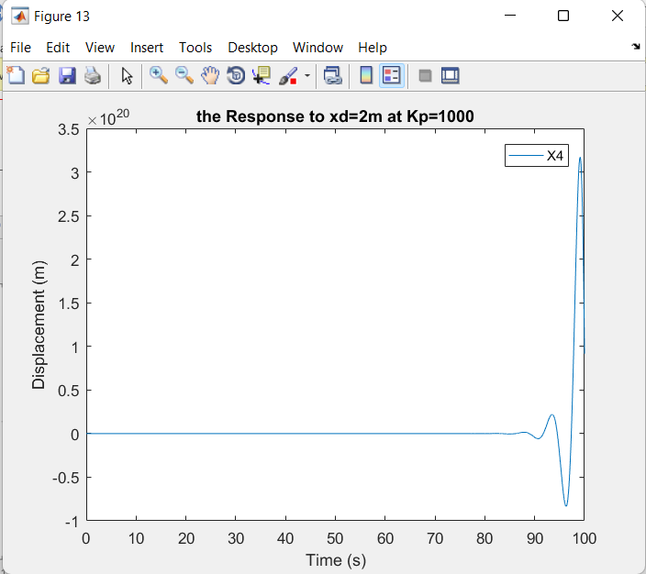

Transient Response:

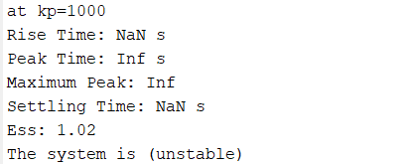

conclusion about req8:

As the value of Kp increases:

* The steady-state error (es.s) decreases. This means that the system's output approaches and maintains its desired value more closely.
* The rise time decreases. Rise time refers to the time it takes for the system's output to reach and settle within a small range around the steady-state value for the first time.
* The settling time decreases. Settling time is the time required for the system's output to reach and remain within a specific tolerance band around the desired value.
* The peak time decreases. Peak time is the time taken for the system's output to reach the first peak or overshoot after the step input.
* The magnitude of the maximum peak increases. This refers to the maximum overshoot of the system's output beyond the desired value.

However, it's important to note that increasing Kp beyond a critical value can lead to instability and unpredictability in the system. At this critical value, the system can become highly sensitive to changes and may exhibit oscillations or divergent behavior.

# **Req 9:**

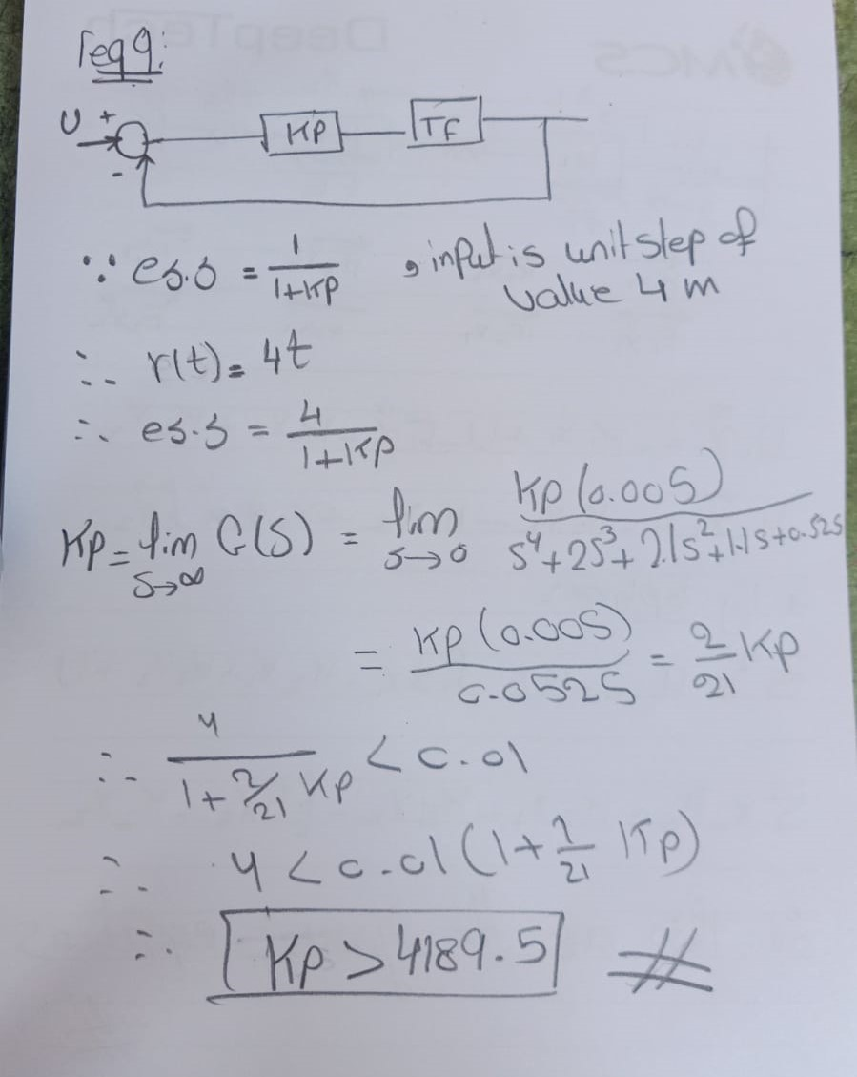

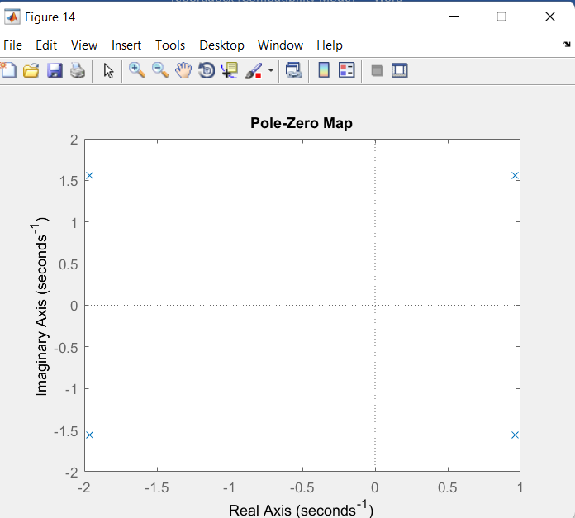

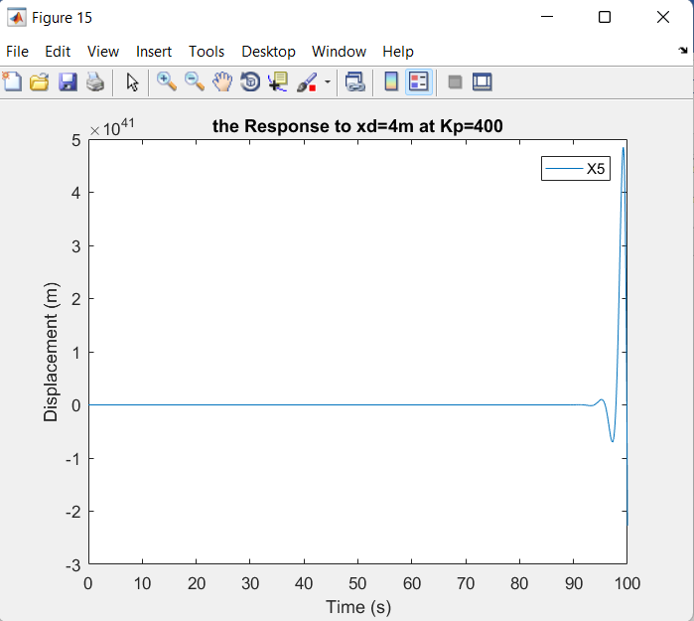

Note:

after solving the problem, we conclude that we need Kp to be greater than 4189.6 to make the es.s less than 0.01 , but this value of Kp make the system unstable.

# **Req 10:**

To improve the steady-state error (ess) in the system, we decided to use a PI controller, which includes an integrator component. After experimenting with different values, we found that setting the integral gain (KI) to 4 and the proportional gain (Kp) to 100 resulted in a stable system.

To enhance the system's steady-state error performance, a PI controller was implemented by adding an integrator. After conducting several trials, it was determined that assigning a value of KI = 4 and Kp = 100 to the integral and proportional gains, respectively, achieved stability while satisfying the desired steady-state error requirements.