Lab_DFT_2

You have to synthesize and insert the DFT logic using DFT Compiler shell and generate Technology Dependent gate level netlists in Verilog format using standard cell libraries (typical, worst, best) inside std_cells folder:-
- scmetro_tsmc_cl013g_rvt_tt_1p2v_25c.db
- scmetro_tsmc_cl013g_rvt_ff_1p32v_m40c
- scmetro_tsmc_cl013g_rvt_ss_1p08v_125c

Steps: -

- Copy Lab_DFT_2 folder from your computer into the virtual machine inside Labs directory
- Open a terminal inside path /home/IC/Labs/ Lab_DFT_2/dft and run dft_script.tcl script through design compiler shell using the following command in the terminal
    - dc_shell -f dft_script.tcl | tee dft.log
- Check the log (dft.log) to be sure that: -
  - No Errors
  - No Warnings
  - No Latches
  - No Comb Loops

- Check Pre-DFT dft_drc violations and fix it
  - Step 1: Inspect the violation using design vision GUI
  - Step 2: Modify in the RTL to fix the violations.

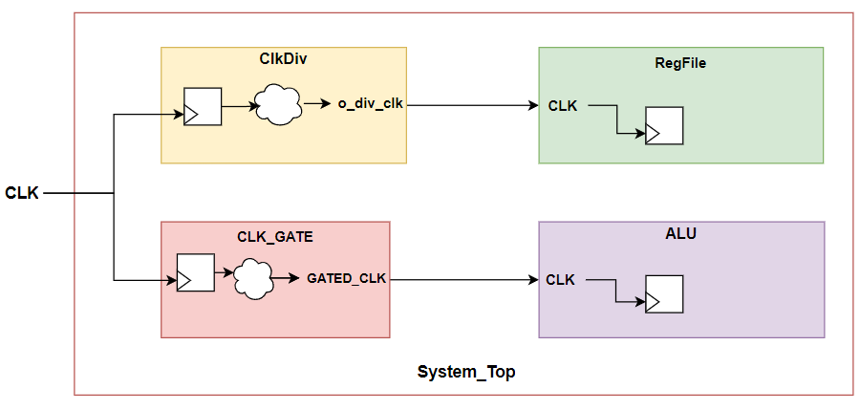
- Here is a simple block diagram for System_Top to help you muxing master clocks as well as generated clocks with the scan clock
- Report the Final test coverage.

