Lab 2

Objective of this lab
- This Lab implements and verifies a 4 MSB of LFSR on the Puzhi ZU4EV FPGA (xczu4ev-sfvc784-2-i) using debug IP cores:
  - Virtual I/O (VIO): Provides a JTAG-based GUI interface for runtime control (Enable, OUT_Enable), compensating for the board's lack of physical toggle switches.
  - Integrated Logic Analyzer (ILA): Monitors full-speed 25 MHz internal register transitions directly within Vivado without requiring external hardware probes.

Steps: -

- You will find LFSR RTL in folder rtl and I/O pin mapping in folder xdc
- Launch Vivado and create a new project inside a folder containing the 2 folders mentioned above

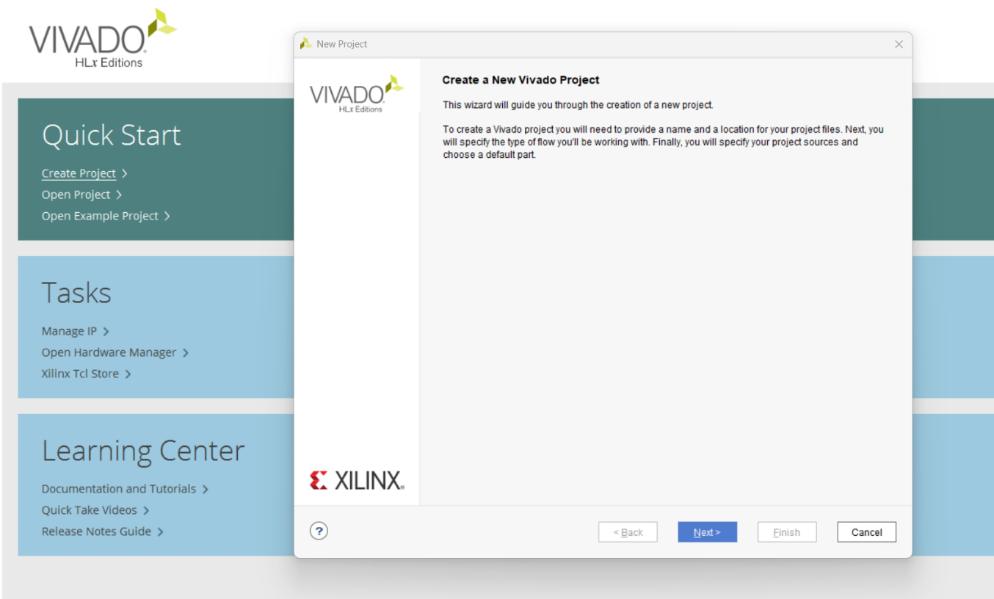

- Specify the project’s name and its location (click on the 3 points to specify the location)

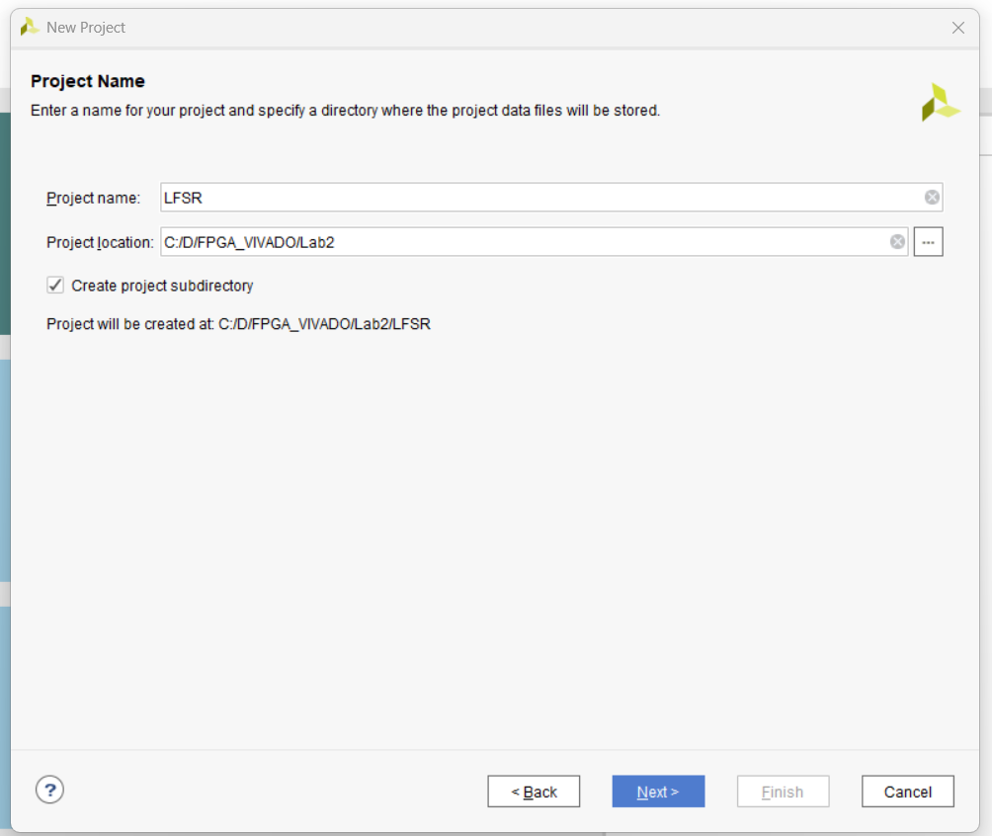

- Select RTL project as the project type
Modify
Link_Library
&
Target_Library
Value

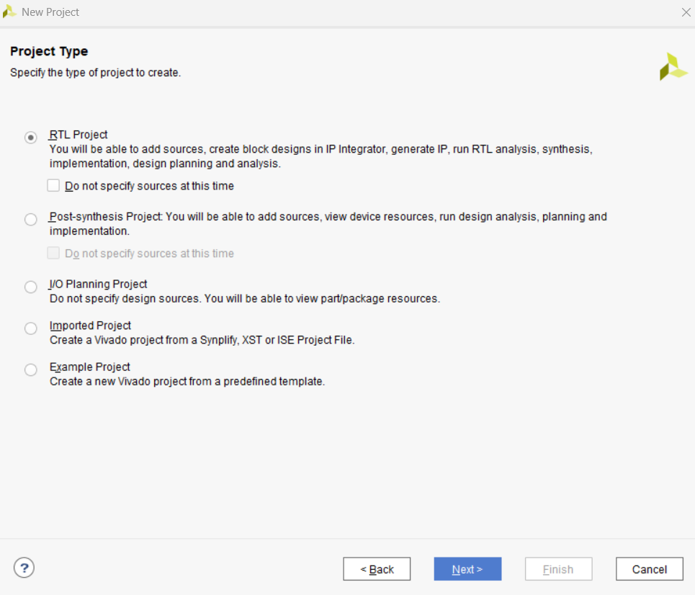
- Add your RTL source files (click on Add Files)

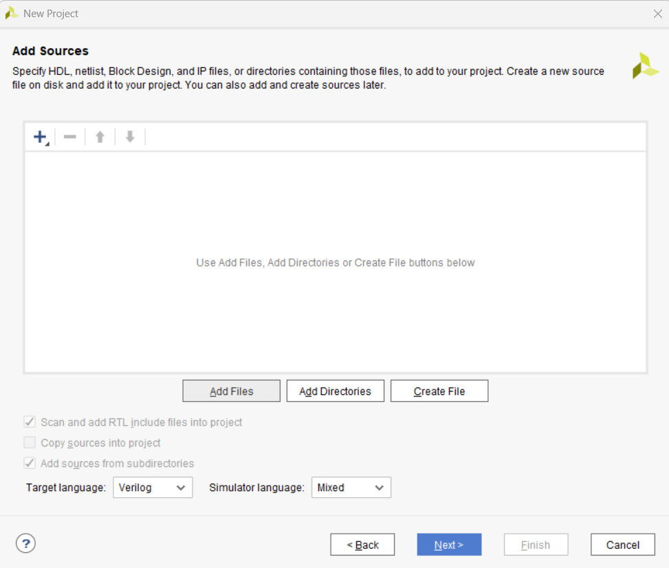

- After adding your RTL files, it will be shown as below:

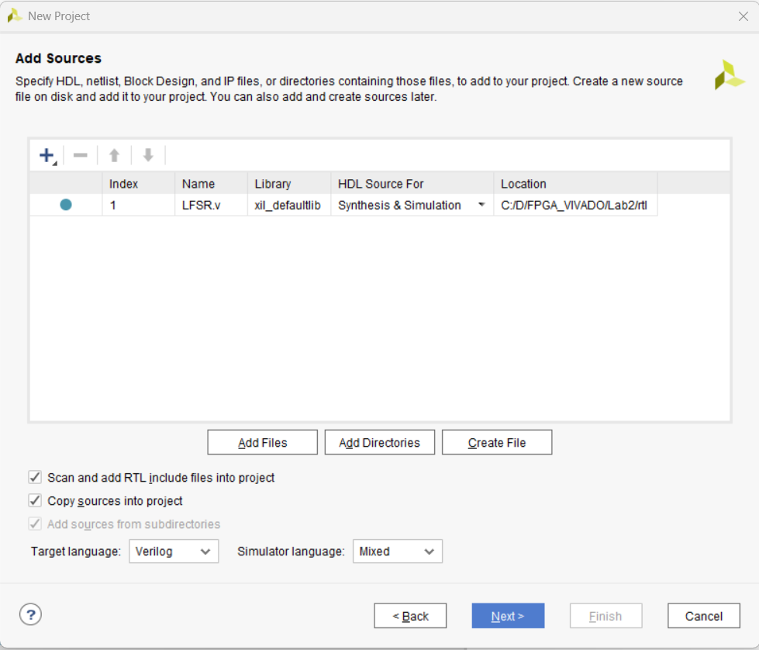

- Add your constraints (XDC) file (click on Add Files)

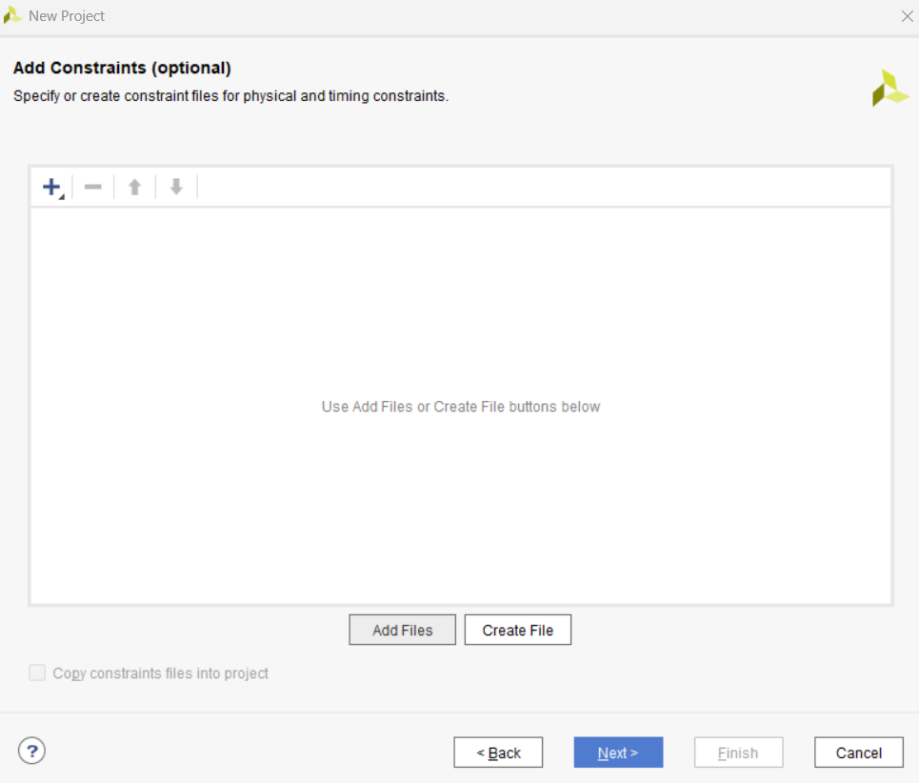

- Your constraints file will have the input/output pin mapping and clock constraints. So, it will be like the following Pic:

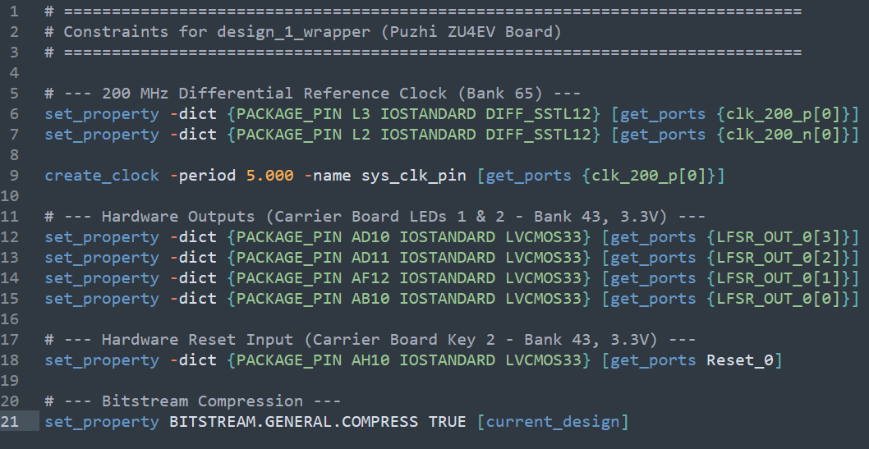

- Select the target FPGA board (xczu4ev-sfvc784-2-i)

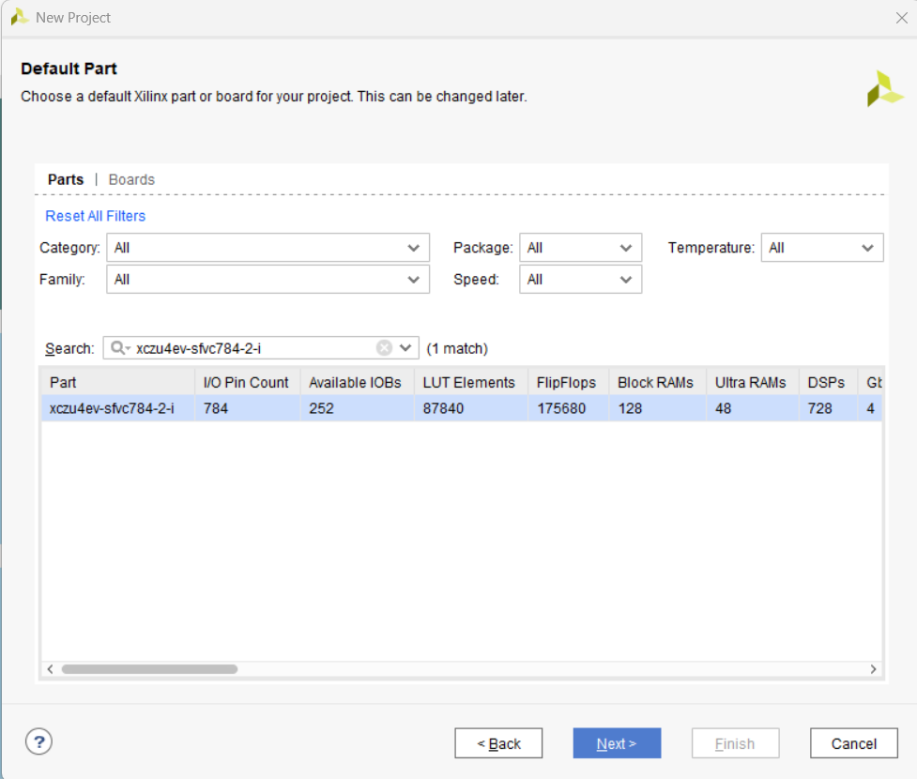

- Review of the selected project settings (click finish after your confirmation)

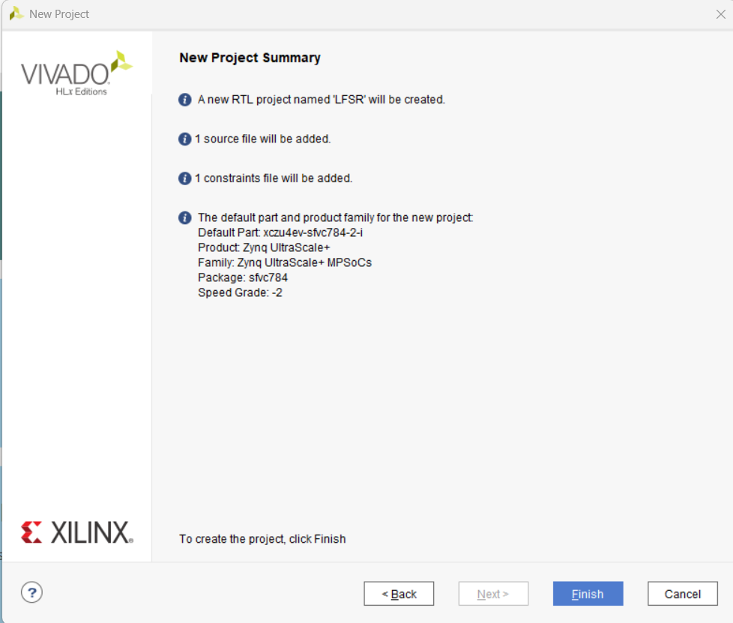

- From IP INTEGRATOR:
  - create block design

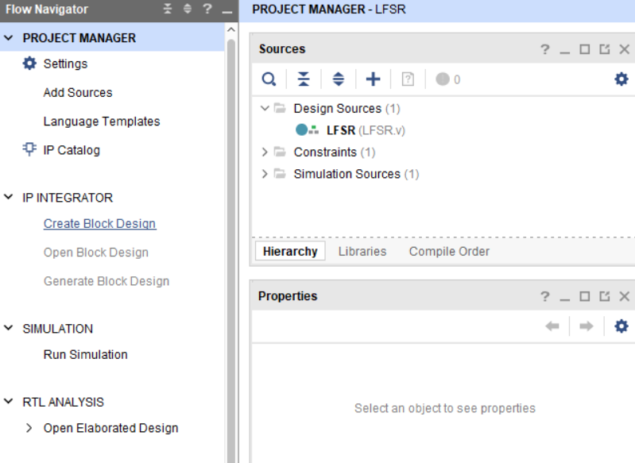

  - Click Add IP then search for Utility Buffer (we will use it to convert the differential clock output from the oscillator to single ended one)

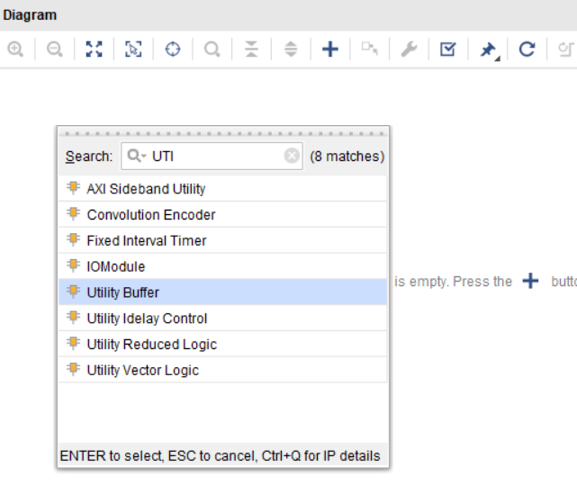

  - Double Click on the buffer and choose IBUFDS

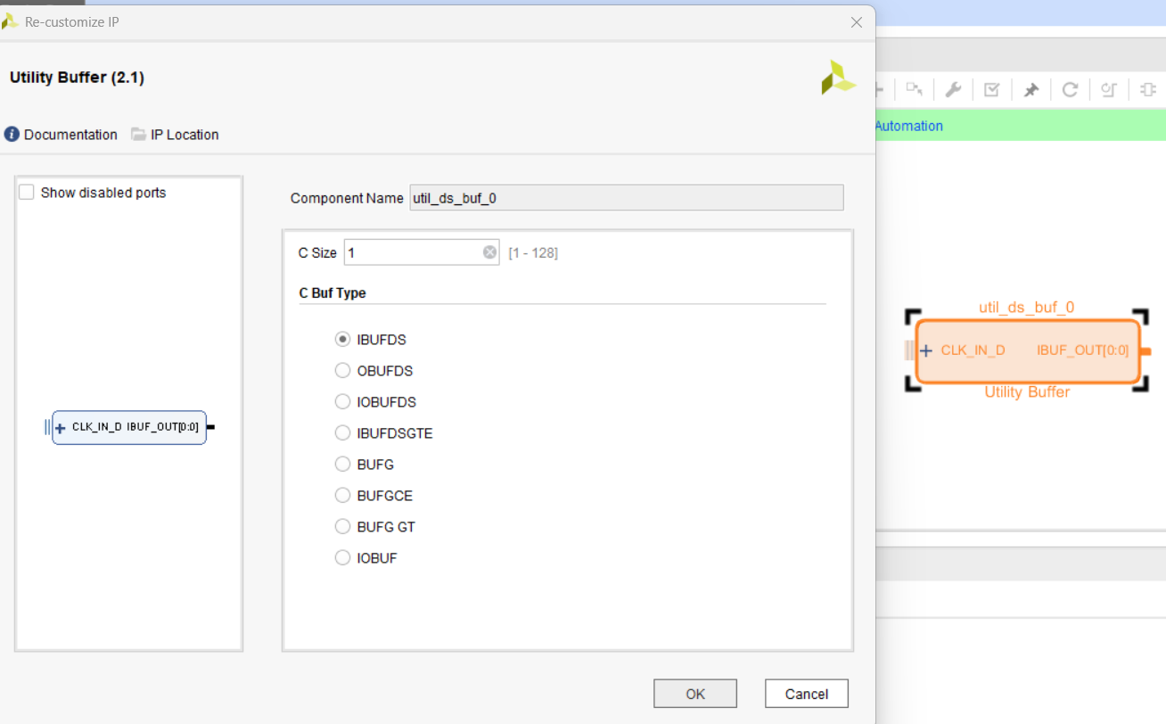

  - Right click on each input port of it then select make external
  - Click on input ports and rename its 2 clock input pins to clk_200_p and clk_200_n and change the frequency to 200 MHz

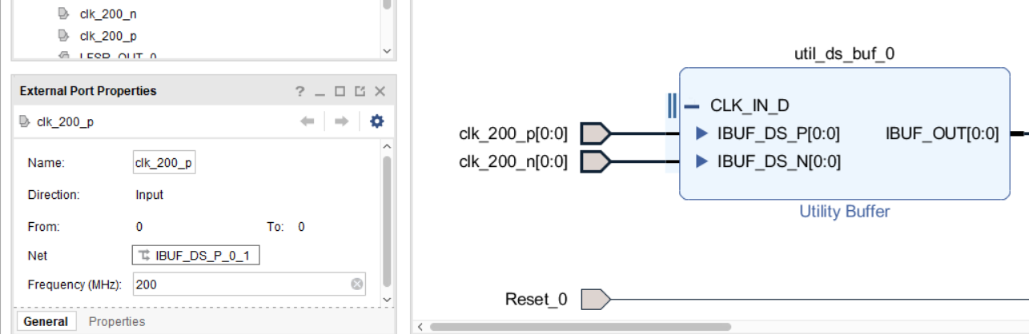

  - Add another IP by Clicking Add IP then search for Clock wizard (we will use it to generate 25 MHz from the 200 MHz)

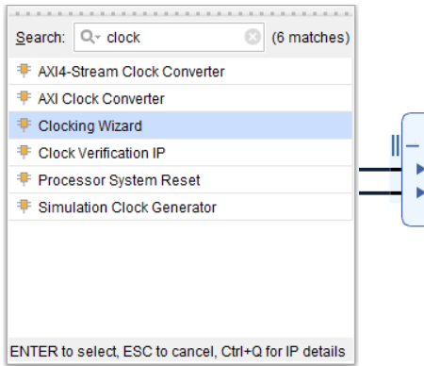

  - Configure the clock to take 200 MHz and output 25 MHz and remove reset and locked ports

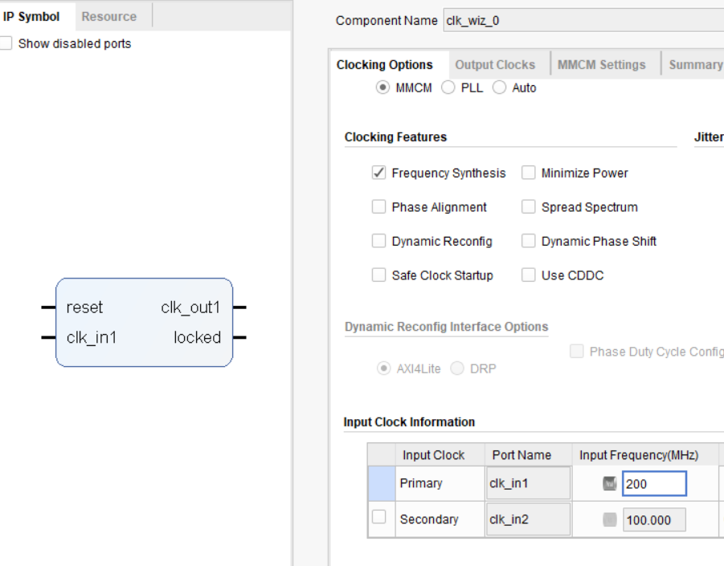

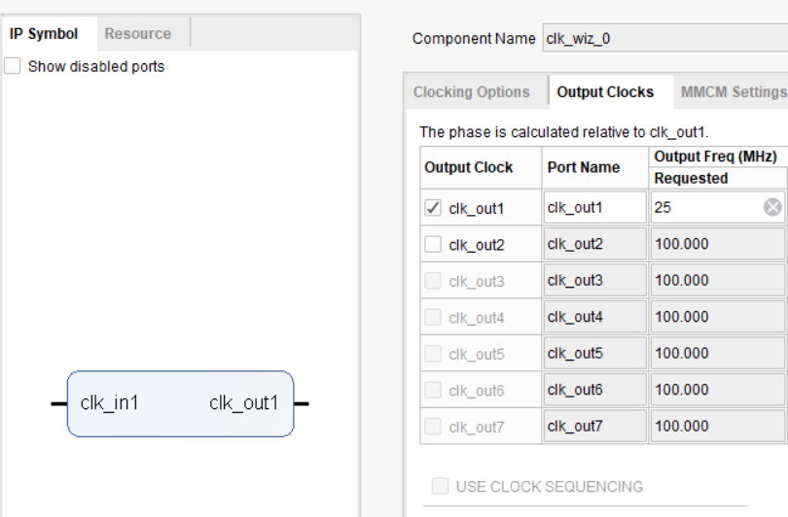

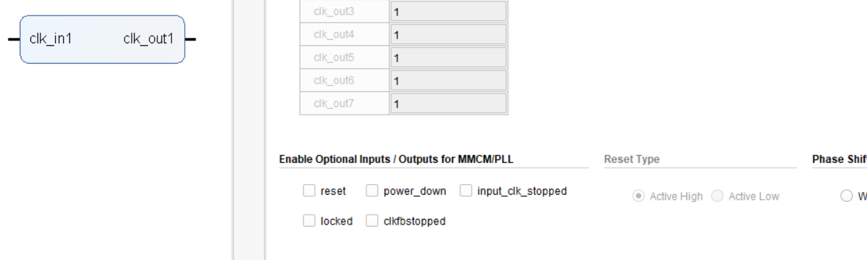

  - Connect the output from the utility buffer to the input of the clock wizard
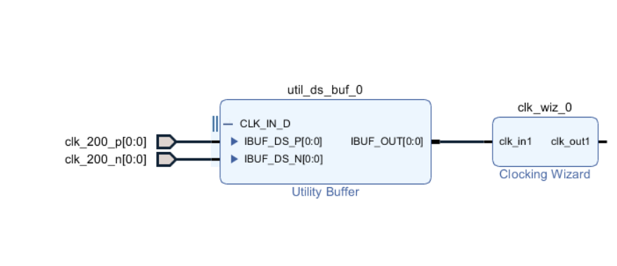

  - Now add your module by right clicking on empty space then select add module

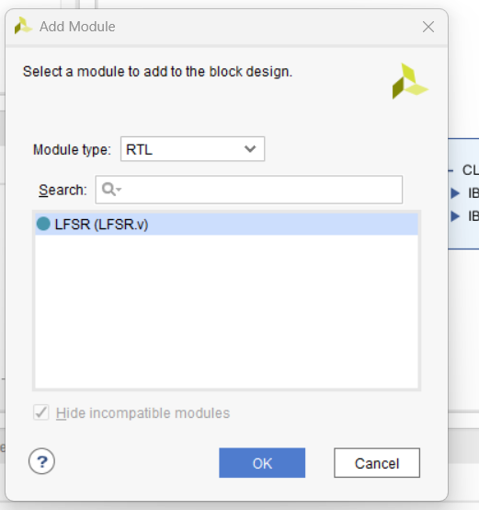

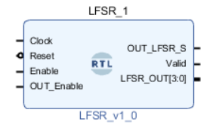

  - Add another IP by Clicking Add IP then search for VIO (Virtual Input / Output)

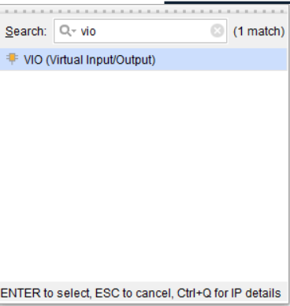

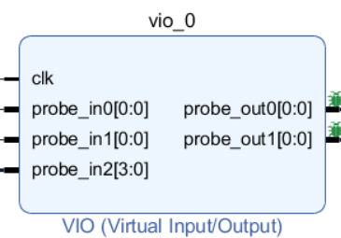

  - Double click on the VIO and do the following:
    - Make input probe count = 3 (from general options)
    - Make output probe count = 2 (from general options)
    - Change PROBE_IN2 width to 4 (from PROBE_IN_PORTS)
    - The remaining ports leave it as 1 bit

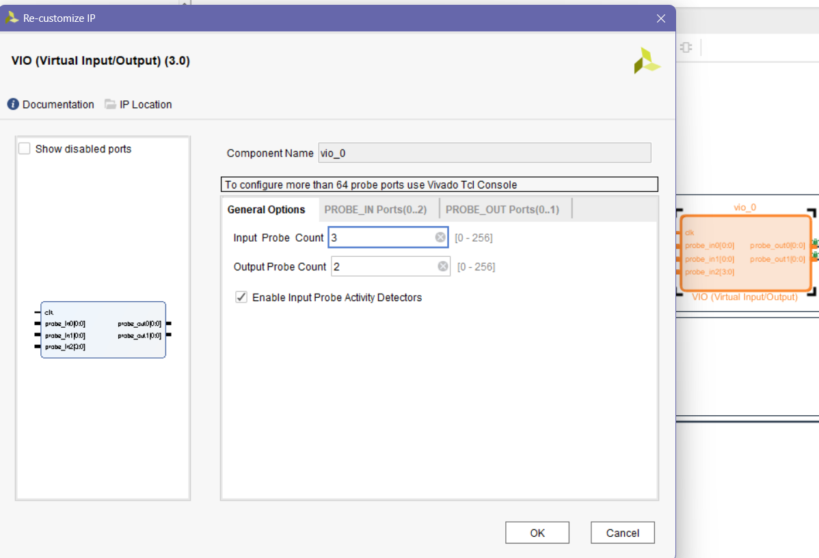

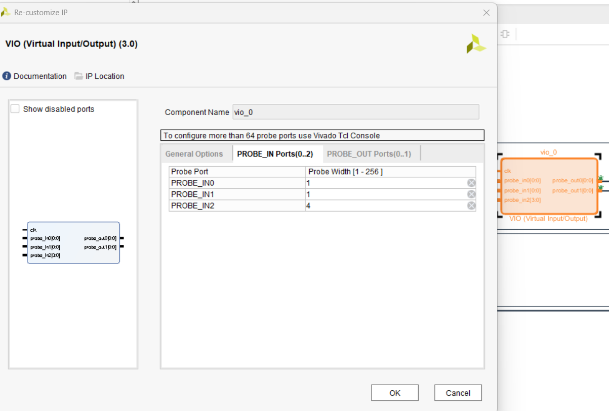

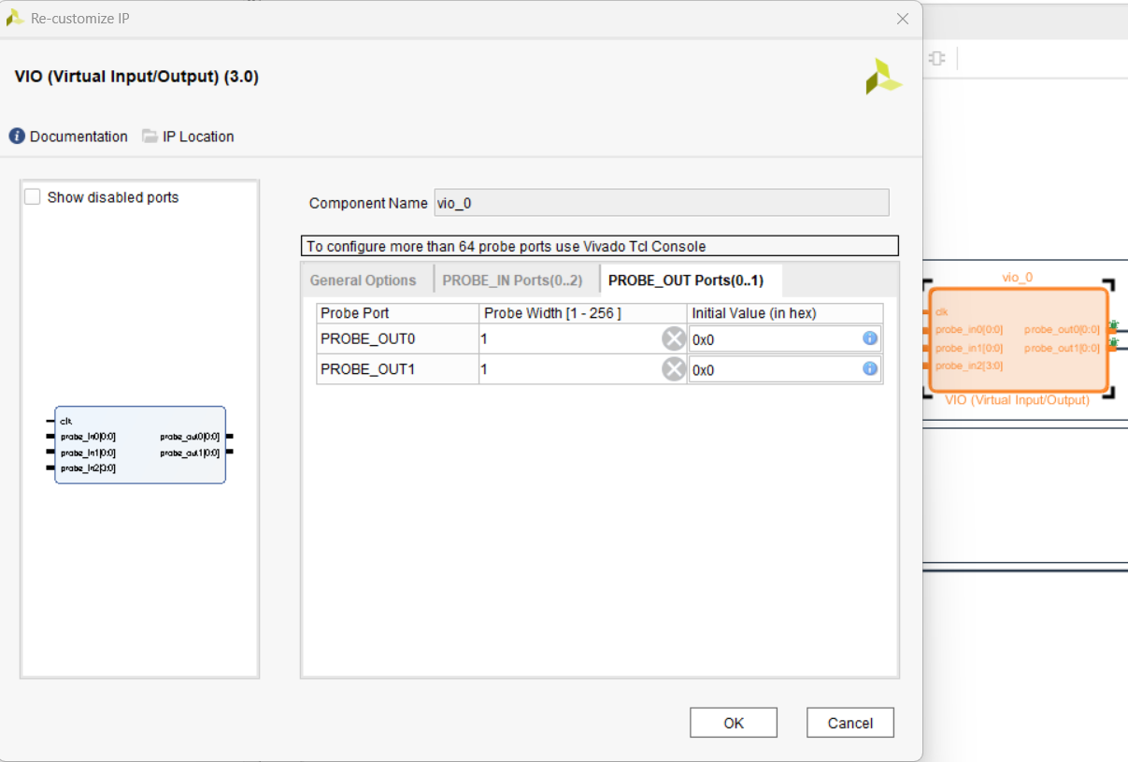

  - Do the following:
    - Right click on LFSR_OUT on our module and select make external
    - Right click on Reset on our module and select make external
    - Connect clock of VIO to clock of our module to clock output from clock wizard
    - Connect Enable and OUT_Enable to the output ports from the VIO
    - Connect OUT_LFSR_S and Valid to input ports of the VIO with 1 bit in width
    - Connect LFSR_OUT to the input port of the VIO with 4 bits in width

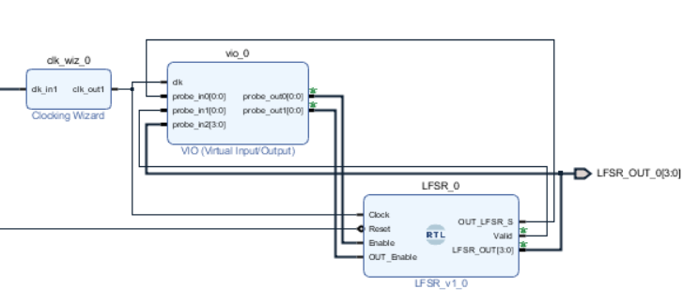

  - Right click on Enable, OUT_Enable, Valid and LFSR_OUT and select debug (Don’t do anything to OUT_LFSR_S)
  - Run connection Automation then select all Net Connections

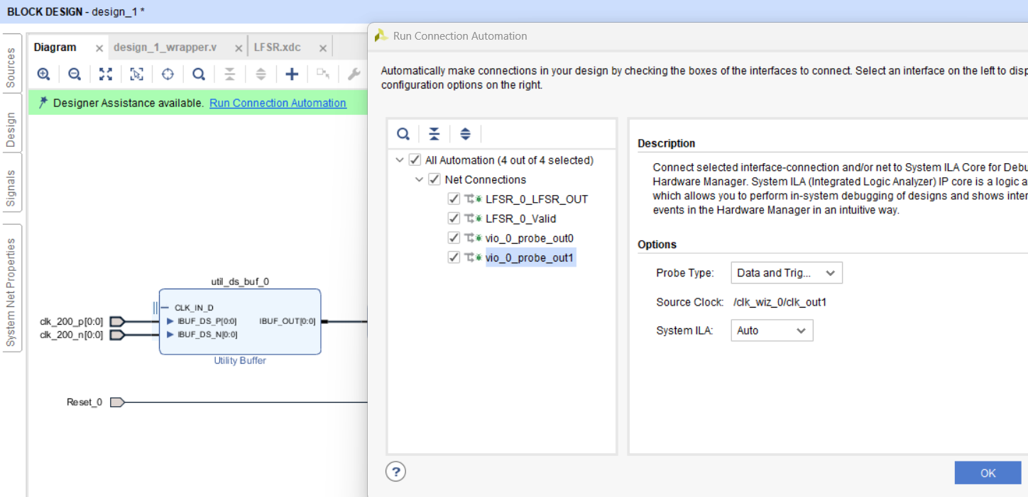

  - Click on regenerate layout then Validate design and solve any problem (clock of ILA will be connected on same clock of VIO and module clock)
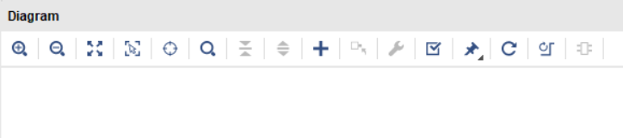
  - This is supposed to be your final layout and connections
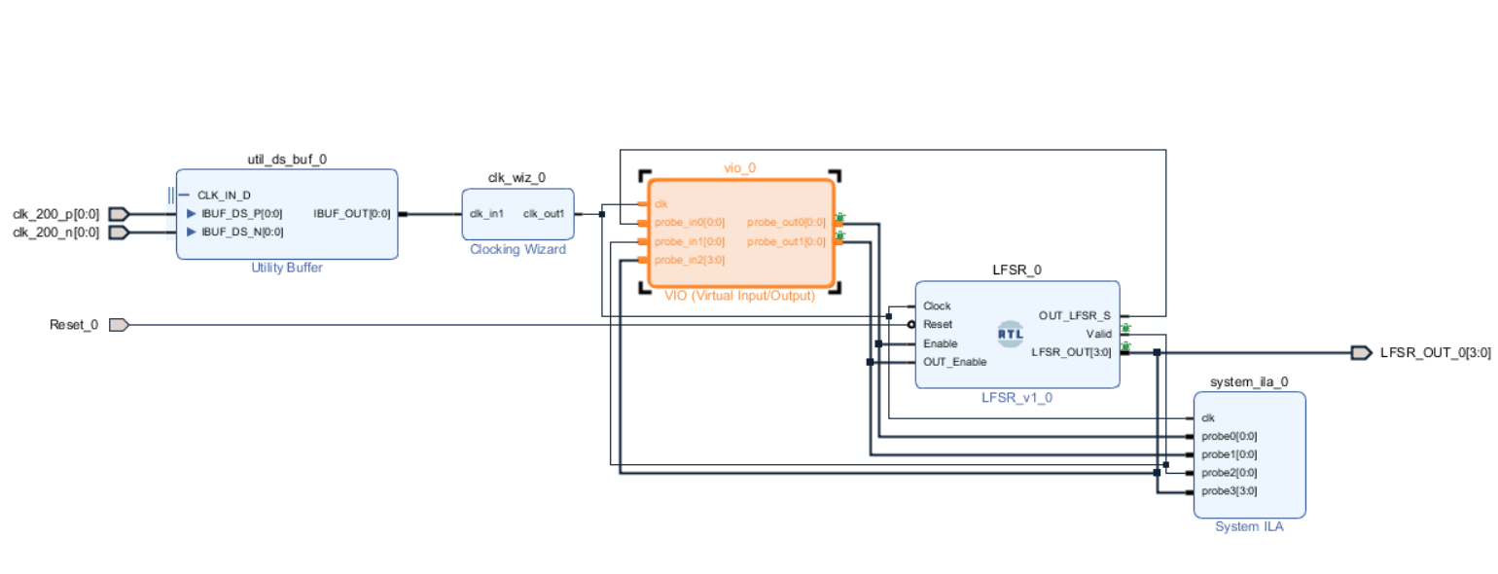

- Right click on .bd file and select create HDL Wrapper
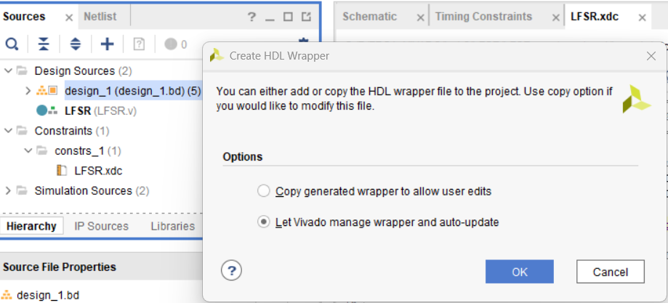

- Open the Wrapper file and modify the constraint file with the right ports naming as it might change

- Run Elaboration
- Run Synthesis (If there is a hold violation, it will be solved after implementation)
- Run Implementation and check on timing report
- Generate Bitstream File

- After Generate Bitstream in Vivado, the flow is:
  - Open Hardware Manager
  - Open Target then Auto Connect
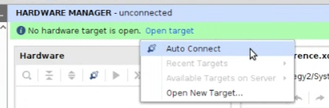

  - Vivado should detect your FPGA board through JTAG.
  - Program the FPGA
  - Click: Program Device.
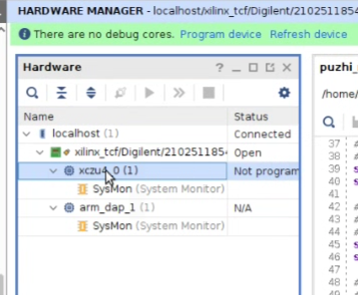

- Select your generated .bit file. Vivado normally finds it automatically.
- Then click Program. Your FPGA is now configured with your design

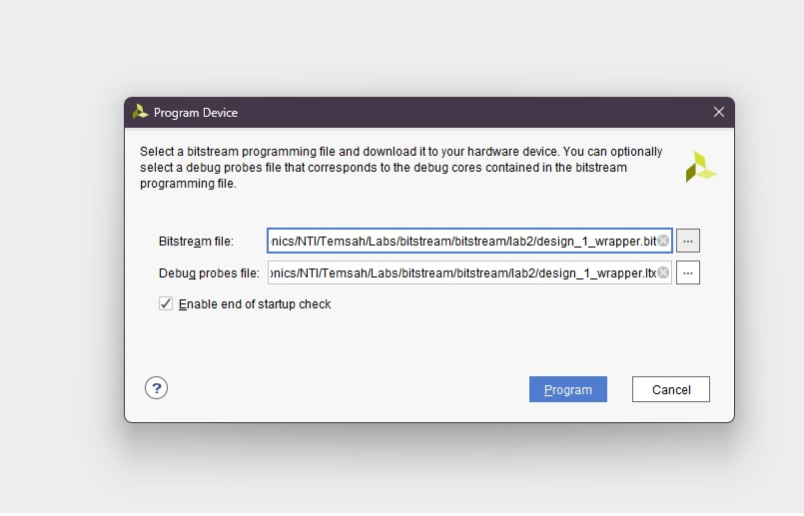

- You can control the input signals using VIO
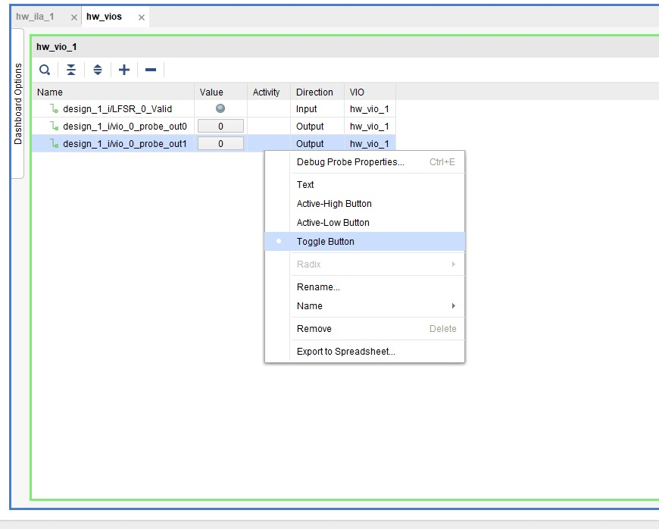

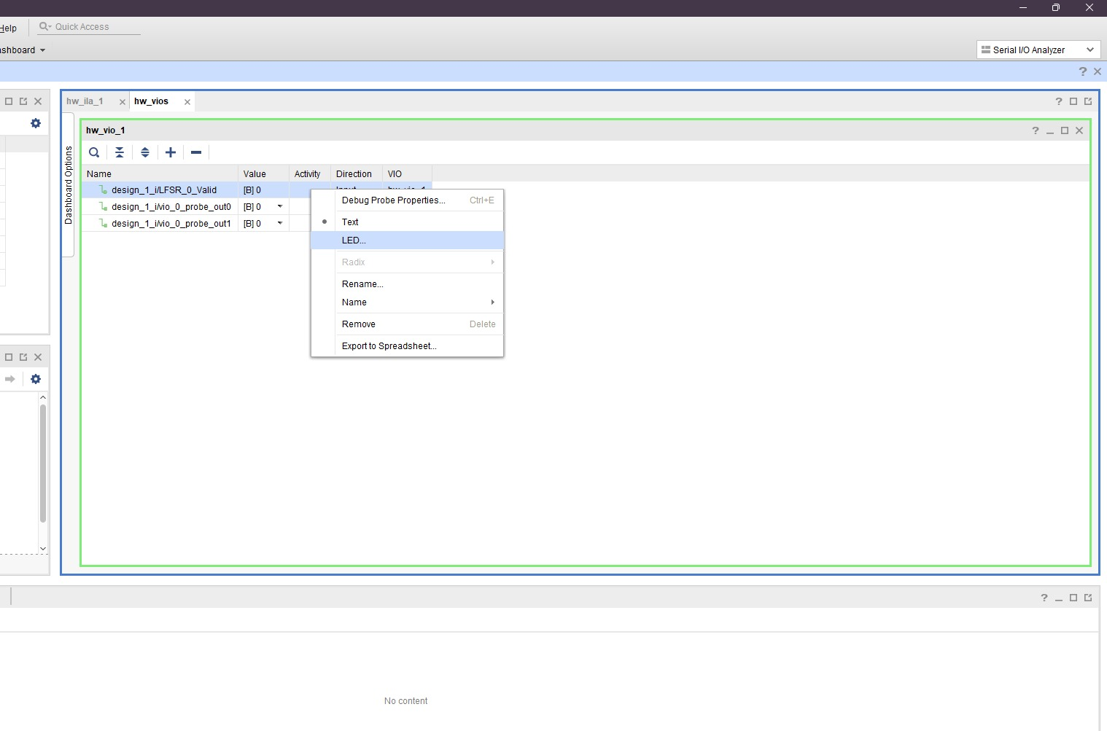
- ILA will show debug signals as a waveform to trace
