E10 — Attention-Based Fusion
Member: Bayo · Date: May 2026 · Project: Compression-Aware Multiscale Feature Fusion for Waste Object Detection and Classification

1. Overview
Experiment E10 is the most sophisticated of Bayo's four experiments. Instead of assigning static weights to entire probability distributions, a PyTorch neural network learns to dynamically gate the contribution of each modality on a per-sample basis. Two separate embedding branches project classical (252-dim) and deep (1,280-dim) features into a shared 128-dimensional space. A softmax attention mechanism then assigns a scalar weight to each branch, producing a weighted combination of the two embeddings as the fused representation for classification.

2. Methodology

2.1 Preprocessing
Both feature modalities are independently standardised using StandardScaler fitted on the training set only, then applied to validation and test sets.
Modality | Input Dim | Scaler
Classical | 252 | e10_scaler_classical.pkl
Deep (EfficientNetB0) | 1,280 | e10_scaler_deep.pkl

2.2 Network Architecture
The AttentionFusion model (PyTorch) has three components:
Component | Layers | Output
Classical branch | Linear(252→256) → ReLU → BN → Linear(256→128) → ReLU | 128-dim embedding
Deep branch | Linear(1280→512) → ReLU → BN → Linear(512→256) → ReLU → BN → Linear(256→128) → ReLU | 128-dim embedding
Attention gate | Concat(128+128=256) → Linear(256→64) → ReLU → Linear(64→2) → Softmax | 2 scalar weights (α_c, α_d)
Fusion | α_c × classical_embed + α_d × deep_embed | 128-dim attended vector
Classifier head | Linear(128→64) → ReLU → Dropout(0.3) → Linear(64→6) → Softmax | 6-class probabilities

2.3 Training Configuration
Hyperparameter | Value
Optimizer | Adam, lr=1e-3
Loss | Cross-Entropy with class_weight='balanced'
Batch size | 32
Max epochs | 100
Early stopping | patience=10, monitor=val_loss
LR scheduler | ReduceLROnPlateau (factor=0.5, patience=5, min_lr=1e-6)
Random seed | 42

3. Results

3.1 Overall Metrics
Metric | Value
Accuracy | 85.64%
Macro-F1 | 0.7752
Weighted-F1 | 0.8525
Balanced Accuracy | 0.7613
AUC-ROC (macro) | 0.9578
Model size | 1.58 MB
Epochs trained | 13 (early stop, patience=10)
Feature dim | 128 (learned fused embedding)

3.2 Per-Class F1 Scores
Class | F1 | Precision | Recall
BIODEGRADABLE | 0.9405 | 0.9108 | 0.9722
CARDBOARD | 0.8578 | 0.8504 | 0.8653
GLASS | 0.7567 | 0.8744 | 0.6669
METAL | 0.7419 | 0.6959 | 0.7943
PAPER | 0.6910 | 0.7928 | 0.6123
PLASTIC | 0.6634 | 0.6704 | 0.6566

3.3 Per-Class Attention Weights
Class | Avg Classical Weight (α_c) | Avg Deep Weight (α_d) | N Samples
BIODEGRADABLE | 0.3863 | 0.6137 | 5862
CARDBOARD | 0.4116 | 0.5884 | 683
GLASS | 0.4260 | 0.5740 | 1555
METAL | 0.4488 | 0.5512 | 948
PAPER | 0.4210 | 0.5790 | 681
PLASTIC | 0.5099 | 0.4901 | 824
Each row sums to 1.0. α_d > α_c for all classes except PLASTIC, reflecting the superior discriminative power of deep features in most cases.

4. Figures
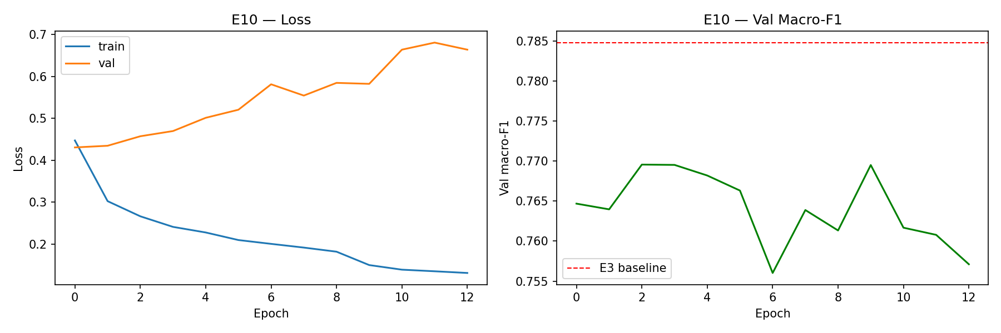
Figure 1 — Training and validation loss/accuracy curves. Early stopping triggered at epoch 13.

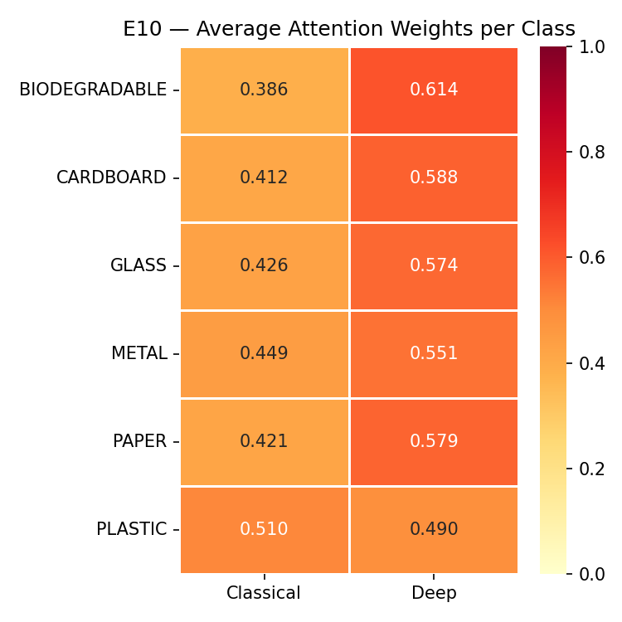
Figure 2 — Per-class average attention weights (heatmap). Deep features (right column) consistently receive higher weight, except PLASTIC.

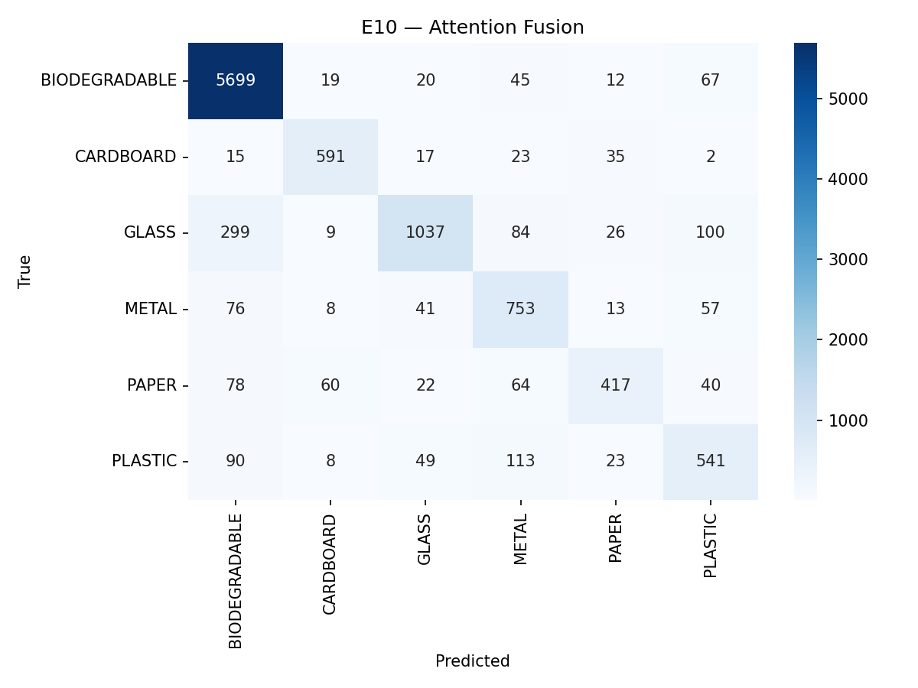
Figure 3 — Confusion matrix for E10 Attention Fusion on the test set (10,553 samples)

5. Insights & Discussion
- E10 achieves the highest accuracy of all Bayo's experiments (85.64%), surpassing even the SVM-only baseline in raw accuracy, though Macro-F1 (0.775) is slightly below E9.
- The attention gate learns near-equal weights overall (α_c≈0.43, α_d≈0.57), but per-class variation is meaningful — PLASTIC is the only class where classical features receive more weight (0.510 vs 0.490).
- BIODEGRADABLE achieves F1=0.941, the highest per-class score, driven by its dominant class frequency and high attention to deep features (α_d=0.614).
- The model is compact at 1.58 MB and converges in 13 epochs — practical for deployment even without GPU acceleration.
- The attention mechanism provides interpretability: per-sample gate weights can be logged at inference time to explain which modality drove each prediction.
- GLASS and METAL remain challenging (F1≈0.72–0.76) for all fusion methods, suggesting class confusion inherent to the visual features rather than a fusion limitation.

