E7 — Feature Selection Fusion
Member: Bayo · Date: May 2026 · Project: Compression-Aware Multiscale Feature Fusion for Waste Object Detection and Classification

1. Overview
Experiment E7 investigates whether applying automated feature selection to a high-dimensional fused feature vector can match—or exceed—the performance of using all raw features, while dramatically reducing the computational and memory footprint. The fused input combines classical hand-crafted descriptors (252-dim) with EfficientNetB0 deep features (1,280-dim), giving a 1,532-dimensional input. A Random Forest selector reduces this to the 200 most informative dimensions before a second RF classifier is trained on the compressed representation.

2. Methodology

2.1 Input Data
Split | Shape | Source
Train | (45,177 × 1,532) | classical_train_clean_X + deep_train_X
Val | (9,935 × 1,532) | classical_val_X + deep_val_X
Test | (10,553 × 1,532) | classical_test_X + deep_test_X

2.2 Two-RF Architecture
A critical design rule is maintained: two completely separate Random Forest objects are used. The selector RF is trained only to extract feature importances; it is never used for prediction and is discarded after selecting the top-200 indices. The final RF is then trained from scratch on the 200-dimensional selected feature matrix.
Step | Object | Purpose
1 — Selector RF | RandomForestClassifier(n_estimators=200, class_weight='balanced', random_state=42) | Fit on full 1532-dim train data → extract feature_importances_
2 — Top-200 index | np.argsort(importances)[::-1][:200] | Identify 200 highest-importance feature indices
3 — Final RF | RandomForestClassifier(n_estimators=200, class_weight='balanced', random_state=42) | Fit on 200-dim selected train data → saved model artifact

2.3 Feature Group Analysis
The 1,532-dim fused vector is partitioned into two groups: Classical (indices 0–251, 252 dims) and Deep/EfficientNetB0 (indices 252–1531, 1280 dims). After selection, the top-200 indices are mapped back to their originating group to understand which modality the RF found most informative.

3. Results

3.1 Overall Metrics
Metric | Value
Accuracy | 80.40%
Macro-F1 | 0.7079
Weighted-F1 | 0.7878
Balanced Accuracy | 0.6502
AUC-ROC (macro) | 0.9283
Feature Dimension | 200 (from 1,532)

3.2 Per-Class F1 Scores
Class | F1 | Precision | Recall
BIODEGRADABLE | 0.8893 | 0.8038 | 0.9952
CARDBOARD | 0.8116 | 0.9061 | 0.7350
GLASS | 0.6160 | 0.8461 | 0.4842
METAL | 0.6911 | 0.7721 | 0.6255
PAPER | 0.6144 | 0.7949 | 0.5007
PLASTIC | 0.6252 | 0.7064 | 0.5607

3.3 Feature Group Breakdown
Group | Features Selected | Percentage
Classical (hand-crafted) | 102 | 51%
Deep (EfficientNetB0) | 98 | 49%

4. Figures
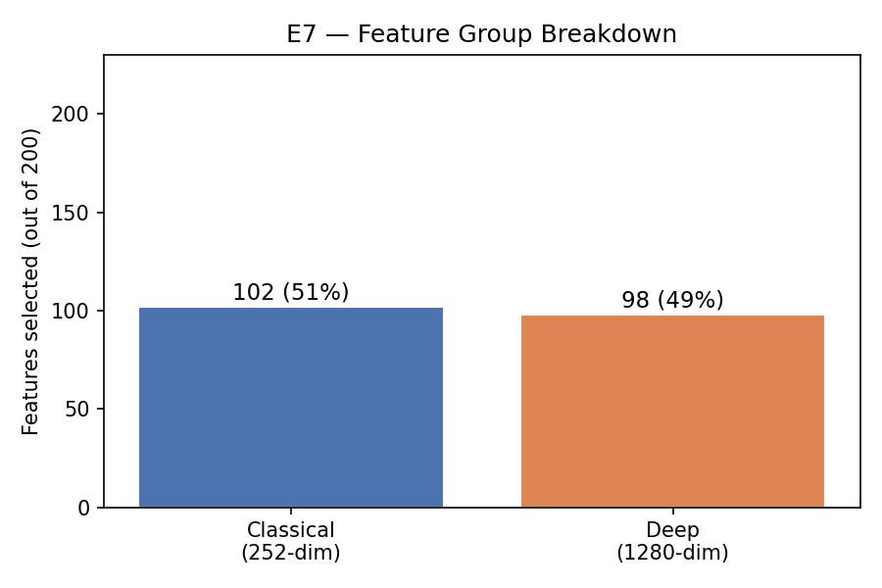
Figure 1 — Feature group analysis: distribution of top-200 selected features across Classical and Deep modalities

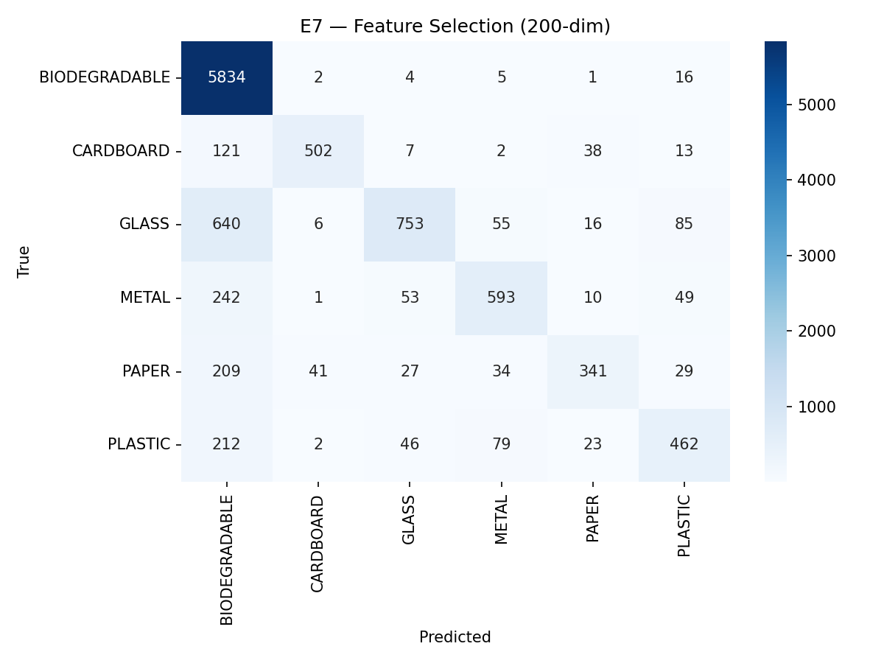
Figure 2 — Confusion matrix on the test set (10,553 samples, 6 classes)

5. Insights & Discussion
- E7 achieves 80.4% accuracy and Macro-F1 = 0.708, which is above the classical-only baseline (E2: 0.648) but below the deep-only SVM baseline (E3: 0.785).
- The RF selector chose 102 classical and 98 deep features — a near-even split, confirming both modalities carry complementary information.
- BIODEGRADABLE achieves near-perfect recall (0.995) due to its dominant class frequency; minority classes (GLASS, PLASTIC) remain challenging (F1 ≈ 0.61–0.63).
- Reducing from 1,532 to 200 dimensions (87% compression) incurs only a moderate performance penalty, making E7 attractive for resource-constrained deployments.
- The two-RF design is intentional: using the selector RF's predictions would leak importance-based bias into the evaluation.

