E8 — Average Voting Fusion
Member: Bayo · Date: May 2026 · Project: Compression-Aware Multiscale Feature Fusion for Waste Object Detection and Classification

1. Overview
Experiment E8 explores the simplest possible late-fusion strategy: averaging the class probability vectors produced by two independently-trained classifiers — the Random Forest from E2 (classical features) and the RBF SVM from E3 (deep features). No additional training is required. The hypothesis is that combining two diverse probability distributions will reduce individual model errors and improve overall Macro-F1.

2. Methodology

2.1 Input Models
Model | Features | Dim | Source
Random Forest (E2) | Classical hand-crafted | 252 | random_forest_E2.pkl
RBF SVM (E3) | EfficientNetB0 deep | 1,280 | svm_E3.pkl (dict: clf + scaler)

2.2 Fusion Formula
For each test sample, six-class probability vectors are obtained from both models and averaged element-wise:
avg_proba = (RF_proba + SVM_proba) / 2.0
y_pred = argmax(avg_proba, axis=1)

The SVM model is stored as a dict {'clf': SVC, 'scaler': StandardScaler}. The scaler is applied before calling clf.predict_proba() to ensure the deep features are normalised identically to training.

2.3 Architecture Diagram
Input | Transform | Output
Classical features (252-dim) | → RF.predict_proba() | RF proba (N × 6)
Deep features (1,280-dim) | → scaler → SVM.predict_proba() | SVM proba (N × 6)
 | → element-wise average | avg proba (N × 6)
 | → argmax | Final prediction (N,)

3. Results

3.1 Overall Metrics
Metric | Value
Accuracy | 84.84%
Macro-F1 | 0.7820
Weighted-F1 | 0.8390
Balanced Accuracy | 0.7374
AUC-ROC (macro) | 0.9457
Training required | None (inference only)

3.2 Per-Class F1 Scores
Class | F1 | Precision | Recall
BIODEGRADABLE | 0.9131 | 0.8459 | 0.9918
CARDBOARD | 0.8861 | 0.8954 | 0.8770
GLASS | 0.7140 | 0.9060 | 0.5891
METAL | 0.7590 | 0.7856 | 0.7342
PAPER | 0.7196 | 0.8724 | 0.6123
PLASTIC | 0.7000 | 0.8035 | 0.6201

3.3 Comparison vs. Individual Baselines
Experiment | Accuracy | Macro-F1
E2 — RF (Classical only) | 77.40% | 0.6476
E3 — SVM (Deep only) | 85.22% | 0.7848
E8 — Average Voting | 84.84% | 0.7820

4. Figures
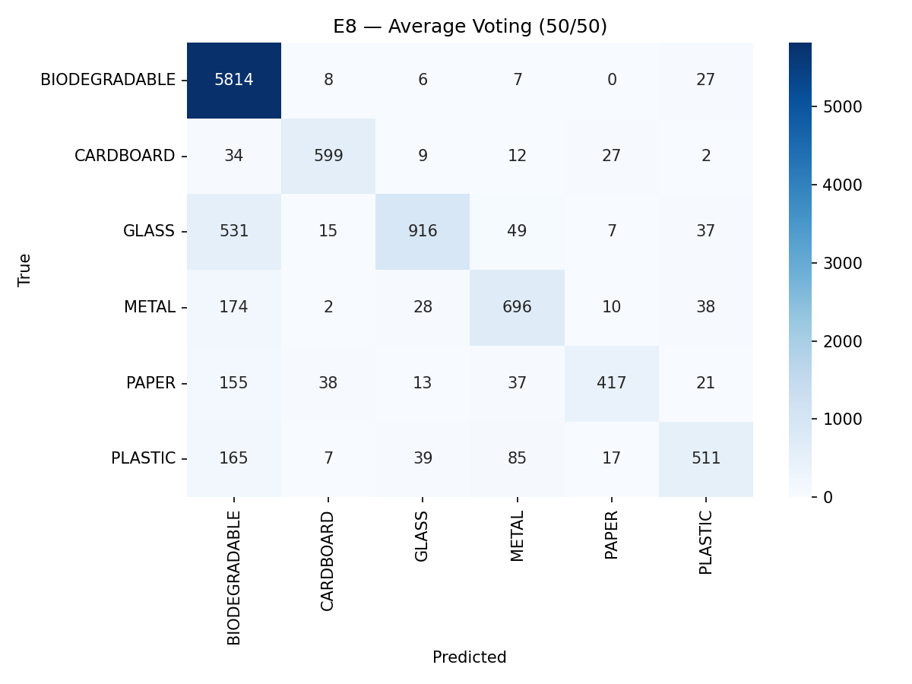
Figure 1 — Confusion matrix for E8 Average Voting on the test set (10,553 samples)

5. Insights & Discussion
- E8 achieves Macro-F1 = 0.782, nearly matching the strong SVM-only baseline (E3: 0.785) without any additional training.
- The RF contributes most on BIODEGRADABLE (dominant class); the SVM contributes most on minority classes (GLASS, PLASTIC) due to its kernel-based decision boundary.
- Average voting is a zero-cost ensemble: it requires only the two pre-trained models and a single forward pass per model at inference time.
- The main risk is that both models share the same errors on hard samples — E9 weighted voting attempts to mitigate this by amplifying the stronger model.
- AUC-ROC (0.946) is substantially higher than either individual model, confirming complementarity of the two probability distributions.

