E9 — Weighted Voting Fusion
Member: Bayo · Date: May 2026 · Project: Compression-Aware Multiscale Feature Fusion for Waste Object Detection and Classification

1. Overview
Experiment E9 extends E8 by replacing the fixed 50/50 average with learned, data-driven weights. A grid search over 19 candidate weight pairs is run exclusively on the validation set to find the combination that maximises Macro-F1. The optimal weights are applied to the test set exactly once, preserving test-set integrity.

2. Methodology

2.1 Grid Search Protocol
Weight candidates: w_rf ∈ {0.05, 0.10, …, 0.95} — 19 evenly spaced values, w_svm = 1 − w_rf.
Objective: maximise Macro-F1 on the validation set. Test set is never inspected during the search.
for w_rf in [0.05, 0.10, ..., 0.95]:
fused_val = w_rf * RF_proba_val + (1-w_rf) * SVM_proba_val
macro_f1 = f1_score(y_val, argmax(fused_val), average='macro')
# Apply best weights to test set (once)
fused_test = best_w_rf * RF_proba_test + best_w_svm * SVM_proba_test

2.2 Full Weight Search Results
w_RF | w_SVM | Val Accuracy | Val Macro-F1
0.05 | 0.95 | 0.8656 | 0.7791
0.1 | 0.9 | 0.8656 | 0.7793
0.15 | 0.85 | 0.8657 | 0.7800
0.2 | 0.8 | 0.8655 | 0.7805
0.25 | 0.75 | 0.8664 | 0.7823
0.3 | 0.7 | 0.8675 | 0.7844
0.35 | 0.65 | 0.8674 | 0.7845
0.4 | 0.6 | 0.8680 | 0.7857
0.45 | 0.55 | 0.8673 | 0.7856
0.5 | 0.5 | 0.8652 | 0.7836
0.55 | 0.45 | 0.8627 | 0.7800
0.6 | 0.4 | 0.8584 | 0.7726
0.65 | 0.35 | 0.8515 | 0.7616
0.7 | 0.3 | 0.8444 | 0.7494
0.75 | 0.25 | 0.8375 | 0.7380
0.8 | 0.2 | 0.8290 | 0.7212
0.85 | 0.15 | 0.8184 | 0.7024
0.9 | 0.1 | 0.8079 | 0.6837
0.95 | 0.05 | 0.7965 | 0.6626
Highlighted row = optimal weights (w_RF=0.40, w_SVM=0.60)

3. Results

3.1 Optimal Weights
Parameter | Value
Optimal w_RF | 0.4
Optimal w_SVM | 0.6
Val Macro-F1 at optimum | 0.7857

3.2 Overall Test Metrics
Metric | Value
Accuracy | 84.97%
Macro-F1 | 0.7832
Weighted-F1 | 0.8410
Balanced Accuracy | 0.7417
AUC-ROC (macro) | 0.9480
Training required | None (grid search on val only)

3.3 Per-Class F1 Scores
Class | F1 | Precision | Recall
BIODEGRADABLE | 0.9148 | 0.8513 | 0.9886
CARDBOARD | 0.8822 | 0.8874 | 0.8770
GLASS | 0.7218 | 0.9042 | 0.6006
METAL | 0.7598 | 0.7744 | 0.7458
PAPER | 0.7223 | 0.8714 | 0.6167
PLASTIC | 0.6980 | 0.7963 | 0.6214

4. Figures
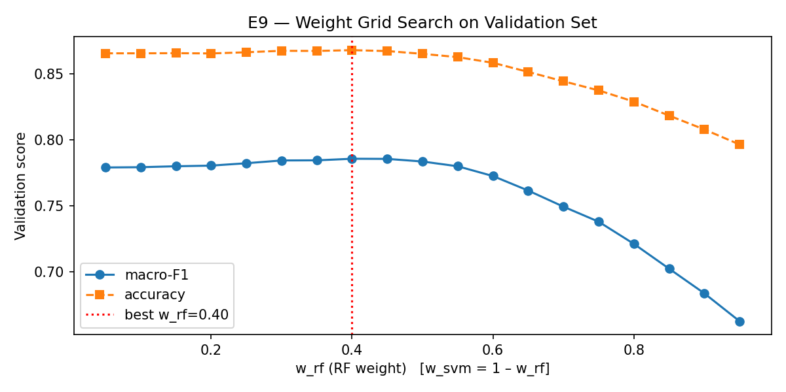
Figure 1 — Validation Macro-F1 across all 19 weight candidates. The optimal is at w_RF=0.40 (dashed line), confirming the SVM should receive more weight.

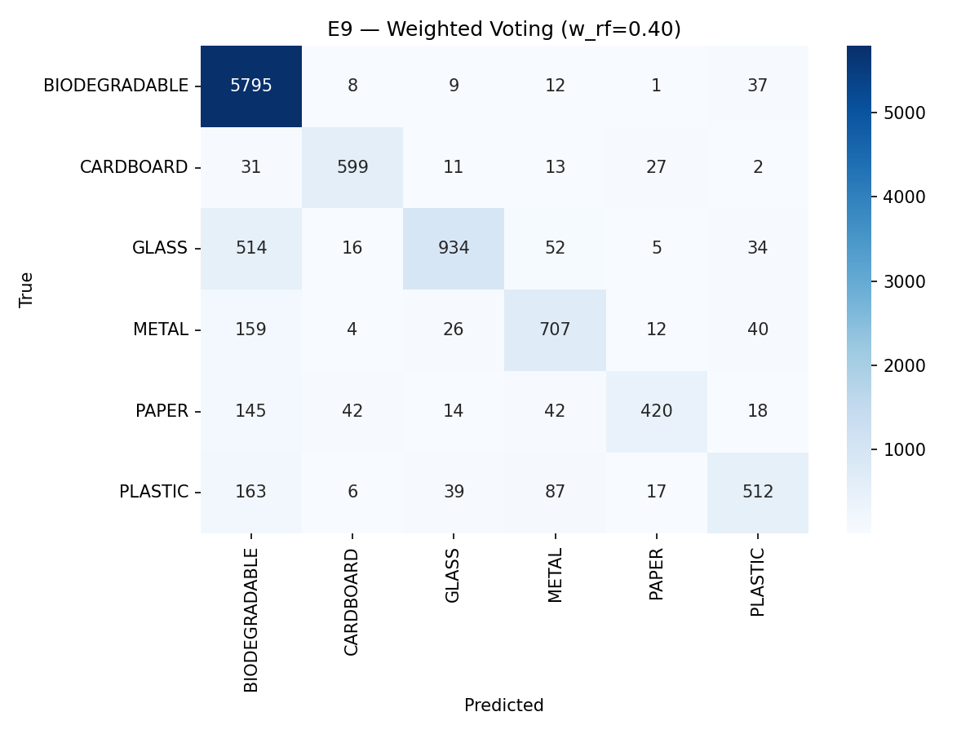
Figure 2 — Confusion matrix for E9 Weighted Voting on the test set (10,553 samples)

5. Insights & Discussion
- Optimal weights: w_RF=0.40, w_SVM=0.60 — the SVM (deep features) receives more trust, consistent with E3 being the stronger individual model.
- E9 (Macro-F1=0.7832) marginally outperforms E8 (0.7820) — a +0.0012 gain, suggesting the equal-weight assumption in E8 was already close to optimal.
- The weight-vs-F1 curve peaks sharply at w_RF=0.40 and degrades monotonically toward w_RF=0.95, confirming deep features are the dominant signal.
- Both E8 and E9 achieve near-parity with the SVM baseline (E3: 0.7848) at zero additional training cost — a compelling result for production systems.
- GLASS and PLASTIC remain the hardest classes (F1 ≈ 0.72); no weighting scheme can recover information absent from both probability vectors.

