Nada Elshami

ICMP Port Unreachable
- Use hping3 to send one UDP segment to port 100XX on your partner’s computer,
- Use one tcpdump command to capture the UDP segment (stimulus), and the ICMP message that was sent back (response).
- Save both packets in a file called 1ICMPPORT.pcap using tcpdump filters and the –w and –c options

Your IP address (sender of ping): vm: 192.168.146.132, host: 10.16.47.227
IP address of your partner (running tcpdump): vm: 10.0.2.15, host: 10.16.46.57
When is this kind of ICMP message sent?
A port unreachable message is sent when a host receives a UDP packet that is destined for a closed port
What is the ICMP message format for this kind of ICMP message? What are the type and code values?
The answer to this question is as follows:
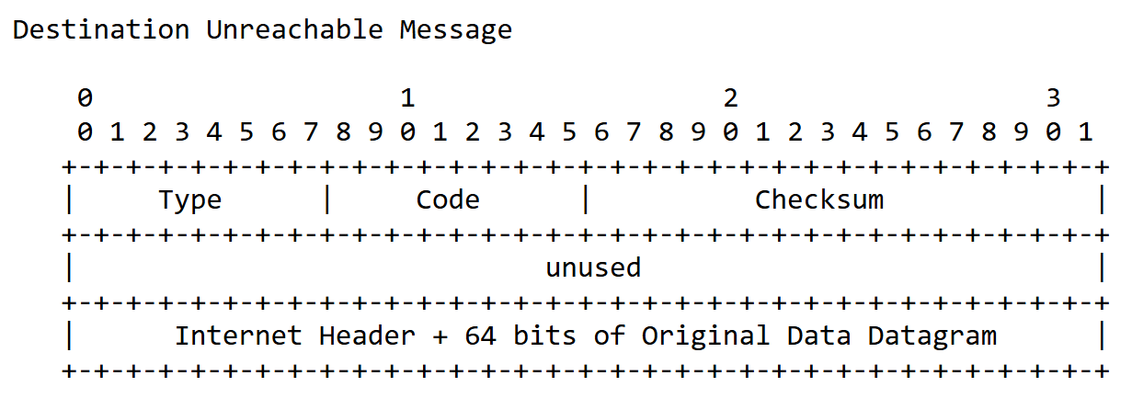
ICMP port unreachable: type = 3, code = 3.
What is the command you used to send the UDP segment?
Hping3 –2 10003 –c 1 10.16.47.227
What is the tcpdump command you used to capture both packets? Include the filter you used to isolate the two packets.
sudo tcpdump –i –eth0 –Xnvr 1ICMPPORT.pcap -c 2 ‘icmp or udp’

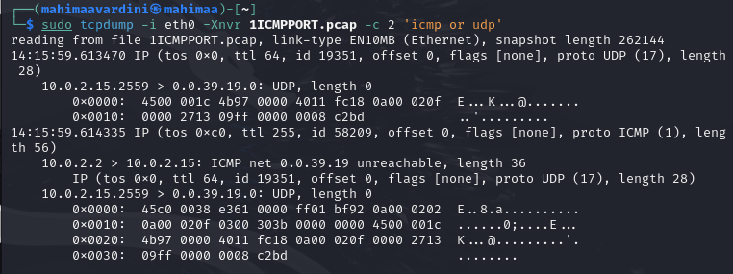

2. ICMP TTL Exceeded
- Use ping or hping3 to send a packet to any host that will result in an ICMP TTL exceeded message being sent back to you. Use tcpdump to capture both packets (stimulus and response).
- Save both packets in a file called 2ICMPTTL.pcap using tcpdump filters and the –w and –c options

When is this kind of ICMP message sent?
ICMP TTL Exceeded message is recieved when a packets time to live (TTL) field reaches zero before reaching its destination
What is the ICMP message format for this kind of ICMP message? What are the type and code values?
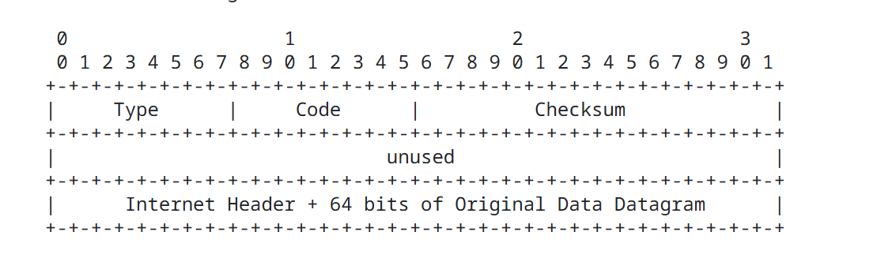ICMP time exceeded: type=11 code=0
What did you do to get this message (include the command you used to create the stimulus packet)?
sudo hping3 -1 -t 1 -c 1 10.16.46.57
What is the tcpdump command you used to capture both packets? Include the filter you used to isolate the two packets (stimulus and response).
tcpdump –n –v -w 2ICMPTTL.pcap -c 2 –x
screenshot of the tcpdump output (hex and ASCII dump) showing the two packets (stimulus and response).
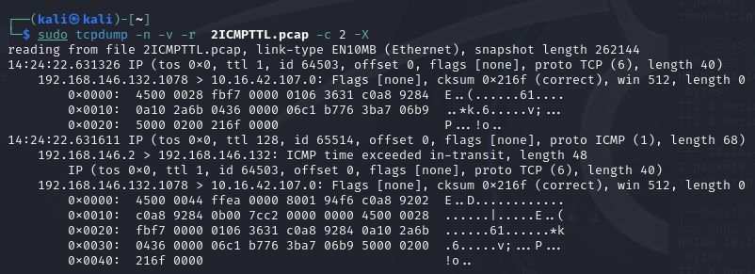

3. ICMP Admin Prohibited
- Use nmap or hping3 to send a packet to any host that will result in an ICMP admin prohibited message being sent back to you. Use tcpdump to capture both packets (stimulus and response).
- Save both packets in a file called 3ICMPADMIN.pcap using tcpdump filters and the –w and –c options

When is this kind of ICMP message sent?
An ICMP Admin prohibited message is sent when a firewall, router or security policy blocks a packet due to access restrictions
What is the ICMP message format for this kind of ICMP message? What are the type and code values?
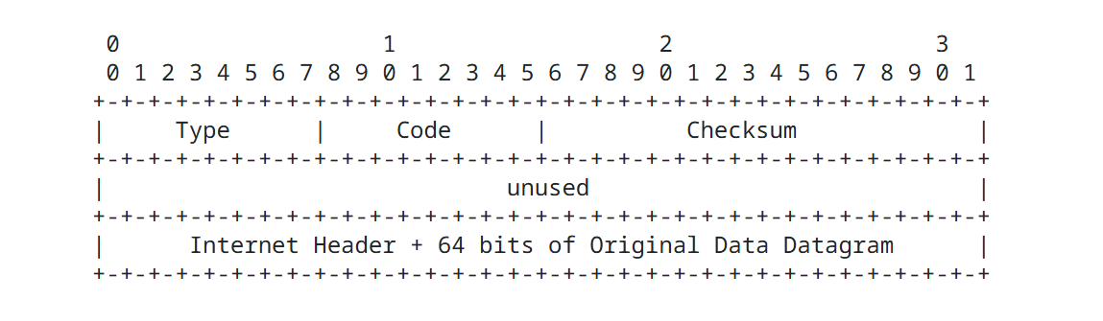
ICMP admin prohibited: Type=3 code=13
What did you do to get this message (include the command you used to create the stimulus packet)?
We used the 3ICMPADMIN.pcap file provided by the professor. We opened it on wireshark and analyzed the packet and got the admin prohibted message
What is the command you used to capture the ICMP message? Include the filter you used to isolate the two packets (stimulus and response).
sudo tcpdump –w 3ICMPADMIN.PCAP -Xnv
screenshot of the tcpdump output (hex and ASCII dump) showing the two packets (stimulus and response).
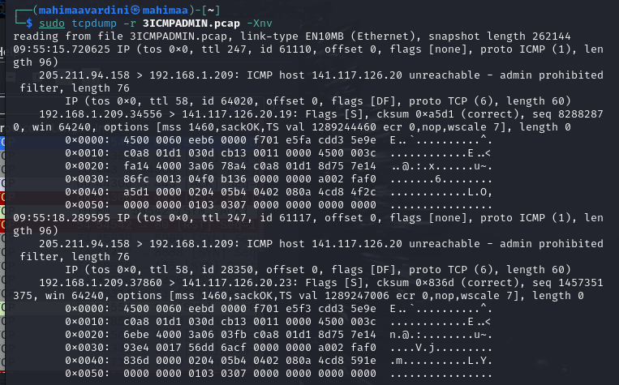

4. ICMP Protocol Unreachable
- Use hping3 to send a packet to your partner’s computer that will result in an ICMP protocol unreachable message being sent back to you. Use tcpdump to capture both packets (stimulus and response).
- Save both packets in a file called 4ICMPPROTO.pcap using tcpdump filters and the –w and –c options

When is this kind of ICMP message sent?
ICMP Protocol Unreachable message is sent when a host does not support or recognize the protocol the packet was sent to.
What is the ICMP message format for this kind of ICMP message? What are the type and code values?
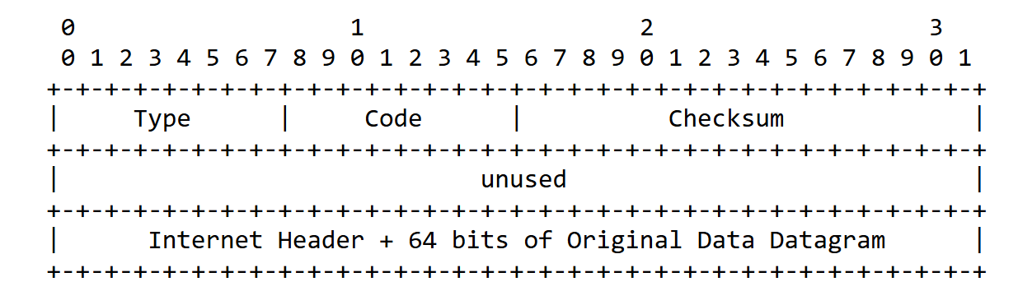
ICMP protocol unreachable : type = 3, code = 2
What did you do to get this message (include the command you used to create the stimulus packet)?
$ sudo hping3 -0 10.16.46.57 --ipproto 250 -c 1

What is the command you used to capture the ICMP message? Include the filter you used to isolate the two packets (stimulus and response).
sudo tcpdump -nv -X "host 10.16.46.57 or icmp" -r 4ICMPPROTO.pcap
screenshot of the tcpdump output (hex and ASCII dump) showing the two packets (stimulus and response).
