KeroMixAI
AI-Powered Audio Mixing Plugin
User Manual
by nadahong

Supported Formats | VST3 (Windows / Mac) | AU (Mac - Logic Pro only)
Supported OS | Windows 10/11 | macOS 10.13 or later
Compatible DAWs | Ableton, FL Studio, Logic Pro, Cubase, Reaper, and more
AI Engine | Groq API (llama-3.3-70b-versatile)
Version | 1.0.0

1. Overview
KeroMixAI is an AI-powered audio effect plugin that adjusts EQ, Compression, Delay, and Reverb parameters in real time based on your natural language commands.
Simply type what you want to hear in Korean or English, and the AI will make the changes instantly.

Key Features
- Natural language control - type anything like 'warmer', 'muddy', 'moody late night'
- Intensity recognition - 'slightly brighter' vs 'much brighter' produce different results
- Real-time audio analysis - AI listens to your audio and responds in context
- Lock groups - freeze any section so AI cannot change it
- Patch system - save and load your favorite settings
- Undo - one-click revert after any AI change
- Bypass - click the frog icon to toggle the plugin on/off

2. Installation
Choose the section that matches your operating system and DAW.

2-1. Windows (VST3)
Required file
- KeroMixAI.vst3

Installation steps
- Download KeroMixAI.vst3
- Copy the file to:
C:\Program Files\Common Files\VST3\
- Open your DAW and run a plugin scan
- Find KeroMixAI in your plugin list and use it
TIP If your DAW does not find the plugin, check that the VST3 scan path in DAW settings includes the folder above.

2-2. Mac (VST3) - Ableton, Cubase, Reaper, etc.
Required file
- KeroMixAI.vst3

Installation steps
- Download KeroMixAI.vst3
- Copy the file to:
/Library/Audio/Plug-Ins/VST3/
- Open Terminal and enter the following commands in order (press Enter after each):
If your password was never asked before - it will not show on screen while typing. This is normal.

Step 1 - Remove macOS quarantine flag
sudo xattr -rd com.apple.quarantine /Library/Audio/Plug-Ins/VST3/KeroMixAI.vst3

Step 2 - Re-sign the plugin
sudo codesign --force --deep --sign - /Library/Audio/Plug-Ins/VST3/KeroMixAI.vst3

NOTE When reinstalling, first delete the existing file with this command before running the steps above:
sudo rm -rf /Library/Audio/Plug-Ins/VST3/KeroMixAI.vst3
- Restart your DAW and run a plugin scan
TIP Open Terminal from Spotlight (Cmd+Space, type 'Terminal') or Finder > Applications > Utilities.
NOTE When typing your password in Terminal, nothing will appear on screen. This is normal - just type your Mac login password and press Enter.

2-3. Mac (AU) - Logic Pro / GarageBand only
Required file
- KeroMixAI.component

Installation steps
- Download KeroMixAI.component
- Copy the file to:
/Library/Audio/Plug-Ins/Components/
- Open Terminal and enter the following commands in order (press Enter after each):
If your password was never asked before - it will not show on screen while typing. This is normal.

Step 1 - Remove macOS quarantine flag
sudo xattr -rd com.apple.quarantine /Library/Audio/Plug-Ins/Components/KeroMixAI.component

Step 2 - Re-sign the plugin
sudo codesign --force --deep --sign - /Library/Audio/Plug-Ins/Components/KeroMixAI.component

NOTE When reinstalling, first delete the existing file with this command before running the steps above:
sudo rm -rf /Library/Audio/Plug-Ins/Components/KeroMixAI.component
- Restart Logic Pro
- Go to Preferences > Plug-in Manager > Reset & Rescan Selection
- Find KeroMixAI under Audio Units > nadahong
NOTE When typing your password in Terminal, nothing will appear on screen. This is normal - just type your Mac login password and press Enter.
TIP In Finder, press Cmd+Shift+G and type the folder path to navigate there directly.

3. Groq API Key Setup
KeroMixAI requires a Groq API key to power its AI features. It is completely free to obtain.

Step 1 - Get your API key
- Go to https://console.groq.com
- Create a free account (no credit card required)
- Navigate to API Keys and click Create API Key
- Copy the generated key (starts with gsk_)

Step 2 - Enter the key in KeroMixAI
- Load KeroMixAI in your DAW
- Click the ... button in the top right of the plugin
- Paste your API key and press Enter
- The key is saved automatically - no need to re-enter next time
TIP The Groq free tier is sufficient for regular mixing use.

4. Interface Guide
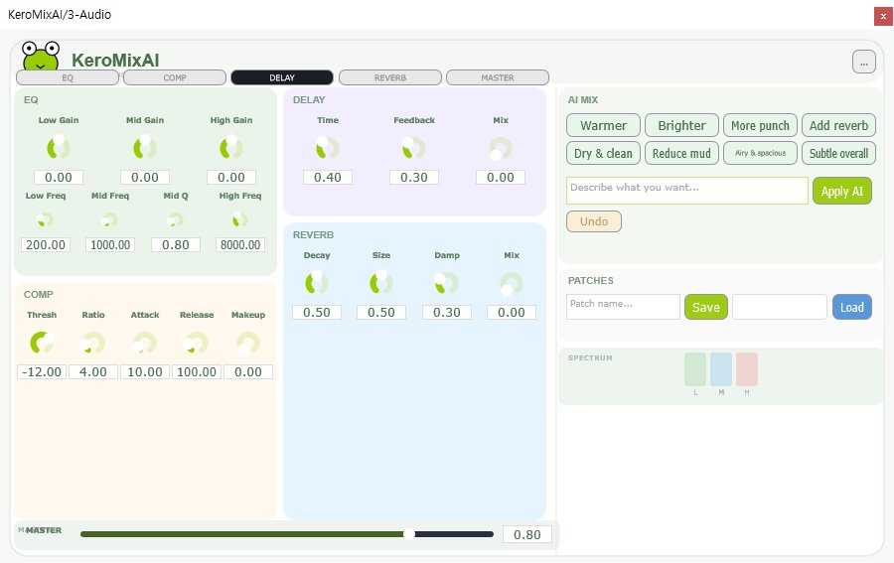
KeroMixAI plugin overview

Frog Icon (Bypass)
Click the frog icon in the top left to bypass (toggle on/off) the entire plugin.
- Click frog = Bypass ON - plugin effect disabled, dry signal passes through
- Click again = Bypass OFF - plugin effect enabled
NOTE The bypass function may not work correctly in Logic Pro. Use the plugin on/off button in Logic's channel strip instead.

Lock Buttons (EQ / COMP / DELAY / REVERB / MASTER)
Click any section name button to lock that section.
- Black = Locked - AI will not change this section
- Default color = Unlocked - AI can freely adjust

EQ Section (top left, green background)
Low Gain | Boost or cut low frequencies (-18 to +18 dB)
Low Freq | Low band center frequency (60 - 600 Hz)
Mid Gain | Boost or cut mid frequencies (-18 to +18 dB)
Mid Freq | Mid band center frequency (300 - 5000 Hz)
Mid Q | Mid band width - higher = narrower (0.3 - 4)
High Gain | Boost or cut high frequencies (-18 to +18 dB)
High Freq | High shelf frequency (3000 - 16000 Hz)

Compressor Section (bottom left, yellow background)
Thresh | Level at which compression starts (-40 to 0 dB)
Ratio | Compression amount (1:1 = off, 20:1 = heavy)
Attack | How fast compression kicks in (1 - 100 ms)
Release | How fast compression lets go (20 - 500 ms)
Makeup | Gain after compression (0 - 24 dB)

Delay Section (center top, purple background)
Time | Delay time (0.05 - 1.0 seconds)
Feedback | Number of repeats (0 = single echo, 0.9 = many)
Mix | Wet/dry blend (0 = dry only, 1 = delay only)

Reverb Section (center bottom, blue background)
Decay | Reverb tail length (0 - 1)
Size | Virtual room size (0 - 1)
Damp | High frequency absorption (0 - 1)
Mix | Wet/dry blend (0 = dry only, 1 = reverb only)

AI MIX Section (right panel)
Quick Buttons | One-click presets: Warmer, Brighter, More punch, etc.
Text Input | Type any command in Korean or English, press Enter or Apply AI
Apply AI Button | Send command to AI (green button)
Undo Button | Revert to state before last AI change
Status Bar | Shows what the AI changed and why

PATCHES Section (bottom right)
Patch name field | Type a name for your patch
Save button | Save current settings as a patch
Dropdown list | Select a saved patch
Load button | Load the selected patch

SPECTRUM / MASTER
SPECTRUM: Displays real-time L (low) / M (mid) / H (high) frequency energy as color bars. The AI uses this data to make smarter decisions.
MASTER: The bottom slider controls the overall output volume (0 - 1).

5. Using the AI

Basic Usage
- Type a command in the text input box on the right
- Press Enter or click the Apply AI button
- The AI adjusts the parameters and shows a reason in the status bar
- If you don't like the result, click Undo

Intensity Scale
Add intensity words to control how much the AI changes:

'slightly' / 'barely' / 'a tiny bit' | Very small change (EQ: +/- 1~2 dB)
'a bit' / 'jogeom' | Small change (EQ: +/- 1~2 dB)
'gently' / 'subtle' | Moderate-small change (EQ: +/- 2~3 dB)
(no qualifier) | Default change (EQ: +/- 3~5 dB)
'more' / 'quite' / 'mani' | Larger change (EQ: +/- 5~8 dB)
'a lot' / 'heavy' | Big change (EQ: +/- 8~12 dB)
'extreme' / 'max' | Push to limits

Command Examples
Tone shaping
- warmer / brighter / darker
- harsh / muddy / thin / full / fat
- spacious => add reverb, open up the sound

Mood / vibe
- moody late night => dark EQ, long reverb, light delay
- lyrical / emotional => warm EQ, smooth compression
- epic / cinematic => big low end, large reverb
- clean / dry => reduce reverb and delay

Instrument specific
- piano => focus 200-1000 Hz, light reverb
- vocal => presence boost 2-4 kHz, gentle compression
- drums => punch 60-200 Hz, transient compression

What the AI Will NOT Do
- Random or gibberish input (e.g. 'asdfjkl') - AI returns no change
- Change sections that are locked (black buttons)
- Reset parameters to defaults - all changes are relative to current values

6. Patch System
Save and recall your favorite plugin settings at any time.

Saving a patch
- Dial in the settings you want to save
- Type a name in the patch name field (bottom right)
- Click Save

Loading a patch
- Select a patch from the dropdown list
- Click Load

Patch storage location
Windows: %APPDATA%\KeroMixAI\patches\
Mac: ~/Library/Application Support/KeroMixAI/patches/

7. Troubleshooting
Plugin not found in DAW | Check the correct VST3/Components folder, then run a plugin rescan in your DAW
AI does nothing | Check your Groq API key via the ... button, check internet connection
'Connection failed' error | Groq API unreachable - check firewall or try again later
'Parse failed' error | Check keromix_debug.txt on your Desktop for the raw AI response
AU not found in Logic Pro | Go to Preferences > Plug-in Manager > Reset & Rescan Selection
macOS security warning | System Preferences > Security & Privacy > Allow Anyway
Parameters not changing | Check if the section's lock button is black (locked state)
Bypass not working in Logic | Use the plugin on/off button in Logic's channel strip instead
Error after reinstall on Mac | Run sudo rm -rf first, then xattr and codesign again

8. Credits
KeroMixAI is developed by nadahong.
Built with the JUCE audio framework and Groq AI API.

For feedback and support, please contact the developer.

