Cairo University  
Faculty of Computers and Information



**CS251**

**Software Engineering I**

GameSpot

Nada Ibrahim

Sahar Ahmed

Marwa Ehab

Sheren Doma

December - 2016

Contents

Team 3

Document Purpose and Audience 3

System Models 3

I. Class diagrams 4

II. Sequence diagrams 7

Class - Sequence Usage Table 11

Ownership Report 11

# Team

|  |  |  |  |
| --- | --- | --- | --- |
| **ID** | **Name** | **Email** | **Mobile** |
| 20140347 | Marwa Ehab | marwah.ehab@gmail.com | 01158491324 |
| 20140288 | Nada Ibrahim | nadaibrahim112@gmail.com | 01147814364 |
| 20140321 | Sheren Doma | sherien_21_@hotmail.com | 01014441157 |
| 20140345 | Sahar Ahmed | Sahar_Ahmed1996@hotmail.co.uk | 01110219885 |

# Document Purpose and Audience

**This document describes the system in terms of class diagram and sequence diagrams, it contains the results of the designing phase and the information that developers need to start implementation phase.**

**It also contains information about our team members.**

**Targeted audience:**

* **Developers**

# System Models

## I. Class diagrams

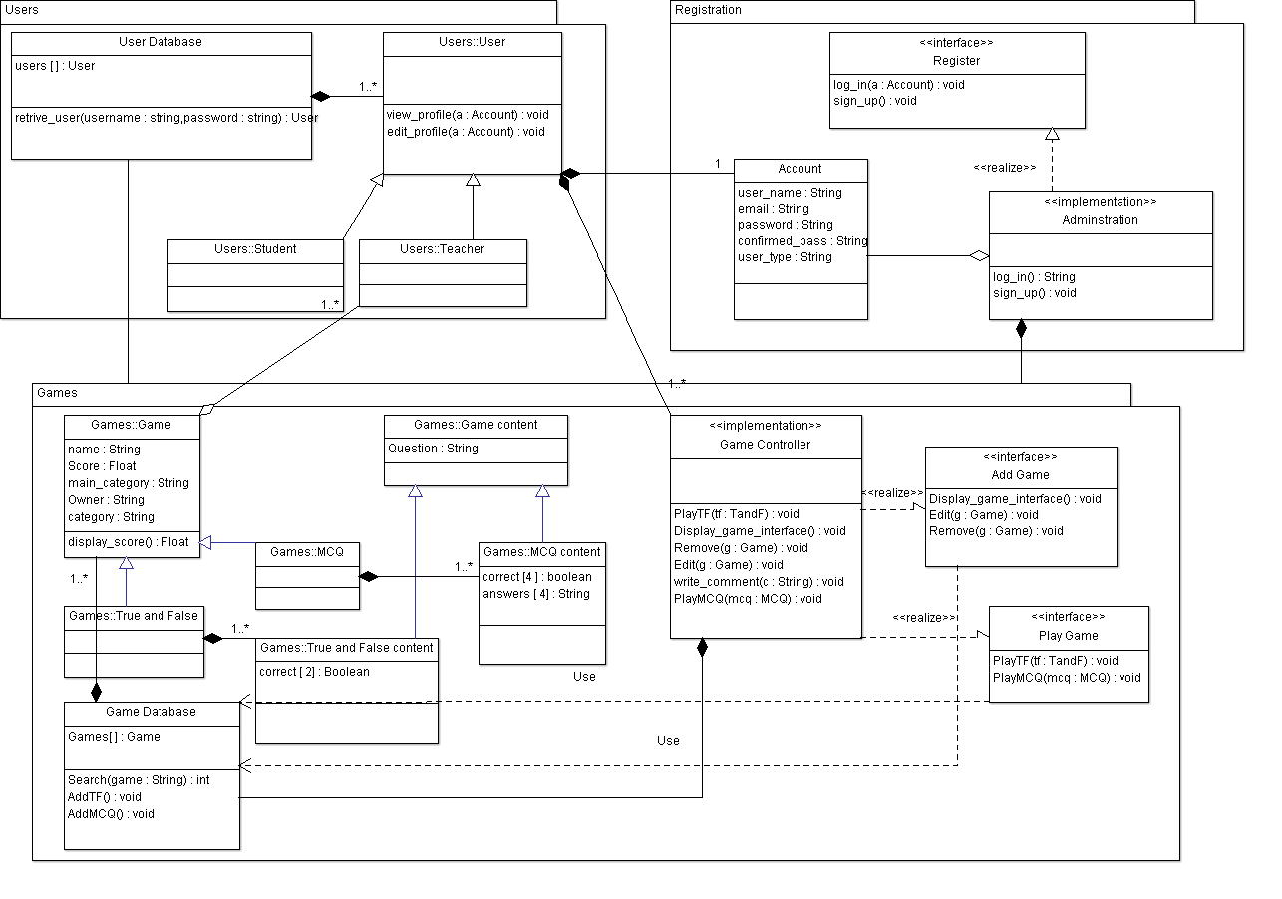

* **Classes Description:**

| **Class ID** | **Class Name** | **Description & Responsibility** |
| --- | --- | --- |
| 1 | User | This class contains users' accounts providing functions that allow any user to make action in the website like writing a comment or editing or viewing his/her profile. |
| 2 | Student | Student is a specific type of users. |
| 3 | Teacher | Teacher is a specific type of users, having additional access to the website by allowing them to add games. |
| 4 | User database | This class contains user's database, their accounts and profiles, their information and scores and games they added – for teachers- if any. |
| 5 | Register | This class provide interface for users to create new account –Sign Up- or logging in to the website.  It also verify the data that taken from users upon signing up or logging in. |
| 6 | Account | A class contains the information of the users like his name and age and also contains his profile. |
| 7 | Administration | This class have the implementation of the function that allow the users to sign up , log in and verify his data and information. |
| 8 | Game | This class contains the information about the game like its name, picture and the scores each user can get in it. |
| 9 | True and false | This class contains game of true and false type. |
| 10 | MCQ | This class contains game of MCQ type. |
| 11 | Game content | This class contain the questions for either MCQ game or True and false game. |
| 12 | True and false content | This class contains the answer for True and false games.  It holds the answer that could be either true or false. |
| 13 | MCQ content | This class contains the 4 possible answers for MCQ games.  In which one answer is the correct one. |
| 14 | Game database | This class contains the database of the games and functions used to add, search or retrieve games by using the game's information. |
| 15 | Game controller | This class contains implementation for all the functions that provide interactions between the users and the game, allowing users to manipulate the game and edit it or remove it according to his access level. |
| 16 | Add game | This class provide interface for the users to manipulate the game like edit it or add game in specific category and select picture and name for it |
| 17 | Play game | This class provide interface for playing, opening or ending any game. |

## II. Sequence diagrams

1. **Play Game**

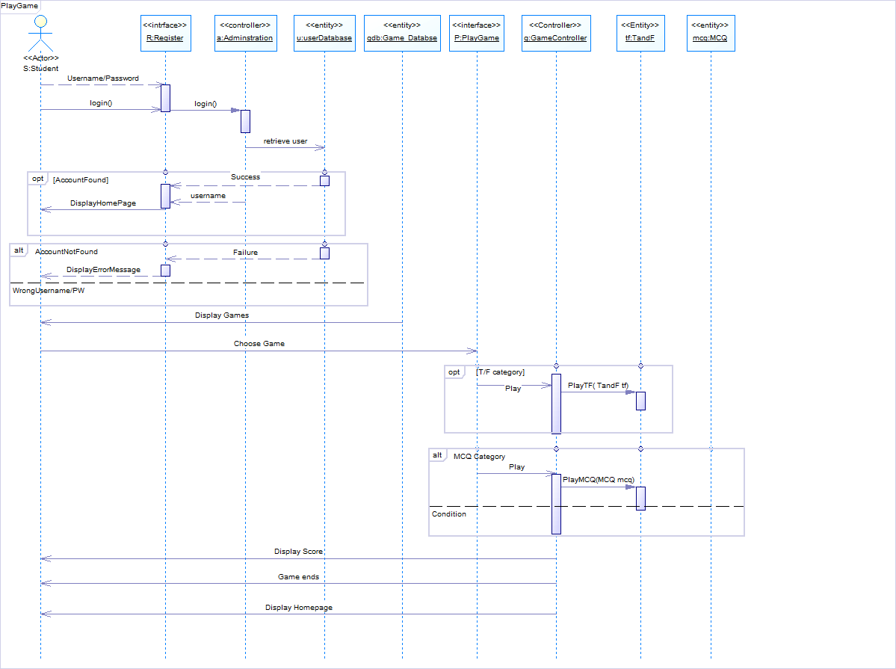

1. **Add Game**

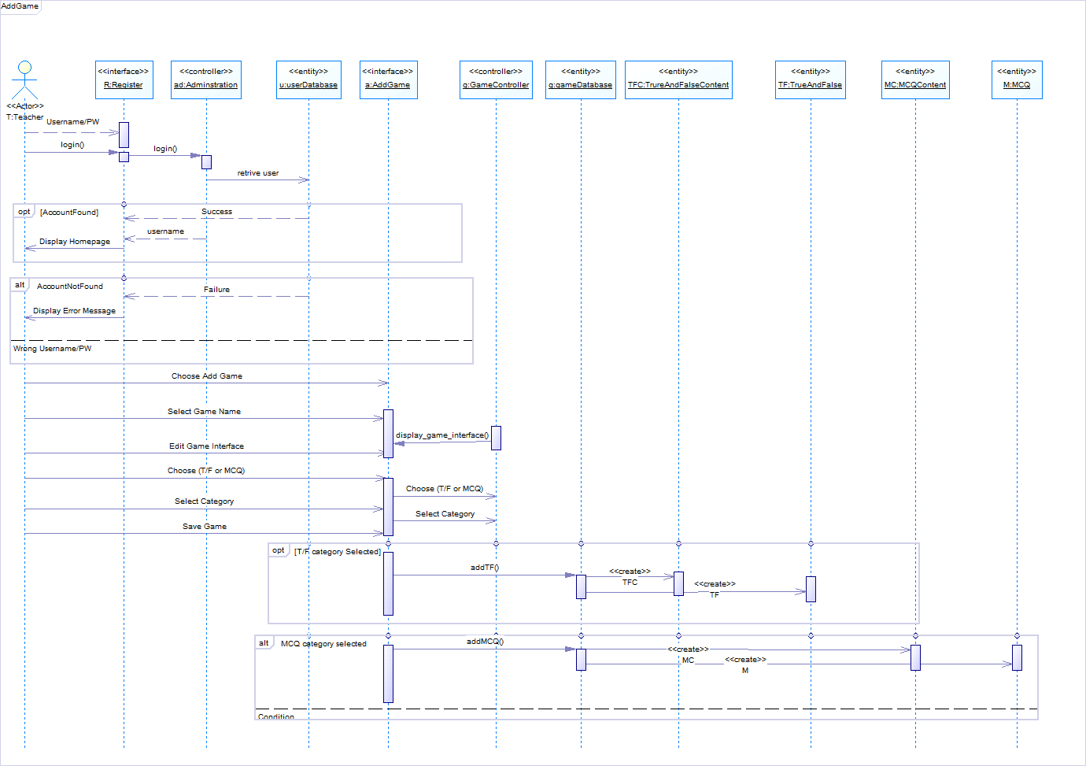

1. **Register**

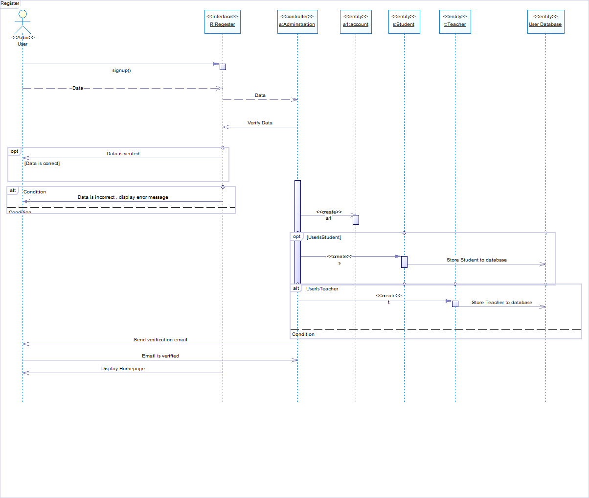

### 

### Class - Sequence Usage Table

| **Class Name** | **Sequence Diagrams** | **Overall used methods** |
| --- | --- | --- |
| Account | 3 | Object created only |
| Teacher | 3 | Object created only |
| Student | 3 | Object created only |
| User Database | 1,2,3 | Object created only |
| Register | 1,2,3 | Login(), Signup() |
| Administration | 1,2,3 | Login() |
| Game Controller | 1,2 | PlayTF() , PlayMCQ(),Display_game_interface() |
| Add Game | 2 | Display_game_interface() |
| Play Game | 1 | PlayTF(),PlayMCQ() |
| Game Database | 2 | AddTF(),AddMCQ() |
| True and False | 2 | Object created only |
| True and False Content | 2 | Object created only |
| MCQ | 2 | Object created only |
| MCQ Content | 2 | Object created only |

# Github Link:

https://github.com/nadaibrahim/Software1

# Ownership Report

|  |  |
| --- | --- |
| **Item** | **Owners** |
| Class Diagram. | *Sahar Ahmed* |
| Sequence Diagrams (Play, Add, Register).  Purpose and Audience. | *Nada Ibrahim* |
| Classes Description table. | *Marwa Ehab* |
| Class-Sequence usage table. | *Sheren Doma* |