Computer Vision Lab Assignment 01
CSE480 CSE482 Computer Vision Lab
Ain Shams University Mechatronics Engineering and Automation Program
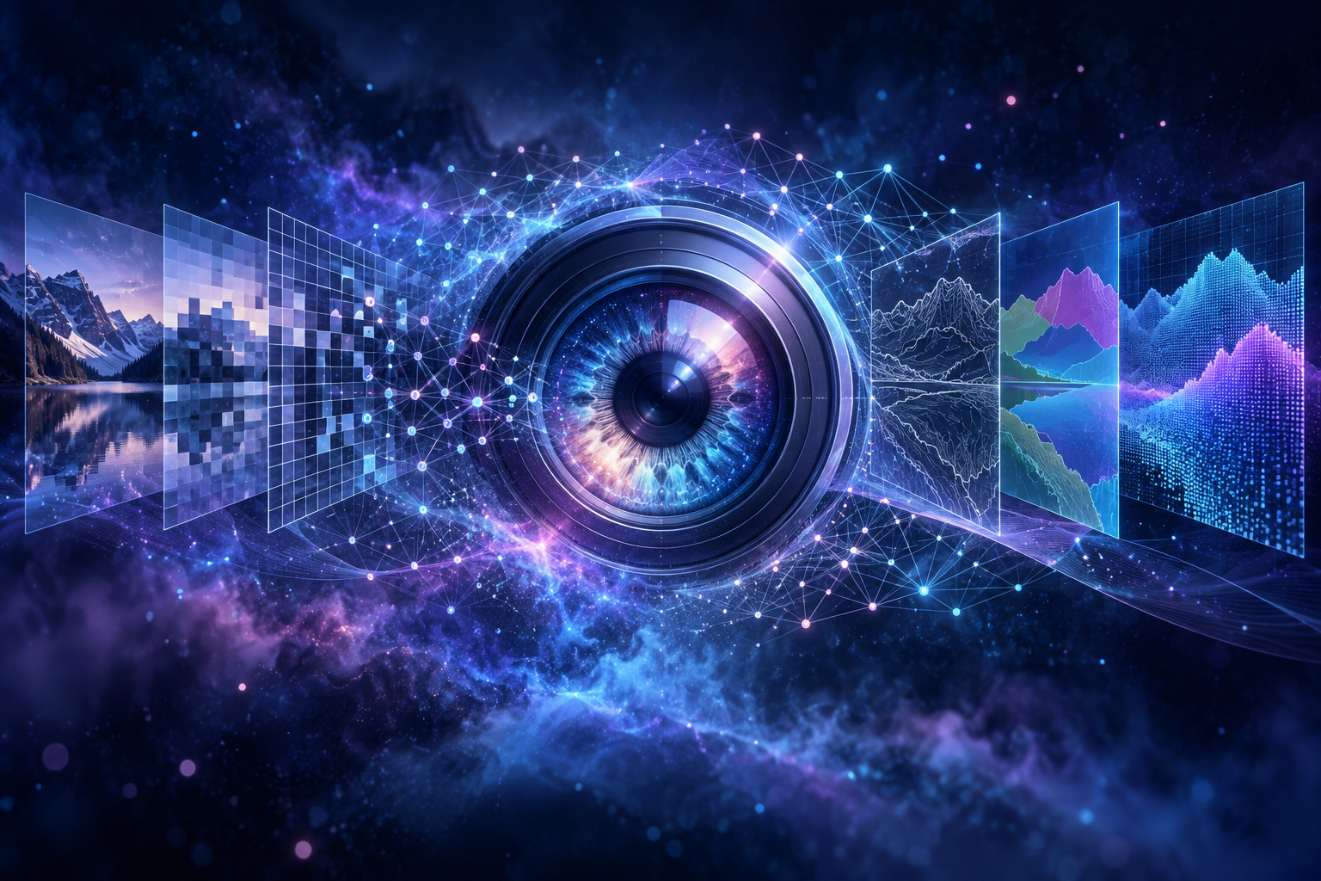
Student name Nada Said Yassin Morgan
Student ID 23P0284

How I approached the lab
I treated the four tasks as small experiments in how pixel values control an image. I kept the supplied images unchanged, processed their NumPy arrays with OpenCV, and converted BGR to RGB only for display. For each result, I relate the visible change to the mask, weights, or channel assignments that produced it.

Task 1 Selective Colour Isolation
Reasoning and method I converted the apple image to grayscale so the unselected region would keep its brightness and texture without colour. I split the original into blue, green, and red planes, remembering that OpenCV returns BGR. A large red value alone can also describe yellow pixels, so the mask requires R >= 70, R - G >= 30, R - B >= 25, and G - B <= 35. Signed subtraction avoids uint8 wraparound. Tighter red gaps would select fewer, purer pixels; looser gaps would keep more skin but also more orange and yellow areas.
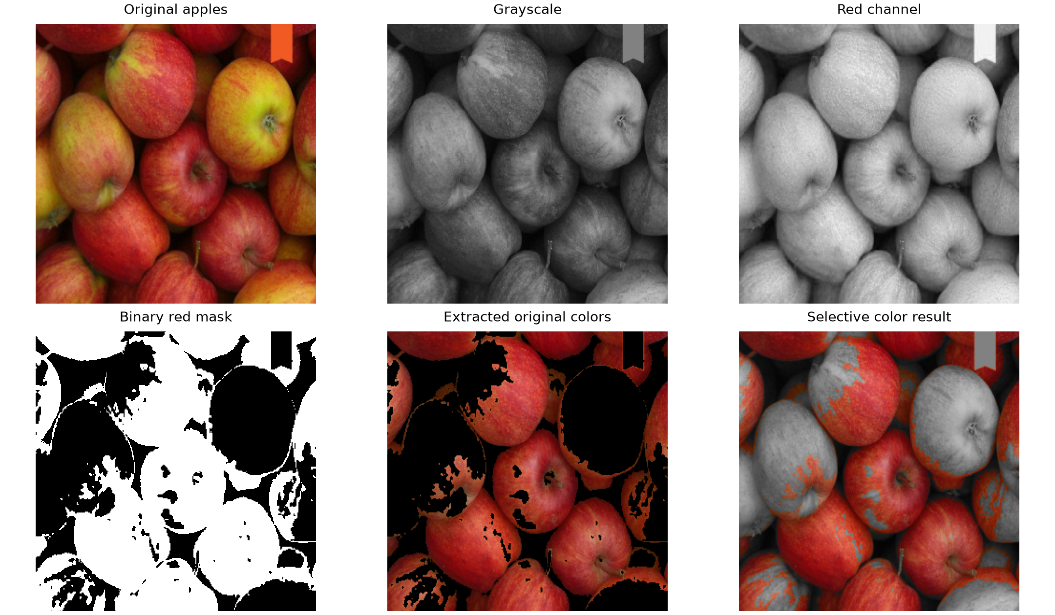
Figure 1 Original image grayscale red channel binary mask extracted colours and final composition
What the figure shows White mask pixels passed all four tests and black pixels failed at least one. The mask selects 54.52% of the image. I use bitwise_and to take original colour under the mask and grayscale under its inverse, then bitwise_or to join the nonoverlapping parts. Red skin stays coloured, while yellow-green mottling, highlights, stalks, and shadowed regions inside the same apples can turn gray. The remaining coloured ribbon strip and the gray holes show the limitation: this rule identifies red-dominant pixels, not complete apples. Whole-object detection would need spatial or shape information.

Task 2 Creating a Ghostly Overlay
Preparing the images Weighted addition works at corresponding pixel positions, so both arrays need the same height, width, channels, and data type. The cameraman is 225 x 225. I resized the zebra proportionally from 425 x 313 to 225 x 166, then added 29 white rows above and 30 below. This keeps the whole zebra without stretching it. Both prepared inputs are 225 x 225 uint8 BGR images on a common canvas, although their unrelated scenes are not registered.
$$I = alpha C + beta Z + gamma$$
I used gamma = 0 and weights that sum to 1. Alpha is the cameraman contribution and beta is the zebra contribution at the same pixel. For example, equal weights combine intensities 80 and 240 as about 160 after rounding.
Experiment | Alpha cameraman | Beta zebra
Cameraman dominant | 0.75 | 0.25
Equal contribution | 0.50 | 0.50
Zebra dominant | 0.25 | 0.75
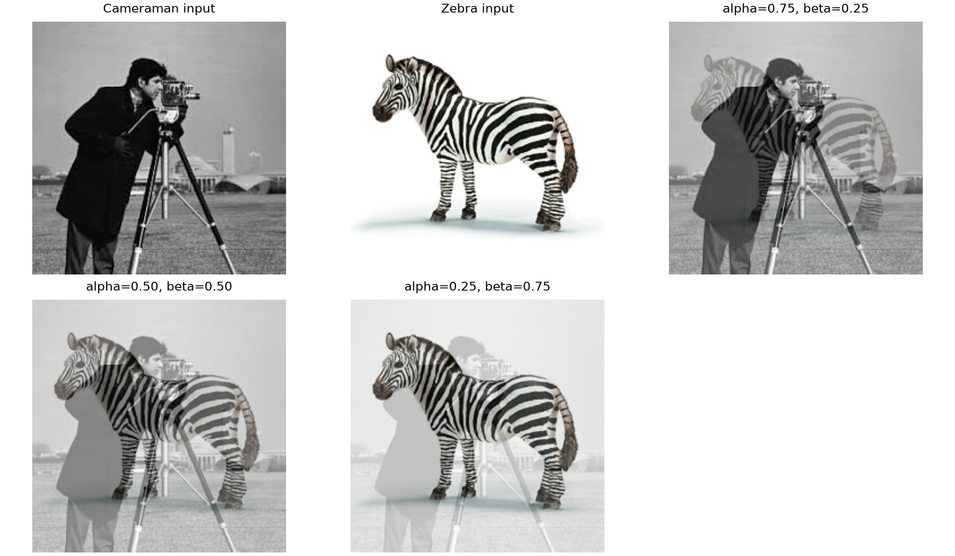
Figure 2 Prepared inputs and three pixel by pixel weighted blends
What the figure shows At 0.75 and 0.25 the cameraman and tripod dominate while the zebra is faint. Equal weights give the two silhouettes similar strength. At 0.25 and 0.75 the zebra dominates and the cameraman looks pale behind it. The frame also becomes brighter as beta increases because most zebra background pixels are white and are mixed into the whole cameraman scene. The ghostly look comes from superimposing two semi-weighted subjects. A cleaner composite would require foreground extraction, which is outside this full-image blending task.

Task 3 Artistic Vignette Filtering
Reasoning and method I wanted the rover and nearby terrain to remain visible while the frame edges became darker. I drew a filled white circle of radius 226 pixels on a black one-channel mask. White represents a multiplication weight near 1 and black a weight near 0. Applying the hard circle directly would create an obvious boundary, so I blurred it with a Gaussian filter. Sigma is 91.2 pixels and the kernel is 549 x 549. After normalization, the floating-point mask contains continuous weights from 0 to 1.
$$V(y,x,c) = round(I(y,x,c) x W(y,x))$$
A weight of 1 preserves a source value, 0.5 halves it, and a value near 0 makes it almost black. I apply the same weight to B, G, and R, so the intended change is brightness rather than hue.
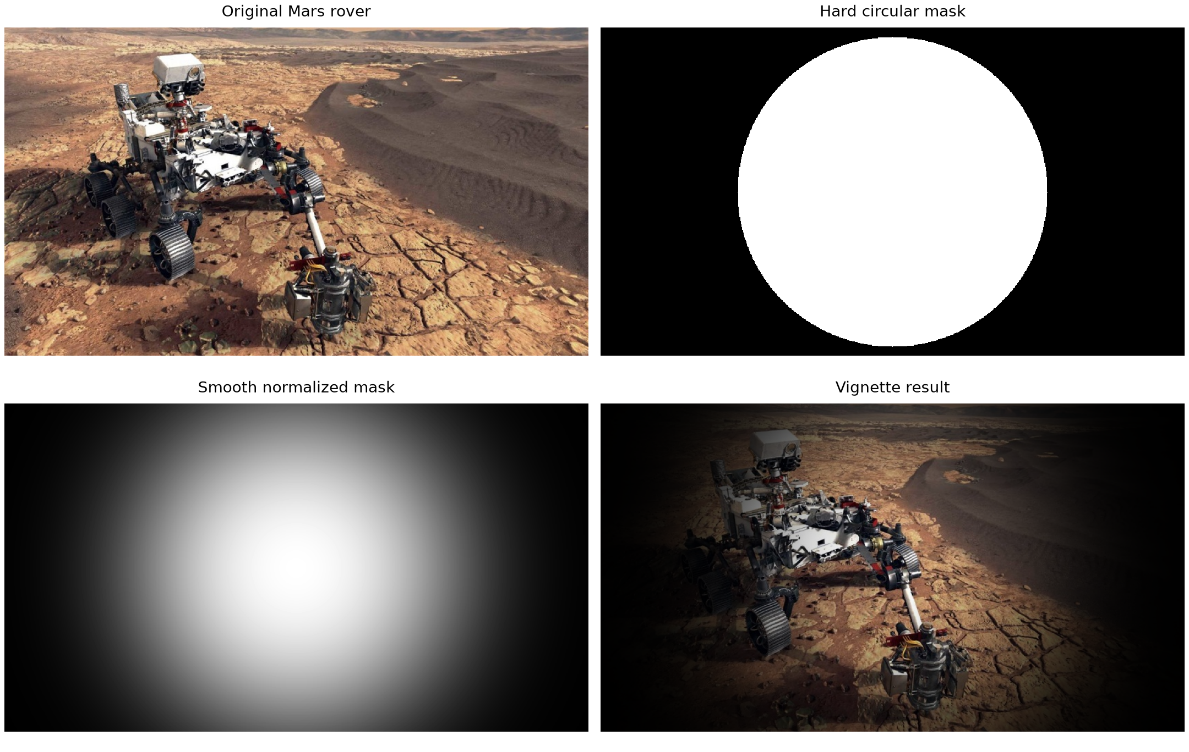
Figure 3 Hard circle smooth normalized weights and the resulting vignette
Measured region | Original mean | Vignette mean
Centre quarter grayscale | 106.88 | 101.00
Four corner patches grayscale | 138.67 | 0.91
What the figure shows The centre pixel is unchanged and the centre-quarter mean changes from 106.88 to 101.00; the corner mean falls from 138.67 to 0.91. The rover body, wheels, arm, and central rock texture remain readable. A smaller radius would darken more of the rover, while a larger one would retain more of the frame. More blur would spread the transition and less blur would reveal the circle. A nonzero minimum weight could preserve corner detail, but the current near-black corners give the requested strong framing.

Task 4 Channel Swapping
Reasoning and method Each colour pixel contains blue, green, and red intensities. OpenCV stores them in BGR order. Splitting the image exposes those planes; merging them in a new order changes which display colour receives each original plane. Output BGR (B,R,G), for example, keeps blue, displays original red as green, and displays original green as red. A neutral pixel has B = G = R, so any permutation of its three equal values is unchanged.
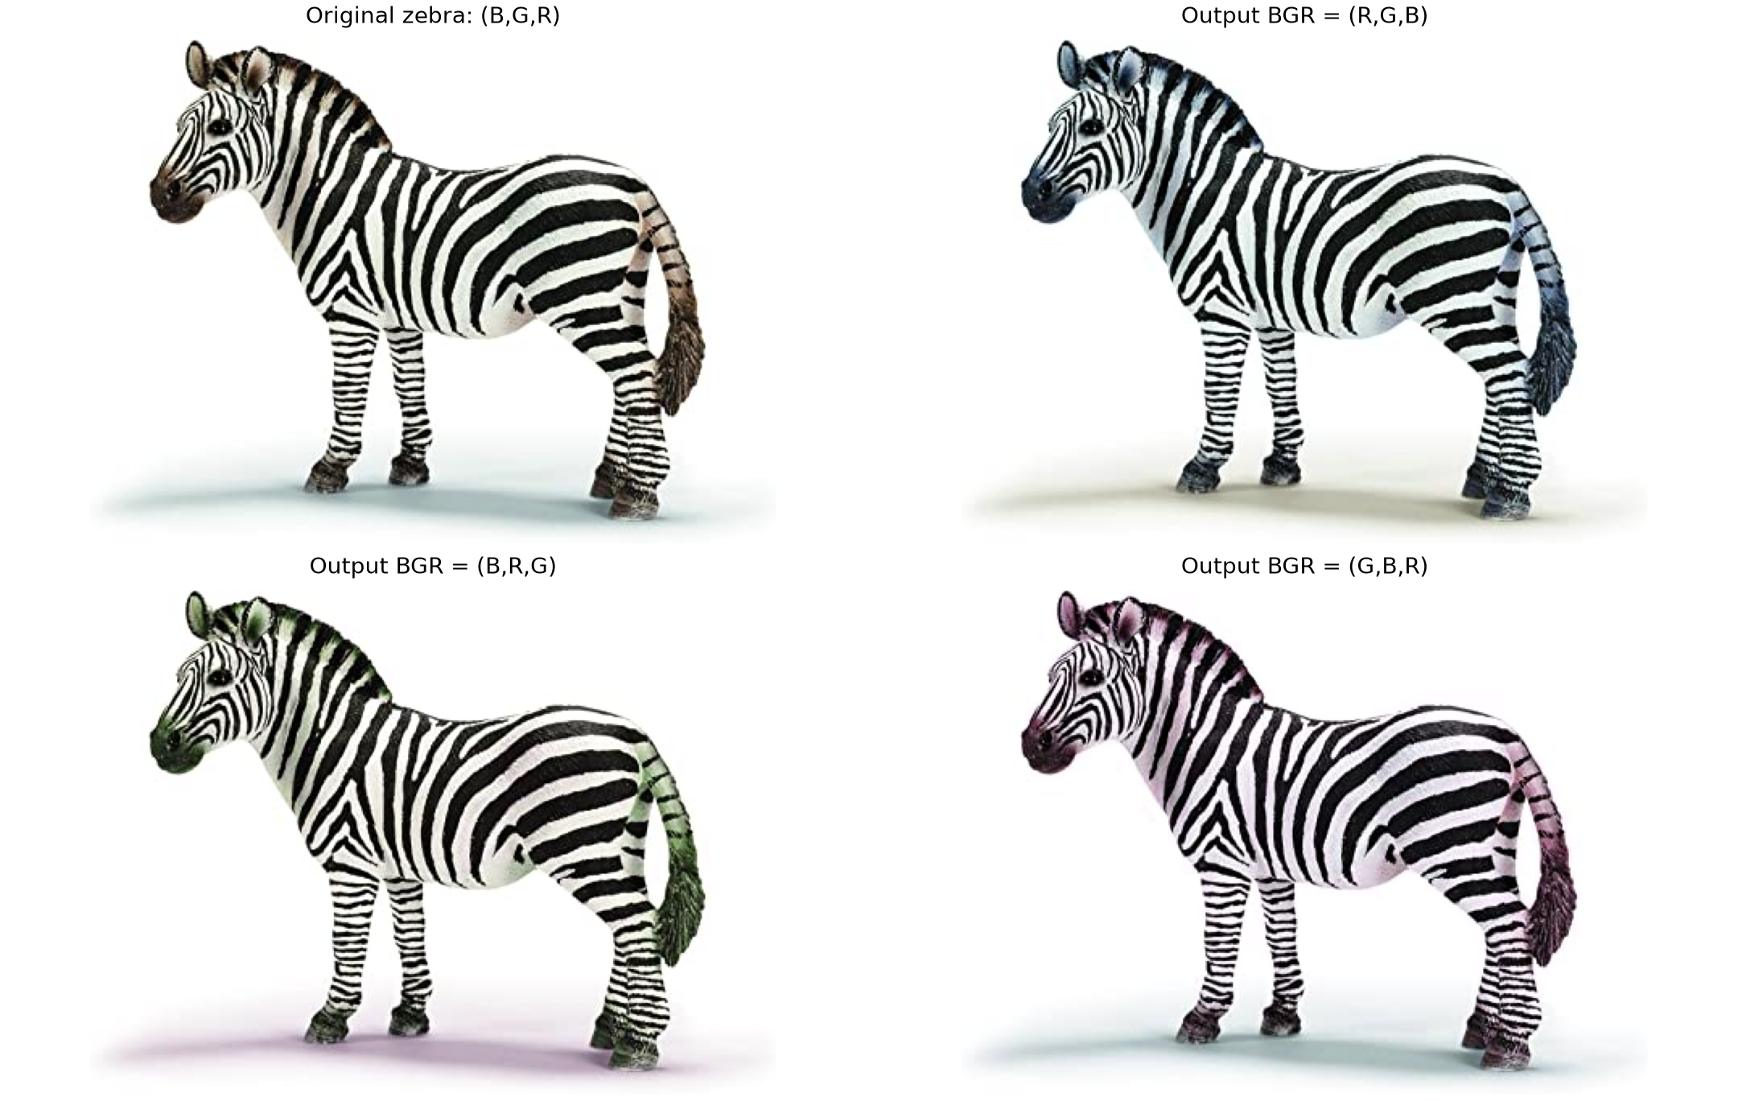
Figure 4 Original zebra and three exact channel permutations
Output BGR | Mean change | Maximum | Changed pixels
(R,G,B) | 2.356 | 64 | 51.10%
(B,R,G) | 1.408 | 34 | 45.17%
(G,B,R) | 1.714 | 35 | 50.15%
What the figure shows The ears, muzzle, tail, and pale shadow shift colour, while the white background and black stripes remain almost unchanged. Exactly 46.47% of pixels have B = G = R. About 45 to 51% of pixels change, but the mean differences are only 1.41 to 2.36 levels out of 255 because many channel values differ only slightly. The experiment changes colour interpretation, not image geometry, and explains why a large changed-pixel count can still look subtle.

Channel Swapping on the Mars Image
I repeated the same assignments on the Mars image without adding a tint or changing contrast. The orange-brown terrain has more unequal BGR values, so this supplementary example makes the channel effects easier to see.
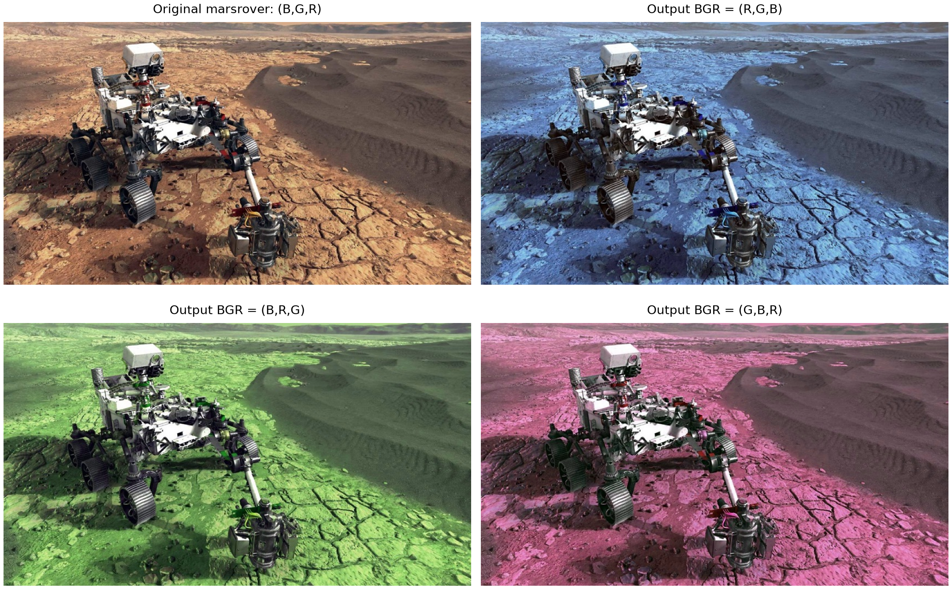
Figure 5 The same channel permutations on the Mars image
Output BGR | Zebra mean change | Mars mean change
(R,G,B) | 2.356 | 29.796
(B,R,G) | 1.408 | 18.264
(G,B,R) | 1.714 | 11.737
What the figure shows The three Mars outputs are strongly blue, green, and magenta. Their mean changes are 29.796, 18.264, and 11.737 levels, much larger than for the zebra. Orange terrain originally has more red than blue, so sending those unequal values to different display channels changes most of the frame. Neutral rover panels remain more stable. The comparison shows that the strength of a permutation depends on the source channel differences.

What I learned and what remains limited
Complementary masks combine colour and grayscale exactly, but a colour threshold does not understand object boundaries. Weighted addition makes both images visible while also mixing their backgrounds. Gaussian smoothing turns a binary circle into controllable brightness weights, although the framing depends on radius and blur. Channel permutation preserves spatial detail while changing colour meaning, and neutral pixels explain why some sources respond less than others. The executed notebook uses these same parameters and reopens all 38 saved PNG files.
Source CSE480 CSE482 Lab Assignment 01 supplied with the project
Project repository https://github.com/nadamorgan69-rgb/cse480-cse482-computer-vision-lab01

