Taranis SA · Geneva · 28 October 2026
TMS vs Tech Long/Short Hedge Funds
Product-page teardown and LinkedIn activity of Cadian, Atreides, Alkeon, Sylebra and Whale Rock against Taranis Market Sentiment, with Monchau and famous tech voices as benchmarks, a SWOT and an operating plan
Subject: Taranis Market Sentiment (TMS), Taranis SA, Geneva (CEO/founder Julien Leegenhoek); linkedin.com/company/taranis-sa. Not Perenco's Taranis energy assets and not the DFSA-registered Taranis Capital.
Data window: LinkedIn 17 Jun – 17 Sep 2026 (13 weeks, Crustdata index) plus a live check to 28 Oct; sites and Form ADV checked 28 Oct 2026
Companion files: dashboard.html (self-contained), data/*.csv, including posts_raw.csv and count_queries.csv

1. Executive summary
- The tech long/short hedge-fund peer set is essentially silent on LinkedIn. In 13 weeks the five company pages published one post between them: Whale Rock's intern class (233 reactions). Cadian, Atreides and Alkeon have never posted on their pages; Sylebra last posted in 2023. Their founders are silent too (Gavin Baker 1 post; Bannasch, Gibson and Sacerdote 0).
- Atreides is not the active exception. Its page has no indexed posts ever and a live search found none. Gavin Baker's visibility comes from other people's channels (podcasts, NVIDIA GTC, the Sohn conference), not his own posts. The only tech funds that post regularly are the benchmarks, Coatue (4.85 a week) and Altimeter (2.23).
- The lane is open, and no direct Swiss peer exists. Taranis's page (2 posts) and Julien Leegenhoek (back to posting since 23 Sep on BFM and RTS) already out-post every focus fund. No fund publishes an AI-disruption or market-sentiment thesis, and all five are US- or Asia-based.
- Peer sites are minimal by design; the TMS page undersells. Cadian and Whale Rock run one-paragraph holding pages, Atreides shows its full team, Alkeon a VC portfolio wall. TMS sits behind a 3-step gate and then shows no fund facts, team or two-sleeve structure, and its award still reads "Managed Futures Newcomer of the Year 2023".
- Four of five pass the hard filter; Sylebra is at risk. Sylebra's site now presents "Sylebra Growth Partners", a growth-equity firm, and its hedge fund appears only in Form ADV data as of 31 Dec 2025. Alkeon (also a UCITS fund and registered sub-advisory) and Whale Rock (also long-only vehicles) are kept on their private hedge funds only.

2. Scope, sources and method
- Hard filter: private technology/TMT long/short equity hedge fund for professional, qualified or accredited investors; UCITS/retail classes, signal vendors, long-only and pure VC/PE excluded. Each fund was re-checked on its live site (TinyFish render, 28 Oct) and in Form ADV data.
- LinkedIn: Crustdata /social_post/search counts (free, limit=0) by company id and actor type, window 17 Jun – 17 Sep 2026; founders by profile URL after verifying each profile by web search. 62 queries are logged in data/count_queries.csv. One paid pull (0.5 credit) fetched Whale Rock's only window post.
- Live refresh: TinyFish web search for public linkedin.com/posts pages after 17 Sep, read with TinyFish fetch. True dates are decoded from each post's activity ID (id >> 22 = milliseconds since epoch).
- Curation is measured from "Source", "via" or "credit" in the post text, not the index's "repost" label.

Caveats
- The Crustdata index ends around 17 Sep 2026. LinkedIn's login wall blocked fetches of the Atreides and Whale Rock company pages and Gavin Baker's profile, so posts after 17 Sep there cannot be fully ruled out; the live search found none. Logged-out pages show comments but not reaction totals.
- Hedge-fund sites are holding or login pages by design; this is recorded as a finding. adviserinfo.sec.gov was unreachable from this environment, so Form ADV facts come from aggregators (privatefunddata, Radient, formds, FINTRX) with the official links given by CRD number.
- AUM figures conflict for every fund (regulatory vs discretionary vs 13F vs press). Each is shown with its source; none is resolved.
- Whale Rock posted on 18 May, 2 Jun and 9 Jun, just before the window, so 13 weeks understates its usual pace. Its intern post is dated 12 Aug in the index and 3 Aug by its post ID.
- Alkeon founder Panayotis Sparaggis has no findable LinkedIn profile. Monchau figures come from the 27 Oct counts; his 290k+ follower count is from a search snippet and unverified.

3. Focus set and hard-filter verification
Fund | HQ | Est. | Strategy | Founder / CIO | AUM (Form ADV) | As of | Hedge fund | Prof. only | Tech | Filter | Flag | Source
Cadian Capital Management | New York | 2007 | Fundamental, value-oriented global L/S equity; TMT first, also healthcare, industrials, consumer | Eric Bannasch | USD 2.68bn regulatory AUM (3 private funds; GAV USD 2.68bn) | Form ADV, latest filed 2026-09-18 | ✓ | ✓ | ✓ partial | Pass | Tech focus partial (multi-sector value L/S) | privatefunddata.com
Atreides Management | Boston | 2019 | Tech and consumer L/S with public/private crossover | Gavin Baker | USD 8.94bn regulatory AUM (29 private funds; GAV USD 9.39bn) | Form ADV ~Mar 2026 (latest ADV filed 2026-05-29) | ✓ | ✓ | ✓ | Pass | Also runs 23 VC + 1 PE vehicles; hedge funds hold most assets | privatefunddata.com
Alkeon Capital Management | New York / San Francisco / Hong Kong | 2001 | L/S growth equity in tech innovators plus private innovation (VC) sleeve | Panayotis (Takis) Sparaggis | USD 25.29bn regulatory AUM (26 private funds; GAV USD 34.41bn) | Form ADV filed 2026-03-30 | ✓ | ⚠ | ✓ | Pass, hedge fund only | Firm also manages a UCITS fund and sub-advises registered funds; only the private hedge funds are compared | privatefunddata.com
Sylebra Capital | Palo Alto / Hong Kong (site); HK/London in brief | 2011 | Small/mid-cap TMT L/S per Form ADV; site now presents 'Sylebra Growth Partners', a growth-equity firm | Dan Gibson | USD 2.90bn regulatory AUM (Sylebra Capital LLC; 3 private funds) | 2025-12-31 (Form ADV filed 2026-03-28) | ⚠ | ✓ | ✓ | At risk | Own site now a growth-equity firm; hedge fund shown in Form ADV only as of 31 Dec 2025 | radientanalytics.com
Whale Rock Capital Management | Boston | 2006 | TMT/semis L/S plus late-stage private; also long-only and MegaCap Tech vehicles | Alex Sacerdote | USD 12.97bn regulatory AUM (fund GAV USD 12.97bn) | Form ADV filed 2026-06-02 | ✓ | ✓ | ✓ | Pass, hedge fund only | Firm also runs long-only vehicles; professional-only inferred from Reg D minimums | formds.com
✓ pass · ⚠ conflict or flag · ✓ partial = tech-led but multi-sector. Crustdata company ids: Cadian 988803, Atreides 990159, Alkeon 1544140, Sylebra 983853, Whale Rock 993750; Taranis 7865447.

Evidence behind each check
Cadian Capital Management. Hedge fund: ✓ Form ADV lists Cadian Master Fund L.P. and Cadian Opportunities Master Fund LP as hedge funds; Radient tags Hedge Fund Manager, Long/Short Equity Professional-only: ✓ Private funds, USD 5M minimum (ADV Sch. D); site T&C 'only to qualified investors' Tech focus: ✓ partial: tagline 'intersection of tech and value' and TMT listed first, but site also lists healthcare, industrials, retail, consumer; Radient sector focus spans 6 sectors Sources: radientanalytics.com · cadiancap.com · adviserinfo.sec.gov · hedgefollow.com
AUM conflicts and flags: AUM CONFLICT: ADV Part 2A says ~USD 1.60bn discretionary at 2025-12-31 (Radient); 13F long book USD 1.32bn at 2026-06-30 (hedgefollow); a search summary cited USD 3.3bn (Mar 2025 ADV) - not opened. Footer copyright still 2024 - site rarely updated. Suggested domain confirmed (cadiancap.com; https:// root without www was unreachable, www works). No recent tier-1 press found (II pieces undated/older).
Atreides Management. Hedge fund: ✓ Atreides Foundation Master Fund LP (Hedge, GAV USD 6.22bn) and other hedge vehicles in Form ADV; Radient tags Long/Short Equity, Long Bias Professional-only: ✓ ADV Part 2A: pooled funds offered by PPM 'to accredited investors and qualified purchasers'; min USD 3M for Foundation Tech focus: ✓ Site: technology and consumer; ADV sector focus IT, Telecom, Consumer Discretionary Sources: radientanalytics.com · privatefunddata.com · adviserinfo.sec.gov · hedgefollow.com
AUM conflicts and flags: FLAG crossover/VC-heavy structure: 23 of 29 ADV private funds are VC (Special Circumstances series) + 1 PE; hedge funds are 5 but hold most GAV. AUM CONFLICT: ADV Part 2A USD 6.49bn discretionary at 2025-12-31; 13F ~USD 5.0bn Q1 2026 (holdingsintel) vs USD 4.1bn (hedgefollow). Search summary mentioned FT report of Lone Pine's Kelly Granat joining as president/co-CIO - not opened, unverified. Site WordPress dated 2019; Team page is the only substantive content.
Alkeon Capital Management. Hedge fund: ✓ 22 of 26 ADV private funds are hedge funds (Alkeon Growth Master Fund GAV USD 11.9bn); ADV 2A: invests 'in long or short positions' of public and private companies Professional-only: ✗/FLAG mixed: private funds use Reg D 506(b) / 3(c)(7) (qualified purchasers, min USD 500k-1M) BUT Alkeon manages a UCITS fund (DMS UCITS Platform ICAV Alkeon UCITS Fund) and sub-advises registered investment funds Tech focus: ✓ ADV sector focus Information Technology; portfolio is software/AI/fintech Sources: radientanalytics.com · adviserinfo.sec.gov · sec.gov
AUM conflicts and flags: FLAG UCITS/retail-accessible vehicles (UCITS via Waystone; registered funds sub-advised for Oppenheimer/SALI per ADV 2A) and VC funds (3 VC in ADV). AUM CONFLICT: ADV 2A ~USD 16bn discretionary + USD 0.44bn uncalled at 2025-12-31; one aggregator claims USD 74bn 13F Q2 2026 (insiderstockbuys, not opened - implausible vs ADV). No recent tier-1 press found. Website founding claim '20+ years' consistent with 2001/2002.
Sylebra Capital. Hedge fund: CONFLICT - ✓ per ADV (Sylebra Capital Partners Master Fund, Hedge, GAV USD 2.39bn; Radient: Long/Short, Equity Market Neutral) but ✗ per own site, now growth equity; raised USD 277M Equity Capital Solutions (PE) fund Aug 2026 Professional-only: ✓ ADV 2A: services 'to qualified investors through private funds' incl. 3(c)(7) funds; min USD 2.5-5M Tech focus: ✓ ADV sector focus IT + Telecom; site tech/tech-enabled Sources: sylebra.com · sylebra.com · adviserinfo.sec.gov · pilhar.ai
AUM conflicts and flags: FINDING: site repositioned to growth equity/PE (pages dated Sep-Oct 2026); hedge-fund status after 2025-12-31 unverified. Regulatory AUM fell from USD 4.68bn (Mar 2025) to USD 2.90bn; 13F USD 1.25bn at 2025-12-31 (pilhar), USD 624M holdings Aug 2026 (trendlyne). II: Sylebra Bell +7.8% 2024, -13.8% Dec 2024, -5.7% Jan 2025. HQ now Palo Alto (not HK/London); HK and Cayman offices remain. Founder 'Dan Gibson' = Daniel Gibson confirmed.
Whale Rock Capital Management. Hedge fund: ✓ 8-10 private funds all classed 'Hedge Fund' in Form ADV (Flagship Master Fund GAV USD 6.25bn); BI: flagship fund vs separate long-only fund Professional-only: ✓ 100% pooled investment vehicles, Reg D Form D offerings, minimums USD 1M-25M (explicit QP/accredited wording not seen) Tech focus: ✓ Site: TMT focus; 'technology-focused hedge fund' (24/7 Wall St/Yahoo) Sources: businessinsider.com · privatefunddata.com · adviserinfo.sec.gov · quiverquant.com
AUM conflicts and flags: FLAG long-only vehicle (Long Opportunities funds; BI: long-only fund -18.8% July 2026) plus MegaCap Tech and hybrid funds alongside flagship L/S. AUM CONFLICT: ADV USD 12.97bn; firm LinkedIn USD 14bn+ (May 2026, from 2026-10-27 notes); BI 'USD 19 billion firm' (Aug 2026); 24/7 Wall St 'USD 8 billion' (13F-based, Apr 2026). BI: flagship +72.5% to June, -21.7% July, +35.1% YTD. CORRECTION vs 2026-10-27 notes ('Login required'): site is a public holding page with a login tab.

4. Product / strategy-page teardown
Rows are attributes and columns are funds; Taranis is the last column. Full cells with their source links are in data/product_pages.csv.
Attribute | Cadian | Atreides | Alkeon | Sylebra | Whale Rock | Taranis TMS
Hedge fund ✓ / professional-only ✓ / tech-focused ✓ | ✓ / ✓ / ✓ partial | ✓ / ✓ / ✓ | ✓ / ⚠ / ✓ | ⚠ / ✓ / ✓ | ✓ / ✓ / ✓ | subject
Site type | One-pager (WordPress, anchor sections) + T&C and privacy pages | Small microsite: one-page home (About + Contact) + Team directory with individual bio pages | One-pager + VC portfolio page + investor login portal + regulatory pages | Multi-page microsite rebranded as 'Sylebra Growth Partners' (growth equity): About, Investment Approach, Investments, Media, Partner With Us | One-pager holding page: logo + About / Login / Contact tabs | Product page within Taranis corporate site (Investment Solutions: TMS, GlobalDataNetwork)
Gate | None (no disclaimer/click-through or login; live render 2026-10-28, TinyFish run b8d5960b); T&C state offers only to qualified investors | None (no disclaimer or login) | Public home/portfolio; investor area login-gated (Login Id/Password, 'New user?' register) | None | Public About/Contact; Login tab (hidden username/password form) for investors. Static fetch tool flags it 'login_required'; live browser render shows public text (TinyFish run a071ff89, 2026-10-28) | 3-step: (1) country of residence: Switzerland / United Kingdom / Other; (2) 'Professional / Qualified' vs 'Private / Retail investor'; (3) Disclaimer, Accept/Decline. /investment overview itself ungated (TinyFish run c2f48efe, 2026-10-28)
Sections | Home (tagline) > About us (strategy paragraph) > Contact (address, phone, ir@ email); footer T&C, Privacy | Home > About (one sentence) > Contact (phone, info@ email); Team page (~40 names/titles, bio subpages); footer Terms of Use, Privacy | About (headline, 'Growth and Innovation', 'VC Portfolio') > Contact (phone + inquiry form); Portfolio page (Innovation Strategy companies filterable by sector); Sign-in; footer T&C, Privacy, EU Disclosure | Home (hero) > About Us (Who We Are, What We Believe, Team) > Investment Approach (Criterion, Strategy, SGP Wheelhouse) > Investments (3 portfolio cos) > Media (news) > Partner With Us (management teams, investors, offices) | Logo ('20th Anniversary, est. 2006') > About (2 sentences + SEC registration disclaimer) > Login > Contact Us (address, phone, email); footer Terms, Privacy | Title 'Taranis Market Sentiment - Long/Short Technology' > strategy description > award > past-performance disclaimer > link to GlobalDataNetwork; global nav Who We Are (Intro, Technology, Team), Investment Solutions, News, Contact
Nav depth | 1 (single page with anchors) | 2 (Home > Team > individual bio) | 2 (Home > Portfolio / Sign-in / EU Disclosure) | 2 (top menu with anchor sub-items; news post pages) | 1 | 2 (Investment Solutions > TMS) behind 3-step gate
Languages | English only | English only | English only | English only | English only | English only (no switcher seen)
Strategy, own words | "a global long/short equity manager" across TMT, healthcare, industrials, retail, consumer; fundamental, value-oriented, long-term; conservative net beta | "brings a long-term perspective to technology and consumer companies across public and private markets" via crossover strategy | platform flexible "to invest in transformative companies throughout their lifecycle"; 50+ private VC holdings | "We are a growth equity firm" investing in tech, tech-enabled, high-growth industries; USD 50-200M tickets | "invested globally with a focus on the Technology, Media and Telecom sectors" since 2006 | "a long/short equity strategy focused on technology": semis, AI infrastructure, space, defense tech, hardware
Tagline | "Cadian Capital. The intersection of tech and value" | none on page; meta: Boston hedge fund firm bringing a PE investor's long-term perspective | "Two decades of investing in transformative companies." | "Partnering With Next Generation Growth Companies" | none (logo: '20th Anniversary, est. 2006') | "Anticipate Trends" (site title)
Differentiators | Discretionary fundamental stock selection; value-oriented long-term; deep industry focus; conservative net beta exposure; tech-led but multi-sector; no AI/data or private-market claims | Crossover public/private; long-term 'private equity' perspective; tech + consumer; discretionary; separate Atreides Ventures and ECM functions visible in team titles; no AI/data-process claims | Growth/innovation lifecycle crossover (public + private); VC portfolio logo wall (Anthropic, Databricks, Stripe, Canva etc.); sector tags incl. 'AI / ML / Data'; discretionary; no net-exposure or short-book talk on site | Platform / Growth / 'Private in Public' (PIPE-style) stages; active engagement and board seats (Aeva, PureCycle); capital-markets toolkit; no mention of hedge fund, shorting or net exposure | TMT focus; SEC-registered RIA statement; nothing on process, AI, exposure or private investments on site | Fundamental stock picking + quantitative overlay on risk appetite/positioning; behavioural sentiment algorithm; high liquidity
Team shown | none (no names on site) | Yes: full staff list incl. Gavin Baker (MP & CIO), PMs, IR, ops; bio subpages | none on site | Yes: co-founders Daniel Gibson, Jeff Fieler, Karan Saraf + partners/principals/associates with bios | none | none on TMS page (separate /team page)
AUM on site | none | none | none | none | none | none
Performance disclosure | none | none | none (login-gated) | none (Karan Saraf bio cites >30% IRR on prior realizations) | none (login) | none (only 'Past performance is not indicative of future results')
Documents | none (T&C and privacy only) | none | Behind login only; public: EU SRD II/SFDR disclosure | none | none public (login) | none (no factsheet/PDF)
Letters | none | none | none public (login portal) | none | none public (login) | none
Investor eligibility | T&C: offers made only to qualified investors via private offering memorandum | none stated on site | Not stated publicly; registration/login for investors | none stated | none stated on site | Disclaimer: strictly qualified/professional investors in Switzerland and UK
Target audience | Existing/prospective institutional LPs who already know the firm | Institutional LPs, founders/companies (crossover), recruits | Existing LPs (portal), founders/VC ecosystem (portfolio wall), EU/UCITS investors (disclosure) | Founders/management teams first; LPs second ('For Investors') | Existing LPs (login) | Swiss/UK professional and qualified investors
Tone | Sparse, legalistic, understated | Minimal, corporate | Confident growth/innovation marketing, brief | Private-equity partnership language, polished | Minimal, discreet | Technical/behavioural-finance, promotional ('compelling features')
Primary CTA | Email ir@cadiancap.com / phone (212) 792-8800 | Phone (617) 422-0000 / info@atreidesmgmt.com; social links X, LinkedIn, Facebook | Inquiry form + phone 212 716 6840; investor Sign In | Partner With Us / Get in Touch (Palo Alto, Hong Kong, Cayman addresses) | Login; info@whalerockcapital.com / (617) 502-9900 | Link to GlobalDataNetwork; contact investments@taranis.net, +41 22 318 43 90
Page | cadiancap.com | atreidesmgmt.com | alkeoncapital.com | sylebra.com | whalerockcapital.com | taranis.net

Positioning summaries
Cadian Capital Management. Cadian presents itself in one paragraph as a fundamental, value-oriented global long/short equity manager at 'the intersection of tech and value', with a conservative net beta. The site is a legalistic one-pager with no team, AUM, performance or documents, aimed at LPs who already know the firm. It makes no AI, data or systematic claims and covers healthcare, industrials and consumer as well as TMT. Against TMS it is a discretionary generalist-leaning value shop, while TMS leads with a behavioural-sentiment quant overlay and a narrower tech/AI-hardware universe. cadiancap.com
Atreides Management. Atreides positions itself as a crossover investor bringing a long-term, private-equity-style perspective to technology and consumer companies across public and private markets. The site is almost empty apart from a large team directory, which signals institutional depth (IR, capital formation, ECM, ventures) rather than explaining a process. Its Form ADV shows a flagship hedge fund alongside many VC/PE vehicles, so its edge is public-private access, not a data or quant signal. TMS by contrast is purely liquid, public-equity tech long/short with a quantitative sentiment overlay and no private-market angle. atreidesmgmt.com
Alkeon Capital Management. Alkeon markets 'two decades of investing in transformative companies' across their lifecycle and leads with a VC logo wall (Anthropic, Databricks, Stripe), with investor material behind a login. It reads as a growth/innovation crossover platform; long/short hedge funds dominate the ADV, but the brand story is private-company access. It also runs a UCITS fund and sub-advises registered funds, so it is not purely professional-only. Compared with TMS it competes on scale (USD 25bn regulatory AUM) and private deal flow, while TMS's angle is behavioural sentiment timing within liquid tech. alkeoncapital.com
Sylebra Capital. Sylebra's site now presents 'Sylebra Growth Partners', a growth equity firm writing USD 50-200M tickets across Platform, Growth and 'Private in Public' stages, with active board engagement. The low-net TMT long/short hedge fund behind its reputation is not mentioned at all; it appears only in Form ADV data as of end-2025, and regulatory AUM has fallen sharply. Its tone is aimed at founders and management teams, not hedge fund allocators. For TMS it is a weak direct comparable: if the hedge fund is being wound down or de-emphasised, Sylebra may fail the hard filter, and its positioning (engaged PE partner) is the opposite of TMS's liquid, signal-driven approach. sylebra.com
Whale Rock Capital Management. Whale Rock's public page is a two-sentence holding page: an SEC-registered Boston adviser investing globally with a TMT focus since 2006, plus a login tab and contact details. All substance (performance, letters) sits behind the login or reaches the market through press, e.g. Business Insider's monthly return leaks. Its line-up mixes the flagship long/short fund with long-only, MegaCap Tech and hybrid/private vehicles. Against TMS it is the scale TMT benchmark (about USD 13bn ADV) with no stated quant or sentiment component, so TMS's differentiation has to rest on its behavioural overlay and risk-appetite timing, not on tech focus alone. whalerockcapital.com
Taranis TMS. TMS sits behind a 3-step country / investor-type / disclaimer gate, then presents itself as a long/short technology equity strategy combining fundamental picking with a quantitative sentiment and risk-appetite overlay. Unlike the peers it explains its process openly, but it shows no fund facts, AUM, performance, team or documents, and it does not set out the two sleeves (systematic since 2016, discretionary tech/AI since Dec 2025). The award is still labelled 'Managed Futures Newcomer of the Year 2023', which clashes with the L/S tech positioning. Peers reveal less but carry brand, scale or press coverage; TMS needs track-record and vehicle facts behind its gate to compete. taranis.net
Contrast with TMS: every peer page is thin, but each tells the visitor one true thing (Atreides: the team; Alkeon: the portfolio; Whale Rock: 20 years in TMT). The TMS page asks for three clicks and then says less about the fund than any of them: no fund facts, no team, no statement of the two sleeves, and an award labelled "Managed Futures".

5. LinkedIn activity
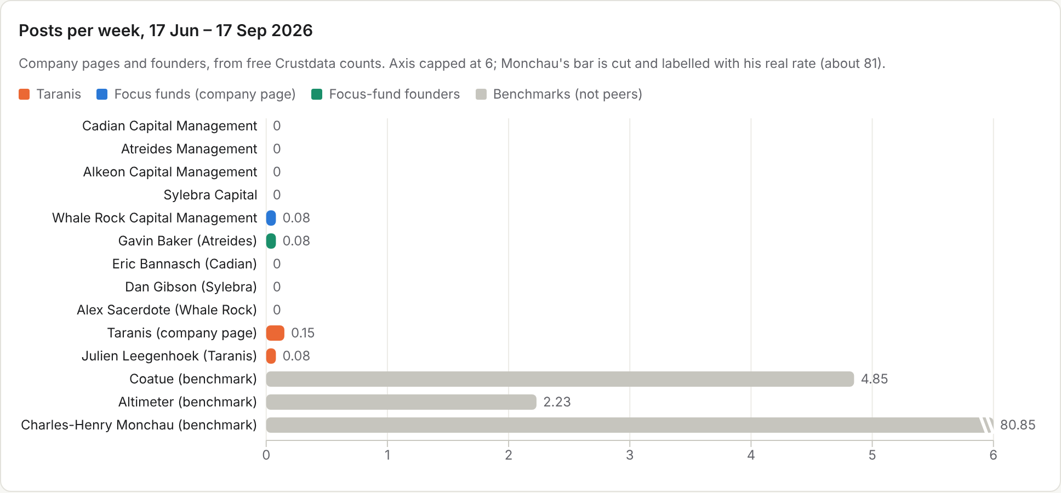
Account | Group | Channel | Posts 13 wk | Per week | Posts ever | Format | Original vs curated | Best post | Link | What Taranis can learn / gap
Cadian Capital Management | Focus fund | Company page empty since creation; founder Eric Bannasch has no posts. | 0 | 0.00 | 0 | none | n/a (no posts) |  |  | None. Nothing to copy; confirms that the hedge-fund peer set does not use LinkedIn.
Atreides Management | Focus fund | Company page empty (0 posts ever). Gavin Baker's own profile: 1 post in the window, 6 ever. His reach comes from other people's channels (podcasts, NVIDIA GTC, Sohn). | 0 | 0.00 | 0 | none | n/a (no posts) |  |  | Founder-as-brand without posting: Baker is quoted and filmed on third-party channels. Taranis can do both: keep Julien's BFM/RTS appearances and post them himself.
Alkeon Capital Management | Focus fund | Company page empty (0 posts ever). Founder profile not found on LinkedIn. | 0 | 0.00 | 0 | none | n/a (no posts) |  |  | Its public story is a VC logo wall (Anthropic, Databricks, Stripe). TMS has no equivalent proof; a sentiment chart is its proof.
Sylebra Capital | Focus fund | 5 posts ever, none since 2023; founder Dan Gibson has no posts. | 0 | 0.00 | 5 | none | n/a (no posts) |  |  | Rebranded as growth equity; no LinkedIn presence for the hedge fund.
Whale Rock Capital Management | Focus fund | 1 company post in the window (summer interns, 233 reactions); 7 ever. Rare milestones (20th anniversary, Sohn, podcast) just before the window. Founder silent. | 1 | 0.08 | 7 | image (1 post) | original (0 credited) | 233 | Open post | Rare milestone posts with a number still draw ~230 reactions. Taranis's awards and TV appearances are the same raw material.
Taranis (TMS) | Subject | Company page 2 posts in window (video, article; both <25 reactions); Julien Leegenhoek 1 in window, 15 ever, posting again since 23 Sep (BFM, RTS) | 2 | 0.15 | 15 | video / article link | original (0 credited) | 28 | Open post | Already ahead of four of the five peers on LinkedIn; the founder's posts outperform the page.
Coatue Management | Benchmark (not a peer) | Company page + LinkedIn newsletter + insights site | 63 | 4.85 | 280 | image 22, video 17, document 12, article 4 | original | 232 | Open post | Turn each research view into a one-line hook plus a chart or clip; run a newsletter from the company page
Altimeter Capital | Benchmark (not a peer) | Company page + founder Brad Gerstner (personal) + partners | 29 | 2.23 | 126 | article 10, image 6, video 2, text ~11 | original | 354 | Open post | Make Julien the public face: TV clips with a quote, a clear policy/market stance, partners interviewing companies
Formats, curation and reaction thresholds were counted for every fund; for the four funds with no window posts all breakdowns are 0. Coatue and Altimeter are benchmarks for how a tech fund can post, not peers.

Posts after the index (17 Sep – 28 Oct, live check)
Author | Date | Format | Reactions | Comments | Post (opening) | Link
Antoine Megarbane (reshared by Taranis) | 2026-10-12 | image | 61 | 7 | Delighted to be part of the judging panel of the WealthBriefing European Awards 2027, recognising excellence and innovation across the European wealth management industry... | Open post
Julien Leegenhoek | 2026-09-23 | article link (bfmtv.com) | 19 | 1 | Avec 2,8 millions de téléchargements en douze jours, le lancement de Muse par Meta marque une nouvelle étape pour l'IA agentique. J'en parlais sur BFM Business invité par Étienne Bracq... | Open post
Julien Leegenhoek | 2026-10-02 | article link (rts.ch) | 28 | 1 | Avez-vous suivi l'entrée en Bourse d'Infomaniak ? Invité sur la RTS - Radio Télévision Suisse par Jacqueline Pirszel j'ai partagé mon regard sur cette entreprise suisse du cloud et sur son arrivée ... | Open post
Taranis | 2026-10-15 | text (no media detected) |  | 7 | We're pleased to welcome Paul Monsigny to Taranis as an Equity Analyst. Paul holds a Master's degree in Asset Management (Master 222) from Université Paris Dauphine, building on his earlier studies... | Open post
No posts by the five funds or their founders were found after 17 Sep; all live posts found are Taranis-related.

6. Benchmark: Charles-Henry Monchau
Context, not a peer: Monchau (Syz Group CIO, profile) is the "loud individual voice" model. In the 13 weeks he published 1,051 posts (about 81 a week, 11.5 a day). 86% credit a "Source"; only 4 of 78 own-view or Syz-branded posts cleared 54 reactions. Tech/AI is about 26% of posts; tech posts beat his average only slightly (+6–7% at 25 and 54 reactions) and go viral less often, because his viral outliers are humour.
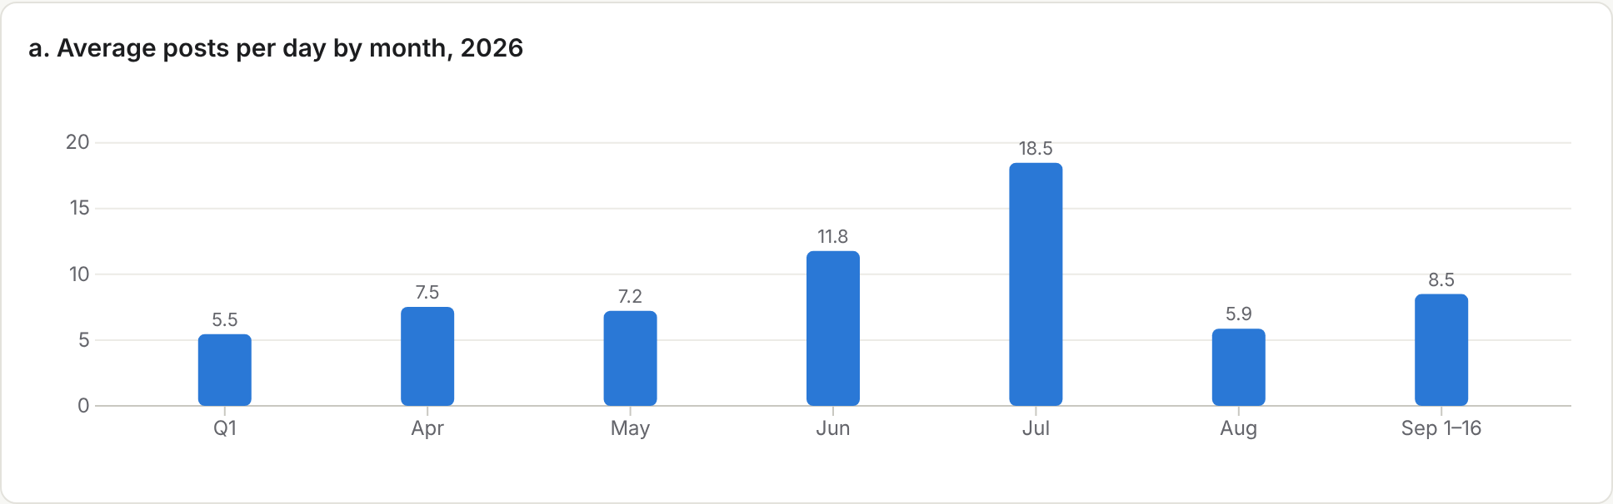
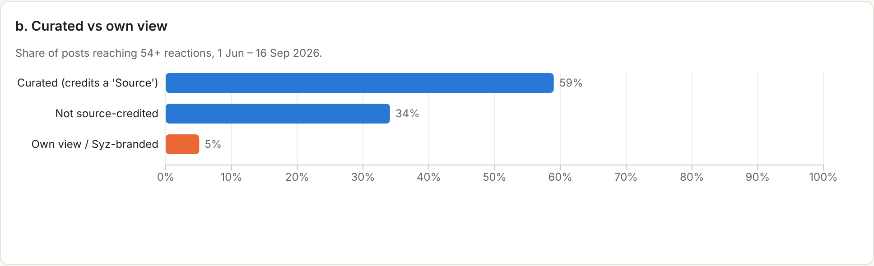
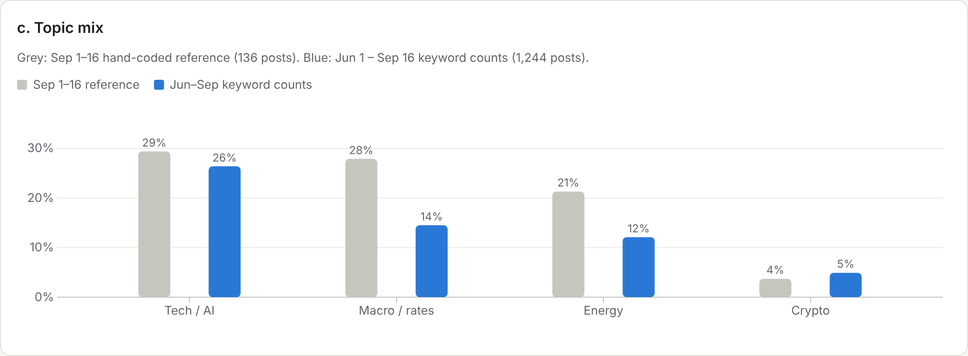
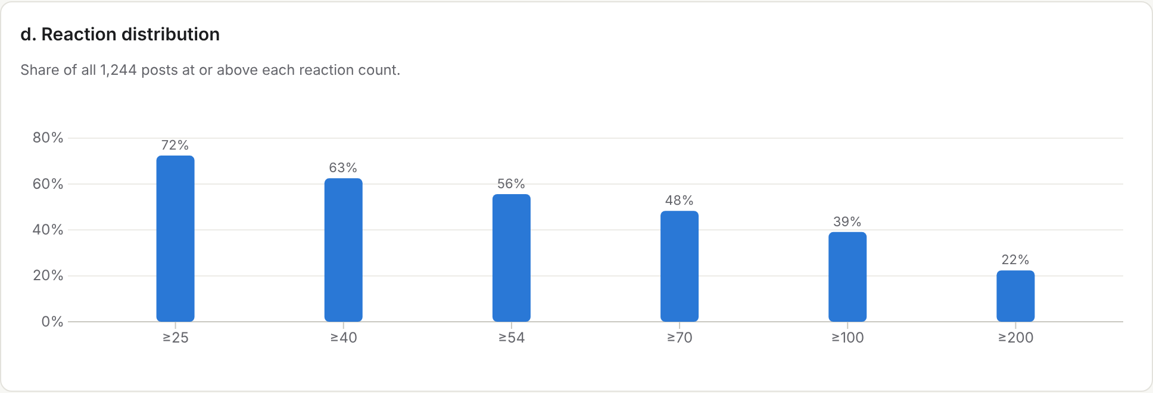
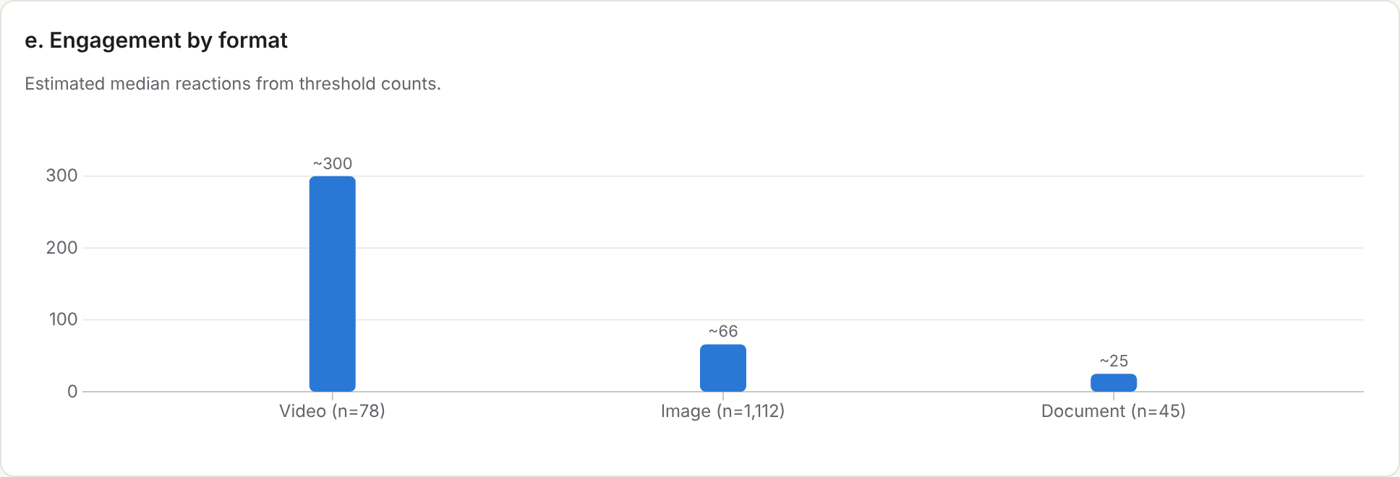
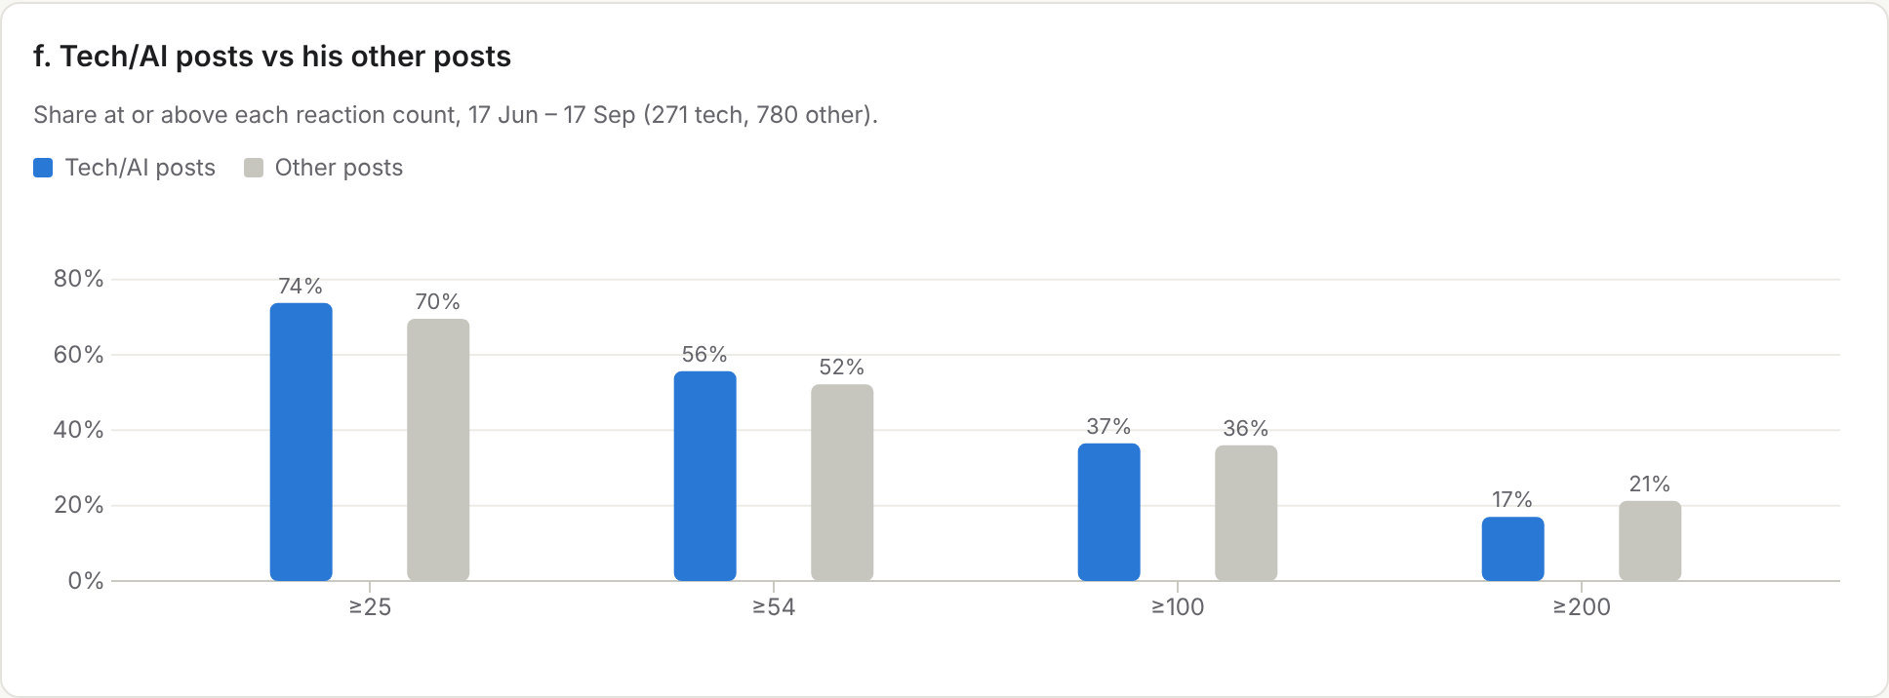
Reading for Taranis: copy the chart-first image format (his most reliable, 57% of image posts clear 54 reactions), not the volume or the curation.

7. Famous tech voices, by format
Their audiences are in the millions, so formats matter more than reactions. None posts as often as Monchau (the most frequent, Eduardo Ordax, posts 19 a week) and none credits sources as much (6–19% against his 86%).
Voice | Posts / week | Credits a source | Top format | Top post | Own voice or curator?
Charles-Henry Monchau (benchmark) | 80.8 | 86% | image | Open post | Curator: 86% credit a Source/via (907 of 1,051); text largely follows the cited account
Eduardo Ordax (AWS, GenAI GTM) | 19.2 | 11% | video | Open post | Mostly own short commentary; humour clips posted natively without a credit line
Linas Beliūnas (fintech/AI) | 15.4 | 19% | video | Open post | Curates others' content but re-frames it in his own voice; 19% carry a credit
Ethan Mollick (Wharton) | 15.3 | 6% | image | Open post | Writes his own: first-hand tests and opinions; 6% credit others
Ruben Hassid (AI writing) | 13.6 | 19% | image | Open post | Own listicle templates with a lead magnet; repeatable format (production team not verifiable)
Brij Kishore Pandey (AI architect) | 12.2 | 19% | image | Open post | Own explainer text over diagrams; ends with a question
Pascal Bornet (AI/automation author) | 11.6 | 11% | video | Open post | Viral clips with his own caption; credits rare (11%)
Bernard Marr (futurist) | 9.3 | 7% | article | Open post | Own articles and newsletter excerpts, hashtag-heavy
Andreas Horn (AI, AIOps) | 9.0 | 12% |  |  | Not sampled; 12% credit others
Ronald van Loon (AI influencer) | 7.6 | n/a |  |  | Not sampled
Evan Kirstel (B2B tech) | 7.3 | n/a |  |  | Not sampled
Antonio Grasso (digital transformation) | 5.9 | n/a |  |  | Not sampled

Voice | Posts / week | Top formats | Best post | What Taranis can borrow
Bill Gates | 5.2 | Video + photo | Open post | Personal relationship stories and short field-trip videos; warmth over data
Satya Nadella | 1.8 | Text-only + one photo | Open post | Results-day post in his own words with 3-4 hard numbers and a framework; physical-milestone photo
Andrew Ng | 1.1 | Article/link + video | Open post | Low volume; every post is a useful artifact (a map / a launch); one-line hook
Ethan Mollick | 15.3 | Image + text-only | Open post | Daily first-hand tests of new AI models with a clear verdict and some dry humor
Aravind Srinivas | 1.0 | Video demo + image | Open post | Builder proof: what we built and the dollar impact in two sentences
Allie K. Miller | 4.1 | Video tutorial + numbered list | Open post | Early-access hands-on review in a numbered list; weekend homework series
Reid Hoffman | 2.4 | Video clips from his podcast | Open post | Cut long-form interviews into 60-90s clips with one takeaway paragraph

8. SWOT and recommendations
Strengths  - The only fund in the set with a behavioural-sentiment quant engine (since 2016) beside discretionary tech picking  - Founder-CEO with BFM Business and RTS airtime, posting again since 23 Sep  - Already posts more than all five peers; HFM award history | Weaknesses  - 0.15 posts a week on the page; posts mostly in French  - Product page hides fund facts, team and the two sleeves; award labelled "Managed Futures"  - Much smaller than the peers (USD 2.7–25bn regulatory AUM)
Opportunities  - The tech long/short hedge-fund peer set is silent on LinkedIn: the lane is open  - Nobody publishes an AI-disruption or market-sentiment thesis  - No direct Swiss peer in the set | Threats  - Founders like Gavin Baker win reach through podcasts and conferences without posting  - Coatue and Altimeter set the bar for how a tech fund communicates  - FinSA limits public performance talk

Recommendations
- Lead through Julien Leegenhoek as an individual voice. The founder-as-brand model of Atreides (Baker on podcasts and stages) and Altimeter (Gerstner on TV and LinkedIn): every BFM or RTS appearance becomes a post by Julien with one quoted claim, and the company page reshares. His posts already beat the page (19–28 reactions against <25).
- Own the empty AI-disruption + market-sentiment thesis lane. A weekly "Sentiment vs disruption" post: what the 2016 sentiment engine reads on one AI or semiconductor theme, and what the discretionary sleeve thinks of it. None of the five peers publishes either half.
- Cadence 3–5 posts a week. About 2–3 from Julien and 1–2 from the page: above Altimeter (2.2), below Coatue (4.85), never Monchau's 81.
- One-line thesis plus one chart. Open with a single claim and carry one chart or clip, Coatue style; Monchau's image posts are his most reliable format. English first, French second.
- Fix the product page. State the two sleeves and their weights, name the PMs, add vehicle, a factsheet behind the existing gate and a "request factsheet" CTA, and relabel the "Managed Futures" award.
- Milestones as events. Awards, hires (e.g. Paul Monsigny, 15 Oct) and TV slots posted with a number; Whale Rock's rare milestone posts still draw about 230 reactions.
- Compliant by design. A one-line risk warning on fund posts, no performance numbers in posts, one Compliance pre-approval of the weekly template.

Operating plan
Lever | Recommendation | Target / week | Evidence
1. Lead through Julien | Julien Leegenhoek is the public face, Atreides/Gerstner style: every BFM/RTS appearance becomes a post by him with one quoted claim; the company page reshares. | 2–3 (Julien) | Peers' founders are silent on their own pages (Baker 1 post in 13 weeks; Bannasch, Gibson, Sacerdote 0); Baker's reach comes from podcasts and conferences; Gerstner's TV clips draw 120+ (Altimeter).
2. Own the AI-disruption + sentiment lane | A weekly 'Sentiment vs disruption' post: what the 2016 sentiment engine reads on one AI/semis theme, and what the discretionary sleeve thinks of it. No peer publishes either half. | 1 | 0 posts on any thesis from Cadian, Atreides, Alkeon, Sylebra or Whale Rock pages in the window.
3. Cadence 3–5 posts a week | About 2–3 from Julien and 1–2 from the page; above Altimeter (2.2) and below Coatue (4.85), never Monchau's 81. | 3–5 | Taranis 0.15/week; peers 0–0.08; Coatue 4.85; Altimeter 2.23.
4. One-line thesis + one chart | Open every post with one claim and carry one chart or clip (Coatue style); English first, French second. | every post | Coatue's best posts pair a one-line thesis with a chart; Monchau's image posts are his most reliable format.
5. Fix the product page | State the two sleeves and their weights (systematic sentiment since 2016; discretionary tech/AI since Dec 2025), name the PMs, add vehicle, factsheet behind the gate and a 'request factsheet' CTA; relabel the 'Managed Futures' award. | – | TMS page shows no fund facts, team, performance or sleeves; Atreides shows its full team, Alkeon a portfolio wall.
6. Milestones as events | Awards, new hires (e.g. Paul Monsigny, 15 Oct), anniversaries and TV slots posted with a number. | monthly | Whale Rock's intern post drew 233 reactions; its rare milestone posts average ~240.
7. Compliant by design | One-line risk warning on fund posts, no performance numbers in posts, one Compliance pre-approval of the weekly template. | – | FinSA limits public performance talk; the TMS gate already restricts to professional investors.

Appendix A. Raw posts
56 posts used in this review (data/posts_raw.csv). True dates are decoded from LinkedIn activity IDs; text is truncated.
Author | Date | Format | React. | Com. | Shr. | Text (truncated) | Link | Source
Altimeter Capital | 2026-07-09 | image | 118 | 2 | 5 | Altimeter Partner Apoorv Agrawal sat down with Glean Founder & CEO Arvind Jain at RAISE Summit... | Open post | Crustdata paid pull (27 Oct review)
Altimeter Capital | 2026-07-16 | image | 131 | 3 | 2 | Congratulations to Altimeter Founder & CEO Brad Gerstner on being named to Observer's 2026 A.I. Power Index. | Open post | Crustdata paid pull (27 Oct review)
Altimeter Capital | 2026-07-17 | image | 354 | 4 | 7 | Small team. Big ambition. Every summer, we take a brief moment to celebrate the people behind Altimeter... | Open post | Crustdata paid pull (27 Oct review)
Altimeter Capital | 2026-09-11 | video | 122 | 11 | 5 | Scott Wapner opened by asking Brad Gerstner about the week's AI safety debate... | Open post | Crustdata paid pull (27 Oct review)
Antoine Megarbane (reshared by Taranis) | 2026-10-12 | image | 61 | 7 |  | Delighted to be part of the judging panel of the WealthBriefing European Awards 2027, recognising excellence and innovation across the European wealth management industry... | Open post | live public page
Brad Gerstner (Altimeter founder) | 2026-09-07 | image | 181 | 16 | 7 | The Social Security Act of 1935 is to labor what the Invest America Act / Trump Accounts are to capital... | Open post | Crustdata paid pull (27 Oct review)
Brad Gerstner (Altimeter founder) | 2026-09-09 | text | 39 | 0 | 1 | Peace through strength. | Open post | Crustdata paid pull (27 Oct review)
Charles-Henry Monchau | 2026-06-19 | image | 680 | 76 | 46 | Bloodbath in IT outsourcing (Accenture, Indian IT) | Open post | Crustdata paid pull (27 Oct review)
Charles-Henry Monchau | 2026-06-26 | image | 608 | 52 | 36 | AI spending boom consuming hyperscaler cash flows | Open post | Crustdata paid pull (27 Oct review)
Charles-Henry Monchau | 2026-07-02 | video | 1487 | 56 | 138 | AI-generated 'Champion of the Universe' video | Open post | Crustdata paid pull (27 Oct review)
Charles-Henry Monchau | 2026-07-28 | image | 2452 | 76 | 156 | Morgan Stanley maps the AI infrastructure supply chain | Open post | Crustdata paid pull (27 Oct review)
Charles-Henry Monchau | 2026-08-04 | video | 628 | 59 | 54 | Ken Griffin: AI does a week of PhD work in hours | Open post | Crustdata paid pull (27 Oct review)
Charles-Henry Monchau | 2026-09-02 | image | 206 | 28 | 19 | Token demand doubled in a month (AI infra crash: zoom out) | Open post | Crustdata paid pull (27 Oct review)
Charles-Henry Monchau | 2026-09-02 | video | 163 | 5 | 9 | Masayoshi Son sold 4% of Nvidia for under $4bn | Open post | Crustdata paid pull (27 Oct review)
Charles-Henry Monchau | 2026-09-07 | image | 145 | 6 | 13 | AI agents use 1,400% more tokens than in February | Open post | Crustdata paid pull (27 Oct review)
Charles-Henry Monchau | 2026-09-13 | image | 230 | 15 | 21 | Hyperscaler debt is exploding | Open post | Crustdata paid pull (27 Oct review)
Charles-Henry Monchau | 2026-09-15 | image | 14 | 0 | 1 | JPM: the largest AI borrowers are not weak credits | Open post | Crustdata paid pull (27 Oct review)
Charles-Henry Monchau | 2026-09-16 | image | 75 | 8 | 1 | Dear Donald (oil + AI capex) | Open post | Crustdata paid pull (27 Oct review)
Charles-Henry Monchau | 2026-09-19 | image/text post |  | 35 |  | Sam Altman and Dario Amodei may be trying to lock the AI door behind them. The chart shows exactly what they have to protect. Anthropic reportedly reached a $65 billion annualized revenue run rate in | Open post | Live public post page (28 Oct)
Charles-Henry Monchau | 2026-09-21 | image/text post |  | 26 |  | Nvidia CEO Jensen Huang’s position as the leader of the world’s most valuable company and the chipmaker at the heart of the AI boom has earned him U.S. President Donald Trump’s favor. Huang is pushing | Open post | Live public post page (28 Oct)
Charles-Henry Monchau | 2026-09-23 | image/text post |  | 12 |  | Europe's largest company $ASML which makes the machines to make the most advanced semiconductors, sold $0 worth of product to customers within Europe last quarter. Source: Evan @StockMKTNewz ASML fili | Open post | Live public post page (28 Oct)
Charles-Henry Monchau | 2026-09-24 | image/text post |  |  |  | The stock market loves Nvidia. The credit market is asking a harder question: who pays for the AI buildout? The cost of insuring Nvidia’s debt against default has roughly doubled this year. SpaceX cre | Open post | Live public post page (28 Oct)
Charles-Henry Monchau | 2026-09-26 | image/text post |  |  |  | Investors may be looking beyond the original AI winners, but GS argues it is too early to move on. Hyperscaler earnings have caught up with performance, leaving valuations much more reasonable than yo | Open post | Live public post page (28 Oct)
Charles-Henry Monchau | 2026-09-29 | image/text post |  | 26 |  | BREAKING: Michael Burry says he has covered his short positions on $MU, $NBIS, $CAT, $SOXX, $CRWV, $NVDA, and $PLTR. He says he replaced many of these short positions with put positions, and cited tax | Open post | Live public post page (28 Oct)
Charles-Henry Monchau | 2026-10-01 | image/text post |  |  |  | Micron Technology $MU took nearly a decade to generate $59B in profit then produced $93B in just three quarters of 2026. Source: Shay Boloor @StockSavvyShay | Open post | Live public post page (28 Oct)
Charles-Henry Monchau | 2026-10-02 | image/text post |  |  |  | 🚨 AI is creating fortunes. India’s IT giants are facing a reckoning. Over two years: 📉 Nifty IT: −34% 📉 TCS: −52% 📉 Infosys: −47% 📉 Wipro: −42% Meanwhile: 📈 South Korea’s KOSPI: +168% 📈 Japan’s Nikkei | Open post | Live public post page (28 Oct)
Charles-Henry Monchau | 2026-10-07 | image/text post |  |  |  | $NVDA #nvidia could buy back ~20% of its market cap by 2030 because every AI dollar eventually becomes a GPU, a network switch or a system and Nvidia sells all three. What’s even more wild is capex wa | Open post | Live public post page (28 Oct)
Charles-Henry Monchau | 2026-10-08 | image/text post |  |  |  | "Most ridiculous IPO of 2026"? I disagree. New Constructs values Anthropic at $150bn, against the reported $2tn target. Their case rests on two numbers, and both are misleading. ❌ "$4.6bn revenue" → t | Open post | Live public post page (28 Oct)
Charles-Henry Monchau | 2026-10-08 | image/text post |  |  |  | BREAKING: Nasdaq Tumbles After FT Reports OpenAI Revenues Disappointing https://lnkd.in/eWuXjqtJ 🚨 A $20 billion reality check for the AI trade. OpenAI’s annualised revenue was approaching $50 billion | Open post | Live public post page (28 Oct)
Charles-Henry Monchau | 2026-10-09 | image/text post |  | 15 |  | BREAKING: Google overtakes Anthropic in the odds to lead the AI race at year-end, worrying investors ahead of Anthropic’s IPO. 43% chance. Source: Polymarket Money @PolymarketMoney | Open post | Live public post page (28 Oct)
Charles-Henry Monchau | 2026-10-13 | image/text post |  |  |  | The AI cash flow paradox: Nvidia gets paid today. Hyperscalers bet on tomorrow. The AI boom is redistributing cash flow on an extraordinary scale. According to JPMorgan, Nvidia’s projected cash flow g | Open post | Live public post page (28 Oct)
Charles-Henry Monchau | 2026-10-13 | image/text post |  |  |  | The gap between KOSPI and Taiwan has become extreme. Korea is essentially a leveraged bet on the memory cycle, while Taiwan is dominated by TSMC and the advanced semiconductor manufacturing ecosystem. | Open post | Live public post page (28 Oct)
Charles-Henry Monchau | 2026-10-15 | image/text post |  |  |  | Some things haven't changed World continues to spend more on alcohol than AI infrastructure Spending in 2026: • Alcohol: $1.70B • AI infrastructure: $1.484B Projections say next year will be the first | Open post | Live public post page (28 Oct)
Charles-Henry Monchau | 2026-10-15 | Syz research note (document) |  |  |  | Please find attached Syz Group FOCUS note "Anthropic Q3: Spectacular Numbers, Harder Questions". Anthropic told investors at its third-quarter results briefing that revenue reached $16.8bn, up 46% fro | Open post | Live public post page (28 Oct)
Charles-Henry Monchau | 2026-10-15 | image/text post |  |  |  | Anthropic just printed $16.8bn in ONE quarter. +46% QoQ. Profitable (adjusted). Cash-flow positive. $1.70 of revenue per $1 of compute. Few companies in history have printed a quarter like this. So wh | Open post | Live public post page (28 Oct)
Charles-Henry Monchau | 2026-10-16 | Syz research note (document) |  |  |  | Please find attached Syz Group FOCUS note "AI: bubble, super-cycle, or both?" Why the hyperscalers’ spending spree and circular #AI financing deserve scrutiny, why the AI boom may still have years to | Open post | Live public post page (28 Oct)
Charles-Henry Monchau | 2026-10-17 | Syz research note (document) |  |  |  | Syz Group Global Markets Weekly Wrap-Up 17.10.2026: AI debt fears and inflation (Syz research note) | Open post | Live public post page (28 Oct)
Charles-Henry Monchau | 2026-10-18 | LinkedIn article |  |  |  | LinkedIn article: Investing in the AI Revolution Without Overconcentration (own long-form) | Open post | Live public post page (28 Oct)
Charles-Henry Monchau | 2026-10-21 | image/text post |  |  |  | OpenAI's latest fundraising [$30BN (at $1.4TN) from SoftBank and MGX] may be bad news for SoftBank but it helped anchor the company's valuation: odds OpenAI valuation hits $1.25TN by Dec 31 spike from | Open post | Live public post page (28 Oct)
Charles-Henry Monchau | 2026-10-25 | image/text post |  | 112 |  | Elon Musk just posted this: “As of the past few weeks, debt markets have almost entirely shut off access to money for any company that doesn’t have substantial revenue independent of AI data centers.” | Open post | Live public post page (28 Oct)
Charles-Henry Monchau | 2026-10-25 | image/text post |  | 20 |  | Tech is trading at same multiples as the 2022 lows except earnings are growing now instead of falling and the Fed was hiking rates by 400+ basis points. If sentiment improves investors could benefit f | Open post | Live public post page (28 Oct)
Charles-Henry Monchau | 2026-10-26 | image/text post |  | 228 |  | 🚨MASSIVE CRASH at the opening in Brazil: $210,000,000,000 wiped out from the Brazilian stock market at open as it crashed -18.2%. Worst day in 36 years. Source: The Macro Paper @macropaperr | Open post | Live public post page (28 Oct)
Charles-Henry Monchau | 2026-10-26 | image/text post |  | 58 |  | SOMETHING VERY STRANGE IS HAPPENING IN THE GOLD MARKET. Gold has crashed more than 25% since the US-Iran war began, falling below $4,000 for the first time in over 3 months. But instead of selling, in | Open post | Live public post page (28 Oct)
Charles-Henry Monchau | 2026-10-27 | image/text post |  | 15 |  | The craziest stat from the $ANT S-1 is that it will have more cash than any other tech company on earth. Source: Michael Sikand @michaelsikand | Open post | Live public post page (28 Oct)
Coatue Management | 2026-05-28 | image | 232 | 2 | 14 | In February we co-led Anthropic's Series G. Today, we're co-leading their Series H... Run-rate revenue crossed $47 billion. Why we are tripling down. | Open post | Crustdata paid pull (27 Oct review)
Coatue Management | 2026-06-24 | video | 153 | 2 | 9 | Intelligence is becoming a utility you pay for monthly... Philippe Laffont joined CNBC's Squawk Box. | Open post | Crustdata paid pull (27 Oct review)
Coatue Management | 2026-07-23 | image | 136 | 3 | 3 | At the RAISE Summit in Paris, Max Cook shared some takeaways on the shift toward multi-model AI. | Open post | Crustdata paid pull (27 Oct review)
Coatue Management | 2026-08-13 | image | 165 | 2 | 6 | Coatue first invested in Databricks in 2019. The pace of Databricks' execution continues to stand out. | Open post | Crustdata paid pull (27 Oct review)
Julien Leegenhoek | 2026-09-23 | article link (bfmtv.com) | 19 | 1 |  | Avec 2,8 millions de téléchargements en douze jours, le lancement de Muse par Meta marque une nouvelle étape pour l'IA agentique. J'en parlais sur BFM Business invité par Étienne Bracq... | Open post | live public page
Julien Leegenhoek | 2026-10-02 | article link (rts.ch) | 28 | 1 |  | Avez-vous suivi l'entrée en Bourse d'Infomaniak ? Invité sur la RTS - Radio Télévision Suisse par Jacqueline Pirszel j'ai partagé mon regard sur cette entreprise suisse du cloud et sur son arrivée ... | Open post | live public page
Taranis | 2026-10-15 | text (no media detected) |  | 7 |  | We're pleased to welcome Paul Monsigny to Taranis as an Equity Analyst. Paul holds a Master's degree in Asset Management (Master 222) from Université Paris Dauphine, building on his earlier studies... | Open post | live public page
Whale Rock Capital | 2026-05-01 | image | 709 | 113 | 24 | May 1, 2026 marks Whale Rock's 20th year... manages over $14 billion for more than 450 investors... | Open post | Crustdata paid pull (27 Oct review)
Whale Rock Capital | 2026-05-18 | image | 252 | 1 | 7 | Alex Sacerdote spoke at the 31st Annual Sohn Investor Conference... 'golden age of hardware'. | Open post | Crustdata paid pull (27 Oct review)
Whale Rock Capital | 2026-06-02 | video | 244 | 4 | 5 | Alex Sacerdote featured at Sohn: the 'golden age of hardware investing'... | Open post | Crustdata paid pull (27 Oct review)
Whale Rock Capital | 2026-06-09 | article | 142 | 0 | 2 | Grateful to Patrick O'Shaughnessy and the Invest Like the Best team for having Alex Sacerdote on the podcast. | Open post | Crustdata paid pull (27 Oct review)
Whale Rock Capital Management LLC | 2026-08-03 | image | 233 | 5 | 1 | This past Friday, our 2026 summer intern class wrapped up their eight-week program with us. It was a pleasure to see them tackle complex projects ranging from robotics and power semiconductors to A... | Open post | crustdata paid

Appendix B. Crustdata query log
Every Crustdata query (62), with result and credits. Total credits spent: 0.5.
Id | Entity | Filters | From | To | Result | Status | Credits
Q001 | Cadian | company_identify_v2 by profile URL (single batched call) -> id 988803 "Cadian Capital Management" |  |  | 1 | ok | 0
Q002 | Atreides | company_identify_v2 by profile URL (single batched call) -> id 990159 "Atreides Management, LP" |  |  | 1 | ok | 0
Q003 | Alkeon | company_identify_v2 by profile URL (single batched call) -> id 1544140 "Alkeon Capital" |  |  | 1 | ok | 0
Q004 | Sylebra | company_identify_v2 by profile URL (single batched call) -> id 983853 "Sylebra Capital" |  |  | 1 | ok | 0
Q005 | Whale Rock | company_identify_v2 by profile URL (single batched call) -> id 993750 "Whale Rock Capital Management LLC" |  |  | 1 | ok | 0
Q006 | Taranis | company_identify_v2 by id (single batched call) -> "Taranis" |  |  | 1 | ok | 0
Q007 | Coatue | company_identify_v2 by id (single batched call) -> "Coatue Management" |  |  | 1 | ok | 0
Q008 | Altimeter | company_identify_v2 by id (single batched call) -> "Altimeter" |  |  | 1 | ok | 0
Q009 | Atreides | company posts; window total | 2026-06-17 | 2026-09-17 | 0 | ok | 0
Q010 | Cadian | company posts; window total | 2026-06-17 | 2026-09-17 | 0 | ok | 0
Q011 | Alkeon | company posts; window total | 2026-06-17 | 2026-09-17 | 0 | ok | 0
Q012 | Sylebra | company posts; window total | 2026-06-17 | 2026-09-17 | 0 | ok | 0
Q013 | Whale Rock | company posts; window total | 2026-06-17 | 2026-09-17 | 1 | ok | 0
Q014 | Taranis | company posts; window total | 2026-06-17 | 2026-09-17 | 2 | ok | 0
Q015 | Coatue | company posts; window total | 2026-06-17 | 2026-09-17 | 63 | ok | 0
Q016 | Altimeter | company posts; window total | 2026-06-17 | 2026-09-17 | 29 | ok | 0
Q017 | Atreides | company posts; lifetime total (no date filter) |  |  | 0 | ok | 0
Q018 | Cadian | company posts; lifetime total (no date filter) |  |  | 0 | dropped-retried | 0
Q019 | Alkeon | company posts; lifetime total (no date filter) |  |  | 0 | ok | 0
Q020 | Sylebra | company posts; lifetime total (no date filter) |  |  | 5 | ok | 0
Q021 | Whale Rock | company posts; lifetime total (no date filter) |  |  | 7 | ok | 0
Q022 | Taranis | company posts; lifetime total (no date filter) |  |  | 15 | ok | 0
Q023 | Atreides | sanity check: any actor named this (no type/id), lifetime |  |  | 0 | ok | 0
Q024 | Alkeon | sanity check: any actor named this (no type/id), lifetime |  |  | 0 | ok | 0
Q025 | Cadian | sanity check: any actor named this (no type/id), lifetime |  |  | 0 | ok | 0
Q026 | Taranis | window; content_type = image | 2026-06-17 | 2026-09-17 | 0 | ok | 0
Q027 | Taranis | window; content_type = video | 2026-06-17 | 2026-09-17 | 1 | ok | 0
Q028 | Taranis | window; content_type = article | 2026-06-17 | 2026-09-17 | 1 | ok | 0
Q029 | Taranis | window; content_type = document | 2026-06-17 | 2026-09-17 | 0 | ok | 0
Q030 | Taranis | window; curation: text (.) "Source" OR "via" OR "credit" | 2026-06-17 | 2026-09-17 | 0 | ok | 0
Q031 | Taranis | window; engagement.total_reactions => 25 | 2026-06-17 | 2026-09-17 | 0 | ok | 0
Q032 | Taranis | window; engagement.total_reactions => 50 | 2026-06-17 | 2026-09-17 | 0 | ok | 0
Q033 | Taranis | window; engagement.total_reactions => 100 | 2026-06-17 | 2026-09-17 | 0 | ok | 0
Q034 | Taranis | window; engagement.total_reactions => 250 | 2026-06-17 | 2026-09-17 | 0 | ok | 0
Q035 | Taranis | month jun: date_posted => 2026-06-17 and < 2026-07-01 | 2026-06-17 | 2026-07-01 | 0 | ok | 0
Q036 | Taranis | month jul: date_posted => 2026-07-01 and < 2026-08-01 | 2026-07-01 | 2026-08-01 | 0 | ok | 0
Q037 | Taranis | month aug: date_posted => 2026-08-01 and < 2026-09-01 | 2026-08-01 | 2026-09-01 | 2 | ok | 0
Q038 | Taranis | month sep: date_posted => 2026-09-01 and < 2026-09-18 | 2026-09-01 | 2026-09-18 | 0 | ok | 0
Q039 | Whale Rock | window; content_type = image | 2026-06-17 | 2026-09-17 | 1 | ok | 0
Q040 | Whale Rock | window; content_type = video | 2026-06-17 | 2026-09-17 | 0 | ok | 0
Q041 | Whale Rock | window; content_type = article | 2026-06-17 | 2026-09-17 | 0 | ok | 0
Q042 | Whale Rock | window; content_type = document | 2026-06-17 | 2026-09-17 | 0 | ok | 0
Q043 | Whale Rock | window; curation: text (.) "Source" OR "via" OR "credit" | 2026-06-17 | 2026-09-17 | 0 | ok | 0
Q044 | Whale Rock | window; engagement.total_reactions => 25 | 2026-06-17 | 2026-09-17 | 1 | ok | 0
Q045 | Whale Rock | window; engagement.total_reactions => 50 | 2026-06-17 | 2026-09-17 | 1 | ok | 0
Q046 | Whale Rock | window; engagement.total_reactions => 100 | 2026-06-17 | 2026-09-17 | 1 | ok | 0
Q047 | Whale Rock | window; engagement.total_reactions => 250 | 2026-06-17 | 2026-09-17 | 0 | ok | 0
Q048 | Whale Rock | month jun: date_posted => 2026-06-17 and < 2026-07-01 | 2026-06-17 | 2026-07-01 | 0 | ok | 0
Q049 | Whale Rock | month jul: date_posted => 2026-07-01 and < 2026-08-01 | 2026-07-01 | 2026-08-01 | 0 | ok | 0
Q050 | Whale Rock | month aug: date_posted => 2026-08-01 and < 2026-09-01 | 2026-08-01 | 2026-09-01 | 1 | ok | 0
Q051 | Whale Rock | month sep: date_posted => 2026-09-01 and < 2026-09-18 | 2026-09-01 | 2026-09-18 | 0 | ok | 0
Q052 | Gavin Baker (Atreides) | person posts by actor.professional_network_url; window total | 2026-06-17 | 2026-09-17 | 1 | ok | 0
Q053 | Gavin Baker (Atreides) | person posts by actor.professional_network_url; lifetime total |  |  | 6 | ok | 0
Q054 | Eric Bannasch (Cadian) | person posts by actor.professional_network_url; window total | 2026-06-17 | 2026-09-17 | 0 | ok | 0
Q055 | Eric Bannasch (Cadian) | person posts by actor.professional_network_url; lifetime total |  |  | 0 | ok | 0
Q056 | Dan Gibson (Sylebra) | person posts by actor.professional_network_url; window total | 2026-06-17 | 2026-09-17 | 0 | ok | 0
Q057 | Dan Gibson (Sylebra) | person posts by actor.professional_network_url; lifetime total |  |  | 0 | ok | 0
Q058 | Alex Sacerdote (Whale Rock) | person posts by actor.professional_network_url; window total | 2026-06-17 | 2026-09-17 | 0 | ok | 0
Q059 | Alex Sacerdote (Whale Rock) | person posts by actor.professional_network_url; lifetime total |  |  | 0 | ok | 0
Q060 | Julien Leegenhoek (Taranis) | person posts by actor.professional_network_url; window total | 2026-06-17 | 2026-09-17 | 1 | ok | 0
Q061 | Julien Leegenhoek (Taranis) | person posts by actor.professional_network_url; lifetime total |  |  | 15 | ok | 0
Q062 | Whale Rock | PAID pull: window posts, limit=1, sorted engagement.total_reactions desc, format json | 2026-06-17 | 2026-09-17 | 1 | ok | 0.5

