Taranis SA · Geneva · 28 October 2026
AI Voices on LinkedIn
How often seven leading AI voices post about tech, how their tech posts perform, and who posts like them
Voices: Allie K. Miller, Andrew Ng, Satya Nadella, Reid Hoffman, Ethan Mollick, Aravind Srinivas, Bill Gates, plus similar voices found in this screen
Data window: LinkedIn posts 17 Jun – 17 Sep 2026 (13 weeks, Crustdata index)
Companion to: TMS LinkedIn Competitive Review (same method as the Charles-Henry Monchau analysis)
Raw data: data/*.csv in this folder

1. Summary
- Frequency varies 15-fold. Ethan Mollick posts 15.31 times a week; Bill Gates 5.23, Allie K. Miller 4.08, Reid Hoffman 2.38, Satya Nadella 1.85, Andrew Ng 1.08 and Aravind Srinivas 1.0. None approaches Monchau's 81 a week.
- Tech posting frequency: by the same keyword rule used for Monchau, Mollick posts 8.54 tech/AI posts a week, Miller 3.69, Hoffman 1.69, Ng 1.0, Gates 0.92, Nadella 0.69 and Srinivas 0.15. As a share of their posts: Ng 93%, Miller 91%, Hoffman 71%, Mollick 56%, Nadella 38%, Gates 18%, Srinivas 15%, against Monchau's 26%.
- Monchau barely moves under the broader rule. On his 1 Jun – 27 Oct window (counts to 17 Sep, 1,244 posts), the same broad keyword set matches 363 posts (29%, against 26% narrow): almost every "model", "GPT" or "compute" post of his already says "AI" or "tech". The big jumps are confined to product-led writers such as Nadella (38% → 88%) and Srinivas (15% → 85%). With a wide net of tech names and themes (big tech, chips, cloud, Musk, Nasdaq), about 39–41% of Monchau's posts are tech-related.
- The keyword rule undercounts the builders. Nadella and Srinivas write about Microsoft, Copilot, Perplexity, agents and compute rather than "AI" or "tech". With a broader keyword set their tech shares rise to 88% and 85%. Only Gates stays mostly non-tech (27% broad).
- Do tech posts perform better? Only clearly for Mollick. 27% of his tech posts clear 500 reactions against 16% of his other posts (+69% relative). For Gates and Srinivas tech and other posts perform about the same; for Nadella, Miller and Hoffman tech posts do slightly worse; Ng posts almost nothing but tech, so there is no comparison. Samples are small for everyone except Mollick and Gates.
- Reach comes from usefulness and authority, not volume. Ng (1.1 posts a week) has 9 of 14 posts above 5,000 reactions and Nadella (1.8 a week) half of his; Mollick (15.3 a week) has one post above 2,500 and Hoffman (2.4 a week) two above 500.
- They write their own posts. Six of the seven mention a source ("Source", "via", "credit") in 3–11% of posts and Srinivas in 4 of 13, against Monchau's 86%. These are original voices, not curators.
- Similar voices: 12 active voices with comparable profiles are measured in section 5 (Clem Delangue, Conor Grennan, Yann LeCun, Dharmesh Shah, Gary Marcus, Cassie Kozyrkov and others).

2. Method and caveats
- All figures are Crustdata /social_post/search count queries (free, limit=0) by LinkedIn profile URL for posts dated 17 Jun – 17 Sep 2026 (13 weeks). The index ends around 17 Sep, so later posts are not counted.
- Tech/AI posts: posts whose text matches AI, Nvidia, OpenAI, semiconductor or tech, the rule used for Monchau (26% tech), so shares are comparable. A broader set (adding Perplexity, model, agent, software, compute, Copilot, Microsoft, GPT, robot) is shown alongside because the narrow rule misses product-led writers.
- Engagement: share of posts at or above a reaction threshold (500, 1,000, 2,500, 5,000). For each person the comparison uses the threshold closest to half of all posts, then compares tech posts with other posts.
- Formats come from the index content type (video, image, article/link); text-only and documents are the remainder. Source credits = posts containing "Source", "via" or "credit".
- Monthly split: June covers only 17–30 June and the index holds few late-June posts for most voices, so month-to-month changes should be read with care.
- Sample posts (three per voice) were pulled earlier for the TMS review and are listed in section 4 with links.

3. Frequency and tech share
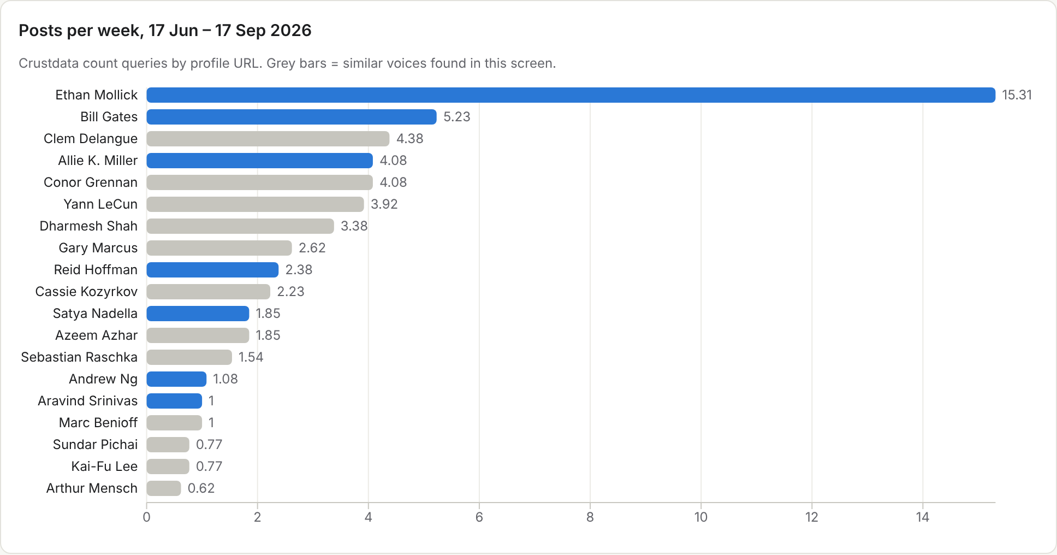
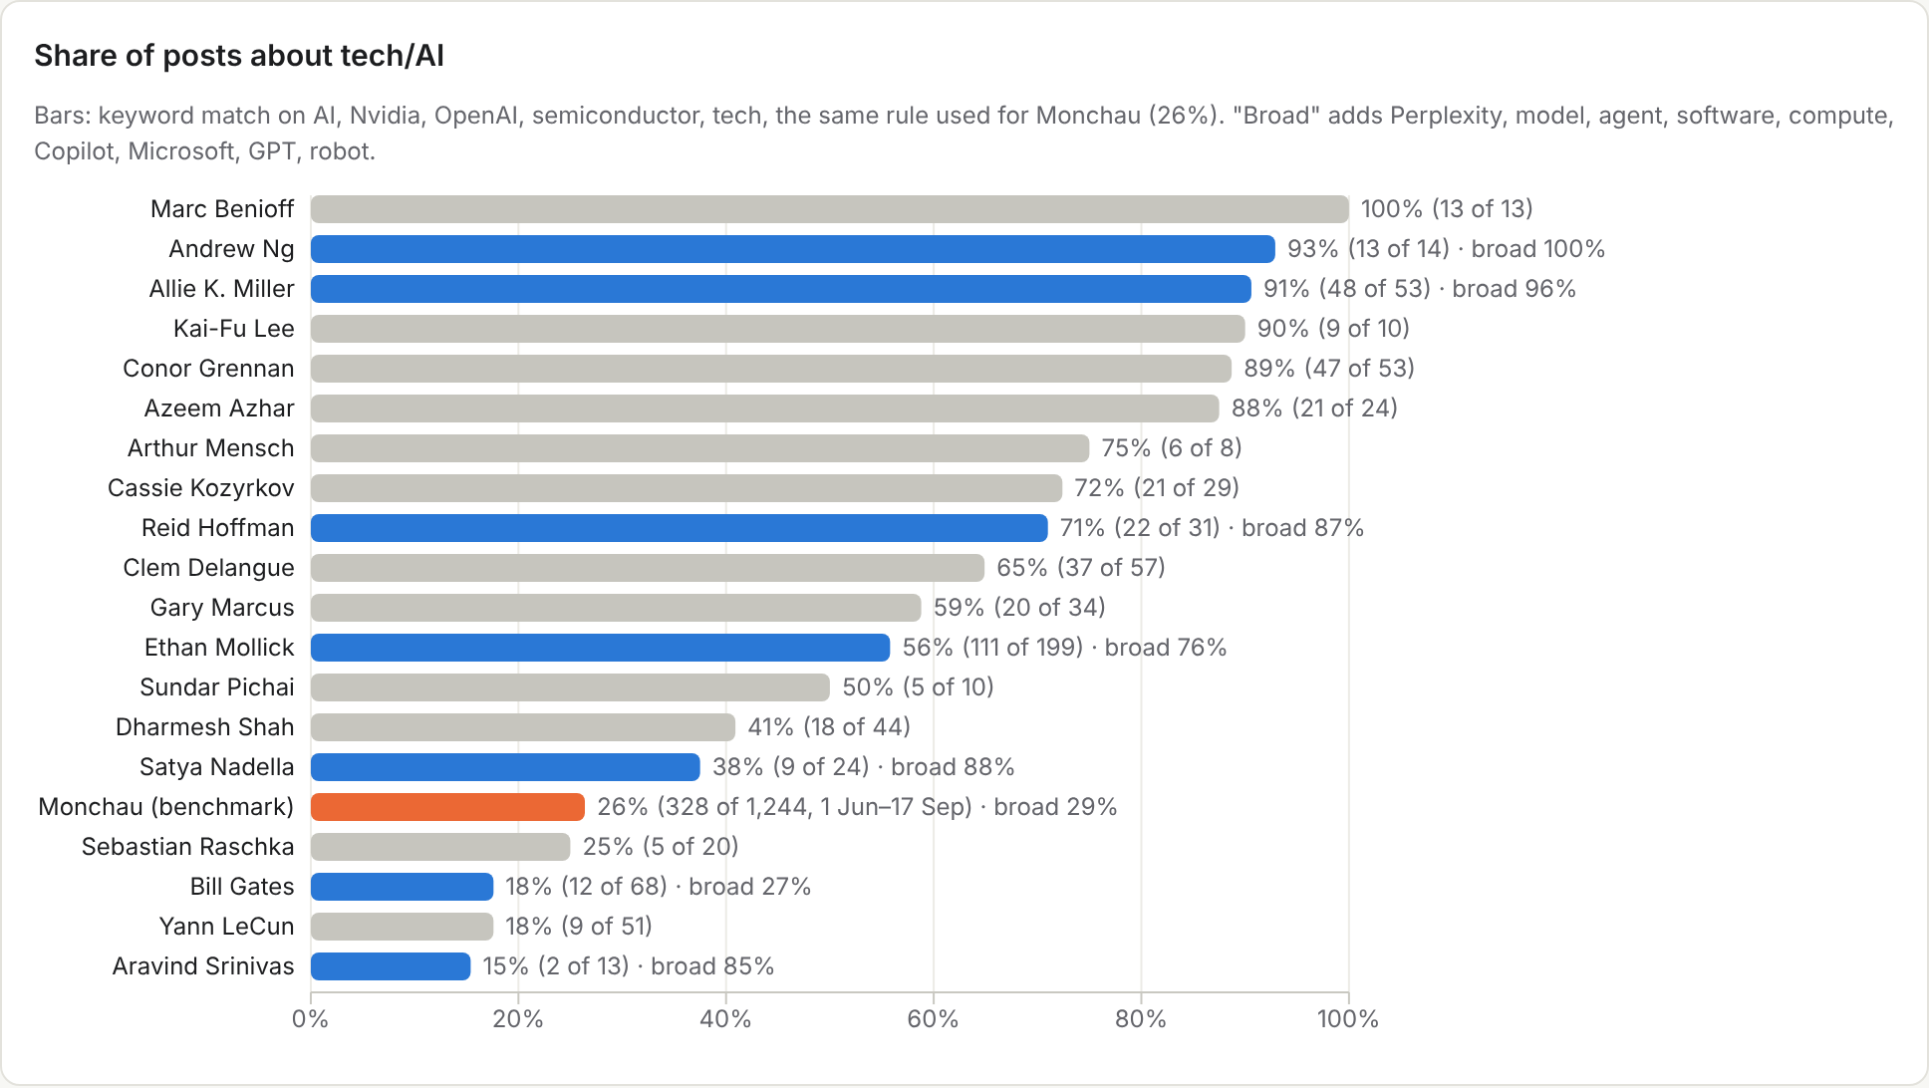
Voice | Profile | Posts 13 wk | Per week | Tech posts | Tech / week | Tech share | Tech share (broad) | Credits a source | Profile
Ethan Mollick | Original hands-on AI experimentation (Wharton) | 199 | 15.31 | 111 | 8.54 | 56% | 76% | 6% | Profile
Bill Gates | Broad-reach tech/AI essays | 68 | 5.23 | 12 | 0.92 | 18% | 27% | 4% | Profile
Allie K. Miller | LinkedIn-native AI creator (~2M followers), engagement-engineered | 53 | 4.08 | 48 | 3.69 | 91% | 96% | 11% | Profile
Reid Hoffman | AI investor-builder, long-form theses | 31 | 2.38 | 22 | 1.69 | 71% | 87% | 3% | Profile
Satya Nadella | Big-tech CEO (Microsoft), agenda-setting | 24 | 1.85 | 9 | 0.69 | 38% | 88% | 13% | Profile
Andrew Ng | Foundational AI educator, research to practice | 14 | 1.08 | 13 | 1.0 | 93% | 100% | 21% | Profile
Aravind Srinivas | Active AI founder voice (Perplexity) | 13 | 1.0 | 2 | 0.15 | 15% | 85% | 31% | Profile
Monchau benchmark, 1 Jun – 27 Oct 2026 (counts to the index end, 17 Sep): 1,244 posts, 80.6 a week, 328 tech (26%; 363 or 29% with the broad keywords; 39–41% with a wide tech net), 86% credit a source.

Do tech posts perform better than their other posts?
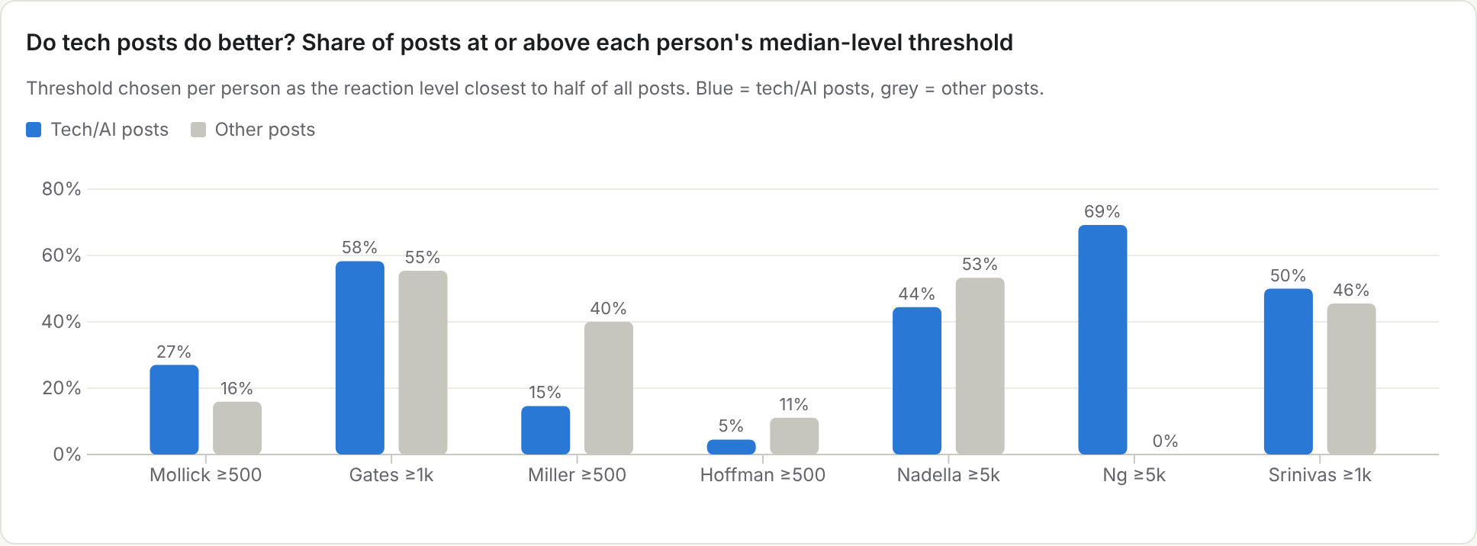
Voice | Threshold (reactions ≥) | All posts at/above | Tech posts at/above | Other posts at/above | Tech lift | Tech / other posts
Ethan Mollick | 500 | 22% | 27% | 16% | +70% | 111 / 88
Bill Gates | 1000 | 56% | 58% | 55% | +5% | 12 / 56
Allie K. Miller | 500 | 17% | 15% | 40% | -63% | 48 / 5
Reid Hoffman | 500 | 7% | 5% | 11% | -59% | 22 / 9
Satya Nadella | 5000 | 50% | 44% | 53% | -17% | 9 / 15
Andrew Ng | 5000 | 64% | 69% | 0% | n/a | 13 / 1
Aravind Srinivas | 1000 | 46% | 50% | 46% | +10% | 2 / 11
Lift = tech share divided by other share, minus one. With fewer than ~10 posts in a group the comparison is indicative only (Ng has 1 non-tech post; Srinivas 2 tech posts by the narrow rule).

Reaction thresholds, all posts vs tech posts
Voice | ≥500 (all / tech) | ≥1,000 (all / tech) | ≥2,500 (all / tech) | ≥5,000 (all / tech)
Ethan Mollick | 44 / 30 | 10 / 7 | 1 / 0 | 0 / 0
Bill Gates | 42 / 8 | 38 / 7 | 21 / 6 | 4 / 1
Allie K. Miller | 9 / 7 | 2 / 1 | 0 / 0 | 0 / 0
Reid Hoffman | 2 / 1 | 1 / 1 | 0 / 0 | 0 / 0
Satya Nadella | 23 / 8 | 20 / 7 | 18 / 6 | 12 / 4
Andrew Ng | 13 / 12 | 12 / 11 | 11 / 10 | 9 / 9
Aravind Srinivas | 11 / 2 | 6 / 1 | 3 / 1 | 0 / 0

Tech share by month and format mix
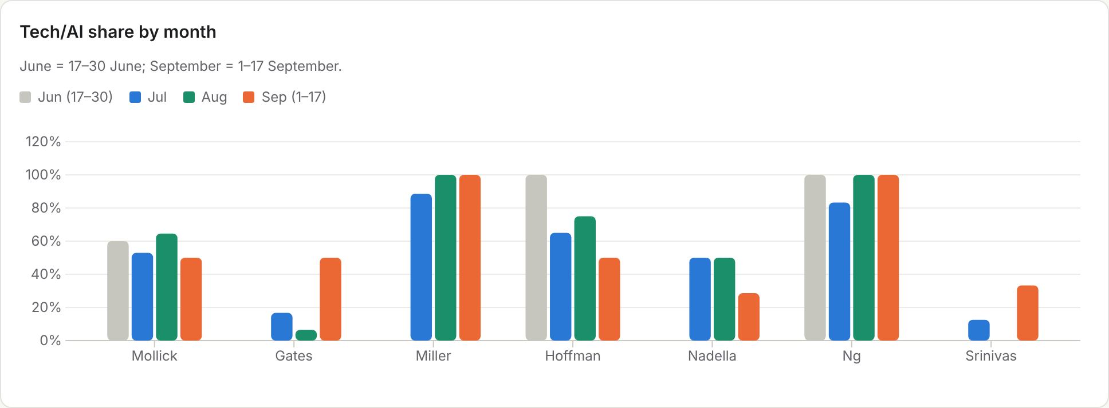
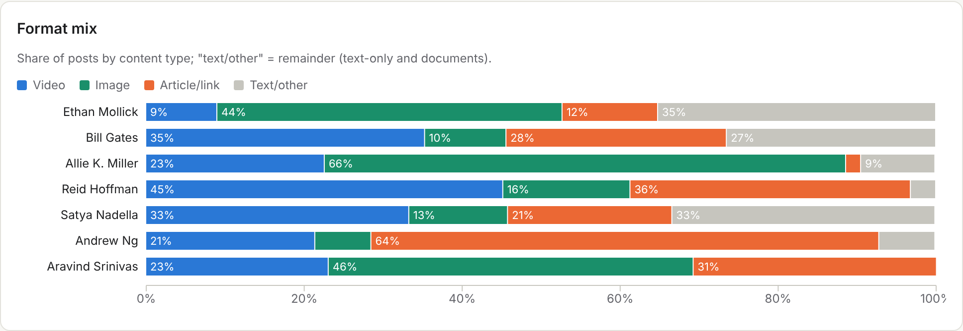

4. Voice by voice

Ethan Mollick: 15.31 posts a week, 56% tech (76% broad)
- By far the most frequent (15.3 a week, about 2 a day). 56% match the narrow keywords and 76% the broad set; the rest is research, education and work. Image-led (87 images): screenshots of his own tests of new models with a short verdict.
- Tech posts do better than his other posts: 27% of tech posts clear 500 reactions against 16% of other posts (+69% relative). Very few go viral (1 post above 2,500). He credits a source in only 6% of posts: he writes his own.
- For TMS: first-hand tests ("we ran our sentiment model on X, here is what it said") written in the first person.
Date | Format | Reactions | Comments | Shares | Post (opening) | Link
2026-06-04 | image | 3928 | 247 | 154 | I have a new book coming out October 20: Co-Existence! | Open post
2026-07-27 | image | 1365 | 130 | 10 | Kimi K3's weights were released... since I can't run it, I've been reading the weights... | Open post
2026-09-13 | text | 2159 | 238 | 137 | I cannot emphasize enough how much GPT-6 Astra and Fable 5.1 are already enough for transformative impact in large sections of the econom… | Open post

Bill Gates: 5.23 posts a week, 18% tech (27% broad)
- About five posts a week, but mostly not tech: 18% by narrow keyword and 26% broad. Most posts are global health, philanthropy and personal stories with field-trip videos (24 videos) and links to his Gates Notes essays (19 articles).
- Reach is broad and steady (56% of posts clear 1,000 reactions); his top post in the window was a birthday note to Warren Buffett (42,692 reactions). Tech posts perform about the same as his other posts (58% vs 55% above 1,000).
- For TMS: warmth and people stories travel; tech is not required for reach.
Date | Format | Reactions | Comments | Shares | Post (opening) | Link
2026-07-24 | video | 5859 | 457 | 525 | I had the most incredible week in Rwanda... | Open post
2026-08-20 | video | 10920 | 489 | 518 | It's the smallest country in South America with some big news: Suriname is officially malaria-free. | Open post
2026-08-30 | image | 42692 | 2227 | 736 | Happy birthday, Warren Buffett! Warren turns 96 this month... | Open post

Allie K. Miller: 4.08 posts a week, 91% tech (96% broad)
- Almost everything she posts is AI (91% by keyword). Format is the engagement engine: two thirds images (carousels and annotated screenshots), numbered "what every professional should know" lists and early-access model reviews, plus a weekend "AI homework" video series.
- Engagement is steady rather than spiky: 17% of posts clear 500 reactions and none cleared 2,500 in the window, despite ~2M followers. Comments are high relative to reactions (her samples draw 145–307 comments), which is what the format is built for.
- For TMS: the repeatable weekly slot and the numbered "what this means for you" structure.
Date | Format | Reactions | Comments | Shares | Post (opening) | Link
2026-06-15 | video | 2362 | 233 | 105 | If your barrier to building an app was code, that barrier is basically gone. I'm going to tell you how to get a live app online by descri… | Open post
2026-07-04 | video | 982 | 145 | 47 | This is your AI homework for the weekend... | Open post
2026-09-03 | image | 1365 | 307 | 44 | OpenAI just released a new model called Astra today. I had early access so let me tell you what I want EVERY business professional to kno… | Open post

Reid Hoffman: 2.38 posts a week, 71% tech (87% broad)
- About 2.4 posts a week, 71% tech by keyword (87% broad). Mostly 60–90 second clips from his podcasts and interviews (14 videos) and links to long-form essays (11 articles).
- Lowest engagement per post in the group: only 2 of 31 posts cleared 500 reactions. Clip-heavy posting builds volume but not reach on LinkedIn.
- For TMS: cutting BFM appearances into clips works only if each clip carries one sharp claim in the text.
Date | Format | Reactions | Comments | Shares | Post (opening) | Link
2026-06-24 | video | 2297 | 398 | 321 | Satya Nadella described a future at Microsoft where there may be more than 20 million agents working alongside employees... | Open post
2026-08-23 | video | 745 | 124 | 59 | I asked Satya Nadella for a book recommendation... | Open post
2026-09-09 | article | 444 | 135 | 30 | Open-source tools can now turn a single image into a live face swap on consumer hardware... | Open post

Satya Nadella: 1.85 posts a week, 38% tech (88% broad)
- About two posts a week. Only 38% match the narrow tech keywords, but 88% match the broad set (Microsoft, Copilot, agents, compute): he writes about AI through Microsoft's products and results.
- Half of his posts clear 5,000 reactions. His best are results-day and milestone posts in his own words with 3–4 hard numbers (earnings, first Vera Rubin deliveries) and a stance on superintelligence and human control.
- For TMS: results and milestones written by the CEO, numbers first, one clear principle.
Date | Format | Reactions | Comments | Shares | Post (opening) | Link
2026-07-29 | text | 11281 | 473 | 539 | Just wrapped our earnings call. It was a very strong close to what was a record fiscal year for Microsoft... | Open post
2026-08-21 | image | 18107 | 642 | 643 | Delivery day at our Microsoft DCs as the first production Vera Rubins arrive. | Open post
2026-09-13 | text | 11966 | 920 | 879 | Any pursuit of superintelligence has to be grounded in the core principle that if the AI we build is not helping humanity and under human… | Open post

Andrew Ng: 1.08 posts a week, 93% tech (100% broad)
- Posts about once a week and nearly always about AI (13 of 14). Every post is an artifact: a new course, an open-source agent, a skills map, a company launch, usually as a link/article card.
- The most reliable reach in the group: 9 of 14 posts cleared 5,000 reactions; samples drew 10,000–14,000. Low volume plus high usefulness beats frequency.
- For TMS: fewer, more useful posts (a sentiment map, a framework) that people save and share.
Date | Format | Reactions | Comments | Shares | Post (opening) | Link
2026-07-23 | video | 11049 | 501 | 925 | Announcing OpenWorker! An open-source agent that doesn't just chat with you, but delivers finished work... | Open post
2026-07-28 | article | 10424 | 508 | 388 | Fifteen years ago, Coursera and online courses changed education... I'm starting LearnVector... | Open post
2026-08-14 | article | 14177 | 427 | 1189 | New: A map of the most important skills in AI Engineering. | Open post

Aravind Srinivas: 1.0 posts a week, 15% tech (85% broad)
- About once a week. The narrow keyword rule badly undercounts him (2 of 13); the broad set finds 11 of 13, because he writes about Perplexity products, agents and compute rather than "AI" as a word.
- Strong reach for a low cadence: 46% of posts clear 1,000 reactions. Posts are builder proof: what was shipped and its measurable impact in two sentences, often with a demo video.
- For TMS: show the machine working, with one number.
Date | Format | Reactions | Comments | Shares | Post (opening) | Link
2026-06-18 | video | 2603 | 123 | 83 | We're rolling out Brain: a self-improving context-graph of all your sessions, connectors, and files. | Open post
2026-09-01 | video | 2530 | 176 | 100 | We're introducing hybrid compute for all users of the Perplexity Mac app... | Open post
2026-09-15 | image | 2935 | 143 | 63 | We built a replacement for AWS DynamoDB... two engineers and hundreds of persistent Perplexity Computer agents over two months... | Open post

5. Similar voices
Voices with a comparable profile to one of the seven, confirmed active on LinkedIn (at least 5 posts in the window) and measured the same way. Profile URLs were verified by web search before counting.
Voice | Role | Similar to | Why similar | Posts / week | Tech share | Posts ≥1,000 reactions | Sample | Profile
Clem Delangue | Co-founder & CEO, Hugging Face | Aravind Srinivas | Highly active AI founder voice: open-source AI advocacy, launches and the NVIDIA deal; near-daily posting with strong engagement | 4.38 | 65% | 13 of 57 | Open post | Profile
Conor Grennan | CEO AI Mindset; former Chief AI Architect, NYU Stern | Allie K. Miller | LinkedIn-native AI adoption creator: daily practical AI-habit posts, courses and newsletter; high cadence but low per-post reach | 4.08 | 89% | 0 of 53 | Open post | Profile
Yann LeCun | Executive Chairman, AMI (Advanced Machine Intelligence); NYU professor; ex-Meta Chief AI Scientist | Andrew Ng | Foundational AI researcher (Turing Award) who posts frequently on LinkedIn about world models and AI research direction; contrarian takes (posts often say LLM / world models rather than AI) | 3.92 | 18% | 16 of 51 | Open post | Profile
Dharmesh Shah | Co-founder & CTO, HubSpot (agent.ai) | Allie K. Miller | ~1.1M-follower LinkedIn-native founder-creator; hook-driven posts on AI agents and product; spiky engagement | 3.38 | 41% | 4 of 44 | Open post | Profile
Gary Marcus | Cognitive scientist, NYU professor emeritus, author (Rebooting AI) | Ethan Mollick | Academic AI commentator posting frequent, opinionated analysis of LLM capabilities (skeptic counterpoint to Mollick); mostly Substack links | 2.62 | 59% | 0 of 34 | Open post | Profile
Cassie Kozyrkov | CEO; Google's first Chief Decision Scientist; AI advisor | Ethan Mollick | Practitioner-academic explainer of how to think and decide with AI; original framing posts rather than news | 2.23 | 72% | 0 of 29 | Open post | Profile
Azeem Azhar | Founder, Exponential View | Reid Hoffman | Investor-analyst voice: long-form theses on the AI economy, newsletter excerpts and podcast or video clips; steady cadence, modest reactions | 1.85 | 88% | 0 of 24 | Open post | Profile
Sebastian Raschka | ML/AI research engineer; author, Build a Large Language Model From Scratch | Andrew Ng | Research-to-practice AI educator: LLM tutorials, paper explainers, code; very high engagement per post (posts say LLM more than AI, so tech filter undercounts) | 1.54 | 25% | 16 of 20 | Open post | Profile
Marc Benioff | Chair & CEO, Salesforce | Satya Nadella | Enterprise-tech CEO framing the agentic-AI agenda (Agentforce, Dreamforce); 100% tech/AI posts with high reach | 1.0 | 100% | 9 of 13 | Open post | Profile
Sundar Pichai | CEO, Google and Alphabet | Satya Nadella | Big-tech CEO, agenda-setting product and AI announcements (Gemini, Pixel); few posts but every post gets very large reach | 0.77 | 50% | 9 of 10 | Open post | Profile
Kai-Fu Lee | CEO, 01.AI; Chairman, Sinovation Ventures; author (AI Superpowers, AI 2041) | Bill Gates | Elder-statesman tech author with broad essays on AI's societal and business impact and book promotion | 0.77 | 90% | 0 of 10 | Open post | Profile
Arthur Mensch | Co-founder & CEO, Mistral AI | Aravind Srinivas | AI-lab founder-CEO voice (Mistral funding, model launches, European AI sovereignty); infrequent but high-reach posts | 0.62 | 75% | 6 of 8 | Open post | Profile

- Same pattern as the seven: the CEOs post rarely and reach widely (Pichai 10 posts, 6 above 5,000 reactions; Benioff 13, all on AI; Mensch 8, 5 above 2,500), while the creators and commentators post 3–4 times a week with modest reach (Conor Grennan 53 posts, 1 above 500; Gary Marcus 34, 1 above 500).
- Most active founder voice: Clem Delangue (Hugging Face) posts 4.4 times a week and is the only high-frequency voice with steady reach (23 of 57 posts above 500 reactions).
- Researchers: Yann LeCun (3.9 a week) and Sebastian Raschka (1.5 a week) are undercounted by the keyword rule because they write "LLM" and "world models" rather than "AI"; Raschka still has 16 of 20 posts above 1,000 reactions.
- Checked but not kept (fewer than 5 posts or unverifiable): Vinod Khosla, Greg Brockman, Arvind Krishna, Rowan Cheung, Zain Kahn, Aidan Gomez, Fei-Fei Li (5 posts each for the last three), Mustafa Suleyman (profile not found). Jensen Huang is active (9 posts) but was not measured further.

6. What Taranis can take from them
- Pick an archetype, not a frequency. The two models that fit a fund are Nadella (CEO, results and milestones with hard numbers, ~2 a week) and Ng (one genuinely useful artifact a week). Mollick's daily cadence only works because each post is a first-hand test.
- Make tech the core but not the only lane. Tech posts beat other posts clearly only for Mollick; for Gates people stories perform as well. A 70/30 tech-to-other mix (Hoffman-like) keeps the AI-disruption focus while leaving room for team, clients and markets.
- Write it yourself. Six of the seven credit a source in 11% or fewer of posts (Srinivas 4 of 13, on a small base). Original, first-person posts are the norm among the most followed AI voices; curation is Monchau's niche, not theirs.
- Show the machine. Srinivas and Mollick get reach by showing what a tool did, with one number. The TMS equivalent: "what our sentiment model flagged this week" with one chart.
- Use a repeatable slot. Miller's weekend "AI homework" and numbered model reviews show a recurring format builds comments, which LinkedIn rewards.

Appendix. Count data
All counts behind this report. Files: data/ai_voices_counts.csv, ai_voices_formats_credits.csv, ai_voices_tech_broad.csv, ai_voices_similar.csv, plus the derived ai_voices_summary.csv.
Voice | total 13w | tech 13w | tech broad 13w | credited 13w | jun total | jun tech | jul total | jul tech | aug total | aug tech | sep total | sep tech
Ethan Mollick | 199 | 111 | 151 | 12 | 15 | 9 | 104 | 55 | 48 | 31 | 32 | 16
Bill Gates | 68 | 12 | 18 | 3 | 1 | 0 | 24 | 4 | 31 | 2 | 12 | 6
Allie K. Miller | 53 | 48 | 51 | 6 | 1 | 0 | 35 | 31 | 14 | 14 | 3 | 3
Reid Hoffman | 31 | 22 | 27 | 1 | 5 | 5 | 20 | 13 | 4 | 3 | 2 | 1
Satya Nadella | 24 | 9 | 21 | 3 | 3 | 0 | 10 | 5 | 4 | 2 | 7 | 2
Andrew Ng | 14 | 13 | 14 | 3 | 1 | 1 | 6 | 5 | 4 | 4 | 3 | 3
Aravind Srinivas | 13 | 2 | 11 | 4 | 0 | 0 | 8 | 1 | 2 | 0 | 3 | 1

