Taranis SA · Geneva · 27 October 2026
TMS LinkedIn Competitive Review
Taranis Market Sentiment against Swiss and international peers: product pages, LinkedIn activity, the Monchau benchmark and an operating plan
Prepared for: Taranis SA (Julien Leegenhoek, CEO; marketing and investor relations)
Data window: LinkedIn 17 Jun – 17 Sep 2026 (13 weeks); product pages read 26–27 Oct 2026
Interactive dashboard: dashboard.html (self-contained, in the same folder)
Raw data: data/posts_raw_all.csv and the other CSVs in data/
Disambiguation: "Taranis" here is Taranis SA, Geneva (FINMA-authorised asset manager, linkedin.com/company/taranis-sa). Not Perenco's Taranis energy assets and not the DFSA-registered Taranis Capital.

1. Executive summary
- TMS discloses the least of any peer. Behind its professional-investor gate the TMS page shows three paragraphs and an award line: no performance, ISIN, fees, AUM, documents or team, and it does not state the two sleeves (2016 systematic sentiment engine, Dec 2025 discretionary tech/AI-disruption sleeve). Schroders (Contour) and UBP (Shannon River) show full performance behind the same kind of Swiss qualified-investor gate; AtonRâ, BIT and DECALIA's factsheet show it openly. Source: taranis.net/investment/tms.
- Taranis posts least among active peers. The company page posted 2 times in 13 weeks (0.15/week); DECALIA, the Swiss boutique bar, posted 30 (2.31/week); Pictet AM 89 (6.85/week, corporate-heavy). Contour, Jericho and Shannon River post nothing, confirmed by live web search, so the international TMT long/short channel is empty.
- People carry reach, not company pages. Symbit's page got 0 reactions on news its co-founder's reshare turned into 108; DECALIA's page best is 63 while its CIO's own post reached 153; Julien Leegenhoek's own posts get 48–64 while the Taranis page's reshares of them get 14.
- Monchau is a curation engine to learn from, not copy. About 81 posts a week, 86% credited to an outside "Source". His own-view and Syz-branded posts clear 54 reactions 5% of the time against 59% for curated posts. His most transferable asset is the single-chart post with a short read-through.
- The Swiss tech-AI thesis lane is open. AtonRâ writes the strongest original tech theses but gets 0–10 reactions per post; Pictet's Robotics and Digital PMs post nothing; only 13% of DECALIA's posts are about tech. A named founder with TV airtime can own the lane.

2. Scope, sources and method
- Competitor set: verified Swiss peers (AtonRâ Partners, DECALIA, Pictet AM), international structural twins and category peers (Symbit Capital, BIT Capital, Shannon River, Schroder GAIA Contour Tech Equity, Jericho Capital, Wellington Disruptive Technology & Innovation), plus a scan of Vontobel, GAM, Bellevue and Mirabaud.
- LinkedIn: Crustdata /social_post/search. Cadence from free limit=0 count queries (actor id + actor type + date window 17 Jun – 17 Sep 2026); engagement and text from small paid pulls of top posts (about 47 credits across three rounds). Every query is logged in the companion CSVs.
- Product pages: read with TinyFish (fetch and browser runs through Swiss qualified/professional-investor gates) and plain fetches on 26–27 Oct 2026; facts not on a page were taken from public factsheets or FT and are labelled as such.
- Dates: every post's true date is decoded from its LinkedIn activity ID (id >> 22 = milliseconds since epoch), because the index's own dates are imputed for older posts and can drift by up to four weeks even in 2026.

Caveats
- The Crustdata index ends around 17 Sep 2026 (only 471 posts platform-wide are dated after 18 Sep). LinkedIn's login wall blocked a live refresh with TinyFish, so posts after mid-September are not counted.
- AtonRâ shows 0 posts in the window, but this is an index gap: Crustdata entity 985778 is the right page, a live company post dated 30 Sep 2026 exists (post), and atonra.ch published nine dated research notes between 2 Jul and 29 Sep 2026 (research hub). Its 2025 same-window rate (15 posts, 1.15/week) is used as the estimate.
- Contour, Jericho and Shannon River read 0, and live web searches on 27 Oct found no posts of their own (only employee profiles and third-party press posts), so they are genuinely quiet rather than under-indexed.
- Pictet and DECALIA counts include corporate content (results, hires, interns, events). Topic shares are keyword matches; themes overlap and chart-only posts are missed.
- The index's "repost" label reflects how a post was crawled, not curation; curation is measured from "Source" credits in the text.
- Post images are linked, not embedded. Follower counts are mostly unavailable (Taranis 1,976 from the index; Monchau's 290,000+ is from a search snippet and unverified).
- Items from the brief that could not be reproduced are labelled where they appear: Monchau's Sep 1–16 hand-coded topic counts and format medians are shown as reference values; the "Anthropic conspiracy theories" post was not found (the index match was a Fort Knox post); the JPM "AI borrowers" post shows 1 share in the index, so "most-shared" is not borne out.
- Founding year: the brief says 2021; Crustdata lists 2020 and Julien Leegenhoek's Sep 2024 post refers to "founding Taranis four years ago" (post). Not resolved.

3. Competitor set
Swiss peers lead, then international funds. Wellington's disruptive-tech long/short launched in March 2020, last reported USD 10.6m (March 2021) and is no longer listed on wellington.com, so it appears closed and is kept only as a category reference.
Group | Fund | Manager | HQ | AUM | As of | Strategy | Why close to TMS | Status | LinkedIn | Source
Swiss | AtonRâ AI & Robotics AMC (+ 11 theme certificates, UCITS umbrella) | AtonRâ Partners | Geneva | Not disclosed per product |  | Conviction thematic tech/health/energy; research since 2004, proprietary indexes since 2014; AI/quant platform Fundy | Closest Swiss match on tech theme and hybrid method; long-only | Active (live post 30 Sep 2026; index gap since 30 Apr) | LinkedIn | atonra.ch
Swiss | DECALIA SICAV - Future SOCIETY | DECALIA SA | Geneva | EUR 139m | 2026-05-31 | Long-only multi-thematic growth (~52% IT, ~35% AI infrastructure); mid-cap/healthcare barbell | Most active Swiss boutique on LinkedIn; tech-tilted fund | Active | LinkedIn | funds-static.pictet.com
Swiss | Pictet - Robotics / Digital; Pictet TR - Atlas Titan | Pictet Asset Management | Geneva | Robotics EUR 13.0bn; Atlas Titan EUR 688m | 2026-10-26 | Thematic tech equities (discretionary); Atlas Titan discretionary global L/S | Incumbent; scale benchmark; Atlas Titan is the L/S analogue | Active | LinkedIn | am.pictet.com
International | Symbit Global Equity L/S | Symbit Capital | Zug | Not disclosed | launched Jul 2026 | AI-native: fundamental discretionary + proprietary AI (incl. investor sentiment); market-neutral, ~200% gross | Closest structural twin to TMS's hybrid model; generalist | Active (new) | LinkedIn | hedgeweek.com
International | BIT Global Technology Opportunities | BIT Capital | Berlin | Fund ~EUR 685-690m; firm EUR 3.0bn | Oct 2026 (aggregators, no as-of date) | Concentrated global tech / AI infra; data-driven; >75% of trades influenced by systematic signals; can short via CFDs/swaps | Same 'human x AI' hybrid; net-long bias; retail-heavy brand | Active | LinkedIn | bitcap.com
International | U Access (IRL) Shannon River UCITS | Shannon River Fund Management | New York (UBP Geneva platform) | USD 21.4m UCITS (may be share class); firm ~USD 905m | 2026-10-22 | Mid-cap tech L/S; ~half of longs second-order AI beneficiaries; net 20-50% | Sold through a Geneva private bank to the same Swiss buyers | Active fund; silent on LinkedIn | LinkedIn | ubp.com
International | Schroder GAIA Contour Tech Equity | Contour Asset Management | New York | USD 860.9m | 2026-10-22 | TMT long/short; top-down + bottom-up; discretionary; SOFR+ target | Same shelf: tech L/S UCITS sold to Swiss/EU professionals | Active fund; silent on LinkedIn | LinkedIn | finanzen.ch
International | Jericho Capital (flagship + Special Opportunities) | Jericho Capital Asset Management | Los Angeles / New York | ~USD 10.1bn (third-party est. from ADV) | 2026 | Global TMT long/short, concentrated, discretionary | Leading pure-TMT L/S; aspirational benchmark | Active fund; silent on LinkedIn (press-only) | LinkedIn | quiverquant.com
International | Wellington Disruptive Technology & Innovation | Wellington Management | Boston | USD 10.6m (last data) | Mar 2021 | Global disruptive-tech long/short (bottom-up) | Category peer only | Appears closed: launched 27 Mar 2020, no current data, absent from wellington.com | LinkedIn | investmentweek.co.uk
Taranis | Taranis Market Sentiment (TMS) | Taranis SA | Geneva | Not shown |  | Tech L/S: 2016 systematic sentiment engine + Dec 2025 discretionary tech/AI-disruption sleeve (~50/50) | Subject | Active | LinkedIn | taranis.net
Crustdata company IDs: AtonRâ 985778, DECALIA 999635, Pictet AM 6035837, Symbit 74483772, BIT Capital 1120813, Shannon River 12895966, Contour 6803658, Jericho 1348019, Wellington 905379, Taranis 7865447.

Wider Swiss scan
Only AtonRâ and Pictet run dedicated tech or AI products in Switzerland. Vontobel offers a multi-theme Megatrends fund; GAM runs the long-only Star Disruptive Growth; Bellevue is healthcare only; Mirabaud has no tech fund.
Firm | Nearest fund | Strategy | Performance | LinkedIn / week | Page
Vontobel | Vontobel Fund II - Megatrends (multi-theme) | No dedicated tech/AI fund; multi-thematic megatrends | Public factsheets | 4.23 | am.vontobel.com
GAM | GAM Star Disruptive Growth | Long-only global growth around disruption, 40-60 stocks | Not on featured page | 3.15 | gam.com
Bellevue | No tech fund (healthcare: Digital Health, AI Health) | Healthcare specialist | Full | 0.92 | bellevue.ch
Mirabaud | No tech/disruptive fund | European SMID and quality global equities | n/a (qualified gate) | 4.85 | mirabaud-am.com

4. Deliverable A: product-page teardown
The key contrast: TMS sits behind a three-step gate (country, professional/retail, "I Accept") that is in line with Schroders and UBP, but behind it the page shows no performance, fund facts or team and does not state its two sleeves. Schroders shows Contour's discrete annual returns, a 5-year figure, a monthly factsheet, the KID and prospectus behind its Swiss qualified-investor gate; UBP shows Shannon River's NAV and returns from MTD to inception plus the full document library behind its own. The gate is not the problem; what sits behind it is.

Comparison, part 1: Swiss peers and Taranis
Attribute | AtonRâ | DECALIA | Pictet AM | Taranis TMS
Structure | Theme page: description, monthly performance grid, statistics, holdings, risks; sidebar with price, ISIN, factsheet, KIID | Strategy themes on corporate site; fund pages on separate gated SICAV site | Standard microsite per share class: key info, objective, process, performance, risk, portfolio, literature | One heading, three paragraphs, award line, disclaimer
Navigation / languages | 2-3 clicks, no gate; English seen | 3+ clicks plus gate; EN/FR/DE/IT | 3+ clicks, audience in URL; EN/FR/DE/IT | 2 clicks plus gate; English only
Fund facts shown | ISIN, inception, ccy, price; fees in factsheet | In public factsheet (ISIN, inception, fees via FT) | NAV, size, inception, SFDR, SRI, benchmark | None (no ISIN, vehicle, fees, AUM)
Performance disclosure | Full (YTD on page; monthly 2019-2026 in factsheet) | Full (public factsheet) | Full on page vs benchmark | None (award line only)
Documents | Factsheet, KIID | Factsheet public; KID/prospectus gated | Factsheet, KID, prospectus, reports, SFDR | None
Team visibility | Team page with LinkedIn links | PMs in factsheet and press | PM names in docs; none on LinkedIn | None on fund page
Strategy in own words | AI pure players across semiconductors, data, software, robotics | Multi-thematic, innovative sectors and disruptive companies | Active, high-conviction stock picking | Fundamental picks with a quantitative overlay on risk appetite
Differentiators claimed | Research since 2004; 1,300-sub-sector taxonomy; Fundy AI/quant platform | Multi-thematic, ESG, mid-cap bias, barbell | Scale, 30-year thematic franchise, ESG | Behavioural sentiment algorithm + fundamentals; long/short
Systematic vs discretionary | Hybrid | Discretionary | Discretionary (Atlas adds quant indicators) | Hybrid (~50/50 sleeves, not stated on page)
Target audience / tone | Broad; marketing-heavy | Private + institutional; factual | Segmented; regulatory | Qualified/professional CH/UK; short, low information
Investor gate | None | Investor category + country | Profile selector in URL | Country, then professional/retail, then I Accept
Primary CTAs | Factsheet, KIID, contact, WhatsApp | Discover funds, newsletter | Download factsheet / NAV / literature | Contact only
Primary source | atonra.ch | decalia.com | am.pictet.com | taranis.net

Comparison, part 2: international funds and Taranis
Attribute | Symbit | BIT Capital | Shannon River (UBP) | Contour (Schroders) | Jericho | Taranis TMS
Structure | Firm one-pager: vision, origin story, team cards; no fund page | Hero, strategy, NAV tiles, share-class tabs (performance, risk, fund details), documents, factsheet subscribe, contact | UBP data page: Performance / Library / Key information tabs; manager has no own site | Schroders tabs (overview, risk, performance, allocation, facts, documents) + 1-page contourasset.com | Holding page: addresses and founder bio | One heading, three paragraphs, award line, disclaimer
Navigation / languages | 1 page; English | 2 clicks, no hard gate; EN/DE | Gate then tabs; EN/FR/DE | Gate then tabs (Schroders); EN | 1 page; English | 2 clicks plus gate; English only
Fund facts shown | None | ISIN, WKN, PMs, terms, allocations | NAV, AUM, ISIN, fees, min, dealing | ISIN, inception, OCF, perf fee | None | None (no ISIN, vehicle, fees, AUM)
Performance disclosure | None | Full, public (NAV, charts, rolling 12m) | Full after gate (MTD to ITD) | Full after gate (annual, 5y, factsheet) | None | None (award line only)
Documents | None | KID, factsheet subscription; reports for UCITS | KID, prospectus, annual/semi-annual reports | Monthly factsheet, KID, prospectus, annual report | None | None
Team visibility | High: 4 founders with LinkedIn links | Named PMs, team page, Chief AI Officer | None on page | PM only (Schroders); ~15 bios (Contour site) | Founder bio | None on fund page
Strategy in own words | Human experience and machine intelligence, working together | Institutional core vehicle of a global technology strategy | No strategy text on page | Exploit rapidly evolving trends within TMT | Investing in global TMT | Fundamental picks with a quantitative overlay on risk appetite
Differentiators claimed | Ex-NBIM PMs; AI-native platform | >30,000 data signals/day; >75% of trades signal-influenced; human final say | Mid-cap inflection points; AI second-order | Alpha not beta; fastest pace of change since the 1990s | Concentration; track record (press) | Behavioural sentiment algorithm + fundamentals; long/short
Systematic vs discretionary | Hybrid (AI + discretionary) | Hybrid (signals + human) | Discretionary | Discretionary | Discretionary | Hybrid (~50/50 sleeves, not stated on page)
Target audience / tone | Allocators; brand-led | Professional (AIF) but retail brand; marketing with data | Professional; data-only | Qualified investors; legal (Schroders) / thesis (Contour) | Allocators via press | Qualified/professional CH/UK; short, low information
Investor gate | None (no fund info) | None (marketing banner) | Not-US + country + profile + legal | Swiss qualified-investor 'I agree' | None | Country, then professional/retail, then I Accept
Primary CTAs | LinkedIn links | Invest now (brokers), factsheet, podcast | Login, newsletter | Watchlist, download; 'Get in touch' | Email, phone | Contact only
Primary source | symbit.com | bitcap.com | ubp.com | contourasset.com | jerichocap.com | taranis.net
Wellington DTI is omitted from part 2 because no current fund page exists. Full per-cell sources: step2_product_pages_research.md and swiss_A_product_pages_research.md in the report folders.

Positioning summaries
AtonRâ Partners. Sells thematic tech as 12+ single-theme certificates plus a UCITS umbrella, backed by research since 2004, a 1,300-sub-sector taxonomy and the Fundy AI/quant platform. Ungated pages show price, YTD and ISIN; the factsheet has monthly returns and fees. Closest Swiss peer on tech theme and hybrid method, but long-only and broad in tone. atonra.ch
DECALIA. A EUR 139m long-only multi-thematic growth UCITS now ~52% IT and ~35% AI infrastructure. Markets through PM interviews and multilingual corporate pages; the fund site is gated but full-performance factsheets are public. Tech is real exposure but not the brand. funds-static.pictet.com
Pictet Asset Management. The scale benchmark: Robotics EUR 13bn, Digital USD 4.3bn, each with a standardised data-dense page and full document library. Regulatory tone, no personal voices. TR-Atlas Titan (EUR 688m) is its discretionary L/S, not tech-specific. am.pictet.com
Symbit Capital. A Zug startup (Jul 2026) running an AI-native market-neutral L/S built by ex-NBIM PMs. Brand-led one-pager that leads with founders and a 'human + machine' philosophy, with no fund data. The closest structural twin to TMS, without a track record. symbit.com
BIT Capital. Turns its data/AI edge into numbers (signals per day, petabytes, % of trades influenced) with a human-in-the-loop line, and publishes NAV, charts and factsheets openly. Strongest storytelling of the hybrid model; retail-heavy brand and net-long bias. bitcap.com
Shannon River. A mid-cap tech L/S distributed as a UCITS on UBP's Geneva platform. The platform page is data-only (full performance after the gate); the manager has no website of its own and does not post. ubp.com
Contour (Schroder GAIA). A USD 861m TMT L/S UCITS on the Schroder GAIA platform. Schroders publishes full returns and documents behind a Swiss qualified gate; Contour's own one-pager gives the thesis and ~15 team bios. Purely discretionary; silent on LinkedIn. contourasset.com
Jericho Capital. The leading US TMT L/S (~USD 10bn) with a bare holding website. Markets through allocator relationships and press (Institutional Investor), not its own channels. jerichocap.com
Wellington DTI. Launched in 2020 as a disruptive-tech L/S UCITS; last data USD 10.6m (Mar 2021) and no longer listed on wellington.com, so it appears closed. Kept only as a category reference. investmentweek.co.uk
Taranis TMS. The only tech L/S with a behavioural-sentiment quant overlay in the set, but the gated page shows no ISIN, fees, AUM, performance, documents or team and does not state its two sleeves. Its only proof point is a 2023 'Managed Futures' award. Peers behind the same kind of Swiss gate (Schroders, UBP) show full performance. taranis.net

5. Deliverable B: LinkedIn activity
Posts per week for every account in the 13-week window. The axis is capped at 16 posts a week; Monchau's bar is cut and labelled with his real rate.
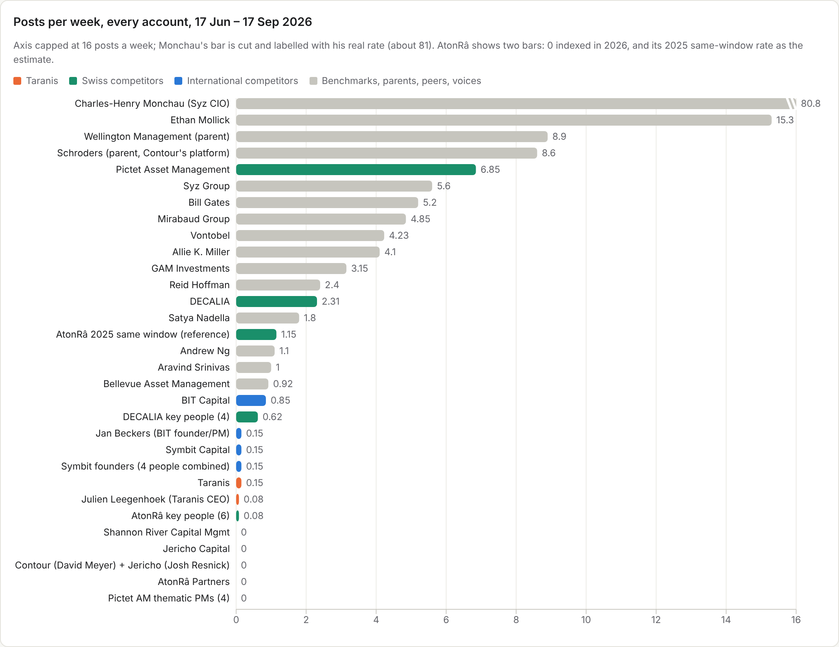
Source: Crustdata /social_post/search count queries, 17 Jun – 17 Sep 2026 (cadence_all.csv).

Channel, cadence, format and best post by competitor
Competitor | Channel | Posts / week | Dominant format | Original vs curated | Median reactions | Best post | Link | What Taranis can learn / where the gap is
AtonRâ Partners | Company page + staff (BD lead) | ~1.15 est. (0 indexed) | Image + long-form thesis | Original (13 of 15 2026 posts); own research links; 0 'Source' | ~6 | 10 | Open post | Owns the original tech-thesis format but gets 0-10 reactions under a brand page and puts YTD numbers in posts. Gap: the same theses from a named founder, compliant.
DECALIA | Company page + CIO Fabrizio Quirighetti | 2.31 | Mixed: document 9, image 7, article 7, video 6 | 73% original; 0 'Source' | ~14 | 63 | Open post | Sets the Swiss boutique bar (~2/week, FR/EN, people and events). The CIO outdraws the page (153 vs 63). Gap: only 13% tech/AI.
Pictet Asset Management | Company page; thematic PMs silent | 6.85 | Image 47, video 24 of 89 | 76% original; 1 'Source' | ~25 | 147 | Open post | Production quality and a risk warning on product posts; AI ETF launch did well (141). Gap: no named tech PM voice.
Symbit Capital | Founders (page gets 0) | 0.15 page + 0.15 founders | Short quote-reshare | Original | 0 (page) | 108 (founder) | Open post | Same news: page 0 reactions vs co-founder 108. Lead through individuals.
BIT Capital | Company page + founder podcasts | 0.85 | Image + long German text + disclaimer | Original; podcast-led | ~107-137 (top 4) | 195 | Open post | Turns performance milestones and founder podcasts into posts with a disclaimer each time. Gap: German-only.
Shannon River | Company page exists (161 followers), no posts | 0 | none | n/a | n/a |  | Open page | Silent (confirmed by live search 27 Oct).
Contour (Schroder GAIA) | None; Schroders mentions Contour/GAIA 2x ever | 0 | none | n/a | n/a |  | Open page | Silent; employees only (live search 27 Oct).
Jericho Capital | None; press coverage reshared by others | 0 | none | n/a | n/a |  | Open post | Press-only presence (Institutional Investor); no own posts found live.
Wellington (parent) | Company page; DTI fund not mentioned | 8.9 | Image; HR and corporate | Original | n/a | 555 | Open post | Corporate cadence context only.
Taranis | Company page reshares CEO TV clips | 0.15 | Video / article (BFM clips) | Reshares of CEO's own posts | ~14 | 52 | Open post | Lowest active cadence; CEO's own posts (48-64) beat the page's reshares (14).

Per-competitor notes
- AtonRâ: long, data-dense, original theses (China tech, grid infrastructure, AI capex) that link to its own research, but 0–10 reactions each, and some posts quote YTD performance ("up 10.3% YTD and 60% since launch"), example. Staff (BD lead Victor Marchand, head of quant Tony Guida) post occasionally with 4–9 reactions.
- DECALIA: lumpy but steady (0 in late June, 10 in July, 14 in August, 6 in early September), FR and EN, mostly events, people and conference recaps; 0 "Source" credits. CIO Fabrizio Quirighetti's light Geneva post reached 153 (post) and his AI-economics take "Are you token to me?" 43 (post).
- Pictet AM: steady (36 in July, 37 in August), image- and video-led (47 and 24 of 89), 76% original, about 26% tech/AI by keyword. Its AI-enhanced ETF launch drew 141 reactions (post) with a capital-risk warning in the post. Thematic PMs (Portner, Lingen, Tsang, Gladwyn) posted 0.
- Symbit: company page posts get 0 reactions; co-founder Marius Skrondal's one-line reshare of the same roadshow news got 108 (post).
- BIT Capital: about one post a week in German, built on NAV milestones and founder Jan Beckers' podcasts, each with a risk disclaimer; best 195 (post).
- Shannon River, Contour, Jericho: no posts of their own (Shannon River's page has 161 followers per a search snippet). Jericho appears only through press reshared by others, e.g. Institutional Investor (post).
- Taranis: the company page mainly reshares Julien's BFM Business TV clips in French (14 reactions each in the window); his own posts reach 48–64 (example).

6. Monchau deep-dive
Charles-Henry Monchau, CIO of Syz Group (profile; Crustdata person 28667460). 1,051 posts in the 13-week window, about 81 a week (11.5 a day). Voice: curator first, educational and data-driven; cautious and hawkish on rates, constructive on AI; broadcast style.

a. Average posts per day by month
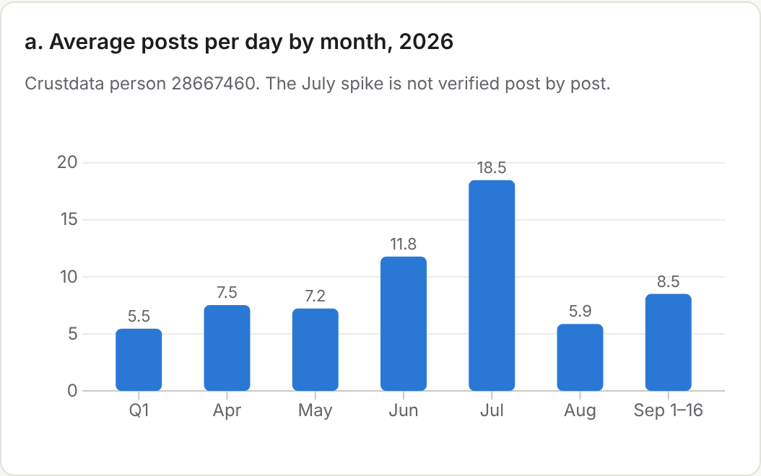
Q1 5.5/day → June 11.8 → July 18.5 → August 5.9 (summer) → Sep 1–16 8.5. The July spike is not verified post by post.

b. Curated vs own view
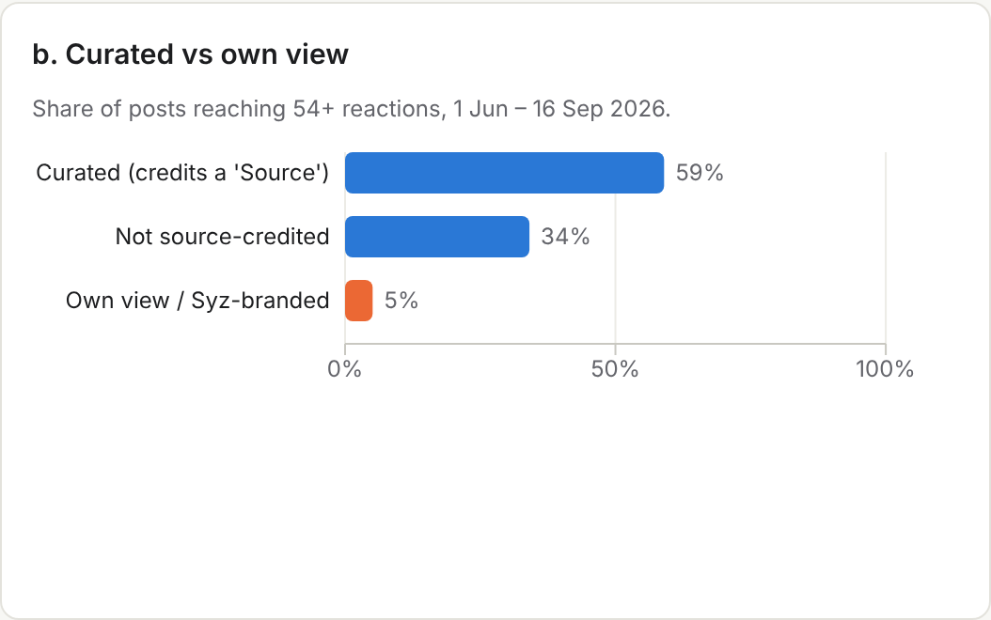
86% of posts (1,074 of 1,244, Jun 1 – Sep 16) credit a "Source"; 59% of those clear 54 reactions. Only 4 of 78 own-view or Syz-branded posts ("my take", "our view", "Syz") do.

c. Topic mix
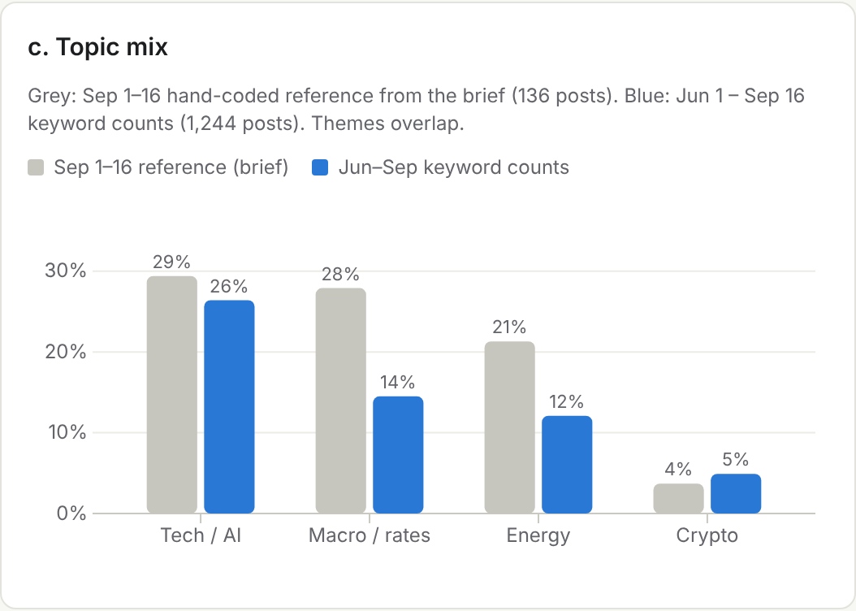
Grey: Sep 1–16 hand-coded reference from the brief (136 posts; Other ~18%). Blue: Jun 1 – Sep 16 keyword counts (1,244 posts). Keyword matching undercounts chart-only posts.

d. Reaction distribution
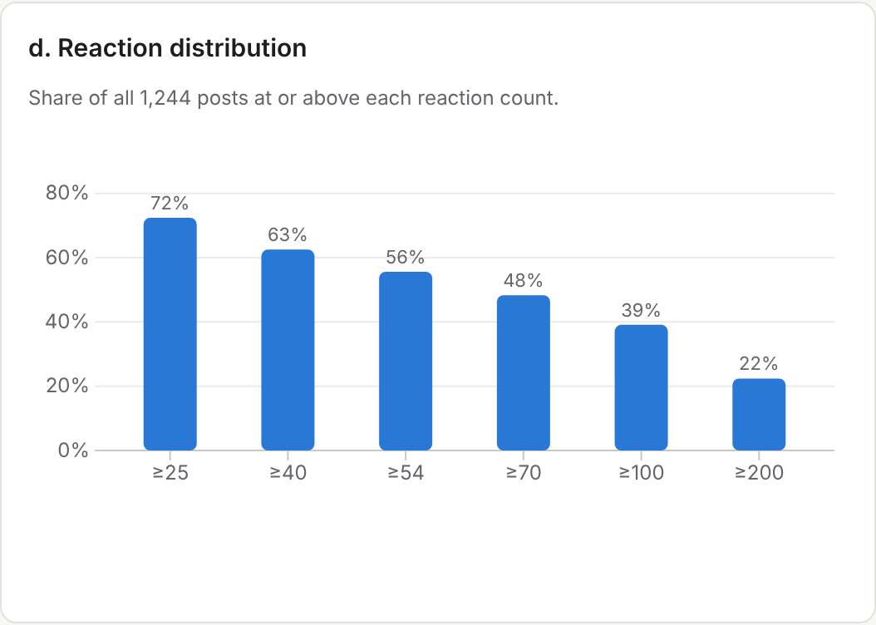
Share of all 1,244 posts at or above each reaction count; median about 65–70.

e. Engagement by format
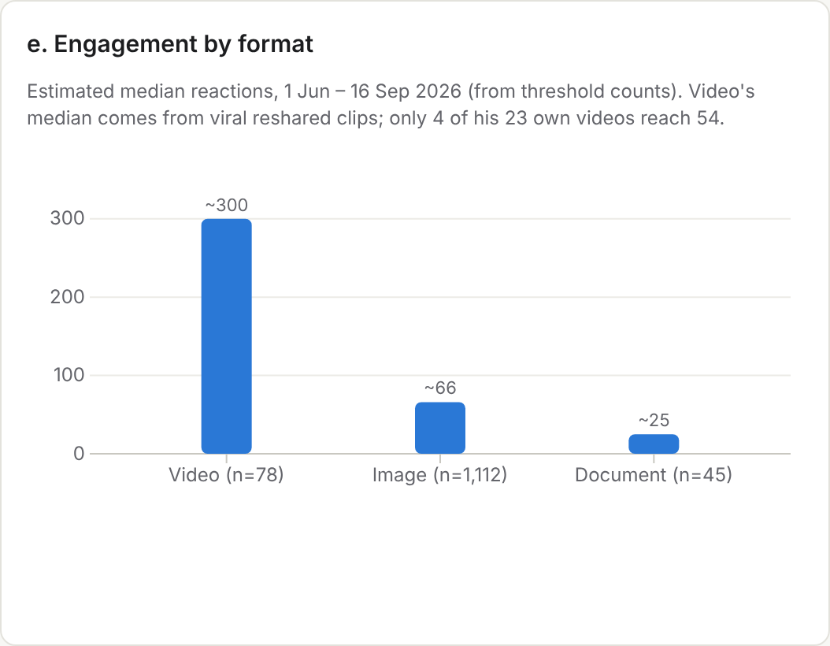
Estimated median reactions from threshold counts: video ~300 (78 posts), image ~66 (1,112), document ~25 (45); articles too few (2). The brief's Sep reference medians were video ~130, image 54, document 25, article 24. Video's high median comes from viral reshared clips: only 4 of his 23 own videos clear 54.

Sample posts
Post | Reactions | Note | Link
My take on FOMC | 19 | Own view on the Fed | Open post
Dear Donald (oil + AI capex) | 75 | Synthesis: Brent supply shock + hyperscaler debt competing with Treasuries | Open post
JPM: largest AI borrowers | 14 | Curated (Source: JPM); 1 share in index, so 'most-shared' not borne out | Open post
Hyperscaler debt is exploding | 230 | Best tech chart post; 21 shares | Open post
Pierce Brosnan photo (humour) | 17611 | Viral outlier | Open post

What to borrow: the single stat-dense chart with a 5–7 line read-through ("Hyperscaler debt is exploding", 230 reactions, 21 shares) and synthesis posts that join two stories ("Dear Donald": oil supply shock plus AI capex competing with Treasuries). What not to borrow: volume, humour reshares and unattributed curation, which work at his scale and not at about 2,000 followers.

8. SWOT and recommendations
Strengths  - The only tech long/short with a behavioural-sentiment quant overlay in the set  - Founder-CEO with BFM Business airtime; his own posts already beat the page (64 vs 14)  - Award history and a clear AI-disruption thesis | Weaknesses  - 0.15 posts a week, the lowest among active peers; the page mirrors TV clips  - Recent posts are French-only; 1,976 followers  - Product page shows no facts, performance, sleeves or team; award label says "Managed Futures"
Opportunities  - Close competitors are silent: Contour, Jericho, Shannon River post nothing; Symbit's page gets 0  - No Swiss tech-AI personal voice with reach (Pictet PMs 0 posts, AtonRâ 0–10 reactions, DECALIA 13% tech)  - A proprietary weekly sentiment read no peer can copy | Threats  - BIT and AtonRâ already tell the human + AI story with numbers  - Symbit occupies "Swiss + AI + long/short"; Pictet markets AI-enhanced equity at scale  - FinSA limits public performance talk

Recommendations
- Benchmark cadence against DECALIA, not zero (Swiss). Lift the company page from 0.15 to at least 2.3 posts a week: a weekly TMS sentiment-gauge chart plus one fund, event or BFM post. DECALIA posted 30 times in the window; Taranis 2.
- Take the tech-AI thesis lane AtonRâ has vacated (Swiss). One original AI-disruption thesis a week under Julien's name: chart first, three lines of read-through, link to a short note. AtonRâ owns the format but not the audience (0–10 reactions; nothing indexed since April); Pictet's tech PMs are absent.
- Lead through Julien Leegenhoek. He is the primary voice at about 3 posts a week (including the thesis); a partner such as Antoine Megarbane covers allocators every two weeks; the company page re-shares with a one-line frame. Evidence: Symbit 0 vs 108, DECALIA 63 vs 153, Taranis 14 vs 64.
- Point of view over curation. About 80/20 original to curated, and curate only to frame a TMS view. Monchau's curation works at his scale; his own-view posts clear 54 reactions 5% of the time, so Taranis wins on a distinct view, not volume.
- Post in English first, French second. Allocators read English; keep French for Romandie and the BFM clips. Recent Taranis posts are French-only, while DECALIA and Pictet run four languages.
- Fix the product page before pushing traffic. Add vehicle, ISIN, fees, liquidity, the two sleeves and their weights, named PMs, a factsheet behind the existing gate and a "request factsheet / book a call" CTA; relabel the "Managed Futures" award and align the public /investment intro ("alternative data and a systematic overlay") with the gated text.
- Compliant by design. A one-line risk warning on fund posts (as Pictet and BIT do), no performance numbers in posts (unlike AtonRâ), and one Compliance pre-approval of the weekly chart template.

Operating plan
Lever | Recommendation | Target / week | Evidence
1. Cadence vs DECALIA (Swiss) | Lift the company page from 0.15 to at least 2.3 posts/week: weekly TMS sentiment-gauge chart + one fund, event or BFM post | 2.3 | DECALIA 30 posts in 13 weeks; Taranis 2
2. Take the tech-AI thesis lane (Swiss) | One original AI-disruption thesis a week from Julien: chart first, three lines of read-through, link to a short note | 1 | AtonRâ's theses get 0-10 reactions and lapsed in the index after April; Pictet PMs post 0; DECALIA 13% tech
3. Lead through Leegenhoek | Julien is the primary voice (3 posts/week total incl. the thesis); a partner covers allocators; the page re-shares with a one-line frame | 3 | Symbit page 0 vs founder 108; DECALIA page 63 vs CIO 153; Taranis page 14 vs CEO 64
4. POV over curation | About 80/20 original vs curated; curate only to frame a TMS view |  | Monchau own-view posts clear 54 reactions 5% of the time; curation works at his scale, not at ~2,000 followers
5. Post in English (plus French) | Lead in English for allocators; French for Swiss Romandie and BFM clips |  | Recent Taranis posts are French-only; DECALIA and Pictet post in 4 languages
6. Fix the product page first | Add vehicle, ISIN, fees, liquidity, the two sleeves and weights, named PMs, a gated factsheet and a 'request factsheet / book a call' CTA; relabel the award |  | Every active peer discloses performance somewhere; Schroders and UBP do so behind the same Swiss gate
7. Compliant by design | One-line risk warning on fund posts; no performance numbers in posts; pre-approve the weekly chart template |  | Pictet and BIT add risk lines; AtonRâ posts YTD figures publicly

Measure monthly: re-run the free count queries (count_queries.csv, count_queries_swiss.csv) once the index catches up. Three-month targets: company page at least 2.3 posts a week; Julien at least 1 original thesis a week; median at least 25 reactions on Julien's originals (Pictet's company-page median).

7. Famous tech voices
Benchmark their formats, not their reaction counts: their audiences are in the millions. Counts are Crustdata, 17 Jun – 17 Sep 2026, by profile URL.
Voice | Posts / week | Top formats | Best post | Link | What Taranis can borrow
Bill Gates | 5.2 | Video + photo | 42692 | Open post | Personal relationship stories and short field-trip videos; warmth over data
Satya Nadella | 1.8 | Text-only + one photo | 18107 | Open post | Results-day post in his own words with 3-4 hard numbers and a framework; physical-milestone photo
Andrew Ng | 1.1 | Article/link + video | 14177 | Open post | Low volume; every post is a useful artifact (a map / a launch); one-line hook
Ethan Mollick | 15.3 | Image + text-only | 3928 | Open post | Daily first-hand tests of new AI models with a clear verdict and some dry humor
Aravind Srinivas | 1.0 | Video demo + image | 2935 | Open post | Builder proof: what we built and the dollar impact in two sentences
Allie K. Miller | 4.1 | Video tutorial + numbered list | 2362 | Open post | Early-access hands-on review in a numbered list; weekend homework series
Reid Hoffman | 2.4 | Video clips from his podcast | 2297 | Open post | Cut long-form interviews into 60-90s clips with one takeaway paragraph

Appendix A. Raw posts
All 102 posts pulled for this review, sorted by author. True dates are decoded from LinkedIn activity IDs. Text is truncated; the full CSV is data/posts_raw_all.csv.
Author | Date | Format | React. | Com. | Shr. | Text (truncated) | Link
Allie K. Miller | 2026-06-15 | video | 2362 | 233 | 105 | If your barrier to building an app was code, that barrier is basically gone. I'm going to tell you how to get a live app online by describing it to Claude Co… | Open post
Allie K. Miller | 2026-07-04 | video | 982 | 145 | 47 | This is your AI homework for the weekend... | Open post
Allie K. Miller | 2026-09-03 | image | 1365 | 307 | 44 | OpenAI just released a new model called Astra today. I had early access so let me tell you what I want EVERY business professional to know about it: 1. ... | Open post
Andrew Ng | 2026-07-23 | video | 11049 | 501 | 925 | Announcing OpenWorker! An open-source agent that doesn't just chat with you, but delivers finished work... | Open post
Andrew Ng | 2026-07-28 | article | 10424 | 508 | 388 | Fifteen years ago, Coursera and online courses changed education... I'm starting LearnVector... | Open post
Andrew Ng | 2026-08-14 | article | 14177 | 427 | 1189 | New: A map of the most important skills in AI Engineering. | Open post
Aravind Srinivas | 2026-06-18 | video | 2603 | 123 | 83 | We're rolling out Brain: a self-improving context-graph of all your sessions, connectors, and files. | Open post
Aravind Srinivas | 2026-09-01 | video | 2530 | 176 | 100 | We're introducing hybrid compute for all users of the Perplexity Mac app... | Open post
Aravind Srinivas | 2026-09-15 | image | 2935 | 143 | 63 | We built a replacement for AWS DynamoDB... two engineers and hundreds of persistent Perplexity Computer agents over two months... | Open post
AtonRâ Partners (company page) | 2026-02-04 | text | 0 | 0 | 0 | Who said making money and saving lives was incompatible | Open post
AtonRâ Partners (company page) | 2026-03-11 | image | 4 | 0 | 1 | The transformer backlog is not a demand spike. It's a structural lock-in. GE Vernova's grid division just reported Q4 orders of $7.4bn... | Open post
AtonRâ Partners (company page) | 2026-03-17 | image | 6 | 0 | 1 | Everyone is watching the Middle East. Nobody is watching Beijing. China's National People's Congress ratified the largest technology spending mandate in hist… | Open post
AtonRâ Partners (company page) | 2026-03-31 | image | 10 | 0 | 0 | The instinct when the Middle East escalates: sell risk, sell China. We think that's backwards. Qatar's helium facility offline... | Open post
AtonRâ Partners (company page) | 2026-04-30 | image | 7 | 0 | 2 | Tencent and Alibaba are in talks to take a stake in DeepSeek AI at a $40bn valuation... Our ChinaTech strategy... up 10.3% YTD and 60% since launch in Februa… | Open post
AtonRâ Partners (company page) | 2026-09-30 |  |  |  |  | Invest with proof, not faith (Fundy platform) - found via web search; not in Crustdata index; engagement not captured | Open post
BIT Capital (company page) | 2026-06-11 | image | 195 | 10 | 8 | Super Return: BIT Global Technology Leaders. Der BIT Global Technology Leaders R-I hat seit dem 7. Mai 2026 einen NAV von über 1.000 Euro je Anteil überschri… | Open post
BIT Capital (company page) | 2026-06-15 | image | 137 | 6 | 2 | Podcast-Tipp Alles auf Aktien: Jan Beckers über die fundamentalen Treiber hinter der Entwicklung an den Technologiemärkten... Micron, Memory-Zyklus, SpaceX, … | Open post
BIT Capital (company page) | 2026-06-17 | text | 78 | 1 | 1 | Nach unserem dritten AI Perspectives Dinner im März in Zürich haben wir vergangene Woche auch in Berlin... US-China-Duopol. | Open post
BIT Capital (company page) | 2026-07-02 | image | 107 | 2 | 1 | Neue Folge Beckers Bets: Jan Beckers und Christoph Damm blicken auf ein starkes erstes Halbjahr zurück... Memory Supercycle; Micron-Positionen seit Q1 2023 z… | Open post
Bill Gates | 2026-07-24 | video | 5859 | 457 | 525 | I had the most incredible week in Rwanda... | Open post
Bill Gates | 2026-08-20 | video | 10920 | 489 | 518 | It's the smallest country in South America with some big news: Suriname is officially malaria-free. | Open post
Bill Gates | 2026-08-30 | image | 42692 | 2227 | 736 | Happy birthday, Warren Buffett! Warren turns 96 this month... | Open post
Charles-Henry Monchau (Syz CIO) | 2026-05-31 | image | 254 | 34 | 14 | AMERICA'S BIGGEST MYSTERY COULD FINALLY FACE A PUBLIC AUDIT... Fort Knox... decades of conspiracy theories... Source: Bull Theory | Open post
Charles-Henry Monchau (Syz CIO) | 2026-06-25 | image | 226 | 21 | 1 | How does it do it? Source: Morning Brew | Open post
Charles-Henry Monchau (Syz CIO) | 2026-07-14 | image | 361 | 25 | 2 | He did it again... | Open post
Charles-Henry Monchau (Syz CIO) | 2026-09-11 | image | 567 | 14 | 26 | Agree. Source: Rahul Chaudhary | Open post
Charles-Henry Monchau (Syz CIO) | 2026-09-11 | image | 240 | 15 | 11 | JUST IN: The odds of a Fed rate hike next week have soared to 86% | Open post
Charles-Henry Monchau (Syz CIO) | 2026-09-12 | image | 1362 | 143 | 43 | BREAKING >>> Sydney Sweeney has been appointed by Treasury Secretary Scott Bessent as the 1st head of marketing in US Treasury history... (This is a fake obv… | Open post
Charles-Henry Monchau (Syz CIO) | 2026-09-13 | image | 525 | 160 | 19 | BREAKING: Anthropic's CEO Dario Amodei says AI is now improving itself so fast that the whole industry needs to slow down... Source: Bull Theory | Open post
Charles-Henry Monchau (Syz CIO) | 2026-09-13 | image | 356 | 34 | 14 | If you invested $10,000 into $BWET Breakwave Tanker Shipping ETF 15 months ago, you'd have $630,000 today. Source: Bull Theory | Open post
Charles-Henry Monchau (Syz CIO) | 2026-09-13 | image | 230 | 15 | 21 | Hyperscaler debt is exploding. Amazon, Alphabet, Microsoft and Meta have already issued more than $200 billion of bonds in 2026... Source: Bloomberg, Hedgeye | Open post
Charles-Henry Monchau (Syz CIO) | 2026-09-14 | image | 17611 | 428 | 117 | The camera man is a genius... (For those who didn't recognize him, this is Pierce Brosnan...) | Open post
Charles-Henry Monchau (Syz CIO) | 2026-09-14 | image | 423 | 17 | 15 | Accurate. Source: Investing visuals @InvestingVisual | Open post
Charles-Henry Monchau (Syz CIO) | 2026-09-15 | image | 14 | 0 | 1 | The largest AI borrowers are not weak credits. JPM estimates hyperscaler gross leverage at roughly 1.6x... AI is increasingly a capital-markets story. Source… | Open post
Charles-Henry Monchau (Syz CIO) | 2026-09-16 |  | 63 |  |  | (lol) - text not pulled | Open post
Charles-Henry Monchau (Syz CIO) | 2026-09-16 |  | 19 |  |  | My take on yesterday's FOMC: as expected... - text not pulled | Open post
Charles-Henry Monchau (Syz CIO) | 2026-09-16 |  | 77 |  |  | Powell right now not having to do these press... - text not pulled | Open post
Charles-Henry Monchau (Syz CIO) | 2026-09-16 | image | 75 | 8 | 1 | Dear Donald, the 'no war no peace' with Iran doesn't work here... Brent closing in on $110... hyperscaler capex >100% of operating cash flow... The trade fun… | Open post
DECALIA (company page) | 2026-07-21 | article | 28 | 0 | 2 | In an interview with Finews AG, Reji Vettasseri, Lead Portfolio Manager at DECALIA, discusses why selectivity, expertise and disciplined execution are essent… | Open post
DECALIA (company page) | 2026-08-13 | image | 63 | 0 | 0 | Despite the extreme summer heat, a few members of the DECALIA cycling crew took on the Salève and made the most of the season together. | Open post
DECALIA (company page) | 2026-08-21 | image | 52 | 0 | 3 | Hier, c'était aussi la rentrée chez DECALIA ! ... notre conférence annuelle « Market Outlook ». Un grand merci à nos trois intervenants... | Open post
DECALIA (company page) | 2026-08-27 | image | 32 | 0 | 2 | Dans un secteur où l'information est partout, la véritable différence se joue dans l'expertise. Sebastien Demole... panel « Se spécialiser pour se différenci… | Open post
DECALIA (company page) | 2026-09-08 | image | 34 | 0 | 3 | Comment se différencier et faire évoluer son modèle dans une gestion de fortune en pleine transformation ? Merci à SPHERE pour les EAM Days... | Open post
Ethan Mollick | 2026-06-04 | image | 3928 | 247 | 154 | I have a new book coming out October 20: Co-Existence! | Open post
Ethan Mollick | 2026-07-27 | image | 1365 | 130 | 10 | Kimi K3's weights were released... since I can't run it, I've been reading the weights... | Open post
Ethan Mollick | 2026-09-13 | text | 2159 | 238 | 137 | I cannot emphasize enough how much GPT-6 Astra and Fable 5.1 are already enough for transformative impact in large sections of the economy... | Open post
Fabrizio Quirighetti (DECALIA CIO) | 2026-06-17 | image | 153 | 4 | 2 | Le lendemain du G7 d'Évian. Chacun peut enfin rejouer les événements à la maison... un Black Bloc Playmobil et un policier Playmobil. | Open post
Fabrizio Quirighetti (DECALIA CIO) | 2026-06-24 | image | 56 | 2 | 0 | Comme à chaque Mundial, j'ai une pensée émue pour Pierre Desproges... « À mort le foot » | Open post
Fabrizio Quirighetti (DECALIA CIO) | 2026-07-08 | image | 43 | 2 | 2 | Are you token to me? ... inference is becoming cheaper. That's great for users, but potentially devastating for AI economics... Source: #Bloomberg & Christop… | Open post
Fabrizio Quirighetti (DECALIA CIO) | 2026-07-29 | image | 24 | 0 | 1 | From Mag7 to Lag7... The Mag7's grip is fading as John Authers rightly points out this morning in his daily Bloomberg column | Open post
Jan Beckers (BIT founder/PM) | 2026-06-15 | image | 143 | 1 | 1 | Der Cutoff von Fable zeigt: Der Handlungsdruck für Europa, um an der KI-Transformation teilzuhaben, wird immer größer... | Open post
Jan Beckers (BIT founder/PM) | 2026-06-17 | image | 0 | 0 | 0 | Last week, we hosted our AI Perspectives Dinner, an intimate, closed-door circle discussing whether the world can still avoid a US/China duopoly... | Open post
Julien Leegenhoek (Taranis CEO) | 2022-04-04 | text | 88 | 14 | 0 | It was great to attend the #WealthBriefing Award ceremony in London where we received the award of the best European Fund Manager. | Open post
Julien Leegenhoek (Taranis CEO) | 2023-10-16 | image | 128 | 19 | 3 | We have been recognized as the Managed Futures Newcomer of the Year 2023 at the European Performance Awards by HFM Global. | Open post
Julien Leegenhoek (Taranis CEO) | 2024-09-10 | text | 52 | 11 | 2 | What a milestone it's been since founding Taranis four years ago! Being shortlisted in four categories at the HFM European performance awards... | Open post
Julien Leegenhoek (Taranis CEO) | 2026-04-24 | image | 64 | 1 | 4 | J'ai eu le plaisir d'être à nouveau invité sur Good Morning Market sur BFM Business... Nous sommes en année 1 de disruption de l'IA. | Open post
Julien Leegenhoek (Taranis CEO) | 2026-05-26 | image | 48 | 1 | 4 | L'IA crée une pénurie que le marché peine encore à valoriser. Invité ce lundi sur BFM Business TV... NVIDIA, Samsung, SK Hynix, AMD, Lumentum... | Open post
Marius Skrondal (Symbit co-founder) | 2026-06-22 | text | 108 | 7 | 1 | A warm welcome to Alex Ring, CFA! He brings exactly what we needed. Let the building begin. | Open post
Marius Skrondal (Symbit co-founder) | 2026-07-22 | text | 41 | 1 | 0 | First Symbit article | Open post
Pictet Asset Management (company page) | 2026-06-02 | image | 116 | 5 | 1 | La semana pasada asistimos a la II edición de los Premios Estrategias de Inversión... premio al Mejor Fondo de Renta Fija EE.UU. | Open post
Pictet Asset Management (company page) | 2026-07-01 | image | 141 | 1 | 20 | We are launching our first European range of AI-enhanced active equity ETFs... Pictet's proprietary AI model drives the entire stock process... Capital Risk … | Open post
Pictet Asset Management (company page) | 2026-07-17 | image | 119 | 2 | 3 | Many of the companies driving the environmental transition are still private... final close of its first dedicated environment co-investment fund, USD 253 mi… | Open post
Pictet Asset Management (company page) | 2026-07-21 | image | 114 | 8 | 2 | Nuevos ingredientes y nuevas recetas... La Cocina Financiera para seguir explicando el mundo de la inversión de una forma tan clara como apetecible. | Open post
Pictet Asset Management (company page) | 2026-08-28 | image | 147 | 0 | 4 | Today, the Pictet Group announced the figures for the first half of 2026... assets clients entrusted to Pictet reached an all-time high. | Open post
Reid Hoffman | 2026-06-24 | video | 2297 | 398 | 321 | Satya Nadella described a future at Microsoft where there may be more than 20 million agents working alongside employees... | Open post
Reid Hoffman | 2026-08-23 | video | 745 | 124 | 59 | I asked Satya Nadella for a book recommendation... | Open post
Reid Hoffman | 2026-09-09 | article | 444 | 135 | 30 | Open-source tools can now turn a single image into a live face swap on consumer hardware... | Open post
Satya Nadella | 2026-07-29 | text | 11281 | 473 | 539 | Just wrapped our earnings call. It was a very strong close to what was a record fiscal year for Microsoft... | Open post
Satya Nadella | 2026-08-21 | image | 18107 | 642 | 643 | Delivery day at our Microsoft DCs as the first production Vera Rubins arrive. | Open post
Satya Nadella | 2026-09-13 | text | 11966 | 920 | 879 | Any pursuit of superintelligence has to be grounded in the core principle that if the AI we build is not helping humanity and under human control, it's not w… | Open post
Schroders (company page) | 2026-06-01 | image | 246 | 22 | 2 | We're pleased to announce the appointment of Robert Reid as Chief Operating Officer, Asia Pacific. | Open post
Schroders (company page) | 2026-06-16 | image | 335 | 5 | 4 | We're excited to welcome our 2026 summer interns to Schroders! | Open post
Schroders (company page) | 2026-07-06 | image | 223 | 0 | 4 | In June, we welcomed 53 interns and 2 placement year students across our offices... | Open post
Schroders (company page) | 2026-08-04 | image | 553 | 156 | 5 | Congratulations to Edwin Lamptey, Equity Solutions Manager, on being named in the Empower 2026 Top 100 Future Leaders list. | Open post
Symbit Capital (company page) | 2026-06-22 | image | 0 | 0 | 0 | We just wrapped a week on the road, meeting with allocators... joined by our new team member, Alex Ring, CFA | Open post
Symbit Capital (company page) | 2026-07-22 | article | 0 | 0 | 0 | Thank you, Sarah Praetorius, for the write-up. This headline violates at least 3 of the 10 laws of Jante in Norway... | Open post
Syz Group (company page) | 2026-05-28 | image | 166 | 4 | 4 | L'âge de raison du Bitcoin - an evening on the maturation of digital assets... led by our CIO Charles-Henry Monchau... | Open post
Syz Group (company page) | 2026-07-07 | image | 152 | 0 | 4 | The beginning of an exciting new chapter. For the past three years, we've had the privilege of supporting Angella Okutoyi... | Open post
Syz Group (company page) | 2026-08-28 | image | 170 | 3 | 6 | Thirty years of Syz is, above all, thirty years of trusted relationships. - Etienne Billaud, Head of External Asset Managers | Open post
Taranis (company page) | 2022-03-16 | image | 0 | 0 | 0 | We are proud to announce that Taranis was named finalist in the 'Fund Manager' category at the Annual WealthBriefing European Awards 2022. | Open post
Taranis (company page) | 2022-04-04 | image | 0 | 0 | 0 | We are honoured to have won the Best Fund Manager award at the #WealthBriefing European Awards 2022. | Open post
Taranis (company page) | 2022-08-19 | image | 26 | 1 | 3 | We are thrilled to announce that Taranis has been shortlisted at the With Intelligence HFM Performance Awards 2022 for Managed Futures - Newcomer category. | Open post
Taranis (company page) | 2023-09-20 | article | 13 | 3 | 3 | Exciting News: Taranis Market Sentiment nominated Again for the With Intelligence HFM European Performance Awards 2023... | Open post
Taranis (company page) | 2024-02-09 | image | 110 | 16 | 5 | Big news from the Taranis front! Thrilled to announce that we were awarded the 'BEST EQUITY-BASED INVESTMENT STRATEGY' at the Annual WealthBriefing Swiss Awa… | Open post
Taranis (company page) | 2024-03-09 | document | 29 | 5 | 2 | We are featured in ACCLAIM magazine's article: Recognising Leaders across the Global Wealth Management Industry... | Open post
Taranis (company page) | 2024-03-25 | image | 86 | 9 | 4 | We are proud to announce that we were awarded last week best Equity-based Investment Strategy at the Wealthbriefing EUROPEAN Awards 2024. | Open post
Taranis (company page) | 2024-04-02 | article | 19 | 0 | 4 | This week's newsletter delves into the heart of decision-making... tribute to Nobel Laureate Daniel Kahneman (1934-2024). | Open post
Taranis (company page) | 2024-05-02 | article | 11 | 0 | 1 | Great publication from one of our most renowned peers about the virtue of complexity in return prediction (Kelly, Malamud, Zhou)... | Open post
Taranis (company page) | 2024-09-09 | image | 0 | 0 | 0 | We are EXTREMELY honoured to be shortlisted by the HFM European performance awards in 4 different categories! ...Taranis Market Sentiment which was launched … | Open post
Taranis (company page) | 2025-10-13 | image | 13 | 1 | 2 | We are proud to share that our Market Sentiment fund has been nominated at the upcoming HFM European Performance 2025 Awards in 3 different categories... | Open post
Taranis (company page) | 2026-02-12 | video | 34 | 0 | 4 | [Taranis on French TV] $200bn in capex is not an accident. Our founder Julien Leegenhoek was invited on BFM Business... Counter-consensus view: probability o… | Open post
Taranis (company page) | 2026-02-16 | image | 52 | 1 | 3 | Fundraising dynamics are shifting in 2026. Last week, Taranis, represented by Partner Antoine Megarbane, attended the With Intelligence Emerging Managers COO… | Open post
Taranis (company page) | 2026-08-07 | video | 14 | 0 | 4 | Le marché se pose des questions sur les profits futurs ou cash flow présents. On attire l'attention sur le cycle d'investissement. Ce matin, sur BFM Business… | Open post
Taranis (company page) | 2026-08-14 | article | 14 | 0 | 3 | Discussion ce matin sur la sous performance des géants chinois de la tech. Invité sur BFM Business aux côtés de Étienne Bracq, Julien Leegenhoek a abordé la … | Open post
Tony Guida (AtonRâ Head of Quant) | 2026-06-16 | text | 4 | 0 | 0 | Spot on comment from Stefano Pasquali. Continuity by design, not by hope | Open post
Victor Marchand (AtonRâ BD) | 2026-04-22 | image | 9 | 0 | 1 | China's AI Value Migration: Why 2026-2027 Belongs to Mid-Caps... Our China Technology strategy runs a quantitative, ~1,000-stock universe | Open post
Victor Marchand (AtonRâ BD) | 2026-05-06 | text | 4 | 0 | 1 | The 2020 China trade is over. Passive exposure isn't paying. Our Chinese Technology strategy: +45% YTD, +53% since Feb '25... | Open post
Wellington Management (company page) | 2026-06-10 | image | 555 | 39 | 3 | We are pleased to announce that John Norberg has been elected a Managing Partner of Wellington Management, effective July 1. | Open post
Wellington Management (company page) | 2026-06-17 | image | 350 | 1 | 4 | Wellington Management is excited to introduce our 2026 Summer Internship Class! | Open post
Wellington Management (company page) | 2026-07-22 | image | 452 | 41 | 2 | Pleased to welcome Fabio Balboni to Wellington Management... Global Macro team as a macro strategist. | Open post
Wellington Management (company page) | 2026-07-22 | image | 222 | 6 | 27 | Today, alongside Blackstone and Vanguard Financial Advisor Services, we announced the launch of two new investment solutions... | Open post
Wellington Management (company page) | 2026-07-30 | image | 147 | 3 | 13 | Our latest campaign, Perspectives that see through the century... Now live in Hong Kong and Singapore. | Open post

Appendix B. Key sources
- Taranis TMS page (gated): taranis.net/investment/tms
- Taranis investment overview: taranis.net/investment
- AtonRâ AI & Robotics: atonra.ch/investment-funds/ai-robotics
- AtonRâ research hub: atonra.ch/investment-research
- DECALIA Future SOCIETY factsheet: funds-static.pictet.com/funds/decalia/factsheet/MR_ES_en_LU2407358063_YES_2026-05-3
- DECALIA PM interview (finews): finews.com/news/english-news/74003-decalia-future-society-fund-intervi
- Pictet Robotics: am.pictet.com/ch/en/intermediaries/funds/pictet-robotics/LU1279334210
- Pictet TR-Atlas Titan: am.pictet.com/ch/en/institutions/funds/pictet-tr-atlas-titan/LU2206555984
- Symbit launch (Hedgeweek): hedgeweek.com/news/new-york-investment-veterans-launch-ai-native-hedge-fu
- BIT Global Technology Opportunities: bitcap.com/en/fonds/bit-global-technology-opportunities
- U Access (IRL) Shannon River UCITS (UBP): ubp.com/en/asset-management/funds/ie00bkdrxc08
- Contour Asset Management: contourasset.com/index
- Schroder GAIA Contour Tech Equity (finanzen.ch): finanzen.ch/fonds/schroder-gaia-contour-tech-equity-a1-lu1725199464
- Jericho Capital: jerichocap.com/
- Wellington DTI launch (Investment Week): investmentweek.co.uk/news/4014116/wellington-launches-long-short-disruptive-tech
- Crustdata pricing / API: docs.crustdata.com/general/pricing

