Programming assignment

a. Submitted separately

b. The accuracy is 0.846. In a random classifier I’d expect to get an accuracy of 0.1, the chance of choosing the right label out of 10 possible ones under a uniform distribution.

c. As you can see in the following chart, the optimal k is 1 (x-axis: k, y-axis: accuracy):

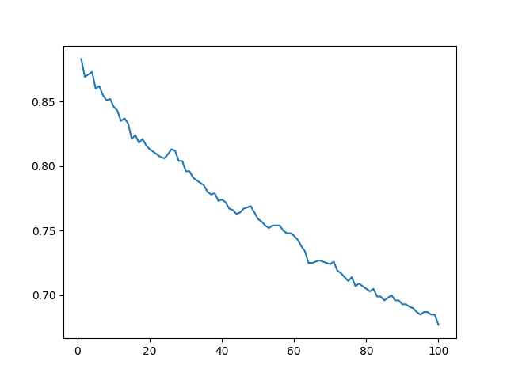

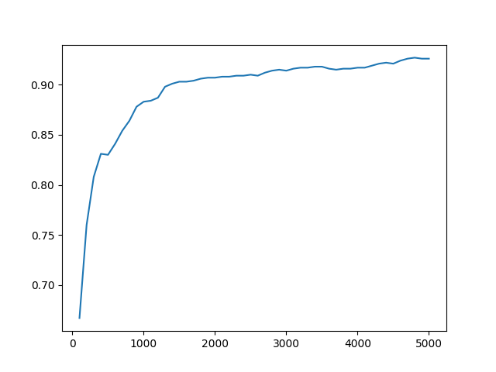d. As you can see in the following chart the more training images the more accurate the model is. This correlation is somewhat logarithmic: