Question 1:

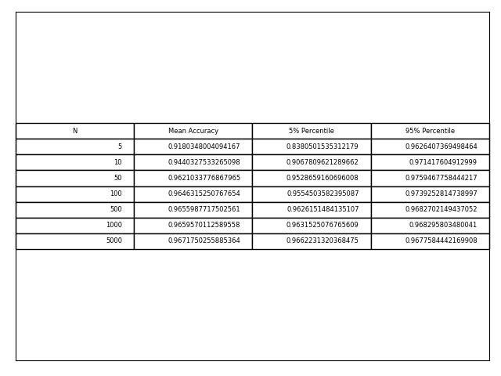

Question 2:

Here is a visual representation of the weight vector:

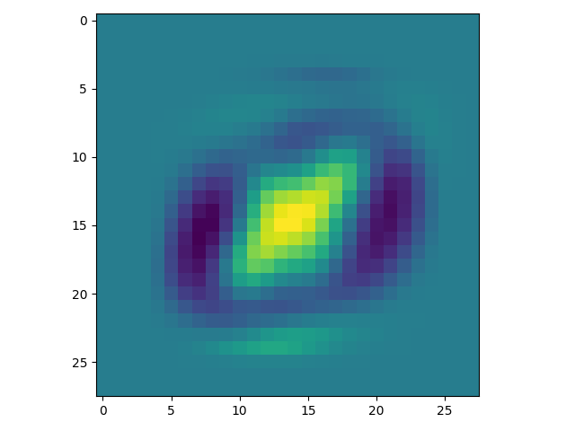

My intuition is that it prioritizes the center of the images over the margins.

Question 3:

The accuracy I received was 0.9672466734902764

Question 4:

I got a misclassification for the following image:

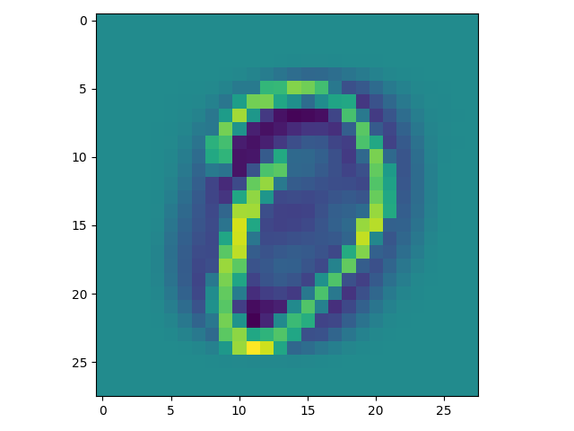

This makes sense - in this image the focus is on the margins and the center is “empty”, exactly the opposite of the Perceptron’s results.